Movie Picture Pipeline
Final Project Submission & Verification Evidence
GitHub Actions • Amazon ECR • Amazon EKS • LoadBalancer • Application Verification

1. Project Repository
GitHub repository:
https://github.com/AtlaSaikrishna/movie-picture-pipeline

2. Deployment URLs
Backend API: http://k8s-default-backend-68b99fe00b-f357fcddc4924b4c.elb.us-east-1.amazonaws.com/movies
Frontend Application: http://k8s-default-frontend-9fbdcdcc3f-3d16bdfc1ac0c831.elb.us-east-1.amazonaws.com

3. Final CI/CD Verification
Workflow / Requirement | Status | Evidence
Frontend Continuous Integration | PASSED | GitHub Actions #2
Backend Continuous Integration | PASSED | GitHub Actions
Backend Continuous Deployment | PASSED | GitHub Actions #4
Backend /movies API | PASSED | LoadBalancer + browser
Frontend Continuous Deployment | PASSED | GitHub Actions #2
Frontend application | PASSED | LoadBalancer + browser

4. GitHub Actions Screenshots
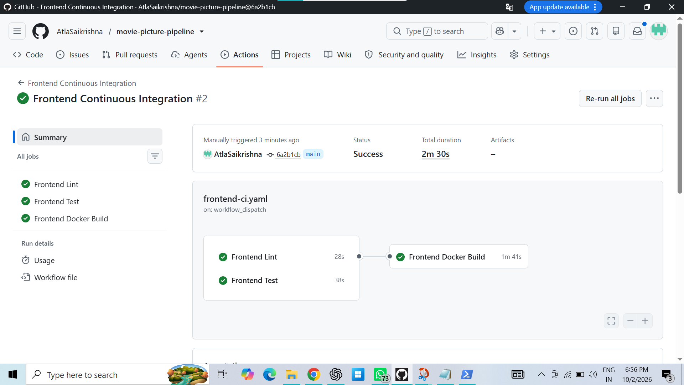
Frontend Continuous Integration #2 — Success. Frontend Lint, Frontend Test and Frontend Docker Build passed.
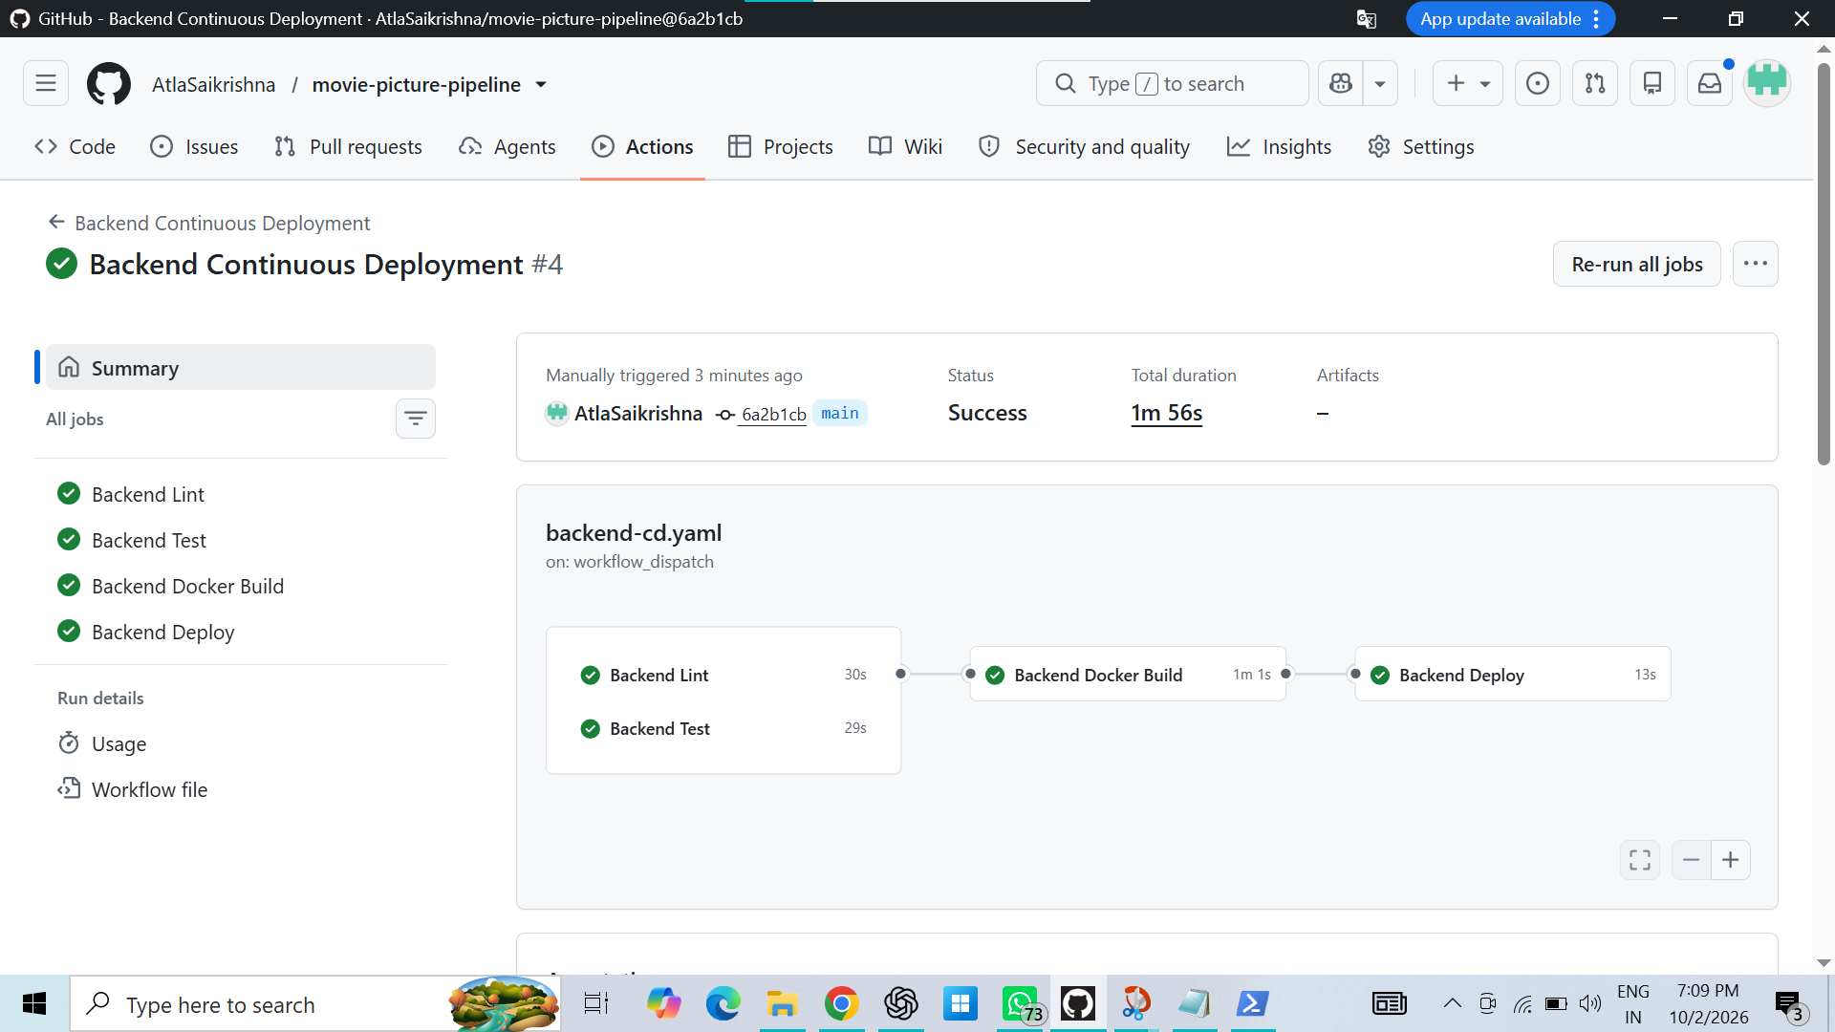
Backend Continuous Deployment #4 — Success. Backend Lint, Backend Test, Backend Docker Build and Backend Deploy passed.
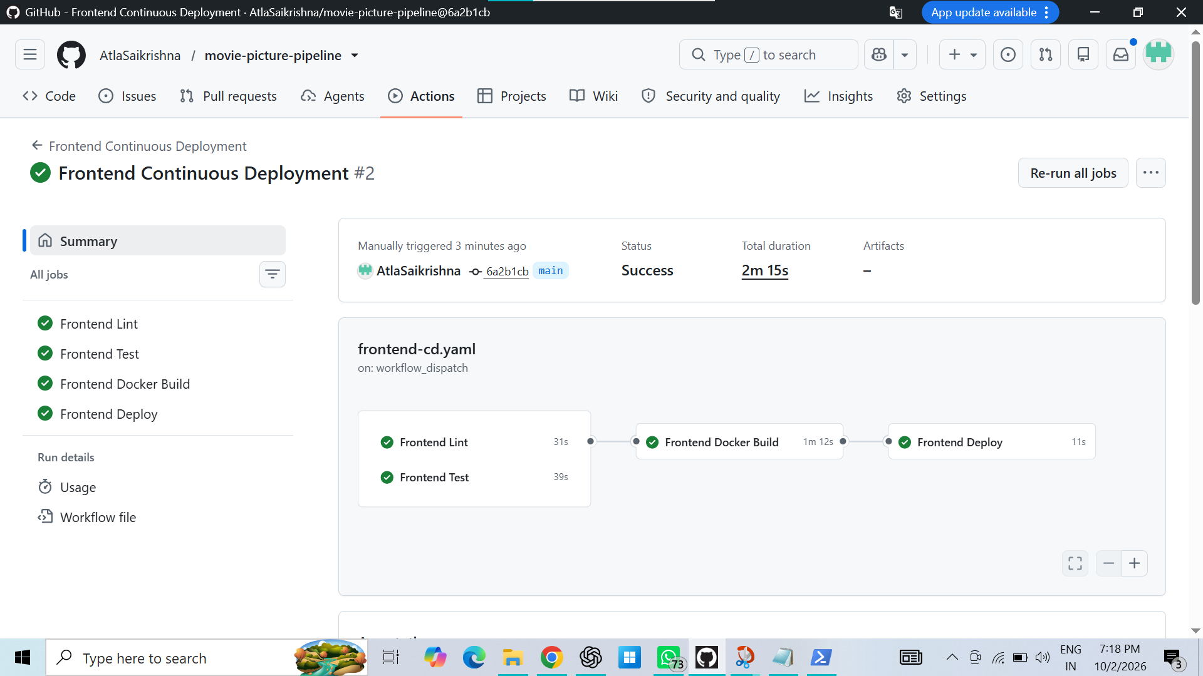
Frontend Continuous Deployment #2 — Success. Frontend Lint, Frontend Test, Frontend Docker Build and Frontend Deploy passed.

5. Backend API Access Proof
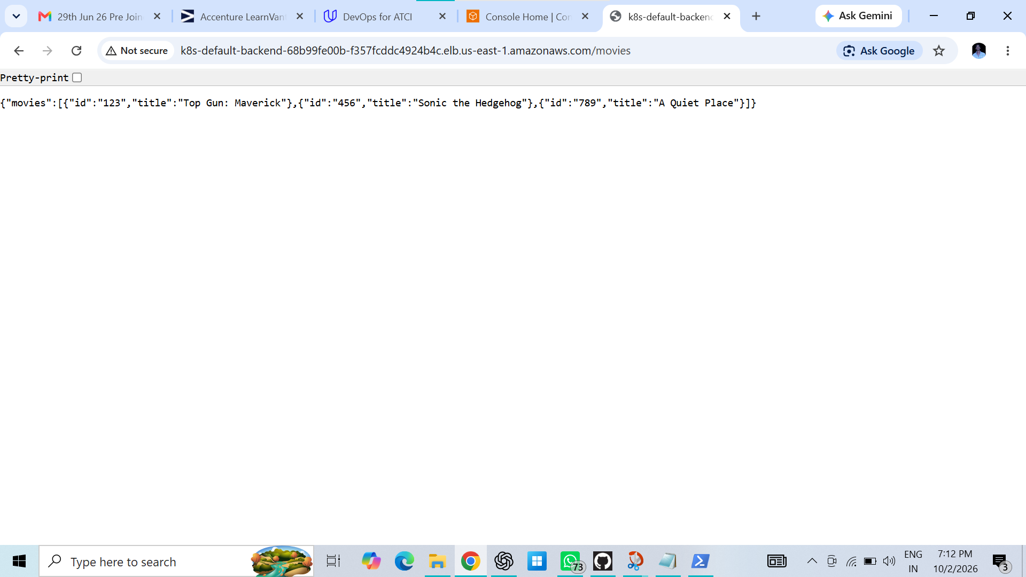
The browser shows the Backend LoadBalancer DNS with /movies and the expected movie JSON response.

6. Frontend Application Access Proof
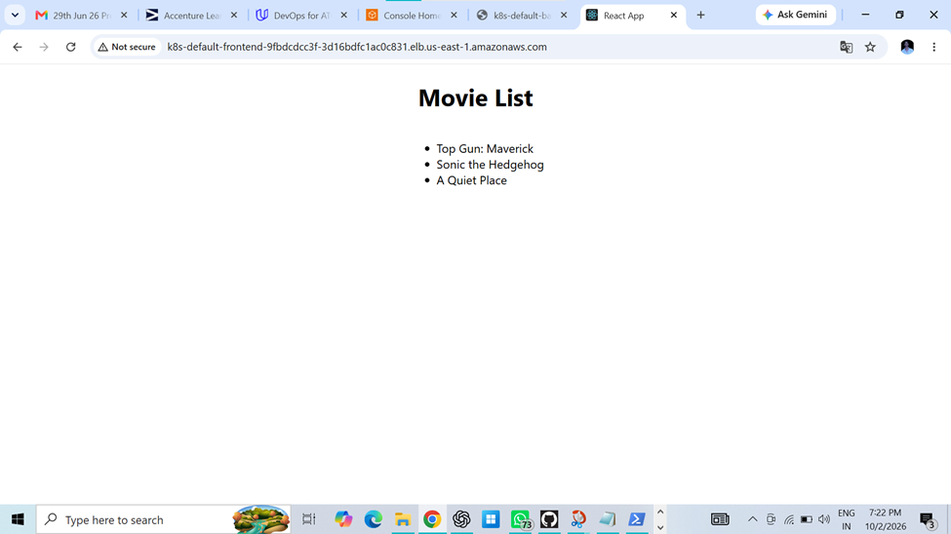
Frontend LoadBalancer URL visible in the browser. The deployed Movie List displays the three movies.
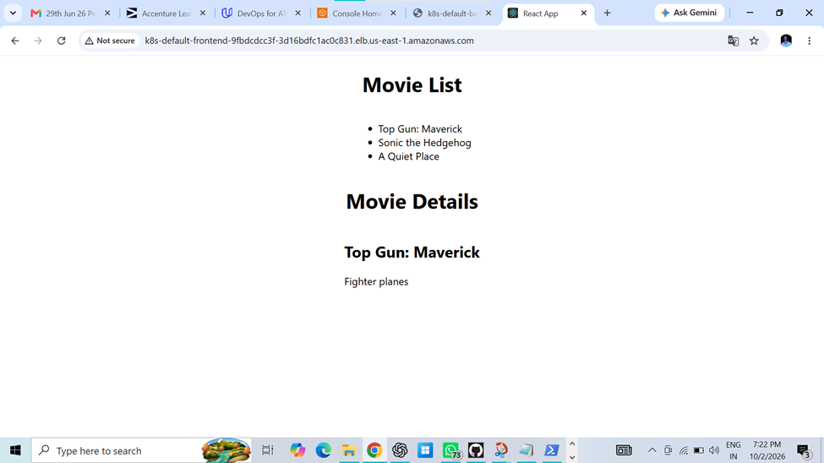
Frontend application displays both the Movie List and Movie Details, confirming the deployed application is functioning.

