Appendix 1: Assignment submission cover sheet
ASSIGNMENT SUBMISSION COVER SHEET

CSE25-310
Student Id:

ATLANG ROMEO KAMBELA
Student names:
cse25-310@thuto.bac.ac.bw
Student email:

Cohort: 2026

SCIS WMD_2026 A01
Assignment title:

Date of submission:
Computer Systems Engineering
Programme of Study:

YEAR 1
Year of Study:

Intellectual property statement
By checking the box below, I certify that this assignment is my own work and is free from plagiarism. I understand that the assignment may be checked for plagiarism by electronic or other means and may be transferred and stored in a database for the purposes of data-matching to help detect plagiarism. The assignment has not previously been submitted for assessment in any other unit or to any other institution. I
have read and understood the Botswana Accountancy College plagiarism guidelines policy.
☑ Agree Signature…………………………………….
Date………………………………………….

INTRODUCTION:

Pula Bank provides essential financial services in Botswana, including registration for debit and credit accounts, applications for personal and business loans, and access to customer account statements. These services are currently handled through in-person processes, which can limit speed, convenience, and accessibility for customers.

I will create a website that will digitize these services, allowing users to register accounts, apply for loans, and check their statements online. This will streamline operations, reduce manual workload, and give customers a faster, more convenient way to manage their finances.

- WEBSITE SPECIFICATIONS:

WEBSITE TYPE: Digital Banking Portal.

WEBSITE OBJECTIVES:
- Registration.
- Reduce Manual Workload
- Enable the bank to handle a larger volume of customer requests simultaneously without increasing physical branch staff.
- Transition from paper-based systems to digital systems, allowing staff to review and approve applications faster.
- making services more accessible to those in remote areas
- Allow users to give feedback about the website

WEBSITE GOALS:

- 24/7 Availability
- Allow users to create account registrations and loan applications to minimize human error.
- Reduce the need for customers to travel to physical branches for financial services.
- Fast access to account statements and application statuses.
- Promote online identity for Pula Bank to compete effectively with large banks
- Site feedback will allow me to be able to modify the site to suit the user’s needs and simultaneously attract new users

TARGET AUDIENCE:

Demographics:

- AGE: The 18-64 age
  - 18-26: Mainly students
  - 27-55: Workers
  - 56+: Pensioners

- GENDER: Evenly distributed among genders, with 52% male and 48% female members.

- INCOME: People with an annual household income of more than P75,000 make up about 23% of the total bank customer base.

Technical Aptitude: Moderate to High.

- INFORMATION DESIGN & TAXONOMY (SITE MAP)
Pula Bank’s website will consist of the following:

- HOME PAGE

- Header & Footer sections will remain consistent throughout the Services, Resources, and Feedback pages to ensure seamless navigation.
- The header will have the company logo, navigation links and account icon
- It will also host carousel which will promote the business and its core services.
- The footer will contain contact information, legal information, social media icons and a link to the vacancy pages about the business

- ABOUT PAGE

  - This page will have a description of the company and a section for the full company contact information.

- BANKING SERVICES PAGE

  - This page will feature interactive cards for each financial product, providing summary details on
- Debit & Credit Accounts:
- Personal & Business Loans: Overview of borrowing limits and repayment terms

- Individual Service Pages: Each financial product will have a dedicated page detailing eligibility requirements and documentation needed.

- ACCOUNT PAGE

- User Dashboard: A private interface displaying:
- Account Overview: Real-time balances for active accounts.
- Loan Tracker: Statuses on pending applications and repayment schedules.
- Statement Generator: Ability for users to view and download transaction histories.

- Profile Management: Secure section for users to update personal details, change passwords, and manage notification preferences.

- FEEDBACK PAGE

  - A Form to gather user opinions and queries
SITE MAP

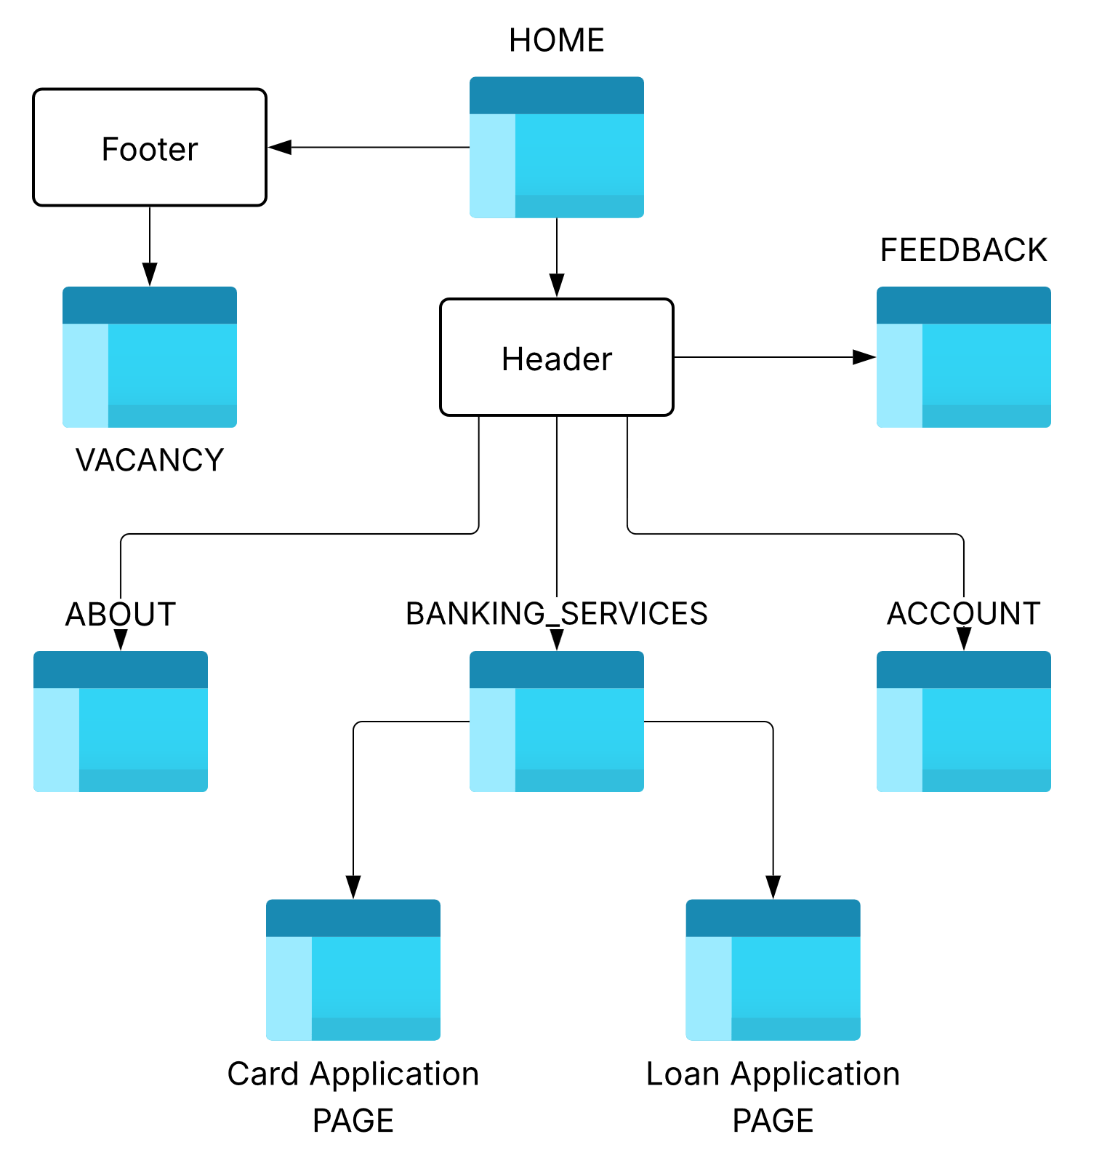

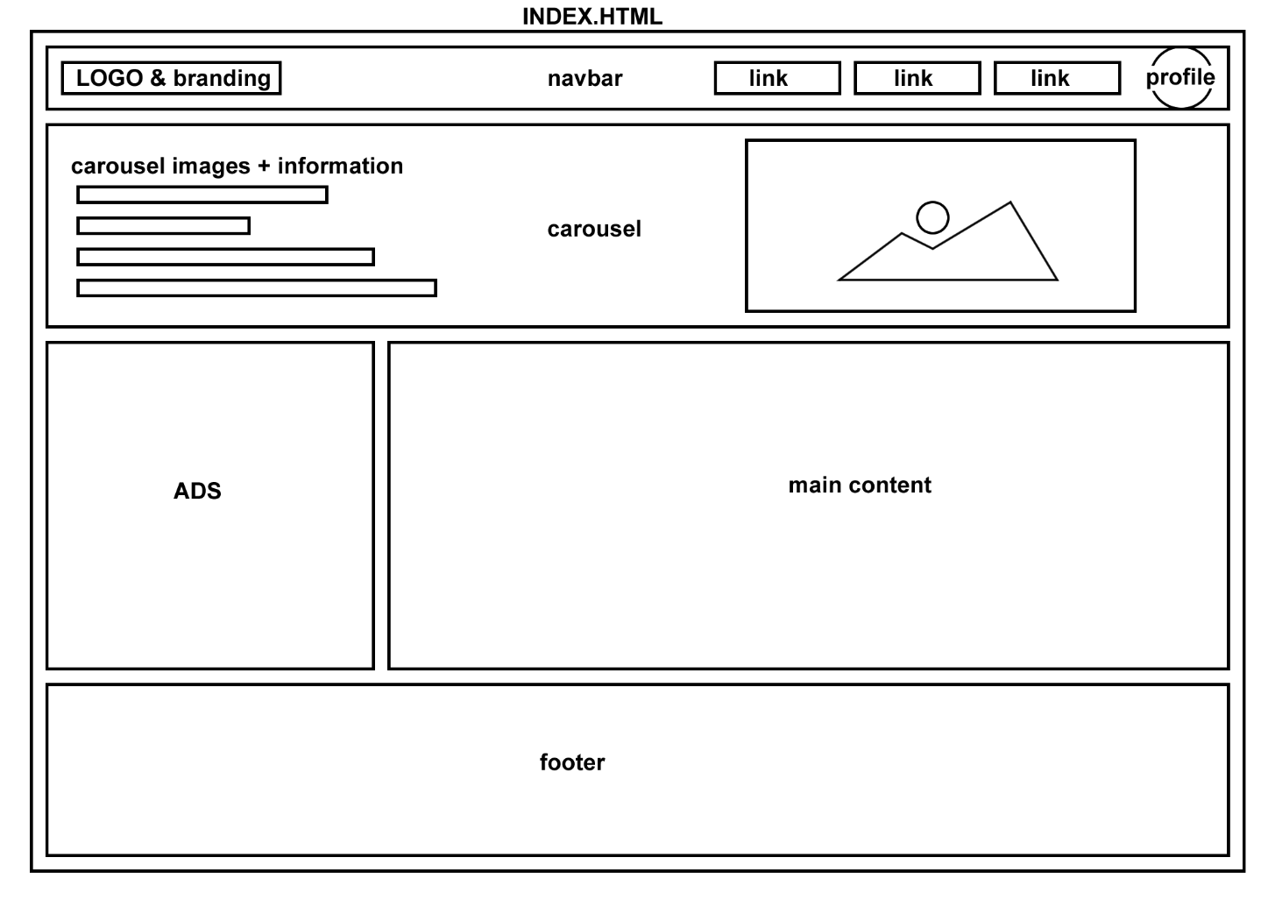
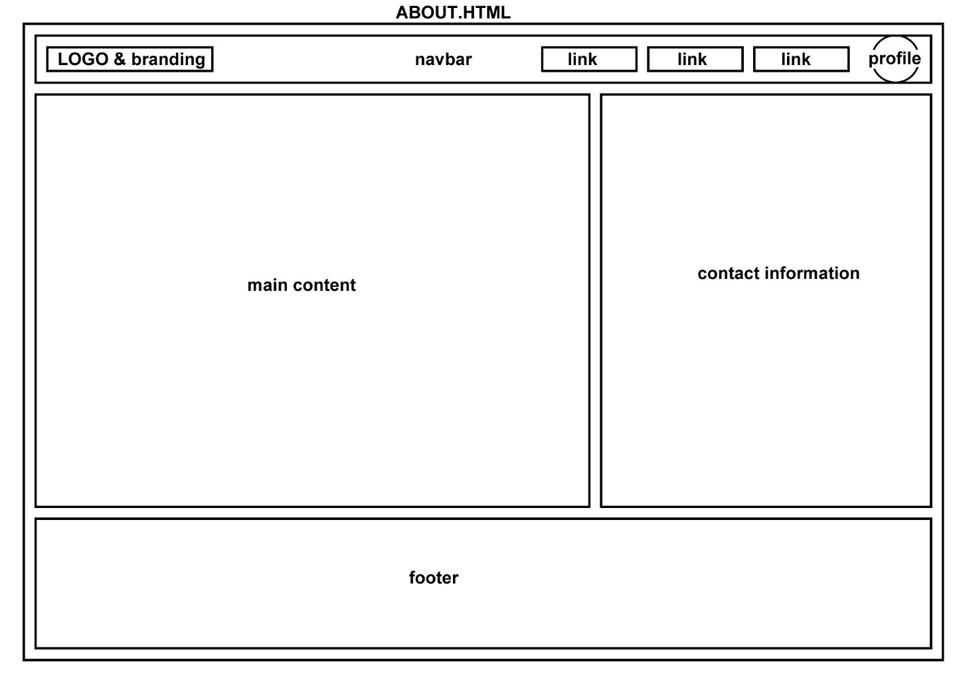
SKETCH WIREFRAMES
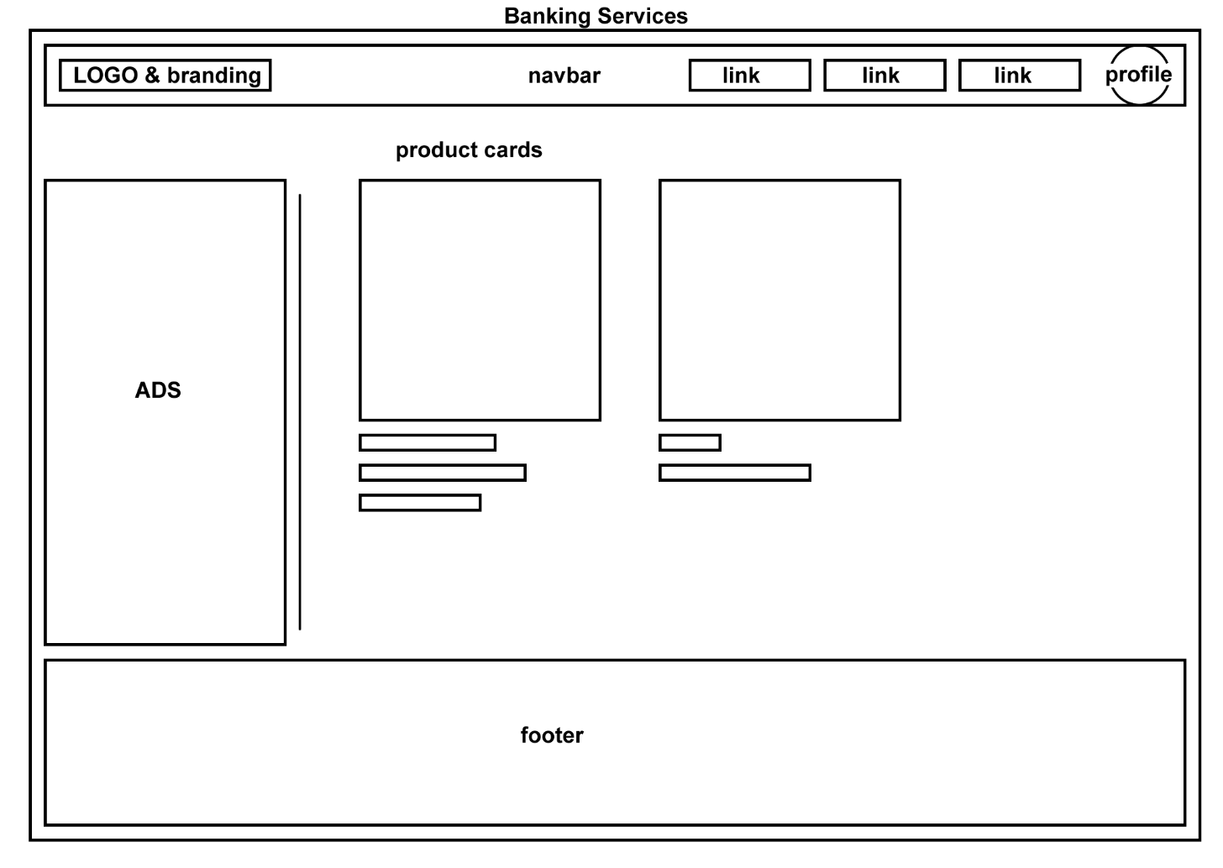
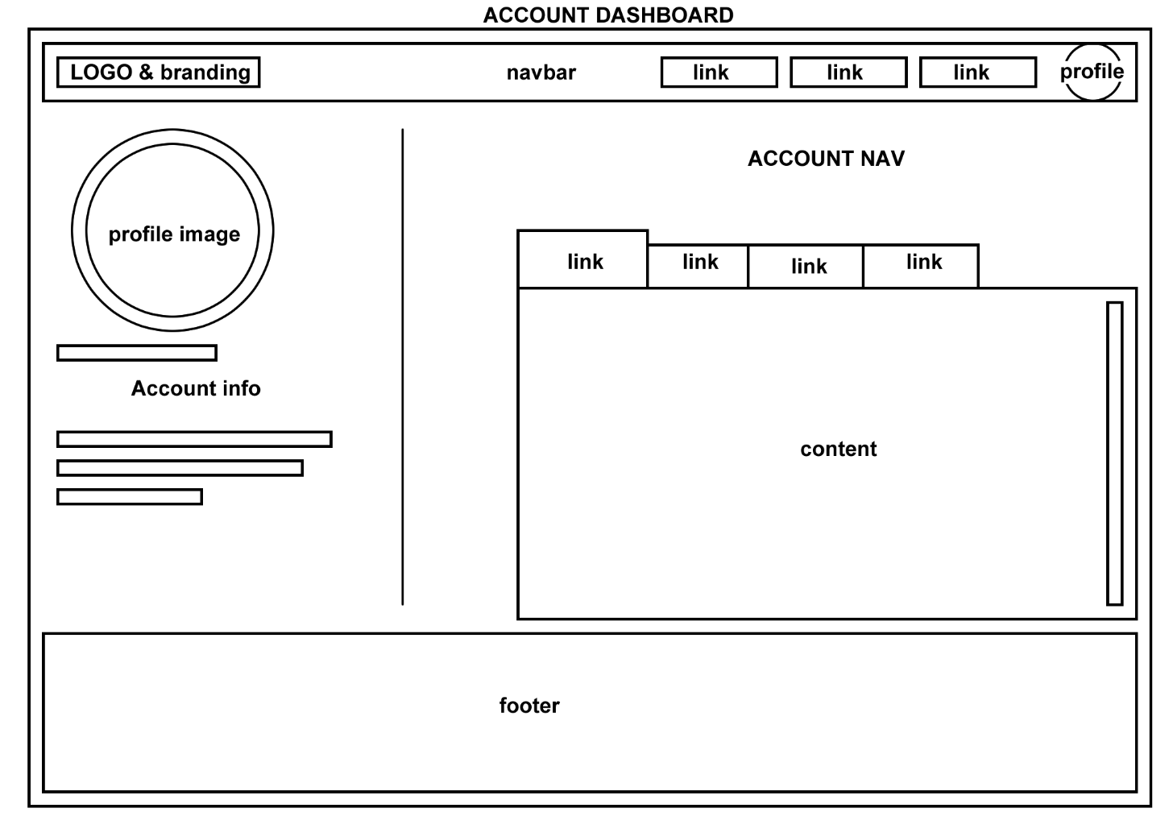

TECHNICAL BRIEF:
- HTML, CSS, BOOTSTRAP, JAVASCRIPT
- VS CODE
- CLIP STUDIO PAINT
- LUCID CHART
- GIT, GITHUB & GITHUB PAGES
- DaVinci RESOLVE

