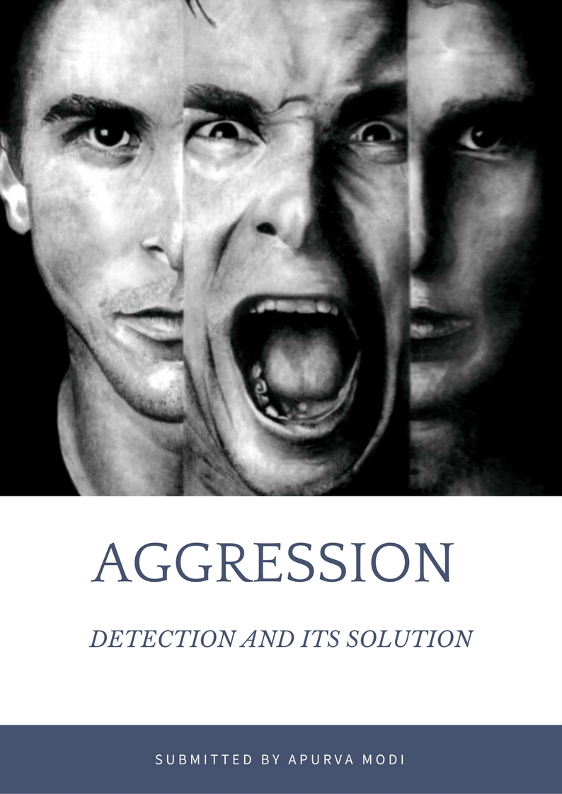

Table of Content

Introduction

What is Aggression?

What is Alzheimer disease?

What is Dementia?

Patient on Patient aggression

Solution on how to detect the Aggression

Introduction

Violent behavior and Poor sportsmanship. Why?

Aggression is something we cannot eradicate, but must learn to control. Without it, the human species could not exist; because of it, the human species will faces extinction. Without it, the individual human being would be reduced to nothingness; because of it, he may inflict appalling suffering on himself and others of his kind.

The main objective of this report is to find a solution to detect aggression of a patient on a care taker or on himself while in treatment or at home so that he may not harm himself or anybody else.

The best solution to this problem can be done by Using Image and voice recognition techniques over to a camera that is in the room of the patient

Aggression

Social psychologists define aggression as behavior that is intended to harm another individual who does not wish to be harmed (Baron & Richardson, 1994). Because it involves the perception of intent, what looks like aggression from one point of view may not look that way from another, and the same harmful behavior may or may not be aggressive depending on its intent.

**Few Example**

The U.S. government perceives the development of a nuclear weapon by North Korea as aggressive because the government believes that the weapon is intended to harm others, but North Korea may see the program as promoting self-defense.

The player whose arm is broken in a football game may attribute hostile intent, the other player may claim that the injury was not intended.

Within the legal system, juries and judges are frequently asked to determine whether harm was done intentionally.

Aggression can manifest in physical actions, such as physical violence towards others, or in a more emotional way, such as cruel words or unkind behavior.

Aggression can build up in an individual over time, due to anger, stress, or any negative circumstances.

Acts of aggression are sometimes directed at the thing or individual which created the negative situation (attacking someone who is bullying you), but can also be directed at an innocent individual (saying something mean to your spouse after a bad day at work).

Aggression can be an expression of passion or anger.

Aggression is not strictly anger as anger has many ways to manifest itself.

Aggression can be active or passive.

Outright expression of aggression is active

While covert expression is passive

Detecting active aggression is easy because it is the 'in your face' sort.

Passive aggression is when someone is too afraid or too politically correct to be properly aggressive.

Aggression can be healthy in contests and unhealthy in rivalries.

Detection of aggression is through behavior and/or facial expressions

Malicious intent can be subtly passive aggressive.

Alzheimer Disease

Alzheimer's is a disease that robs people of their memory. At first, people have a hard time remembering recent events, though they might easily recall things that happened years ago.

People with Alzheimer's might forget their loved ones. They might forget how to dress themselves, feed themselves, and use the toilet.

The disease makes brain tissue break down over time. It usually happens to people over age 65.

A person can live with Alzheimer's disease for just a few years or for a few decades. More often, however, people live with it for about 9 years. About 1 in 8 people age 65 and over has the disease. Women are more likely to have it than men.

Brain cell connections and the cells themselves degenerate and die, eventually destroying memory and other important mental functions.

Memory loss and confusion are the main symptoms. No cure exists but medications and management strategies may temporarily improve symptoms.

People may experience:

Cognitive: mental decline, difficulty thinking and understanding, confusion in the evening hours, delusion, disorientation, forgetfulness, making things up, mental confusion, difficulty concentrating, inability to create new memories, inability to do simple math, or inability to recognize common things

Behavioral: aggression, agitation, difficulty with self-care, irritability, meaningless repetition of own words, personality changes, lack of restraint, or wandering and getting lost

Mood: anger, apathy, general discontent, loneliness, or mood swings

Psychological: depression, hallucination, or paranoia

Whole body: loss of appetite or restlessness Also

Common: inability to combine muscle movements or jumbled speech

Dementia

Dementia itself is not a disease, but a syndrome; its symptoms are common to several brain diseases.

It will get worse over time. But [medications](http://www.webmd.com/drugs/index-drugs.aspx) might slow that decline and help with symptoms, such as behavior changes.

Experts think between 60% to 80% of people with dementia have this disease. More than 5 million Americans have been diagnosed with [Alzheimer's](http://www.webmd.com/alzheimers/default.htm). It's what most people think of when they hear "dementia."

If someone you know has [Alzheimer's](http://www.webmd.com/alzheimers/ss/slideshow-alzheimers-overview), you'll notice symptoms such as [memory loss](http://www.webmd.com/brain/memory-loss) and trouble planning and doing familiar tasks.

The symptoms are mild at first but get worse over a number of years. Your friend or relative might:

* Be confused about where he is or what day or year it is
* Have problems speaking or writing
* Lose things and be unable to backtrack to find them
* Show poor judgment
* Have mood and personality changes

Dementia is a form of forgetfulness which comes with age

It manifests itself as diseases such as Alzheimer's

Brain damage, Blunt force trauma or accidents can cause dementia

Dementia may lead to confusion which may manifest itself as aggression if the patient is not treated well or handled carefully

Patient on Patient Aggression

A cause for patient on patient aggression can be jealousy

Patient on patient aggression is usually seen among mentally ill patients

For some of them, it gets difficult to comprehend the consequences of their actions, since they act in the heat of the moment

It is also seen among recovering addicts

When they are in the throes of relapse they lose sense of rational and irrational and may hurt anyone nearby or anyone who tries to restrain them

Patient on Patient aggression implies that the aggression is the consequence of the specific conditions the patients have

## [1]Dataset and human assessment

### A. Database of aggression in trains

Aggression and unwanted behavior have a variety of manifestations. To distinguish those, we considered a baseline of normal behavior. We defined a set of rules that describe normal behavior in trains.

We can set up to many scenarios, each of them breaking one or more of the rules. The scenarios contain different abnormal behaviors like harassment, hooligans, theft, begging, football supporters, medical emergency, traveling without ticket, irritation, passing through a crowd of people, rude behavior towards a mother with baby, invading personal space, entering the train with a ladder while the conductor is against, mobile phone harassment, lost wallet, fight for using the public phone, mocking a disoriented foreign traveler and irritated people waiting at the counter or toilet.

### B. Human annotation

The human annotation has been done in the following settings: *audio-only* – the rater is listening to samples of the database without seeing the video, *video-only* – the rater is watching samples of the database without sound, and *multimodal* – the rater uses both video and audio samples.

For each annotation scheme the data has been split into segments of homogeneous aggression level by two expert annotators.

When annotating audio-only and video-only the raters were asked to consider strictly the segment they are watching or hearing because these labels were meant for automatic predictions.

When rating the multimodal data they were allowed to use any cue they could get from the two modalities.

### C. Analysis of human assessment

We want to understand how the audio, video and multimodal annotations relate to each other. Especially we are interested in those cases where these three labels do not agree. In Figure 1 we have plotted a 3D confusion matrix of the annotations, which we call a confusion cube.

[2.1]Acoustic features

Vocal manifestations of aggression are dominated by negative emotions such as anger and fear, or stress.

The audio feature set consists of features inspired from [5]: speech duration, mean, standard deviation, slope, range of pitch (F0) and intensity, mean and bandwidth of the first four formants F1-F4, jitter, shimmer, high frequency energy (HF500), harmonics to noise ratio (HNR), Hammarberg index, center of gravity and sleekness of the spectrum.

These features are computed on segments of length equal to 2 seconds, because this resembles better what we can expect in real-time processing.

[2.2]Linguistic features

The used language has the characteristics of spontaneous speech, with a lot of interruptions, restarts, overlapping speech, slang, interjections and nonverbal utterances (’um’,’eh’,’he’). The first step was to manually transcribe the speech from the database to text.

These keywords were selected manually

1. one class may contains words that express positive emotions, e.g. ’nice’, ’cool’, ’helpful’.

2. another class may contains words/expressions conveying negative emotions, e.g. ’irritated’, ’don’t want to’, ’unfair’, ’disturb’, ’lousy’.

3. actions class contains words/ expression related to actions that relate to the fact that somebody is being disturbing, e.g. ’don’t touch me’, ’behave normally’, ’leave me alone’, ’stay still’, ’go away’, ’pay attention’, ’stop’.

4. The words in this class are good indicators of special contexts. e.g. ’police’, ’ambulance’, ’thief’, ’drugs’, ’sniffing’, ’dead’, ’criminal’, ’wallet’.

5. Cursing class contains cursing and offensive words.

6. In Nonverbal class we have added semantic tags to a number of nonverbal sounds, e.g. singing, clapping, knocking, noise and repetitions. These can also be detected automatically but in this paper we first wanted to determine their added value

[3.1]Facial expression

A facial expression is one or more motions or positions of the muscles in the skin. These movements convey the emotional state of the individual to observers. Facial expressions are a form of nonverbal communication. They are a primary means of conveying social information among humans, but also occur in most other mammals and some other animal species. Humans can adopt a facial expression to read as a voluntary action.

[3.2]Group representation

In the mathematical field of representation theory, group representations describe abstract groups in terms of linear transformations of vector spaces; in particular, they can be used to represent group elements as matrices so that the group operation can be represented by matrix multiplication. Representations of groups are important because they allow many group-theoretic problems to be reduced to problems in linear algebra, which is well-understood.

[3.3]Continuous function

In mathematics, a continuous function is a function for which, intuitively, "small" changes in the input result in "small" changes in the output. Otherwise, a function is said to be "discontinuous". A continuous function with a continuous inverse function is called "bicontinuous". Continuity of functions is one of the core concepts of topology

[3.4]Surprise (emotion)

Surprise is a brief emotional state experienced as the result of an unexpected event. Surprise can have any valence; that is, it can be neutral/moderate, pleasant, or unpleasant. If a person experiences a very powerful or long lasting surprise, it may be considered shock.

[3.5]Disgust

Disgust is a type of aversive reaction that involves withdrawing from a person or object with strong expressions of revulsion whether real or pretended. Another definition of disgust can be defined as a revulsion response towards potential contamination. Disgust can be described as a universal, basic emotion that functions to help protect an organism from ingesting potentially harmful substances, thereby promoting disease avoidance.

[3.6]Valence (psychology)

Valence, as used in psychology, especially in discussing emotions, means the intrinsic attractiveness (positive valence) or averseness (negative valence) of an event, object, or situation. However, the term is also used to characterize and categorize specific emotions. For example, the emotions popularly referred to as "negative", such as anger and fear, have "negative valence". Joy has "positive valence".

Positively valenced emotions are evoked by positively valenced events, objects, or situations. The term is also used to describe the [hedonic](https://en.wikipedia.org/wiki/Hedonic) tone of [feelings](https://en.wikipedia.org/wiki/Feeling), [affect](https://en.wikipedia.org/wiki/Affect_(psychology)), certain [behaviors](https://en.wikipedia.org/wiki/Behavior) (for example, approach and avoidance), goal attainment or nonattainment, and conformity with or violation of [norms](https://en.wikipedia.org/wiki/Norm_(sociology)). [Ambivalence](https://en.wikipedia.org/wiki/Ambivalence) can be viewed as conflict between positive and negative valence-carriers.

[3.7]Sadness

Sadness is emotional pain associated with, or characterized by feelings of disadvantage, loss, despair, helplessness, sorrow, and rage. These feelings of certain things are usually negative. When one is sad, people often become outspoken, less energetic, and emotional. Crying is an indication of sadness. Sadness can be viewed as a temporary lowering of mood, whereas depression is more chronic. Sadness is one of Paul Ekman's "six basic emotions - happy, sad, angry, surprised, afraid, and disgusted".

Citation

<http://ieeexplore.ieee.org/document/6327978/?part=undefined%7Csec2#sec2>

<https://link.springer.com/chapter/10.1007/978-0-387-89676-2_9>

## [1] Dataset and human assessment

<http://ieeexplore.ieee.org/document/6327978/?part=undefined%7Csec2#sec2>

[2.1] Acoustic features

<https://link.springer.com/chapter/10.1007/978-0-387-89676-2_9>

[2.2] Linguistic features

<https://link.springer.com/chapter/10.1007/978-0-387-89676-2_9>

[3.1-3.7] Facial expression, Group representation, Continuous function, Surprise (emotion), Disgust, Valence (psychology), Sadness

https://www.wikipedia.org