Equations relevant to representing the hydrocarbon industries in Atlantis

Shipping dynamics
The Salish Sea has year-round deep-sea shipping ports in Burrard Inlet, on the Fraser River estuary, at Roberts Bank, on Vancouver Island's east coast, on Howe Sound and at Powell River. These ports are typically linked with railheads, and with forest-products mills or other manufacturing plants.
To visualise and assess vessel traffic across the Salish Sea, we used shipping data supplied from Transport Canada (Nathan Leung and Adrian Nicoll). This included fused terrestrial and satellite AIS data of different types and sizes of vessels from between 2015 to 2018. Counts of the number of transits throughout the time period were provided at a density gird of 1 km² resolution.
A simple model originally developed for the Australian port of Gladstone (Fulton et al. 2018) was adapted and applied to the Salish Sea. This model uses four vessel size classes:
- Large (> 150000 DWT)
- Medium (10,000 – 150,000 DWT)
- Small (< 10,000 DWT)
- Recreational (outboards, smaller motor cruisers etc)
The number of large cargo-carrying vessels per class (I-III) traversing the waterways at the southern end of the Salish Sea is read in from the scenario forcing file, with a background of other vessel activity solely within the Salish Sea is also defined per scenario. For fishing vessels this is related back to the fishing pressure applied in the fisheries model.

Ship movements
Ships travel to-and-fro along a chain of way points, from offshore entry points through shipping channels to the port locations (or vice versa). If the current port capacity is exceeded, ships must queue at marked anchor points. Vessels can only use ports (wharves) appropriate given their size.
Recreational vessels have much greater freedom of movement and can be launched from any suitable ramp, marina or other launch point (with the specific number of such entry points per box configured based on current/planned access points). The number of recreational vessels (N_{v,rec}) active in a given location is given by:
$N_{v,rec,i}=\sum_{b}{\sum_{p}{\frac{Z_{p}∙ρ_{rec}∙E_{rec}}{d_{ramp,b}∙d_{home,b}}} }$ Equation 1
where Z_{p} is the population defined for the nearest land/urban area (as there are no dynamic land areas in this model these are defined to be at fixed points along the model edges or on islands) p, ρ_{rec} is the proportion of the population that recreationally fishers, E_{rec} is the fishing pressure (tithe) anglers impose, d_{ramp} is the distance of the current location to launch point b and d_{home} is the distance between settlement p and launch point b.

Collisions
Ship movements are associated with a chance of collision, either with other vessels or wildlife. The chance of a collision between vessels (ρ_{collide}) is given by:
$ρ_{collide}=\frac{\sum_{s}{N_{V,s}∙γ_{shiprisk}}}{A_{i}}$ Equation 2
where γ_{shiprisk} is the per area risk of collision. A uniform random number (ζ_{collide}) is compared against this probability to determine if a collision occurs, if it does then the size of the spill is given by:
$R_{spill}=\frac{ρ_{collide}}{ζ_{collide}}$ Equation 3
with the resulting contaminant release a linear function of the size of the spill. Other spills can be intentionally introduced as part of the definition of a scenario (see more details below).
Ship strikes on marine fauna are dictated by how many ships the functional group interacts with (i.e. how many ships pass through the water column layers the fauna are in). The probability of a strike (ρ_{strike}) is given by:
$ρ_{strike}=\sum_{s}{N_{V,s}∙γ_{strike}}$ Equation 4
where γ_{shiprisk} is the likelihood of a ship strike if fauna get within visual distance of a vessel. A uniform random number (ζ_{strike}) is compared against this probability to determine if a strike occurs, in which case the number killed is dictated by the strike mortality rate (m_{strike,i}).

Noise and light pollution
Another consideration of shipping is the noise generated and the potential for light pollution along and adjacent to shipping lanes. These effects are represented as a disturbance footprint (the size of which is tied to the size of the vessel) scaled by the number of transits in a time step. The magnitude of the resulting noise and light footprints per box is then taken into account during the movement routines for the individual functional groups. Larger footprints and higher specific sensitivity by the group sees the animals avoid the area in the same way they would avoid locations with less favourable environmental conditions.

Port activity and incident response
The port activity requires maintenance activities. This is not a focus of the model in a dynamic sense, but is called upon when an incident response is triggered post-spill. Where physically invasive clean up us required, this sub-model simulates the collection and disposal of material (this is done using parameterised rates of clean-up/extraction, effectiveness and spatial footprints defined by the scenario). Where other forms of incident response are used – such as dispersants – that is handled explicitly by Atlantis (via its hydrodynamic transport sub-model which represents exchange by currents). The level of use of a response method is defined as part of the scenario configuration – drawn up in consultation with Transport Canada.

Oil spill fate model
Modelling the fate of oil spills is a complicated process due to processes such as evaporation, weathering and dispersion. While Atlantis can represent dispersion, it is much more effective to convert the broad flows to spill footprint though nesting of finer scale processes and of connectivity modelling. As such, the spill footprints and likelihood of contact is estimated using the connectivity (CONNIE) model or the Parcels toolkit, where hydrodynamic flows were taken from the hydrodynamic model (so as to be consistent with Atlantis physical forcing) and CONNIE/Parcels models the dispersal of polycyclic aromatic hydrocarbon (PAH) within oil particles (i.e. oil droplets), where the properties of those particles matched the mix of contaminants considered in the spill scenario of interest.

Oil spill effects modelling
Oil spills have been shown to have large impacts on seabirds, marine mammals, and pelagic fish and plankton species, including physical disturbance, behavioural changes, fouling and ingestion, with additional physiological effects from bioaccumulation of toxic components of oil. All of these effects are represented in the full model (Figure 1).
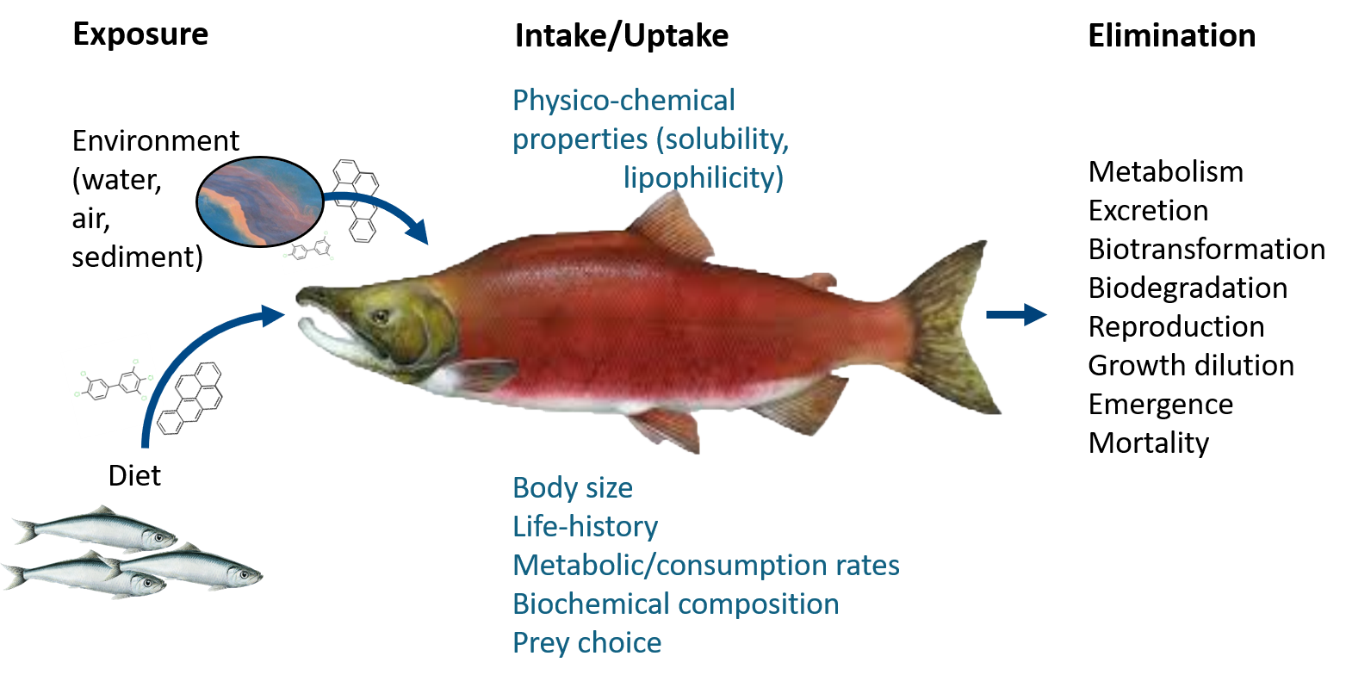
Figure 1: Schematic of contaminant considerations included in the Atlantis model.
Contaminants (simplified to only include the PAH components of the oil) are tracked in 3D though the model domain to allow for the representation of both acute (direct contact) effects, such as mortality, as well as the chronic outcomes of uptake and distribution through the food web. This representation of the oil spill dynamics represents a refined version of previous representations, which were much simpler. Initially, only direct contact was considered in most spill models, but modelling has gone much further since.
Transfer from water to fish is estimated using bioconcentration factors. Intake of contaminants can either occur through direct contact, general (linear, sigmoidal or piecewise-linear) uptake or through consumption. Contaminants are primarily lost through a decay term, which can be simulated via an exponential or linear decay function. Further elimination is possible through respiration, egestion, growth, dilution, and metabolism. Contaminants may have multiple toxic impacts. Acute effects of exposure are represented via a mortality rate, whereas chronic exposure can cause death if a lethal tissue loads are reached, but can also lead to sub-lethal effects that influence feeding, growth, movement and reproductive capacity. The potential for impacts are calculated based on concentration and then applied via a scalar to the relevant rate process. Contaminants can be lost due to metabolism and can also be transferred through trophic transfers (in proportion to the biomass of contaminated material consumed).
Most parameter values change according to the PAH group (simplified to number of rings in the structure) and the functional group modelled (see Appendix A). These base rates were taken from literature that was derived from laboratory studies or from the literature on previous oil spills, including Deepwater Horizon and Exxon Valdez. Information was also drawn from the online database at https://pubchem.ncbi.nlm.nih.gov/compound. The review of available literature can be found in Appendix B.
Uptake of a contaminant can occur either through contact, general uptake or through consumption. For each group the contaminant option needs to be set. There are currently three options for uptake:
- Linear uptake (parameter is in parts/sec):
$C_{uptake}=τ∙C_{env}$ Equation 5
where τ is the uptake rate and C_{env} is the ambient contaminant level in the environment.

- Sigmoidal uptake – this is ideal for representing interactions with a toxin that has no effect until a critical concentration is reached
$C_{uptake}=\frac{1}{dt}∙\left(\frac{C_{env,i}}{C_{i}+\left(C_{env,i}-C_{i}\right)∙e^{-τ∙dt}}-C_{i}\right)$ Equation 6
where C_{in} is the contaminant level within the functional group (i.e. internal level).
- piecewise-linear, which allows for the approximation of most concentration and uptake profiles (it currently includes two segments, but could be extended to n-segments
$C_{uptake}= α_{c1,i}\left(C_{thresh}-C_{env,i}\right)+α_{c2,i}\left(C_{env,i}-C_{thresh}\right)$ Equation 7

where C_{in} is the is the transition point between the segments; and α_{cn,i} is the slope of segment N.

Mortality effects
Both acute and chronic effects can lead to mortality of the modelled biological groups if the internal contaminant concentrations get sufficiently high.
In applying mortality rates within the model, LC₅₀ rates (lethal concentration required to kill 50% of the population) are modified for the exposure time per location and ambient temperature using the methods from models such as French-McCay et al. (2004).
Mortality due to smothering (M_{smother}), as in French-McCay et al. (2004), only applies to birds, marine mammals, benthic biogenic habitat groups (e.g. sponges and filter feeders) and is represented as:
$M_{smother}= \left\{\begin{aligned}0 \text{if} C_{env,i}<C_{env,i} \\ m_{i.j,s}\text{ otherwise}\end{aligned}\right.$ Equation 8
where C_{env,i.s} is the level of environmental concentrations lead to smothering for species s, and m_{i,s} is the species specific mortality rate due to smothering.
Where a single contaminant was present the direct mortality effects (M_{contam}) due to internal tissue content uses the formulation:
$M_{contam}= \frac{log\left(1+{\left(\frac{C_{i,s}}{{LC50}_{i,s}}\right)}^{{LDβ}_{i.s}}\right)}{T_{LD,i,s}}$ Equation 9
where C_{i.s} is the level of tissue concentration for contaminant I, LDβ_{i,s} the LD slope coefficient and T_{lDi,s} is the time to LD50.
If multiple contaminants are present, the individual effects can be amplified or the contaminants can interact and compound in non-linear ways. This is represented via multivariate co-mortality surfaces that map the exposures of all the contaminants to the LC-centiles. Where insufficient data is available to fit this surface, contaminants are assumed to act independently.
Contaminants released from dead bodies re-join ambient environmental levels.
Other chronic effects effect reproduction, growth and movement specifically with any other metabolic rates effected using a simple scalar that is triggered if ambient contaminant levels exceed a group specific threshold.
The level of accumulated contaminants in the individual can impact its growth (κ_{mum,i}) using either
- if the internal contaminant levels exceed a threshold for chronic effects, then for consumers a simple growth effect scalar is applied (following French-McCay et al. 2004) while for primary producers:
$κ_{mum,i}= \frac{1}{1+{\left(\frac{C_{i,s}}{{EC50}_{i,s}}\right)}^{{ECβ}_{i.s}} }$ Equation 10
where ECβ_{i,s} the slope coefficient for the effects curve and E_{C50i,s} is the EC₅₀ level.
- or the following logistic curve:
$κ_{mum,i}= 1-\frac{L_{i}}{1+e^{-a_{i}\left(C_{i}-b_{i}\right)}}$ Equation 11
A value must be provided per functional group per contaminant for L, a and b.
Reproduction effects (κ_{reprod,i}) are currently simply represented by:
$κ_{reprod,i}= ω_{r,i}C_{i}$ Equation 12
where ω_{r,i} is the rate effect of contaminants on reproductive output.
Movement effects (κ_{move,i}) are represented similarly to reproduction as:
$κ_{move,i}= ω_{m,i}C_{i}$ Equation 13
where ω_{m,i} is the rate effect of contaminants on movement rates.

Contaminant breakdown and decay
Contaminants can be lost from the system by dispersal but also by breakdown and decay. In the water column the rate of decay means contaminant levels change as:
$C_{i,t+dt}= max\left(0,C_{i,t}\left({0.5}^{\frac{dt}{{hl}_{i}}}\right) \right)$ Equation 14
Where hl_{i} is the half-life of the contaminant. The same formulation (appropriately parameterised) is used to represent metabolism within living organisms (following the metabolic driven decay form of Mathew et al., 2008).

Animal Movement
For age structured groups – especially the mobile groups – you do not need just to look at the contaminant levels in gross terms but the proportion of individuals effected. The initial proportion (p_{i}) is calculated as:
$p_{i,0}=min\left(1,\frac{C_{uptake}}{min\left(EC50i,s ,AvC50i,s \right)}\right)$ Equation 15
where Av_{C50i,s} is the contaminant avoidance level.
Mobile individuals can avoid any contaminants they detect – this is done by setting a contaminant avoidance level - if contaminants are above that level the animal has the potential not to move into that layer/box. The amount to which this happens is done in the same way as for avoiding other environmental properties (temperature, salinity, oxygen) that are beyond tolerances. If the relative distribution of a species changes as a result of movement, contaminated individuals are assumed to move in a pro-rata sense (along with non-contaminated species), moving from boxes where the relative distribution has dropped to the closest boxes where the relative distribution has increased (beginning with the closest and if that cannot absorb all the extra individuals, the remainder go to the next closest and so on).
When individuals consume (or are consumed) then the proportion contaminated is calculated as
$p_{i,post}=p_{i,pre}+\frac{B_{contam_transfer}}{B_{i}}$
where B_{contam_transfer} is the contaminated biomass transferred and B_{i} is the biomass of the receiving group in that location (in age structured groups this is the biomass of the cohort of the group).

