Supplementary material (to be made available online) for:
“Finding the accelerator and brake in an individual quota fishery”
Isaac C. Kaplan, Daniel S. Holland, and Elizabeth A. Fulton

Supplementary Material, Section A: Methods
Figures A.1, A.2. The Atlantis model domain with initial relative abundance of four rockfish species (Sebastes spp.). Abundance follows the colour spectrum (red with near-zero abundance, with green, blue and violet having increasingly higher abundance). Atlantis model cells are delineated by the black lines, and light blue cells (background colour) have zero abundance.

Figure A.3 Price model for scarce quota for six rockfish species. Price = (m/e³)*e^{(p*3)}, where m is a parameter representing the maximum ($10 or $50) and p is the proportion of the quota harvested in the previous year.

Supplementary Material, Section B: Results

Generally we were able to accurately capture the spatial distribution of each fleet’s effort. Examples are shown in Figures B.1-B.2. Predicted effort was spread slightly more in the north-south direction than observed effort, but this usually involved minimal amounts of effort (white cells in Figure B.1). Instances where vessels travelled extremely far from the home port (e.g. San Francisco vessels fishing off the Columbia River, 900km from port) are rare in the observed data and are not predicted by the model (Figure B.2). The closed Rockfish Conservation Area is clearly visible in the simulation as a band without fishing effort, for instance north of 40° 10’ and between the 150-200m isobath (4th cell from the coast). The Rockfish Conservation Area is less apparent in the data because the true closed area shifts seasonally and annually. The effect of travel time is strongly apparent in both observations and model, with vessels constrained to stay within reach of their home port during the fixed three day trips.

Simulated catches in the cumulative landings limits scenario match the 2004 PacFIN logbook data (ratio of 0.97 +/- 0.17 standard deviation, Table B1). Simulated catches of key target species (small flatfish, sablefish, large flatfish, and deep large rockfish) are typically within 5% of observed catches. Catches of the six rockfish species are low and are therefore less precisely matched to the logbook data, but typically modelled catches fall within 20% of observed.

Table B1. Ratio of catch reported in 2004 PacFIN logbooks to simulated catch, by fleet and functional group. The first six rows are rockfish groups with low quotas. Excluding the small amount of pelagic sharks recorded for the Moss Landing fleet (7kg), the mean is 0.97, std. deviation 0.17.

 | SOUTH |  |  |  |  |  |  |  |  |  | NORTH
 | Morro Bay | Moss Landing | San Francisco | Fort Bragg | Eureka | Crescent City | Brookings | Coos Bay | Newport | Astoria | Westport | Neah Bay
Darkblotched rockfish | -- | 0.92 | 0.86 | 0.96 | 0.86 | 0.58 | 0.71 | 0.77 | 0.71 | 0.46 | 0.88 | 0.64
Pacific ocean perch | -- | -- | 0.97 | -- | -- | -- | 0.86 | 0.70 | 0.68 | 0.81 | -- | --
Canary Rockfish | -- | 0.96 | 0.96 | 1.03 | 0.98 | 1.09 | -- | 1.23 | 1.55 | 0.89 | 1.00 | 0.95
Bocaccio | -- | 0.95 | 0.92 | 0.90 | 0.83 | -- | -- | 1.31 | -- | -- | -- | --
Widow rockfish | -- | 0.86 | 0.93 | -- | 0.88 | -- | -- | 0.90 | 1.01 | 0.88 | -- | 0.72
Yelloweye rockfish | -- | 0.99 | -- | -- | -- | -- | -- | 0.96 | -- | 1.00 | -- | 0.77
Small Flatfish | 1.18 | 1.10 | 0.98 | 0.94 | 0.96 | 0.96 | 0.95 | 0.92 | 1.35 | 0.81 | 0.97 | 0.82
Large Flatfish | 1.15 | 1.16 | 0.96 | 0.94 | 0.93 | 0.94 | 0.91 | 0.97 | 1.08 | 0.81 | 0.92 | 0.78
Sablefish | 0.96 | 1.01 | 0.94 | 0.95 | 0.96 | 0.94 | 0.93 | 0.89 | 1.14 | 0.78 | 0.95 | 0.81
Hake | -- | 0.28 | -- | -- | 0.99 | -- | -- | 0.87 | 1.18 | 0.85 | 0.97 | 0.90
English sole | -- | 1.13 | 1.00 | 0.99 | 0.98 | 0.99 | 1.00 | 0.97 | 0.91 | 0.84 | 0.97 | 0.84
Deep Small Rockfish | 0.97 | 0.98 | 1.08 | 0.93 | 0.98 | 1.06 | 1.03 | 1.16 | 1.68 | 1.11 | 0.99 | 0.88
Skates and Rays | -- | 1.02 | 0.96 | 1.01 | 0.99 | 1.00 | 1.05 | 0.93 | 0.92 | 0.81 | 1.00 | 0.90
Deep Lg. Rockfish | 0.97 | 1.01 | 0.95 | 0.95 | 0.98 | 1.02 | 0.98 | 0.95 | 1.06 | 0.80 | 0.97 | 0.85
Midwater Rockfish | 1.21 | 1.12 | 1.00 | 1.00 | 0.96 | 1.05 | -- | 1.04 | 1.28 | 1.04 | 0.98 | 0.92
Deep Misc Fish | -- | 0.98 | 0.98 | 0.98 | 0.96 | 1.03 | 1.00 | 1.02 | 1.32 | 0.99 | -- | --
Sm. Dem. Sharks | -- | 0.96 | 0.96 | -- | -- | -- | -- | 1.00 | 1.00 | 0.79 | -- | 0.89
Lg. Dem. Predators | -- | 1.05 | 1.01 | 0.99 | 1.02 | 1.12 | 1.05 | 1.14 | 1.50 | 0.93 | 0.99 | 0.89
Chilipepper rockfish | 1.15 | 1.16 | 1.00 | 1.03 | 1.03 | -- | -- | 1.08 | 1.34 | -- | -- | --
Shallow Sm. Rockfish | -- | 1.17 | 0.98 | 0.97 | 1.02 | 1.07 | -- | 0.98 | 1.10 | 0.91 | 0.98 | 0.89
Cephalopods | -- | 1.14 | -- | 1.01 | -- | -- | -- | 1.02 | 1.14 | 0.97 | -- | 0.94
Shallow Lg. Rockfish | -- | 1.18 | 1.00 | 1.03 | 1.02 | -- | -- | 1.02 | 1.26 | 0.75 | -- | --
Misc. Pelagic Sharks | -- | 39.96 | -- | -- | -- | -- | -- | -- | -- | -- | -- | --

Table B2. Relative overlap of rockfish (Sebastes spp.) distributions and fishing areas available to each fleet. Values of 1 represent fishing area availability that mirrors rockfish distribution; values greater than one indicate that fishing areas of that fleet are concentrated in regions with higher rockfish abundance. Availability of fishing areas to each fleet is based on steaming (travel) time from port. Fleets ordered from south to north.
 | Canary | Darkblotched | Yelloweye | Boccacio | Pacific Ocean Perch | Widow
Morro Bay | 0.06 | 0.02 | 0.05 | 0.40 | 0.00 | 0.00
Moss Landing | 0.13 | 0.07 | 0.19 | 0.61 | 0.00 | 0.01
San Francisco | 0.16 | 0.13 | 0.38 | 0.73 | 0.02 | 0.03
Fort Bragg | 0.32 | 0.24 | 0.68 | 0.78 | 0.04 | 0.09
Eureka | 0.23 | 0.31 | 0.81 | 0.61 | 0.09 | 0.08
Crescent City | 0.58 | 0.50 | 0.97 | 0.52 | 0.29 | 0.35
Brookings | 0.61 | 0.56 | 0.96 | 0.50 | 0.38 | 0.42
Coos Bay | 0.89 | 0.74 | 0.97 | 0.40 | 0.59 | 0.66
Newport | 1.10 | 1.03 | 0.71 | 0.41 | 1.09 | 1.04
Astoria | 1.03 | 0.97 | 0.62 | 0.33 | 1.08 | 1.10
Westport | 0.98 | 0.93 | 0.53 | 0.35 | 1.14 | 1.11
Neah Bay | 0.69 | 0.85 | 0.35 | 0.29 | 1.06 | 1.02

Table B3. Percent of total catch per fleet comprised of six rockfish species. Year 1 results from scenario with cumulative landings limits. Fleets ordered from south to north. * Catches of less than 0.005% shown rounded to 0.00.

 | Canary | Darkblotched | Yelloweye* | Bocaccio | Pacific Ocean Perch | Widow
Morro Bay | 0.00 | 0.00 | 0.00 | 0.00 | 0.00 | 0.00
Moss Landing | 0.02 | 0.07 | 0.00 | 0.15 | 0.00 | 0.01
San Francisco | 0.03 | 0.28 | 0.00 | 0.32 | 0.00 | 0.01
Fort Bragg | 0.00 | 0.80 | 0.00 | 0.01 | 0.00 | 0.00
Eureka | 0.03 | 0.72 | 0.00 | 0.01 | 0.00 | 0.00
Crescent City | 0.01 | 0.53 | 0.00 | 0.00 | 0.00 | 0.00
Brookings | 0.00 | 0.19 | 0.00 | 0.00 | 0.02 | 0.00
Coos Bay | 0.02 | 1.75 | 0.00 | 0.00 | 0.14 | 0.00
Newport | 0.01 | 2.03 | 0.00 | 0.00 | 1.12 | 0.02
Astoria | 0.03 | 1.15 | 0.00 | 0.00 | 0.96 | 0.02
Westport | 0.02 | 0.06 | 0.00 | 0.00 | 0.00 | 0.00
Neah Bay | 0.05 | 0.15 | 0.00 | 0.00 | 0.00 | 0.00

Table B4. Effort per fleet over first five years of the simulation, relative to the cumulative landings limits effort. Quota systems include the cumulative landings limits in place prior to 2011, competitive total allowable catches (TACs), and individual transferable quotas (ITQs). The sum over all fleets, and the mean and standard deviation across fleets is listed at the bottom. Quota lease price and “scarce quota” lease price described in main text.
Quota system | Cumulative landings limits | Competitive TAC | ITQ | ITQ | ITQ | ITQ | ITQ
Over-quota penalty, $/kg | - | 0 | 5 | 0 | 0 | 5 | 10
Quota lease price | - | 0 | 0 | Newell | 0 | Newell | Newell
"Scarce quota" lease price (max $/kg) | - | 0 | 0 | 0 | 50 | 50 | 50
Morro Bay | 1.00 | 0.69 | 0.40 | 0.69 | 0.69 | 0.38 | 0.25
Moss Landing | 1.00 | 13.83 | 5.59 | 13.88 | 13.83 | 10.27 | 2.74
San Francisco | 1.00 | 0.54 | 0.18 | 0.53 | 0.54 | 0.25 | 0.43
Fort Bragg | 1.00 | 19.54 | 4.61 | 19.54 | 19.54 | 7.39 | 3.33
Eureka | 1.00 | 27.00 | 5.16 | 27.01 | 27.00 | 6.30 | 3.65
Crescent City | 1.00 | 0.99 | 0.20 | 0.99 | 0.99 | 0.30 | 0.14
Brookings | 1.00 | 2.44 | 0.48 | 2.44 | 2.44 | 0.70 | 0.32
Coos Bay | 1.00 | 25.95 | 5.27 | 25.96 | 25.95 | 4.24 | 3.21
Newport | 1.00 | 4.83 | 1.07 | 4.83 | 4.83 | 1.29 | 0.91
Astoria | 1.00 | 1.16 | 0.25 | 1.16 | 1.16 | 0.32 | 0.14
Westport | 1.00 | 1.02 | 0.20 | 1.02 | 1.02 | 0.29 | 0.14
Neah Bay | 1.00 | 1.97 | 0.42 | 1.98 | 1.97 | 0.58 | 0.61
Sum of all fleets | 1.00 | 2.09 | 0.48 | 2.09 | 2.09 | 0.61 | 0.38
Mean across fleets | 1.00 | 8.33 | 1.99 | 8.34 | 8.33 | 2.69 | 1.32
Standard deviation across fleets | 0.00 | 10.36 | 2.36 | 10.36 | 10.36 | 3.49 | 1.44

Table B5. Biomass of each functional group at year 30, relative to year 30 under cumulative landings limits. Dashed horizontal lines separate the six rockfish species of conservation interest, other species harvested by groundfish trawlers, and species only indirectly affected by groundfish trawling.
Quota system | Cumulative landings limits | Competitive TAC | ITQ | ITQ | ITQ | ITQ | ITQ
Over-quota penalty, $/kg | - | 0 | 5 | 0 | 0 | 5 | 10
Quota lease price | - | 0 | 0 | Newell | 0 | Newell | Newell
"Scarce quota" lease price (max $/kg) | - | 0 | 0 | 0 | 50 | 50 | 50
Darkblotched rockfish | 1.00 | 0.09 | 0.90 | 0.09 | 0.09 | 0.94 | 1.14
Pacific ocean perch | 1.00 | 0.77 | 1.02 | 0.77 | 0.77 | 1.02 | 1.03
Canary rockfish | 1.00 | 0.99 | 1.02 | 0.99 | 0.99 | 1.01 | 1.01
Bocaccio rockfish | 1.00 | 0.98 | 1.00 | 0.98 | 0.98 | 1.00 | 1.00
Widow rockfish | 1.00 | 1.01 | 1.01 | 1.01 | 1.01 | 1.01 | 1.00
Yelloweye rockfish | 1.00 | 0.97 | 1.00 | 0.97 | 0.97 | 1.00 | 1.00
Smal flatfish | 1.00 | 0.34 | 0.73 | 0.34 | 0.34 | 0.51 | 0.91
Large flatfish | 1.00 | 0.07 | 0.69 | 0.07 | 0.07 | 0.70 | 1.03
Sablefish | 1.00 | 0.18 | 0.80 | 0.18 | 0.18 | 0.94 | 1.21
Hake | 1.00 | 0.97 | 1.01 | 0.97 | 0.97 | 1.01 | 1.01
English sole | 1.00 | 0.55 | 0.86 | 0.55 | 0.55 | 0.79 | 0.97
Deep small rockfish | 1.00 | 0.11 | 1.16 | 0.11 | 0.11 | 1.15 | 1.32
Skates and rays | 1.00 | 0.28 | 0.51 | 0.28 | 0.28 | 0.56 | 0.91
Deep large rockfish | 1.00 | 0.45 | 0.89 | 0.45 | 0.45 | 0.89 | 0.98
Midwater rockfish | 1.00 | 0.55 | 0.92 | 0.55 | 0.55 | 0.77 | 0.96
Deep miscellaneous fish | 1.00 | 0.88 | 0.95 | 0.88 | 0.88 | 0.92 | 1.00
Small demersal sharks | 1.00 | 0.96 | 0.99 | 0.96 | 0.96 | 0.99 | 1.00
Large demersal predators | 1.00 | 0.94 | 1.07 | 0.94 | 0.94 | 1.07 | 1.03
Chilipepper rockfish | 1.00 | 0.73 | 0.95 | 0.73 | 0.73 | 0.95 | 0.97
Shallow small rockfish | 1.00 | 1.00 | 0.99 | 1.00 | 1.00 | 0.99 | 1.00
Cephalopods | 1.00 | 1.30 | 1.10 | 1.30 | 1.30 | 1.11 | 1.01
Shallow large rockfish | 1.00 | 1.02 | 1.01 | 1.02 | 1.02 | 1.00 | 1.00
Misc. pelagic sharks | 1.00 | 0.98 | 0.99 | 0.98 | 0.98 | 0.99 | 1.00
Large planktivores | 1.00 | 1.07 | 1.03 | 1.07 | 1.07 | 1.03 | 1.01
Small planktivores | 1.00 | 1.67 | 1.11 | 1.67 | 1.67 | 1.11 | 1.00
Migrating birds | 1.00 | 1.00 | 1.00 | 1.00 | 1.00 | 1.00 | 1.00
Deep vertically migrating fish | 1.00 | 1.44 | 0.99 | 1.44 | 1.44 | 1.02 | 0.95
Miscellaneous nearshore fish | 1.00 | 1.34 | 1.06 | 1.34 | 1.34 | 1.05 | 1.00
Large demersal sharks | 1.00 | 1.01 | 1.01 | 1.01 | 1.01 | 1.00 | 1.00
Surface seabirds | 1.00 | 1.12 | 1.02 | 1.12 | 1.12 | 1.02 | 1.01
Diving seabirds | 1.00 | 1.55 | 1.14 | 1.55 | 1.55 | 1.14 | 1.03
Pinnipeds | 1.00 | 1.09 | 1.05 | 1.09 | 1.09 | 1.03 | 1.02
Transient orcas | 1.00 | 1.00 | 1.00 | 1.00 | 1.00 | 1.00 | 1.00
Baleen whales | 1.00 | 1.00 | 1.00 | 1.00 | 1.00 | 1.00 | 1.00
Toothed whales | 1.00 | 1.00 | 1.00 | 1.00 | 1.00 | 1.00 | 1.00
Otters | 1.00 | 0.98 | 0.96 | 0.98 | 0.98 | 0.97 | 0.98
Shallow benthic filter feeders | 1.00 | 1.61 | 1.21 | 1.63 | 1.61 | 1.08 | 1.14
Other benthic filter feeders | 1.00 | 1.00 | 1.00 | 1.00 | 1.00 | 1.00 | 1.00
Deep benthic filter feeders | 1.00 | 1.22 | 0.98 | 1.22 | 1.22 | 0.98 | 0.99
Benthic herbivorous grazers | 1.00 | 1.01 | 1.01 | 1.01 | 1.01 | 1.04 | 1.03
Deep macro-zoobenthos | 1.00 | 1.11 | 0.97 | 1.11 | 1.11 | 0.93 | 0.94
Mega-zoobenthos | 1.00 | 1.00 | 1.00 | 1.00 | 1.00 | 1.00 | 1.00
Shallow macro-zoobenthos | 1.00 | 1.00 | 1.01 | 1.00 | 1.00 | 1.00 | 1.00
Shrimp | 1.00 | 0.63 | 0.99 | 0.63 | 0.63 | 1.01 | 1.00
Large zooplankton | 1.00 | 1.02 | 1.00 | 1.02 | 1.02 | 1.00 | 1.00
Deposit feeders | 1.00 | 1.00 | 1.00 | 1.00 | 1.00 | 1.00 | 1.00
Macroalgae | 1.00 | 1.00 | 1.00 | 1.01 | 1.00 | 1.00 | 0.98
Seagrass | 1.00 | 1.00 | 1.00 | 1.00 | 1.00 | 1.00 | 1.00
Carnivorous infauna | 1.00 | 1.00 | 1.00 | 1.00 | 1.00 | 1.00 | 1.00
Gelatinous zooplankton | 1.00 | 1.00 | 1.00 | 1.00 | 1.00 | 1.00 | 1.00
Large phytoplankton | 1.00 | 1.00 | 1.00 | 1.00 | 1.00 | 1.00 | 1.00
Small phytoplankton | 1.00 | 1.00 | 1.00 | 1.00 | 1.00 | 1.00 | 1.00
Mesozooplankton | 1.00 | 1.00 | 1.00 | 1.00 | 1.00 | 1.00 | 1.00
Microzooplankton | 1.00 | 1.07 | 1.01 | 1.07 | 1.07 | 1.00 | 1.00
Pelagic bacteria | 1.00 | 1.23 | 0.97 | 1.23 | 1.23 | 0.90 | 1.14
Benthic bacteria | 1.00 | 1.01 | 0.98 | 1.01 | 1.01 | 0.95 | 0.97
Meiobenthos | 1.00 | 1.22 | 0.44 | 1.22 | 1.22 | 0.62 | 0.56

Figure B.1. Relative trawl effort for the Astoria limited-entry trawl fleet, from 2004 PacFIN data and as predicted by the cumulative landings limit scenario in the Atlantis model. Effort is proportional to the intensity of the shading (black is highest effort). Clear (light blue) polygons have no effort.

Figure B.2. Trawl effort (hrs) for the San Francisco limited-entry trawl fleet, from 2004 PacFIN data and as predicted by the cumulative landings limit scenario in the Atlantis model. Effort is proportional to the intensity of the shading (black is highest effort). Clear (light blue) polygons have no effort.

Figure B.3. Example of the effect of quota system on the timing of fishing effort. Fleet effort for Newport trawl fleet with a) cumulative landings limits, b) ITQs with no penalties or quota costs, and c) ITQs with $5/kg penalties for exceeding quotas, and quota lease costs based on Newell (2005). Y-values represent trawl effort (trawl hours * vessels) per five day output interval. Abscissa labels are months over a five year simulation.

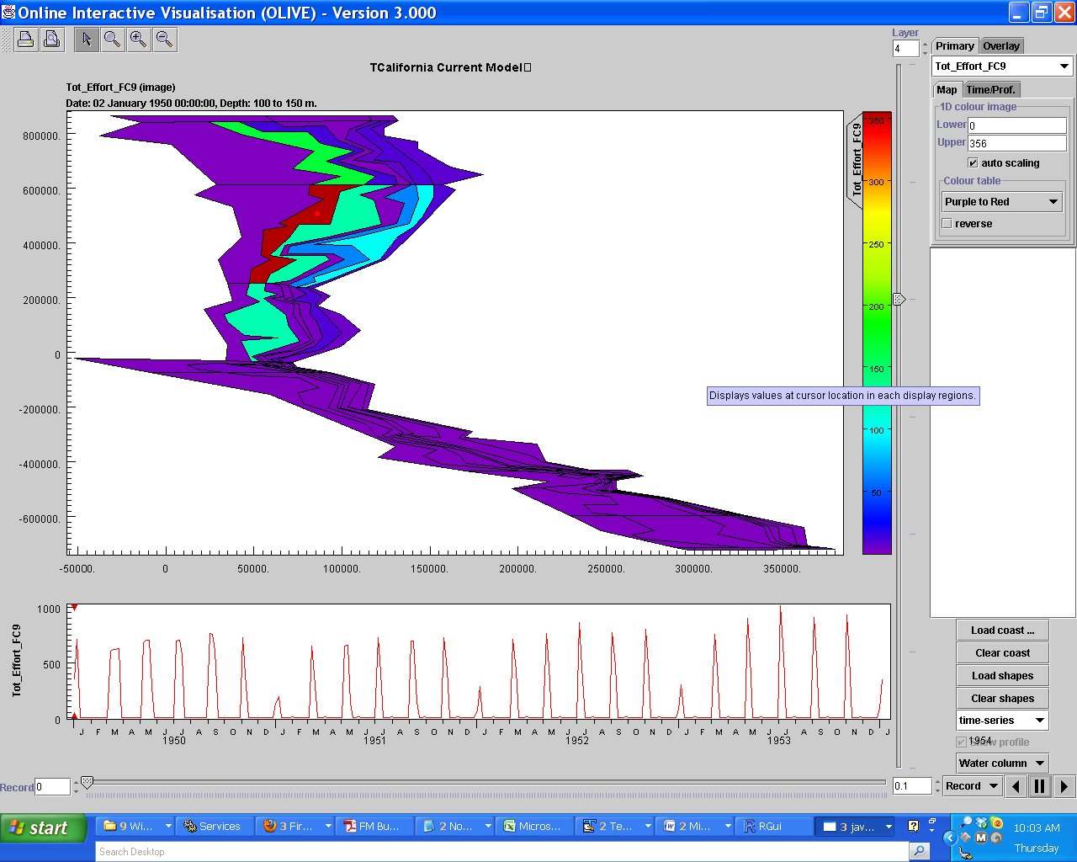

b)
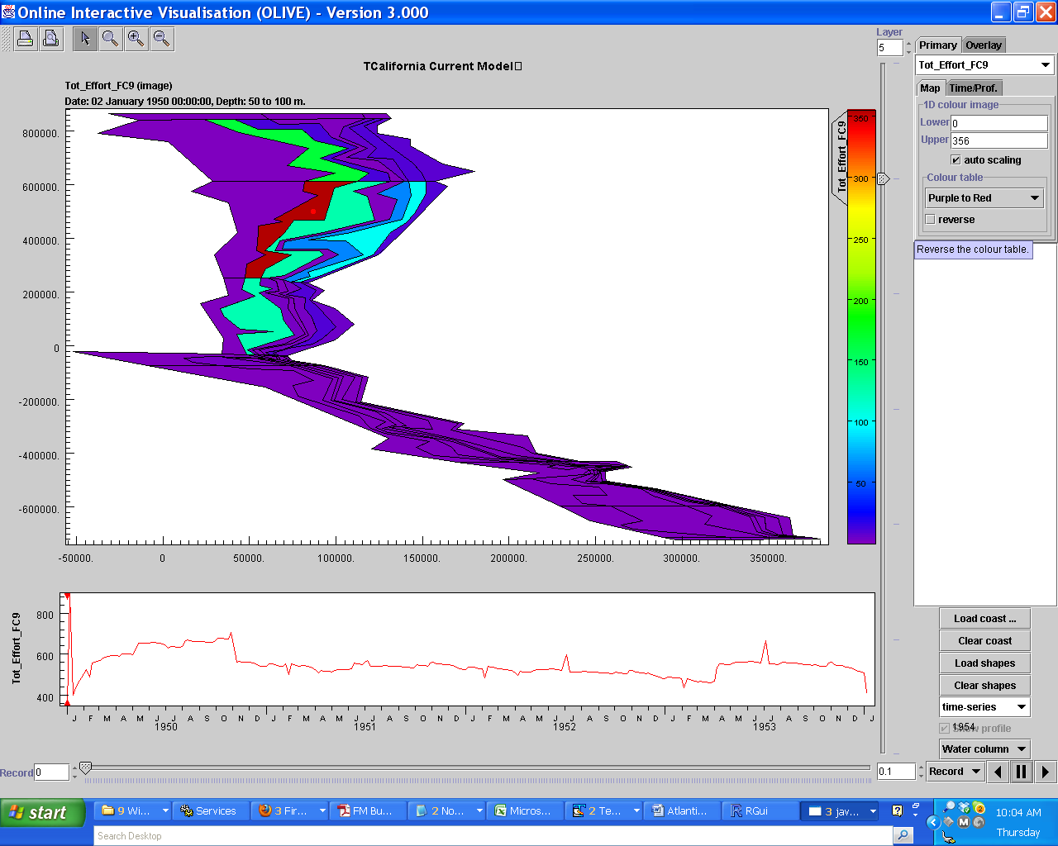

c)
