Designing an AI-Enabled IFRS S1 & S2 Readiness Assessment Tool for Emerging Markets
This document presents a flagship postdoctoral innovation titled “Designing an AI-Enabled IFRS S1 & S2 Readiness Assessment Tool for Emerging Markets.” The tool operationalises IFRS S1 and IFRS S2 requirements into an interactive chatbot that assesses organisational readiness, identifies disclosure gaps, and provides context-sensitive guidance for emerging market institutions, with a focus on South Africa and BRICS economies.

1. Background and Motivation
The adoption of IFRS Sustainability Disclosure Standards (IFRS S1 and IFRS S2) presents significant implementation challenges for organisations in emerging markets. These challenges stem from institutional capacity constraints, data availability issues, weak climate governance structures, and limited technical expertise. An AI-enabled readiness assessment tool provides a scalable, decision-support mechanism to bridge the gap between regulatory expectations and organisational capabilities.

2. Research Objectives
The primary objective is to design and demonstrate an AI-enabled chatbot that evaluates organisational readiness for IFRS S1 and IFRS S2 compliance. Specific objectives include:
• Translating IFRS S1 & S2 standards into measurable readiness indicators.
• Developing a structured chatbot logic aligned with governance, strategy, risk management, and metrics & targets.
• Generating readiness scores and actionable feedback tailored to emerging market contexts.
• Demonstrating policy, managerial, and academic relevance.

3. Theoretical Foundations
The chatbot is grounded in three complementary theories. Institutional Theory explains how coercive and normative pressures drive sustainability disclosure adoption. Agency Theory highlights information asymmetry between managers and stakeholders, which structured disclosures help mitigate. Dynamic Capabilities Theory underpins the tool’s focus on organisational learning, adaptation, and reconfiguration in response to climate risks.

4. System Architecture and Chatbot Design
The chatbot operates as a rule-based and AI-assisted decision-support system. Users interact through structured questions mapped directly to IFRS S1 and IFRS S2 disclosure requirements. Responses are scored using a weighted readiness index, producing an overall readiness classification (Low, Moderate, High) alongside diagnostic feedback.
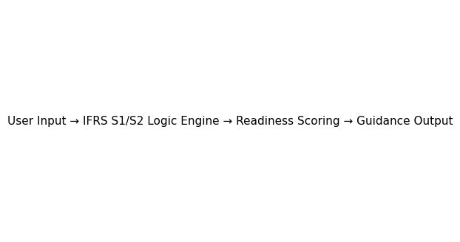

5. IFRS S1 & S2 Readiness Dimensions
The chatbot assesses readiness across four dimensions consistent with IFRS S1 and IFRS S2:
• Governance: Board oversight, climate accountability, and control structures.
• Strategy: Integration of climate risks and opportunities into business models and planning.
• Risk Management: Identification, assessment, and mitigation of physical and transition risks.
• Metrics and Targets: Use of quantitative indicators, emissions data, and climate targets.
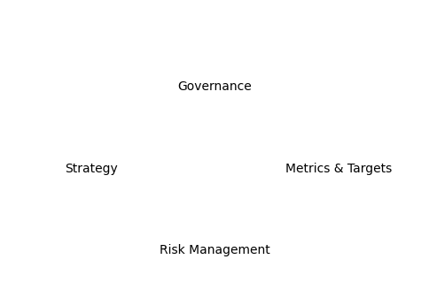

6. Output and Decision-Support Value
Upon completion, the chatbot generates a readiness score and diagnostic report. The output includes disclosure gaps, priority improvement areas, and practical recommendations aligned with emerging market constraints. This makes the tool suitable for corporate managers, public entities, universities, regulators, and policymakers.

7. Postdoctoral Evaluation and Impact
As a postdoctoral output, the chatbot demonstrates research innovation, societal relevance, and interdisciplinary impact. It aligns with UMP’s sustainability agenda, supports policy engagement, and provides a foundation for grant applications, industry collaboration, and high-quality journal publications.

8. Publication and Future Development Pathways
The tool can be extended into empirical validation studies, cross-country BRICS comparisons, and integration with real corporate disclosure datasets. It is immediately publishable as a design science or methodological paper in Scopus-indexed sustainability and accounting journals.

