Qustion 2.9
- Construct a stem-and-leaf display for these data
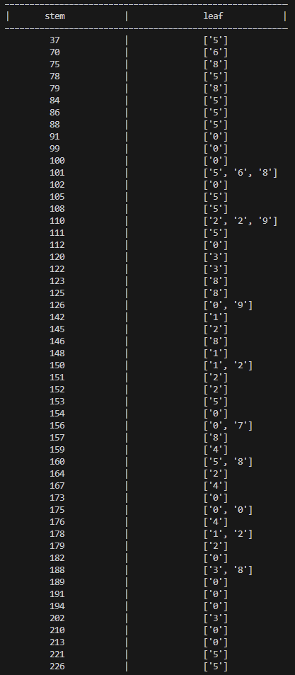
(b)Does it appear likely that a coupon will survive beyond cycles justify your answer
Survive rate = $\frac{Σcycles>2000}{testing count}$
Survive rate = $\frac{5}{70}$ = $≈$ 0.07 | 7.14%
ANS Chance is extremely unlikely. The vast majority of the coupons (65 out of 70 or 92.86%) failed before reaching 2000 cycles
Question 2.10
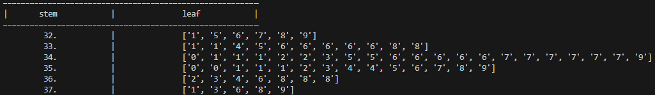

Question 2.17
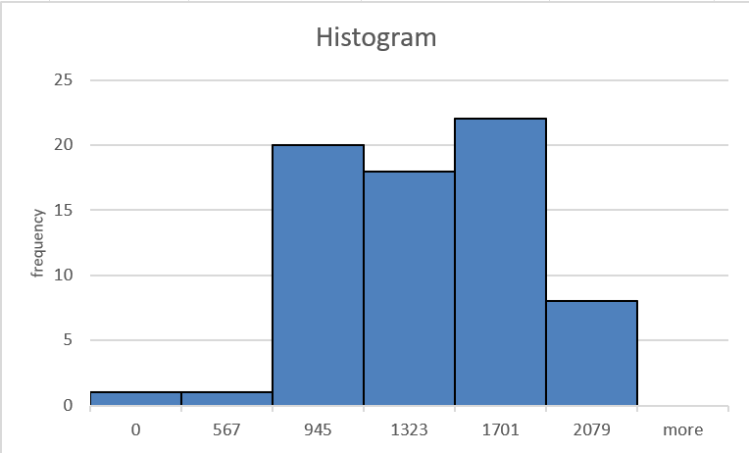

Question 2.18

