# 黑白图像上色技术说明书

## 1 项目开发目的和意义

在智能手机越来越普及的今天，拍摄一张色彩鲜艳、清晰的照片轻而易举。但是老照片没有如此“幸运”，大多为黑白。借助人工智能，可以一定程度上帮助老照片还原原来色彩。

本项目是黑白图像上色应用，旨在华为Atlas200DK上实现输入黑白图像，自动对黑白图像进行上色，还原彩色图像。本应用能够输入多张黑白图片，上传至Atlas200DK，程序读取图片并加载训练好的自动上色模型进行上色，保存上色后的图片。

## 2 总体设计

本应用可以划分为图像预处理、模型推理、后处理三个engine。前处理engine读取图片，归一化，把图片转换为模型推理需要的Lab色彩空间，resize到224*224模型需要的尺寸，提取L通道，减均值等操作，为模型推理做准备。模型推理engine加载模型，对前处理engine处理好的L通道数据进行推理，得到预测的ab通道数据，并把推理结果发送给下游后处理engine。后处理engine接收推理结果，并把ab通道数据和L通道数据合并，resize回原图像大小，生成并保存上色后的图像，至此，自动上色完成。

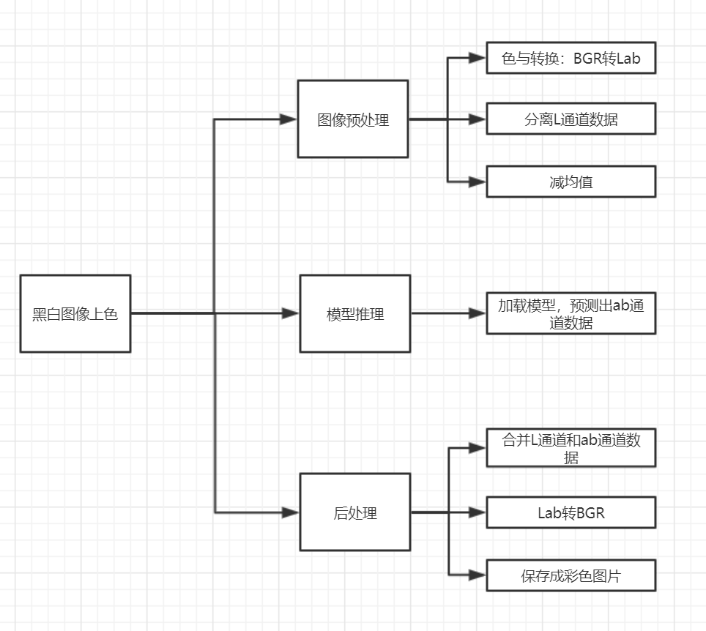

## 3 算法设计

给定一张灰度图，该模型可以使得图像的颜色显得十分逼真。过去的黑白图像上色要么需要用户交互参与，要么会生成去饱和的图像。以前的作品使用均方误差（Mean Squared Error ,MSE）作为训练模型的损失函数，MSE将尝试“平均”出颜色，以获得最小的平均误差，这将导致平淡的外观。于是该模型将图片着色变为分类问题。该模型使用了LAB色彩空间模式（最常见的使RGB）。在LAB方案中，L通道记录了光强值，另外两个通道则记录了一组对抗色，绿-红和蓝-黄。使用LAB颜色空间的一个很有利的原因是它能使光强值保持分离。好处是黑白图片可以被当作L通道，这样模型在预测时就不必学习如何保持光强（使用RGB则必须）。这样，模型只需学习怎样将图像彩色化，从而专注于关键步骤。模型输出的AB通道值，可以被直接应用到黑白图像是上得到彩色图片。该模型是一个相当标准的卷积神经网络，模型并没有用池化层，取而代之的是使用上/下采样层。该模型使用的损失函数是标准的交叉熵：



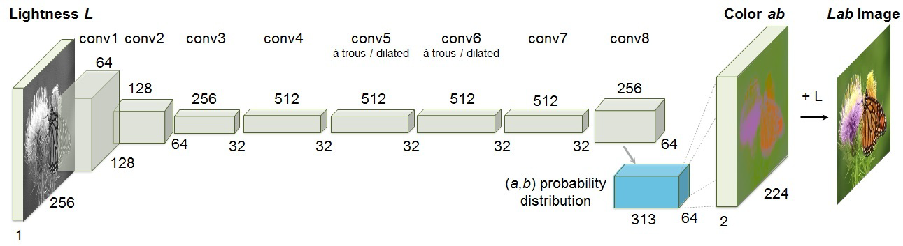

模型网络结构图

颜色值在分类中会出现不均衡，使用交叉熵作为损失函数在分类不均衡上不能很好地发挥作用，通常具有较少示例的类具有更高的权重。而不饱和色灰色和浅蓝色相比其他会更加丰富广泛，因为它们常常出现在背景色中。所以该模型中采用了权重方案：



要获得分布，从整个ImageNet训练集上估计量化后的ab空间中色彩的经验概率，并用一个高斯kernel做平滑处理。Q是类型数量（313），λ取经验值0.5有不错的效果。考虑权重后，损失函数最终如下：



直接用313个色彩分类会使图像很粗糙，只有少数能与真实色彩匹配。为了从预测模型中得到更加多样化的色彩范围，又加了一步后续处理：



Z是模型的输出，T是一个超参数，经试验不通取值有不通效果：

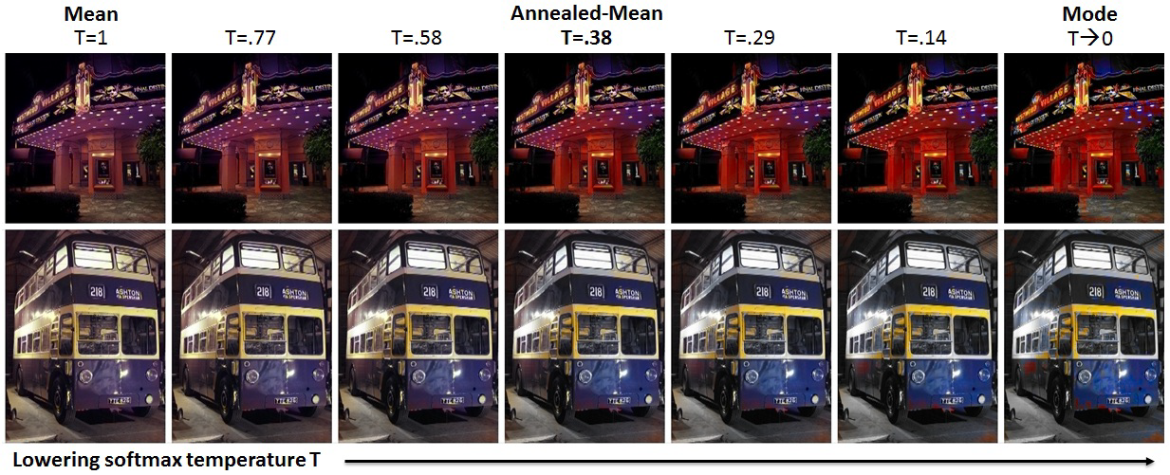

这是很巧妙地一步，原因是模型的输出是一组概率值，相比只取最大概率所对应的颜色值，上述函数试图利用模型输出一组概率值的信息来计算颜色，因此效果更好。

训练这样一个神经网络分为两部分，首先训练数据正向传播，计算输出得到预测结果。然后计算H的倒数来计算损失（Loss）。

### 3.2 数据集制作

该模型训练的数据集为ImageNet数据集。

### 3.3 模型训练

该模型来自GitHub：<https://github.com/richzhang/colorization> 请从GitHub中获取模型网络结构，预训练模型等。

### 3.4 模型转换

要将训练好的caffe模型应用到Atlas200DK上，首先要将其转换为Ascend310芯片支持的离线模型，模型转换的擦书如下图所示。Model File为记录网络机构的prototxt文件，Weight File为记录参数值的caffemodel文件。推理过程的batch size需要设为1，图像的宽、高、通道数不变，因此输入的维度N、C、H、W分别对应为1、3、224、224。

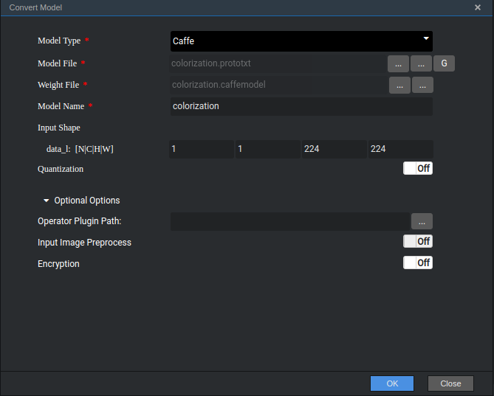

### 3.5 图像预处理

本应用图像预处理部分，使用opencv的imread接口读取图片，读取出来的是BGR格式。模型输入为224×225，因此需要把读取到的图像resize到224×224。Resize后对数据做归一化处理。如算法设计部分所言，该模型采用Lab色彩空间，因此需要把BGR格式转为Lab格式数据。该模型用L通道数据预测出可能的ab空间数据，所以要从Lab数据中分离出L通道数据。再对所得的数据减均值，即可得到模型需要的输入数据。

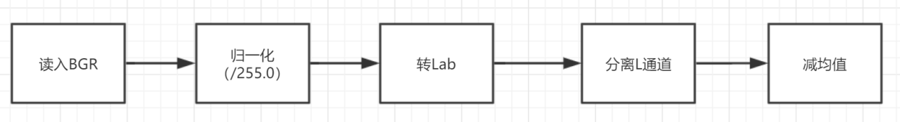

### 3.6 模型推理

解析预处理engine发送来的数据，调用模型管家的Process接口进行推理，并把推理数据发送给下游后处理engine。

// 2. process

  HIAI_ENGINE_LOG("aiModelManager->Process start!");

  ret = ai_model_manager_->Process(ai_context, input_data_vec, output_data_vec,

                                   kAiModelProcessTimeout);

### 3.6 模型后处理

模型推理得到预测出的ab空间数据。首先把得到的数据resize回原图像大小，然后和原图像L通道数据合并，即得到完整Lab图像。把Lab图像转回BGR格式即可保存为jpeg图片，得到上色后的图像。

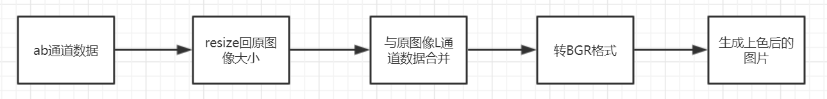

## 4 运行示例

黑白图像1：

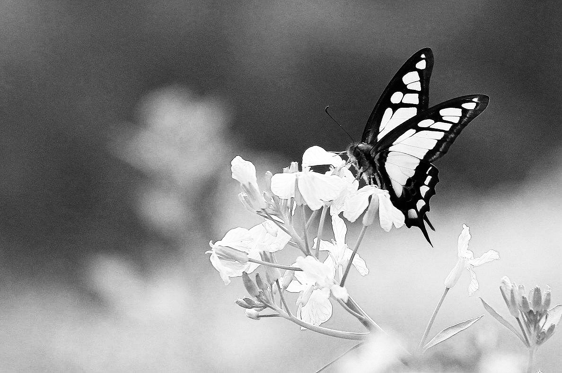

自动上色后的图片1：

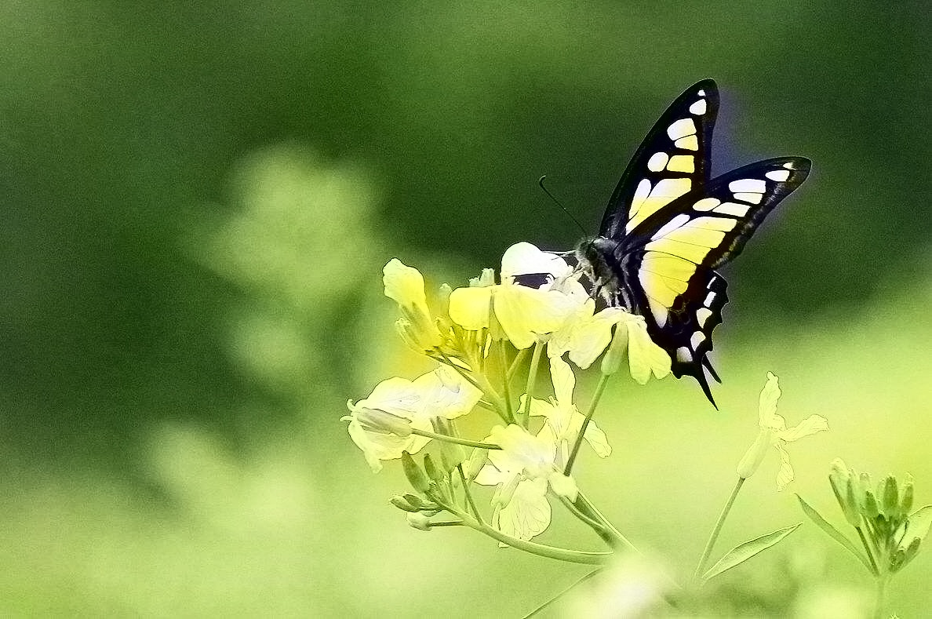

黑白图像2：

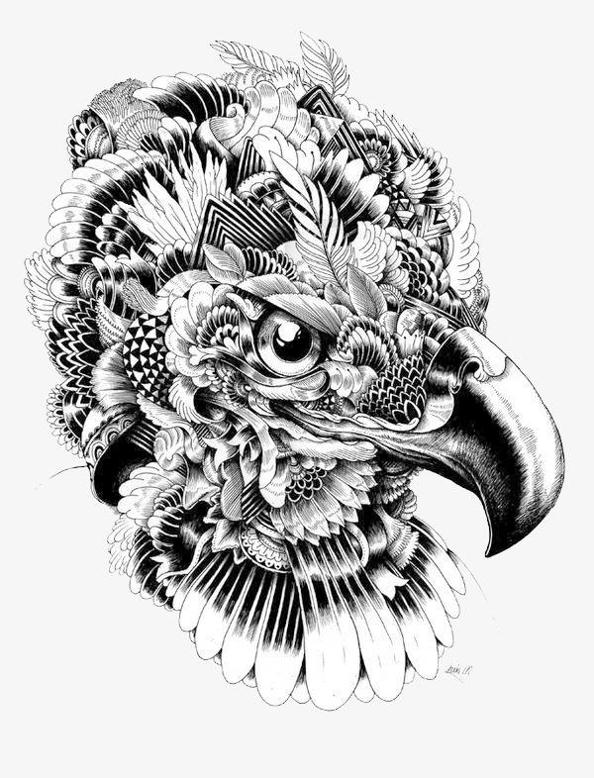

自动上色后的图片2：

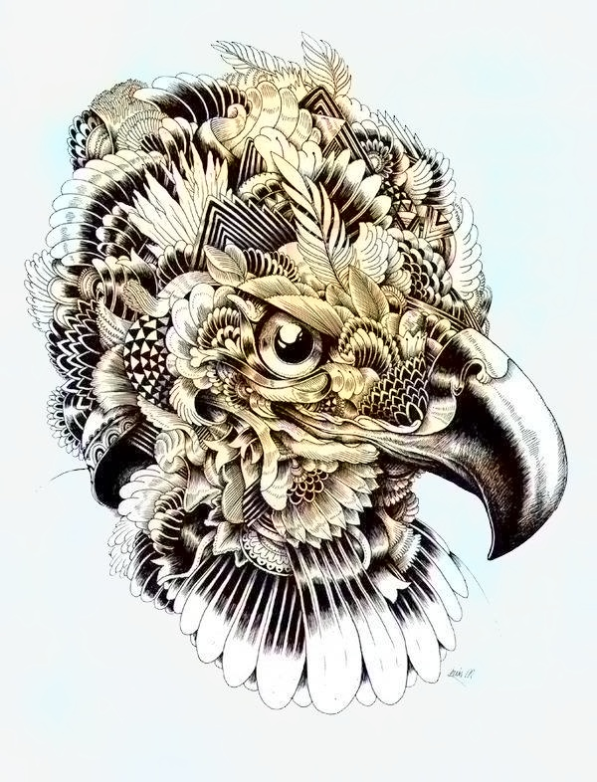

黑白图像3：

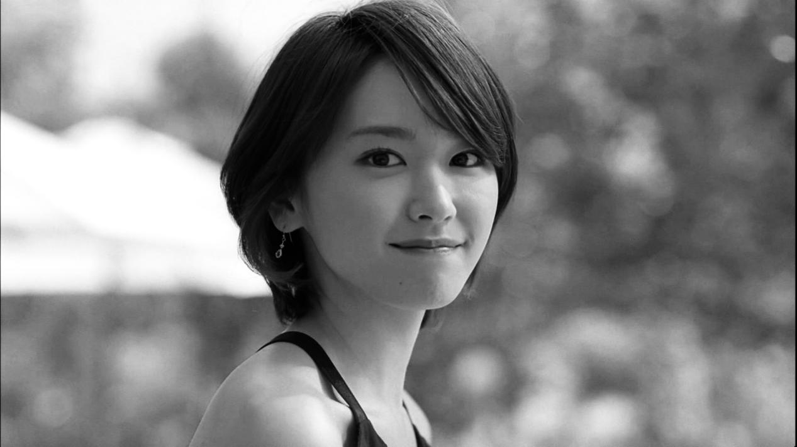

自动上色后的图像3：

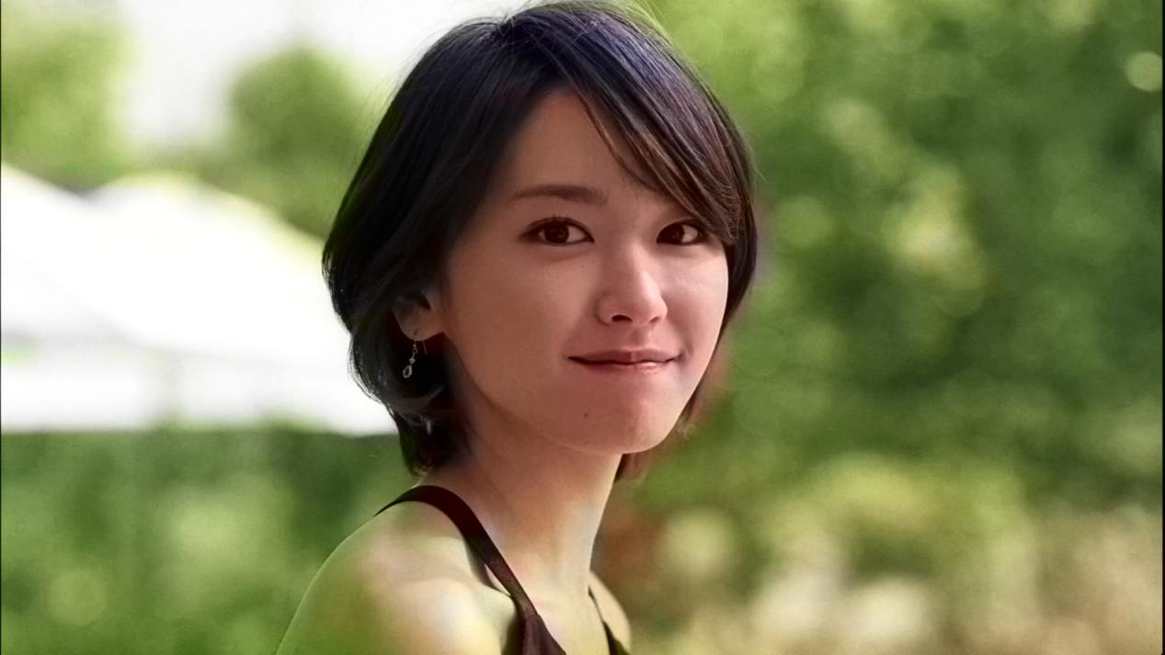

黑白图像4：

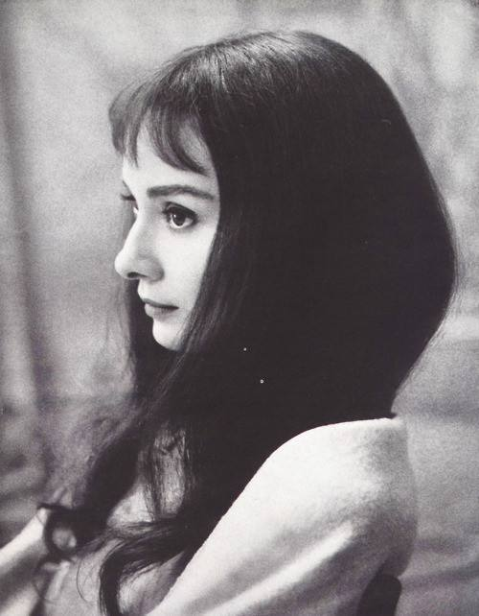

自动上色后的图像4：

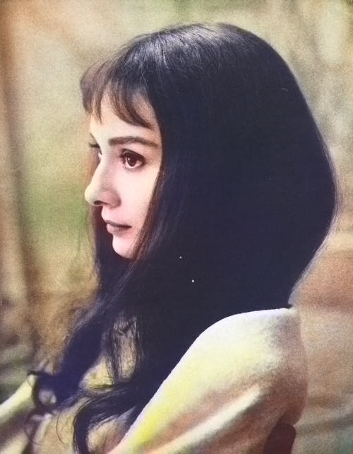

## 5 关键代码说明

5.1 图像预处理关键代码

bool GeneralImage::ArrangeImageInfo(shared_ptr<EngineTrans> &image_handle,

const string &image_path) {

// read image using OPENCV

cv::Mat mat = cv::imread(image_path, CV_LOAD_IMAGE_COLOR);

//resize

cv::Mat mat_rs;

cv::resize(mat, mat_rs, cv::Size(224,224));

// deal image

mat_rs.convertTo(mat_rs,CV_32FC3);

mat_rs = 1.0*mat_rs/255;

cv::cvtColor(mat_rs, mat_rs, CV_BGR2Lab);

// pull out L channel and subtract 50 for mean-centering

std::vector<cv::Mat> channels;

cv::split(mat_rs, channels);

cv::Mat mat_rs_l = channels[0] - 50;

if (mat.empty()) {

ERROR_LOG("Failed to deal file=%s. Reason: read image failed.",

image_path.c_str());

return false;

}

// set property

image_handle->image_info.path = image_path;

image_handle->image_info.width = mat_rs_l.cols;

image_handle->image_info.height = mat_rs_l.rows;

// set image data

uint32_t size = mat_rs_l.total() * mat_rs_l.channels()*4;

u_int8_t *image_buf_ptr = new (nothrow) u_int8_t[size];

if (image_buf_ptr == nullptr) {

HIAI_ENGINE_LOG("new image buffer failed, size=%d!", size);

ERROR_LOG("Failed to deal file=%s. Reason: new image buffer failed.",

image_path.c_str());

return false;

}

error_t mem_ret = memcpy_s(image_buf_ptr, size, mat_rs_l.ptr<u_int8_t>(),

mat_rs_l.total() * mat_rs_l.channels()*4);

if (mem_ret != EOK) {

delete[] image_buf_ptr;

ERROR_LOG("Failed to deal file=%s. Reason: memcpy_s failed.",

image_path.c_str());

image_buf_ptr = nullptr;

return false;

}

image_handle->image_info.size = size;

image_handle->image_info.data.reset(image_buf_ptr,

default_delete<u_int8_t[]>());

return true;

}

bool GeneralImage::SendToEngine(const shared_ptr<EngineTrans> &image_handle) {

// can not discard when queue full

HIAI_StatusT hiai_ret;

do {

hiai_ret = SendData(kSendDataPort, "EngineTrans",

static_pointer_cast<void>(image_handle));

// when queue full, sleep

if (hiai_ret == HIAI_QUEUE_FULL) {

HIAI_ENGINE_LOG("queue full, sleep 200ms");

usleep(kSleepInterval);

}

} while (hiai_ret == HIAI_QUEUE_FULL);

// send failed

if (hiai_ret != HIAI_OK) {

HIAI_ENGINE_LOG(HIAI_ENGINE_RUN_ARGS_NOT_RIGHT,

"call SendData failed, err_code=%d", hiai_ret);

return false;

}

return true;

}

HIAI_IMPL_ENGINE_PROCESS("general_image",

GeneralImage, INPUT_SIZE) {

HIAI_StatusT ret = HIAI_OK;

// Step1: check arg0

if (arg0 == nullptr) {

ERROR_LOG("Failed to deal file=nothing. Reason: arg0 is empty.");

return HIAI_ERROR;

}

// Step2: get all files

shared_ptr<ConsoleParams> console_param = static_pointer_cast<ConsoleParams>(

arg0);

string input_path = string(console_param->input_path);

vector<string> file_vec;

GetAllFiles(input_path, file_vec);

if (file_vec.empty()) {

ERROR_LOG("Failed to deal all empty path=%s.", input_path.c_str());

return HIAI_ERROR;

}

// Step3: send every image to inference engine

for (string path : file_vec) {

shared_ptr<EngineTrans> image_handle = nullptr;

MAKE_SHARED_NO_THROW(image_handle, EngineTrans);

if (image_handle == nullptr) {

ERROR_LOG("Failed to deal file=%s. Reason: new EngineTrans failed.",

path.c_str());

continue;

}

// arrange image information, if failed, skip this image

if (!ArrangeImageInfo(image_handle, path)) {

continue;

}

// send data to inference engine

image_handle->console_params.input_path = console_param->input_path;

image_handle->console_params.model_height = console_param->model_height;

image_handle->console_params.model_width = console_param->model_width;

image_handle->console_params.output_nums = console_param->output_nums;

image_handle->console_params.output_path = console_param->output_path;

if (!SendToEngine(image_handle)) {

ERROR_LOG("Failed to deal file=%s. Reason: send data failed.",

path.c_str());

continue;

}

// sleep

usleep(kSleepInterval);

}

// Step4: send finished data

shared_ptr<EngineTrans> image_handle = nullptr;

MAKE_SHARED_NO_THROW(image_handle, EngineTrans);

if (image_handle == nullptr) {

ERROR_LOG("Failed to send finish data. Reason: new EngineTrans failed.");

ERROR_LOG("Please stop this process manually.");

return HIAI_ERROR;

}

image_handle->is_finished = true;

if (SendToEngine(image_handle)) {

return HIAI_OK;

}

ERROR_LOG("Failed to send finish data. Reason: SendData failed.");

ERROR_LOG("Please stop this process manually.");

return HIAI_ERROR;

}

5.2 模型推理部分关键代码

bool GeneralInference::Inference(

shared_ptr<EngineTrans> &image_handle,

vector<shared_ptr<hiai::IAITensor>> &output_data_vec) {

// neural buffer

shared_ptr<hiai::AINeuralNetworkBuffer> neural_buf = nullptr;

MAKE_SHARED_NO_THROW(neural_buf, hiai::AINeuralNetworkBuffer);

if (neural_buf == nullptr) {

HIAI_ENGINE_LOG(HIAI_ENGINE_RUN_ARGS_NOT_RIGHT,

"new AINeuralNetworkBuffer failed");

return false;

}

neural_buf->SetBuffer((void*) image_handle->image_info.data.get(), image_handle->image_info.size);

// input data

shared_ptr<hiai::IAITensor> input_data = static_pointer_cast<hiai::IAITensor>(

neural_buf);

vector<shared_ptr<hiai::IAITensor>> input_data_vec;

input_data_vec.push_back(input_data);

// Call Process

// 1. create output tensor

hiai::AIContext ai_context;

hiai::AIStatus ret = ai_model_manager_->CreateOutputTensor(input_data_vec,

output_data_vec);

// create failed

if (ret != hiai::SUCCESS) {

HIAI_ENGINE_LOG(HIAI_ENGINE_RUN_ARGS_NOT_RIGHT,

"call CreateOutputTensor failed");

return false;

}

// 2. process

HIAI_ENGINE_LOG("aiModelManager->Process start!");

ret = ai_model_manager_->Process(ai_context, input_data_vec, output_data_vec,

kAiModelProcessTimeout);

// process failed, also need to send data to post process

if (ret != hiai::SUCCESS) {

HIAI_ENGINE_LOG(HIAI_ENGINE_RUN_ARGS_NOT_RIGHT, "call Process failed");

return false;

}

HIAI_ENGINE_LOG("aiModelManager->Process end!");

return true;

}

bool GeneralInference::SendToEngine(

const shared_ptr<EngineTrans> &image_handle) {

// can not discard when queue full

HIAI_StatusT hiai_ret;

do {

hiai_ret = SendData(kSendDataPort, "EngineTrans",

static_pointer_cast<void>(image_handle));

// when queue full, sleep

if (hiai_ret == HIAI_QUEUE_FULL) {

HIAI_ENGINE_LOG("queue full, sleep 200ms");

usleep(kSleepInterval);

}

} while (hiai_ret == HIAI_QUEUE_FULL);

// send failed

if (hiai_ret != HIAI_OK) {

HIAI_ENGINE_LOG(HIAI_ENGINE_RUN_ARGS_NOT_RIGHT,

"call SendData failed, err_code=%d", hiai_ret);

return false;

}

return true;

}

void GeneralInference::SendError(const std::string &err_msg,

std::shared_ptr<EngineTrans> &image_handle) {

image_handle->err_msg.error = true;

image_handle->err_msg.err_msg = err_msg;

if (!SendToEngine(image_handle)) {

HIAI_ENGINE_LOG(HIAI_ENGINE_RUN_ARGS_NOT_RIGHT, "SendData err_msg failed");

}

}

bool GeneralInference::SendResult(

shared_ptr<EngineTrans> &image_handle,

vector<shared_ptr<hiai::IAITensor>> &output_data_vec) {

for (uint32_t i = 0; i < output_data_vec.size(); i++) {

shared_ptr<hiai::AISimpleTensor> result_tensor = static_pointer_cast<

hiai::AISimpleTensor>(output_data_vec[i]);

Output out;

out.size = result_tensor->GetSize();

out.data = std::shared_ptr<uint8_t>(new (nothrow) uint8_t[out.size],

std::default_delete<uint8_t[]>());

if (out.data == nullptr) {

HIAI_ENGINE_LOG(HIAI_ENGINE_RUN_ARGS_NOT_RIGHT,

"dealing results: new array failed");

continue;

}

errno_t mem_ret = memcpy_s(out.data.get(), out.size,

result_tensor->GetBuffer(),

result_tensor->GetSize());

// memory copy failed, skip this result

if (mem_ret != EOK) {

HIAI_ENGINE_LOG(HIAI_ENGINE_RUN_ARGS_NOT_RIGHT,

"dealing results: memcpy_s() error=%d", mem_ret);

continue;

}

image_handle->inference_res.emplace_back(out);

}

return SendToEngine(image_handle);

}

HIAI_IMPL_ENGINE_PROCESS("general_inference",

GeneralInference, INPUT_SIZE) {

HIAI_StatusT ret = HIAI_OK;

// arg0 is empty

if (arg0 == nullptr) {

HIAI_ENGINE_LOG(HIAI_ENGINE_RUN_ARGS_NOT_RIGHT, "arg0 is empty.");

return HIAI_ERROR;

}

// just send data when finished

shared_ptr<EngineTrans> image_handle = static_pointer_cast<EngineTrans>(arg0);

if (image_handle->is_finished) {

if (SendToEngine(image_handle)) {

return HIAI_OK;

}

SendError("Failed to send finish data. Reason: Inference SendData failed.",

image_handle);

return HIAI_ERROR;

}

// inference

vector<shared_ptr<hiai::IAITensor>> output_data;

if (!Inference(image_handle, output_data)) {

string err_msg = "Failed to deal file=" + image_handle->image_info.path

+ ". Reason: inference failed.";

SendError(err_msg, image_handle);

return HIAI_ERROR;

}

// send result

if (!SendResult(image_handle, output_data)) {

string err_msg = "Failed to deal file=" + image_handle->image_info.path

+ ". Reason: Inference SendData failed.";

SendError(err_msg, image_handle);

return HIAI_ERROR;

}

return HIAI_OK;

}

5.3 图像后理关键代码

HIAI_StatusT GeneralPost::ColorizationPostProcess(

const std::shared_ptr<EngineTrans> &result) {

string file_path = result->image_info.path;

cout << "file_path = " <<file_path << endl;

// check vector

if (result->inference_res.empty()) {

ERROR_LOG("Failed to deal file=%s. Reason: inference result empty.",

file_path.c_str());

return HIAI_ERROR;

}

// only need to get first one

Output out = result->inference_res[0];

int32_t size = out.size / sizeof(float);

// get a channel and b channel result data

cv::Mat mat_a(56, 56, CV_32FC1, const_cast<float *>((float *)out.data.get()));

cv::Mat mat_b(56, 56, CV_32FC1, const_cast<float *>((float *)out.data.get()+size/2));

// pull out L channel in original image

cv::Mat mat = cv::imread(file_path, CV_LOAD_IMAGE_COLOR);

mat.convertTo(mat,CV_32FC3);

mat = 1.0*mat/255;

cv::cvtColor(mat, mat, CV_BGR2Lab);

std::vector<cv::Mat> channels;

cv::split(mat, channels);

// resize to match size of original image L

int r = mat.rows;

int c = mat.cols;

cv::Mat mat_a_up(r,c,CV_32FC1);

cv::Mat mat_b_up(r,c,CV_32FC1);

cv::resize(mat_a, mat_a_up, cv::Size(c,r));

cv::resize(mat_b, mat_b_up, cv::Size(c,r));

// result Lab image

cv::Mat newChannels[3] = {channels[0], mat_a_up, mat_b_up};

cv::Mat resultImage;

cv::merge(newChannels, 3, resultImage);

//convert back to rgb

cv::cvtColor(resultImage, resultImage, CV_Lab2BGR);

// generate colorized image

int pos = file_path.find_last_of(kFileSperator);

string file_name(file_path.substr(pos + 1));

cout << "file_name = " << file_name << endl;

stringstream sstream;

sstream.str("");

sstream << result->console_params.output_path << kFileSperator

<< kOutputFilePrefix << file_name;

string outputPath = sstream.str();

resultImage = resultImage * 255;

cv::imwrite(outputPath, resultImage);

if (size <= 0) {

ERROR_LOG("Failed to deal file=%s. Reason: inference result size=%d error.",

file_path.c_str(), size);

return HIAI_ERROR;

}

// transform results

float *res = new (nothrow) float[size];

if (res == nullptr) {

ERROR_LOG("Failed to deal file=%s. Reason: new float array failed.",

file_path.c_str());

return HIAI_ERROR;

}

errno_t mem_ret = memcpy_s(res, sizeof(float) * size, out.data.get(),

out.size);

if (mem_ret != EOK) {

delete[] res;

ERROR_LOG("Failed to deal file=%s. Reason: call memcpy_s failed.",

file_path.c_str());

return HIAI_ERROR;

}

// get topN

int32_t top_n = result->console_params.output_nums;

vector<float> varr(res, res + size);

string top_n_str = GenerateTopNStr(top_n, varr);

delete[] res;

//INFO_LOG("Success to deal file=%s.", file_path.c_str());

//INFO_LOG("Top index and confidence:%s", top_n_str.c_str())

return HIAI_OK;

}

HIAI_IMPL_ENGINE_PROCESS("general_post", GeneralPost, INPUT_SIZE) {

HIAI_StatusT ret = HIAI_OK;

// check arg0

if (arg0 == nullptr) {

ERROR_LOG("Failed to deal file=nothing. Reason: arg0 is empty.");

return HIAI_ERROR;

}

// just send to callback function when finished

shared_ptr<EngineTrans> result = static_pointer_cast<EngineTrans>(arg0);

if (result->is_finished) {

if (SendSentinel()) {

return HIAI_OK;

}

ERROR_LOG("Failed to send finish data. Reason: SendData failed.");

ERROR_LOG("Please stop this process manually.");

return HIAI_ERROR;

}

// inference failed

if (result->err_msg.error) {

ERROR_LOG("%s", result->err_msg.err_msg.c_str());

return HIAI_ERROR;

}

// arrange result

return ColorizationPostProcess(result);

}

## 6 重要问题及解决

问题1：模型转换时报Silence算子不支持

解答：Silence算子是屏蔽无用打印信息作用，可以从prototxt中删除

问题2：无论换什么图片，模型输出都是0

解答：模型输出层节点需要加载一个cluster centers数据。先用caffe读取权重文件，再把该数据赋值给class8_ab层即可

问题3：自动上色后的图像总是有一块区域色彩上色错了位置

解答：ab通道数据resize时宽高指定反了