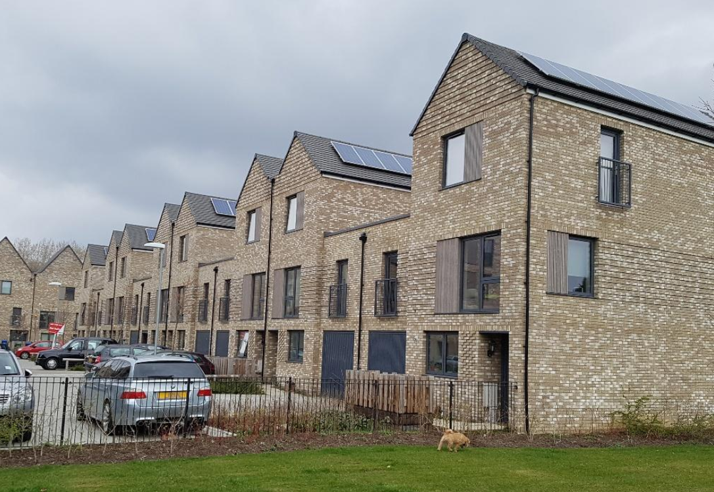

*Figure 1. New Fisher Close Development in a town house style on the far Northern boundary of Russia Dock Woodland*

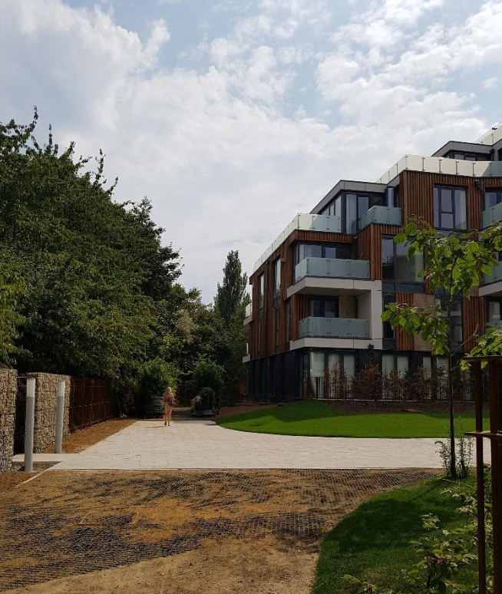

*Figure 2. The three storey stepped back design of the Quebec Quarter building mirrors the shape of the canopy edge and reduces the physical, visual and shade impact upon the woodland. The habitat walls provide a natural buffer.*

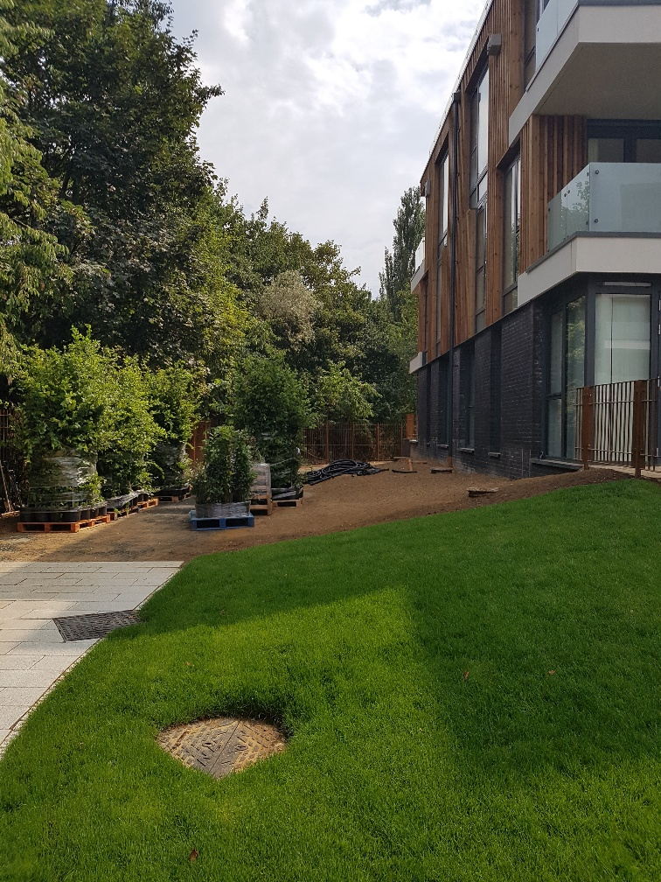

*Figure 11. The 10 metre buffer zone within the development site, including a native planting scheme, between the Quebec Quarter development and Russia Dock Woodland.*

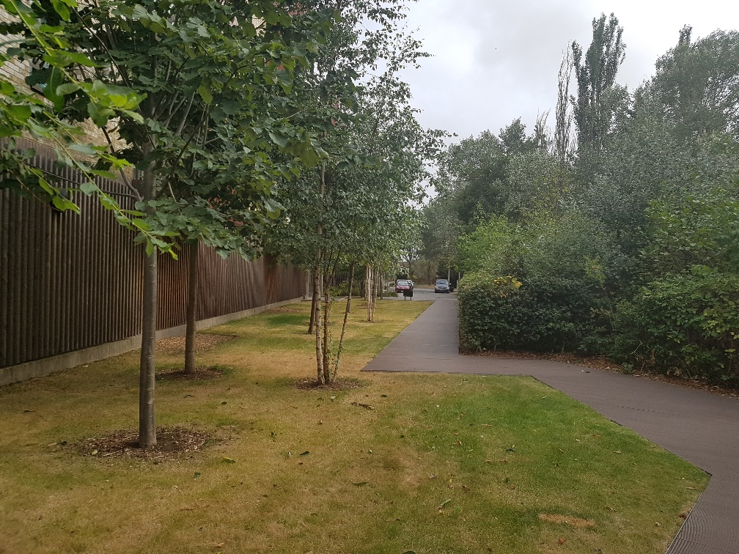

*Figure 12. The 12 metre buffer zone created between the Downtown development and Russia Dock Woodland Nature Reserve*