Week 2 Markdown Script

20015367

2025-10-07

## R Markdown

This is an R Markdown document. Markdown is a simple formatting syntax for authoring HTML, PDF, and MS Word documents. For more details on using R Markdown see <http://rmarkdown.rstudio.com>.

When you click the **Knit** button a document will be generated that includes both content as well as the output of any embedded R code chunks within the document. You can embed an R code chunk like this:

dataset <- read.csv("../Data/week2data.csv")

## Including Plots

You can also embed plots, for example:

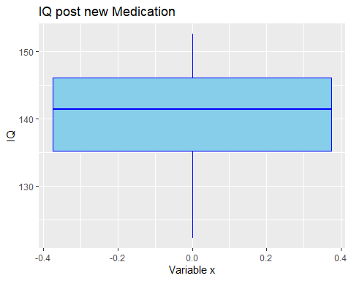

## Interperating the Data

The average IQ pre-treatment is 100. This data shows an average IQ approximately 140 showing some correlation between IQ & the medication.