# **Robot Framework Installation Guide**



# **Introduction**

This document is an installation instructions for new automate tester which explains the steps by steps of automate test environment.

## The purpose of documentation

1. To introduce and describe the overall of robot framework.
2. To help new users to follow the steps of installation guide.

## Robot Framework

Robot framework is open source software which is used for acceptance testing and acceptance-test driven development. In addition, the syntax is easy to use and easy to understand.

## Pre-Requisite

1. Selenium

Download from: <http://www.seleniumhq.org/download/>

1. Python 2.7 64 bit

Download from: <https://www.python.org/downloads/>

1. WxPython 64 bit version 2.8

Download from <https://sourceforge.net/projects/wxpython/files/wxPython/2.8.12.1/>

**(11/09/2017) Update Wxpython 64 bit can be use**

1. Appium Desktop App version 1.4.6.1

Download from <https://appium.io/downloads.html>

1. Node JS

Download from <https://nodejs.org/en/download/>

1. Java JDK

Download from <http://www.oracle.com/technetwork/java/javase/downloads/jdk8-downloads-2133151.html>

1. Android SDK

Download from <https://developer.android.com/studio/index.html>

1. SDK Manager Tool

Download from <http://www.mediafire.com/file/s0b00yagi27fht4/Android+SDK+Manager.exe>

1. USB Samsung Device

Download from <http://developer.samsung.com/technical-doc/view.do?v=T000000117>

1. Tortoise SVN

Download Tortoise SVN from <https://tortoisesvn.net/downloads.html>

1. PyCharm

Download from <https://www.jetbrains.com/pycharm/download/>

1. Microsoft Visual C++ Compiler for Python 2.7 (ต้องลงก่อน PIP “pycrypto”)

Download from <https://www.microsoft.com/en-us/download/details.aspx?id=44266>

Before begins the installation steps, we have to set the proxy first

## Proxy Server Setting

* Open Settings on Chrome Web Browser
* Click on ‘Change proxy settings’

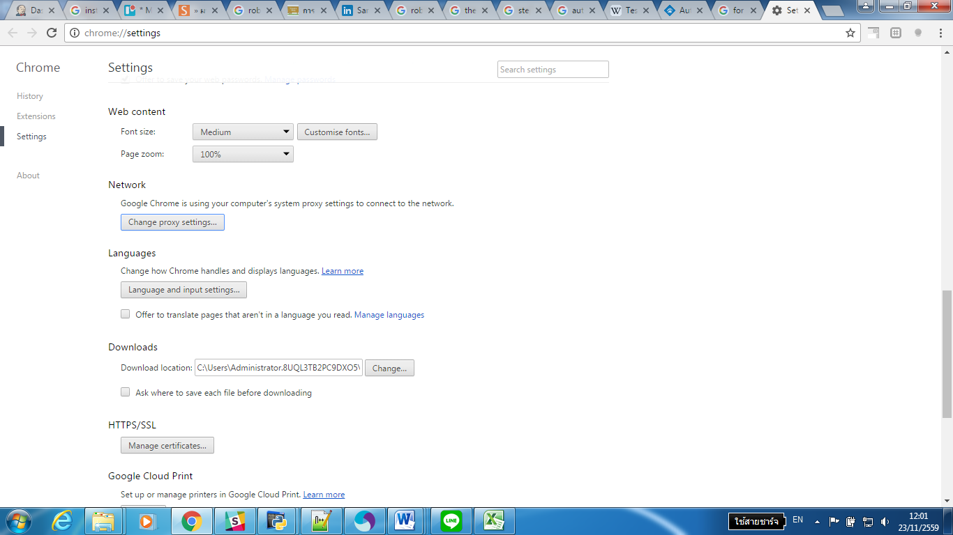

* Click on ‘LAN settings’

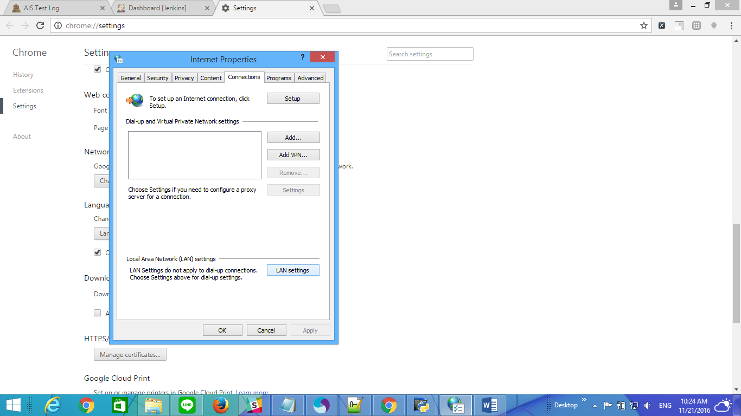

* Select ‘Use a proxy server for your LAN’

**Address:** proxya.ais.co.th

**Port:** 2520

* Select ‘Bypass proxy server for local address’
* Click OK

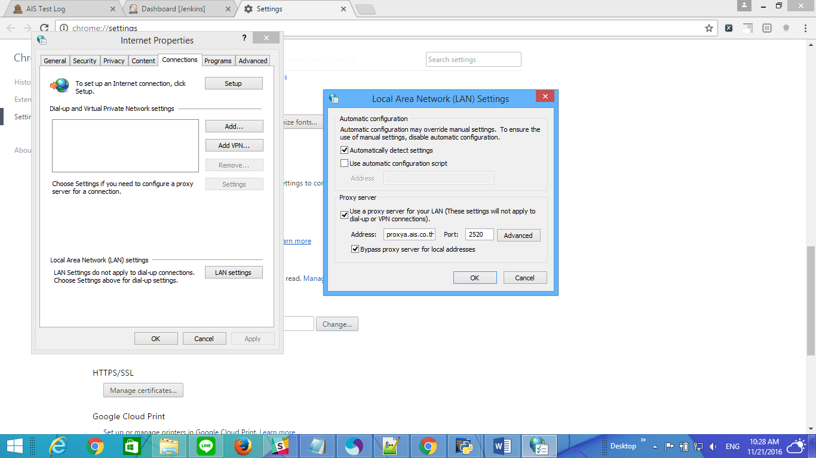

## IPV4 Setting

* Open Network and Sharing Center
* Select ‘Ethernet’ or ‘Local Areas Connection ’

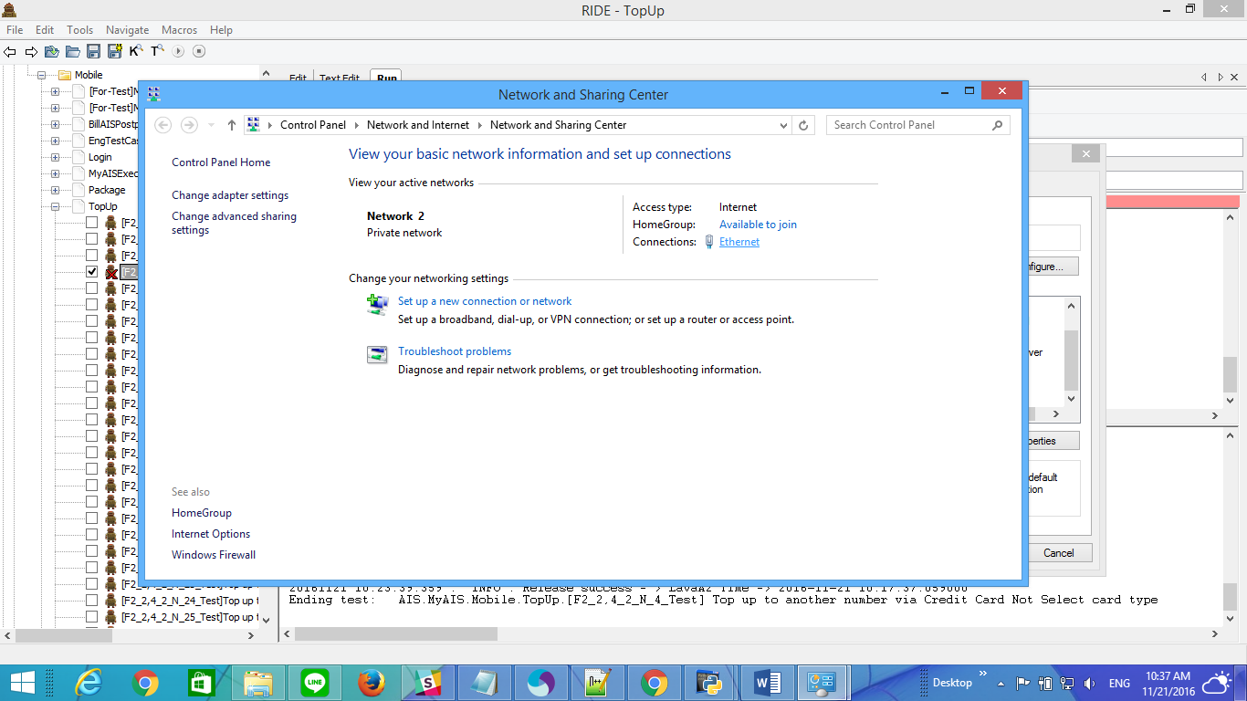

* Select Properties

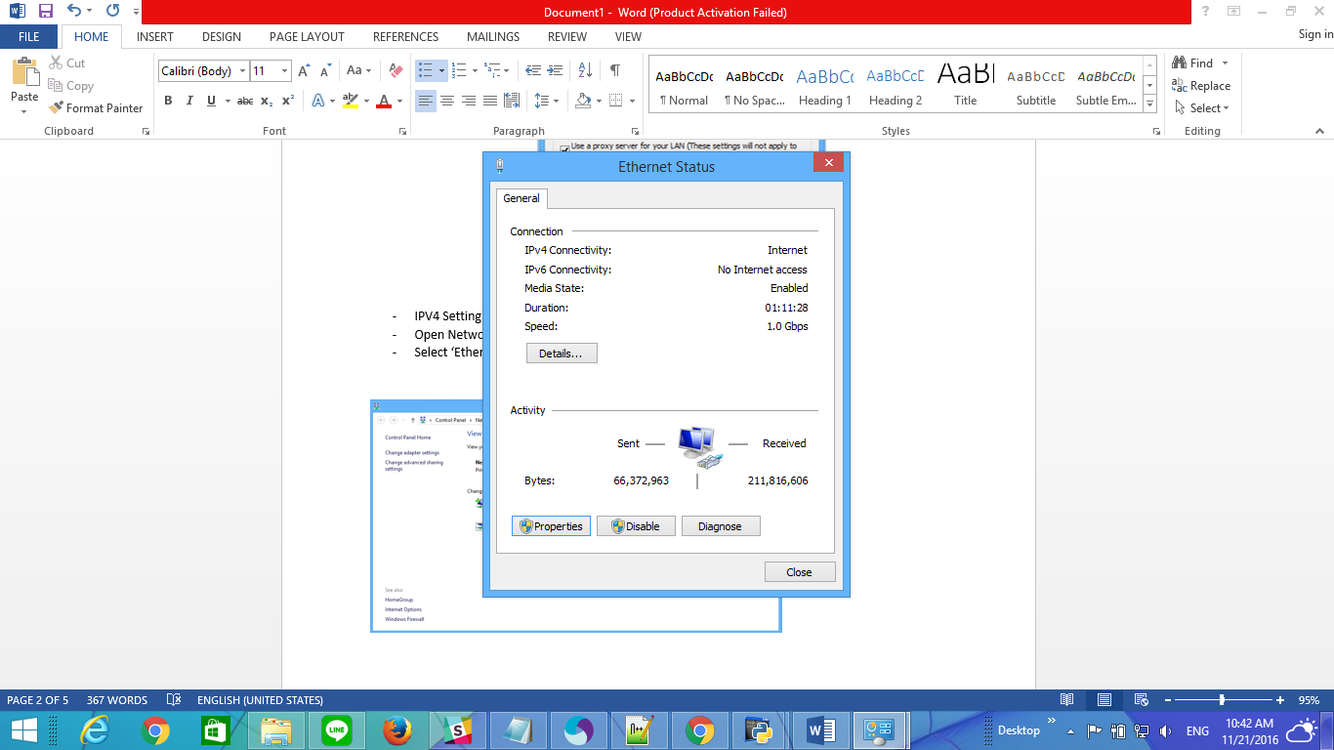

* Select Internet Protocol Version 4(TCP/IPv4)

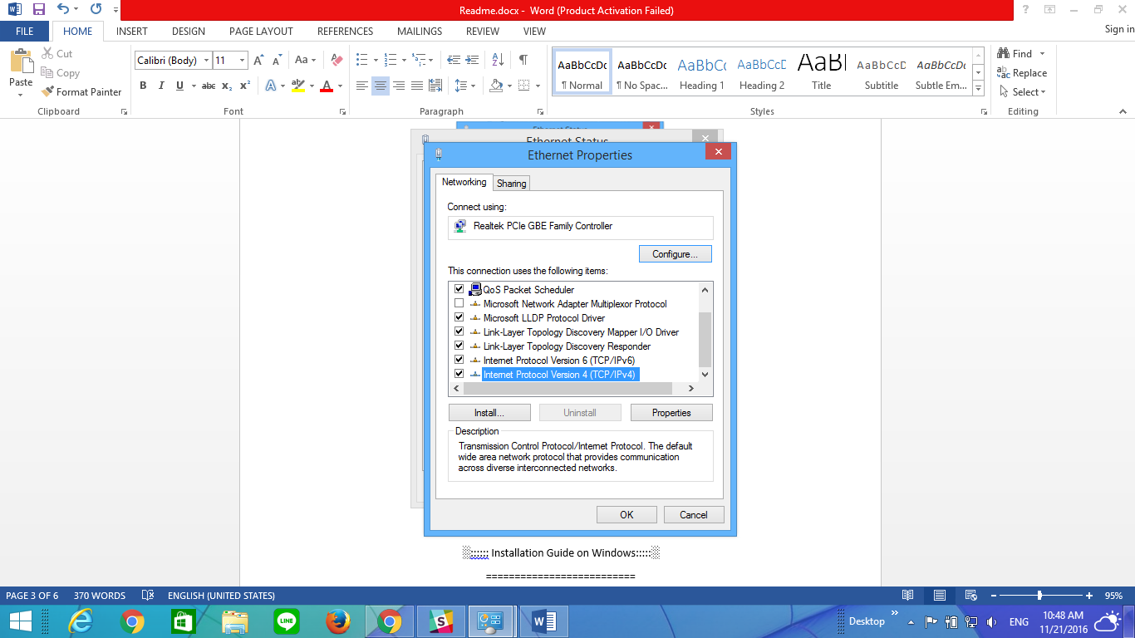

* Select Use the following IP address
* Set **IP Address** : 10.239.223.xx (Your IP Address)

**Subnet mask** : 255.255.255.0

**Default gateway** : 10.239.223.1

* Select Use the following DNS server addresses
* Set **Preferred DNS server**: 10.15.33.21

**Alternate DNS server**: 10.15.33.22

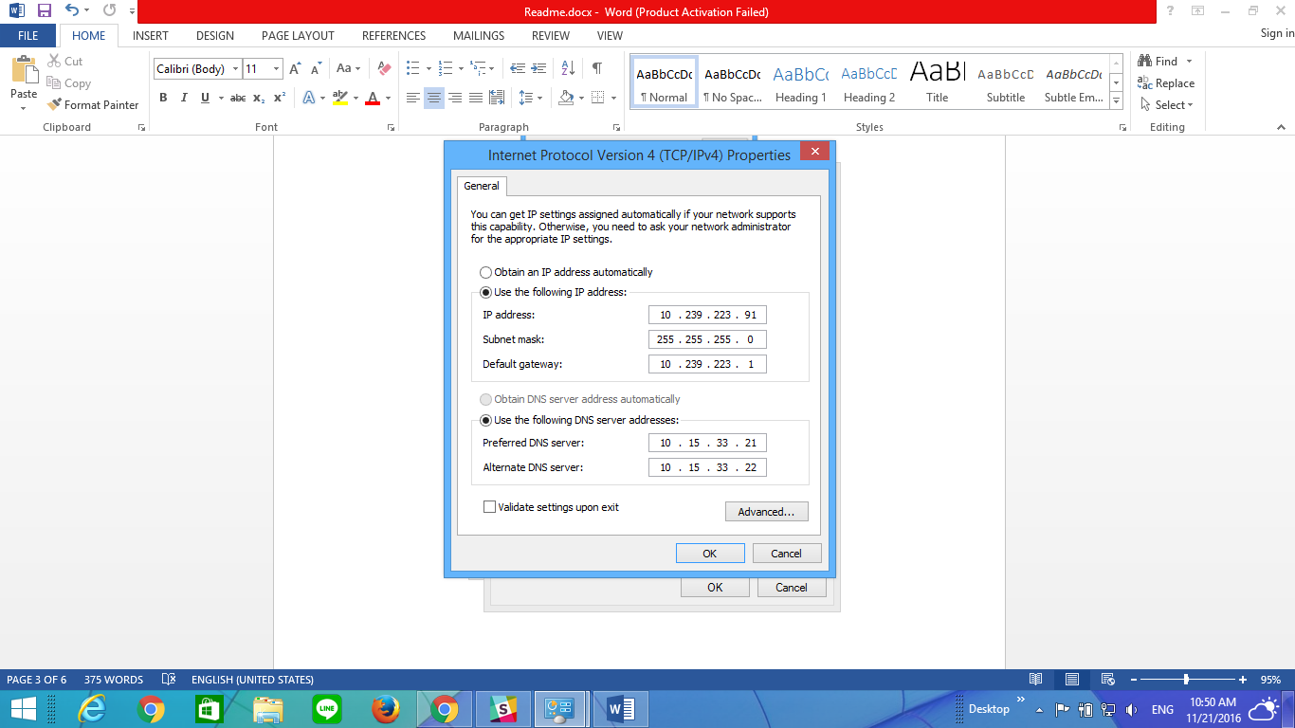

## Python Installation

After installed, python will be kept in this path C:\Python27. After that, verify that python can work by

* Open cmd
* Type >python

The result will show **‘python is not recognized as an internal or external command**’. It can solve by set variable environment path.

## Pip (Python Installer Package)

Pip is a package management system which used to install and manage package library e.g. Robot Framework.

1. Download get-pip.py from <https://pip.pypa.io/en/stable/installing/>

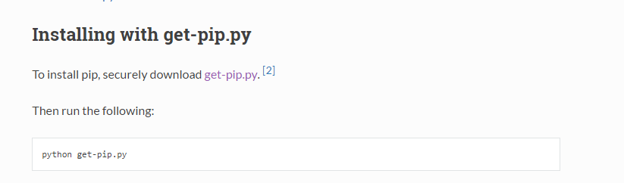

1. Then, move file to working directory and run this command >python get-pip.py
2. To test pip can work by typing >pip .The screen will show as below picture

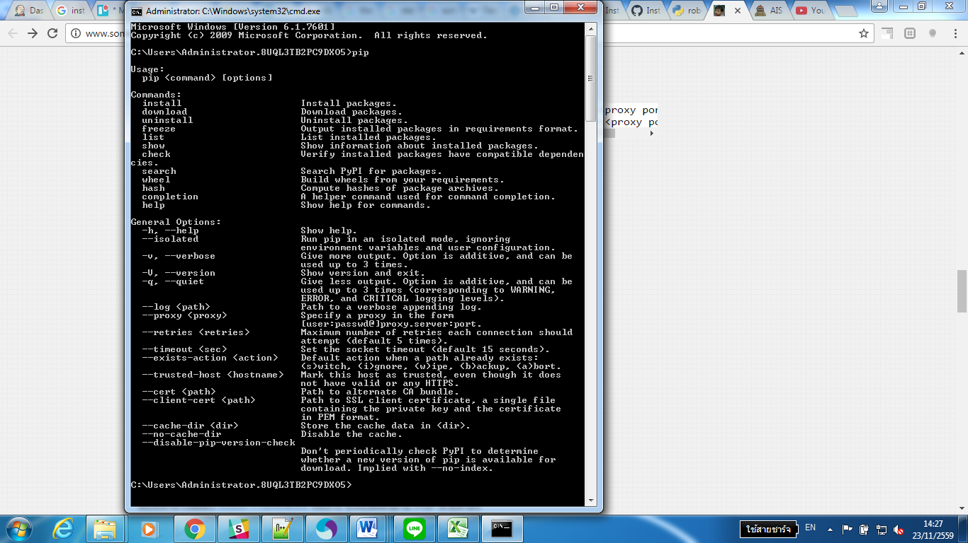

## Installation via command Line

* Install Robot Framework

>pip install robotframework

>pip install robotframework-ride

* Install Selenium2 & Appium library

>pip install robotframework-selenium2Library

>pip install robotframework-appiumlibrary

**Remark: Firefox Browser on selenium 3.x require version 0.48 or later**

* Install Excel Library for Robot Framework via Command line

>pip install robotframework-excellibrary

Append --upgrade to update both the library and all its dependencies to the latest version:

>pip install --upgrade robotframework-excellibrary

* Install beautifulsoup&xlsxWriter Library for Robot Framework via Command line

Install beautifulsoup Library use pull data from Report.html:

>pip install beautifulsoup4

* Install xlxs Library for write data to Excel file

>pip install xlsxWriter

* Install AutoItLibrary for Robot Framework

Install pypiwin32 library extension modules for access window api function

>pip install pypiwin32

* Install AutoItLibrary for Automation Test on COM Interface

>pip install AutoItLibrary or Download from source

(e.g. <https://pypi.python.org/pypi/AutoItLibrary/1.1.post1>)

**# Update 03/04/2017**

* Install psutil module

> pip install psutil

**# Update on 02/12/2016**

* Install Lock File for use in take virtual device

>pip install lockfile

(<http://docs.openstack.org/developer/pylockfile/>)

* + Install trello api
    - Pip install trello (<https://pypi.python.org/pypi/trello>)

**#Update 31/01/2017**

* + Install library (For add card in Trello)
    - pip install openpyxl

**# Update0 4/05/2017**

* + Install library for processing XML/HTML in python language
    - pip install lxml

**#Update 05/07/2017**

* + Install database library
    - pip install robotframework-databaselibrary
  + For Oracle Database

1. you must install oracle client first
2. install oracle client from => <http://www.oracle.com/technetwork/database/enterprise-edition/downloads/index.html>
3. make sure :win7 x64; python x64; oracle client x64
4. pip install cx_Oracle(Must use Lastest version pip)
   * python –m pip install –upgrade pip

**#Update 04/10/2017 ( For test REST API)**

* + Install RESTful library
  + pip install robotframework-requests
  + pip install --upgrade robotframework-httplibrary
  + Install encrypt library (for test My Ais API)
  + pip install pycrypto
  + Install via command “python setup.py install”
    - <https://github.com/doegox/python-cryptoplus>
    - <https://github.com/janglin/crypto-pkcs7-example>
  + Install Json library
  + pip install robotframework-jsonlibrary

## Installation ADB keyboard

**#Update 15/06/2016**

* + Install ADB Keyboard <http://www.mediafire.com/file/rgdia9vj0ib0q4q/ADB+Keyboard.apk>

## General Configuration

**#Update 05/07/2017**

* + Control Panel > Region and Language
    - Change format, Location and Administrative to Thailand

## Android SDK

* + Download and install android SDK from <http://www.mediafire.com/file/s0b00yagi27fht4/Android+SDK+Manager.exe>

Or Android Studio <https://developer.android.com/studio/index.html>

* + After installed reach to this path : %WORKSPACE%\AppData\Local\Android\android-sdk

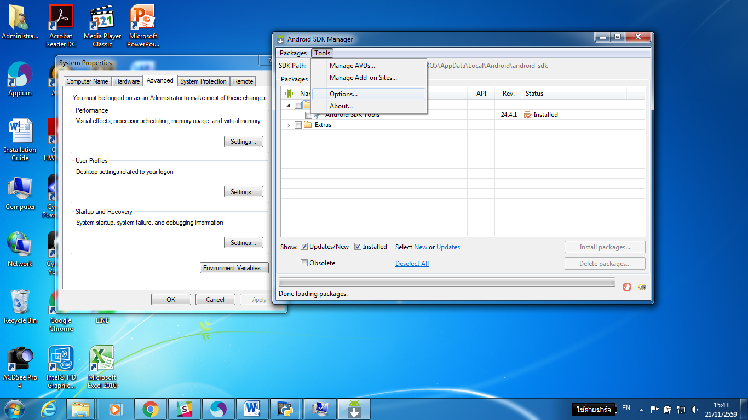

* Set proxy

**HTTP Proxy Server**: proxya.ais.co.th

**HTTP Proxy Port**: 2520

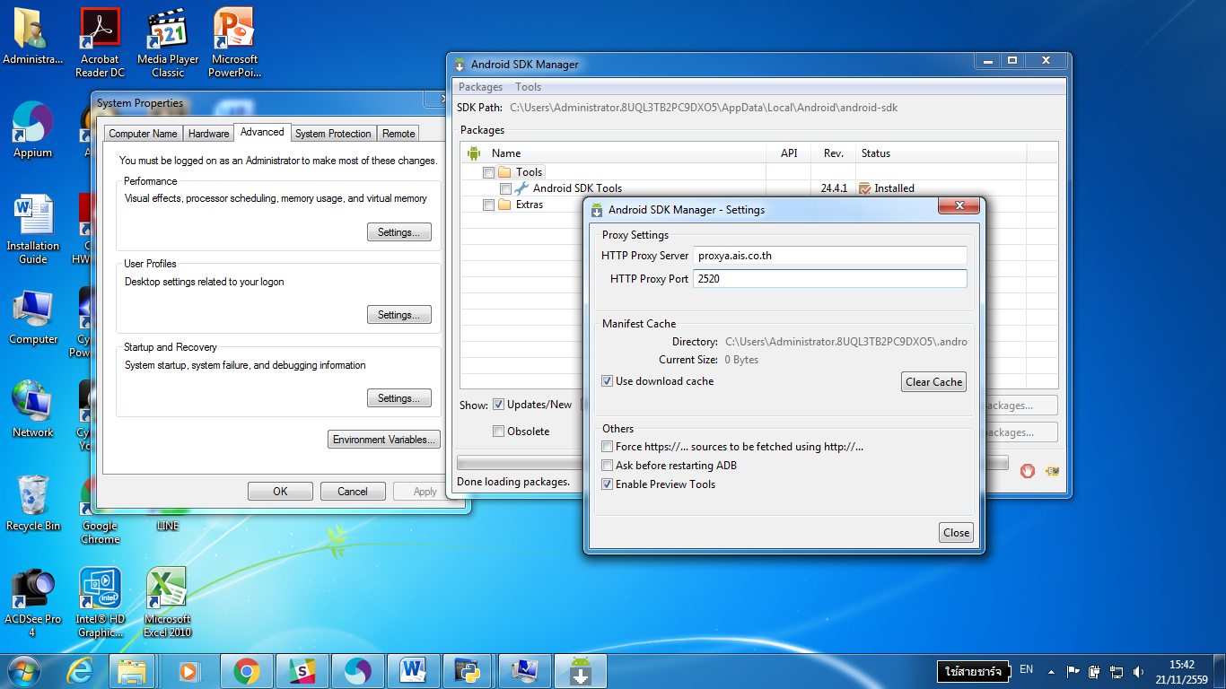

* Select the following packages and install.

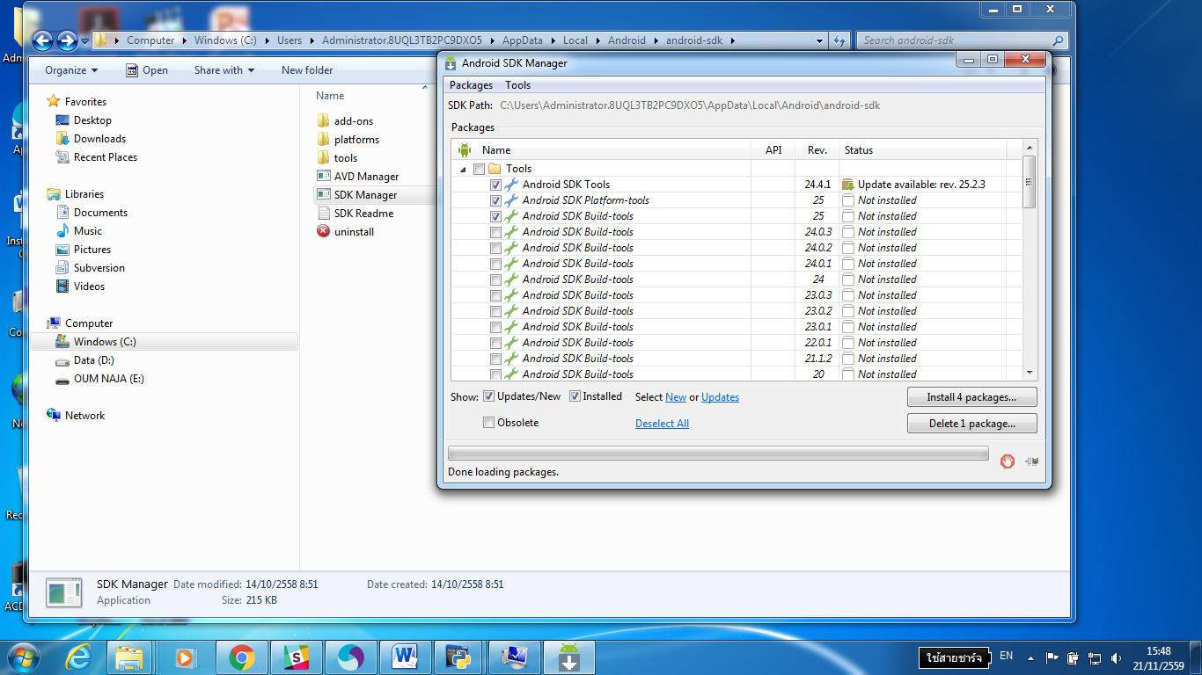

## Set environment variables path

* **Python27**

Set path variable >> C:\Python27

* **Java JDK**

Set path variable >> C:\Program Files\Java\jdk1.8.0_91\bin

* **Android SDK**

Set path variable >> C:\Users\ Users \AppData\Local\Android\sdk\platform-tools

* **Appium**

Set path variable >> C:\Program Files (x86)\Appium

Set path variable >> C:\Program Files (x86)\Appium\node_modules

* **Node.js**

Set path variable =C:\Program Files\nodejs

* **ANDROID_HOME**

Add system variable path

Variable Name: ANDROID_HOME

Value: C:\Users\MyUser\AppData\Local\Android\android-sdk