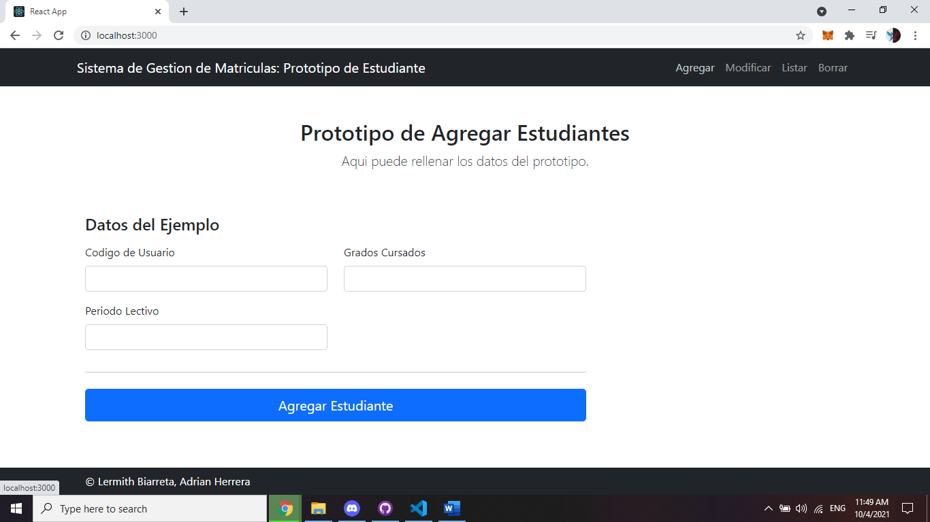Prototipo: Agregar

Prototipo: Modificar

Prototipo: Listar

Prototipo: Borrar

