CREATING & MANAGING TAXONOMY IN THE BDRS

Notes

Document Information

|  |  |
| --- | --- |
| Prepared For: | Atlas of Living Australia  Administrators and developers off the Atlas Field Data Capture Software |

Publication History

|  |  |
| --- | --- |
| Edition | Date |
| V1.0 | March 2012 |

Contents

Introduction 3

This document: 3

1: CREATING TAXONOMIC GROUPS 5

Instructions for creating or editing a new Taxon Group: 5

2: CREATING TAXONOMIC PROFILES – SPECIES PAGES 9

Adding a BASIC Species Page 9

Unformatted Basic Species Page Display – Admin View 12

Unformatted Basic Species Page Display – User View 13

Add RICH CONTENT to a Species Page - MANUALLY 14

Standardised Species Page – the Taxon Template 18

Creating Templated Species Pages 19

3: IMPORTING ALA TAXONOMY TO POPULATE THE BDRS 23

1: IMPORTING A SPECIES PAGE 23

2: IMPORTING MULTIPLE SPECIES PAGES 30

3: IMPACT ON SPECIES PAGE FORMATTING 34

PART 3: USING THE TAXON PROFILE TEMPLATE 38

Taxon Profile Template Summary: WHY 38

Taxon Profile Template Summary: HOW 38

APPENDIX A: 40

MANAGED FILES INTERFACE 40

# Introduction

There are two main methods for creating and managing taxonomic structures and content in the Biological Data Recording System (BDRS)

The simplest is to **import** species pages from the Atlas of Living Australia (Atlas).

The more complex method is to **create** the structures and content by hand.

**BDRS Taxonomy** comes in two parts – the **Taxonomic Group** and the **Taxonomy Page**.

The **Taxonomic Page** is the BDRS equivalent of a **species profile** page in the Atlas and contains information about the particular species of interest including images, description, habitat, diet and so on – whatever you want to show to visitors to your site.

These profile pages can be developed for all levels of a taxonomic structure including sub-species, species, genus, subfamily, family etc to whatever level of detail you wish to go to and is appropriate for your audience and useful in surveys.

The **Taxonomic Group** is a flexible grouping classification tool. You can group things by anything you like:

* For example type - lizards, snakes, skinks, waterfowl, birds of prey, etc; OR
* or within a family or kingdom: Waterfowl, Herons, Ibis etc, Birds of Prey, Shorebirds and Gulls, Pigeons and Doves, Cockatoos, Parrots and Lorikeets, Robins, Cuckoos, and so on; OR
* by habitat – wetlands, dry forest etc.

Clicking on the taxonomic group opens the next level down which is usually a list of species – then Clicking on an individual species opens the selected species profile page.

You can group species at whatever level of detail you like, is appropriate for your audience and is useful in setting the context of more formal scientifically driven surveys (vs a casual “any species” sighting record with basic Darwin Core Fields).

Most BDRS sites have a field guide or species guide which shows this first level of grouping that provide users with the opportunity to browse your content within the grouping or association framework and which shape and guide their understanding of what your particular projects are all about.

## This document:

Part 1 describes the processes for creating Taxonomy Groups.

Part 2 describes the processes for creating Taxon/Species pages.

Part 3 describes the processes for creating & updating taxonomy groups and species pages using the Atlas of Living Australia Import functionality.

Part 4 describes the use of taxon profile templates to create standard fields to direct data entry into species pages.

**Note:**

You will need to be an administrator to perform the actions described in this document.

The menus may not look exactly like the images shown here as your site may be themed with different colours and/or text. The functionality will be the same however so look at the admin screens as they will not generally be themed.

# 1: CREATING TAXONOMIC GROUPS

The Taxonomic Group is a flexible grouping and classification tool. You can group things by anything you like – for example type: lizards, snakes, skinks, waterfowl, birds of prey, etc

Most BDRS sites have a field guide or species guide which shows this first level of grouping.

Clicking on the taxonomic group opens the next level down which is usually a list of species – then Clicking on an individual species opens the selected species profile page.

## Instructions for creating or editing a new Taxon Group:

1. Log in to your web site as usual.
2. Click on Admin from the navigation menu and Select Manage Portal, then Manage Taxonomy on the sub-menu

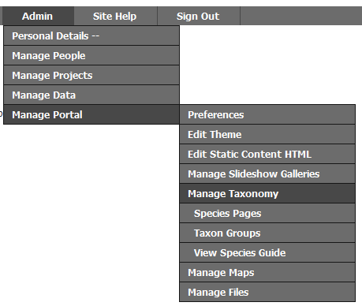

1. Select Add a New Taxonomic Group from the list

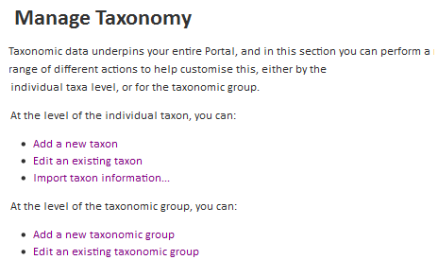

#### Tip

You can also click the Add Taxon Group button on the Edit an Existing Taxonomic Group Page

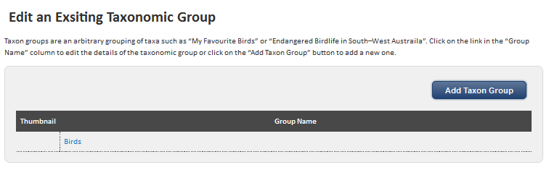

1. Type a Name

Naming is important as it is how people distinguish between groups of objects – for example it is usually better to use common names rather than scientific names to improve the usability of the site.

In this example we have used “Threatened mammals”

**Note** that you can also add an Image and/or Thumbnail image for a species representative of your group which will be displayed on the field guide page.

We recommend you do this to add visual appeal to your web site and help people understand and differentiate between the species contained within your taxon groups.

*Continuing with the Threatened Mammals example*

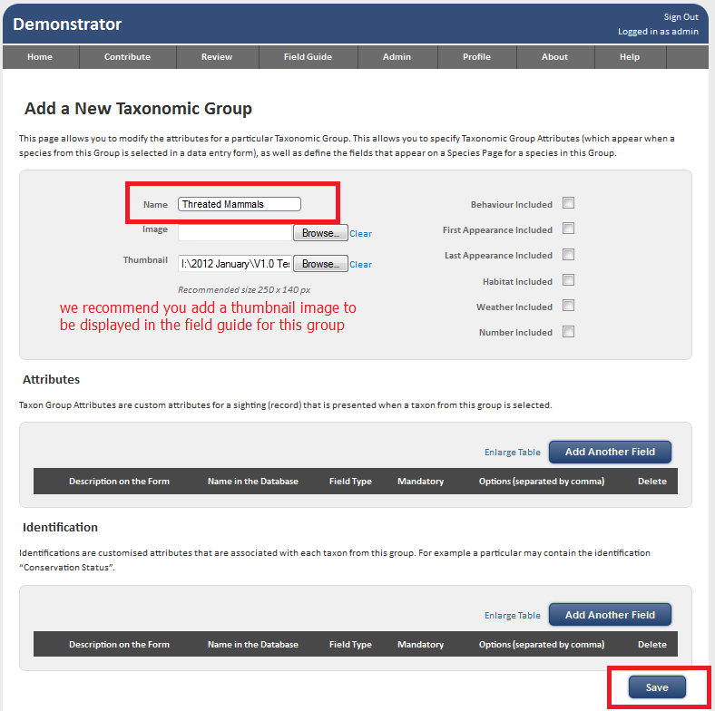

1. Click the Save button

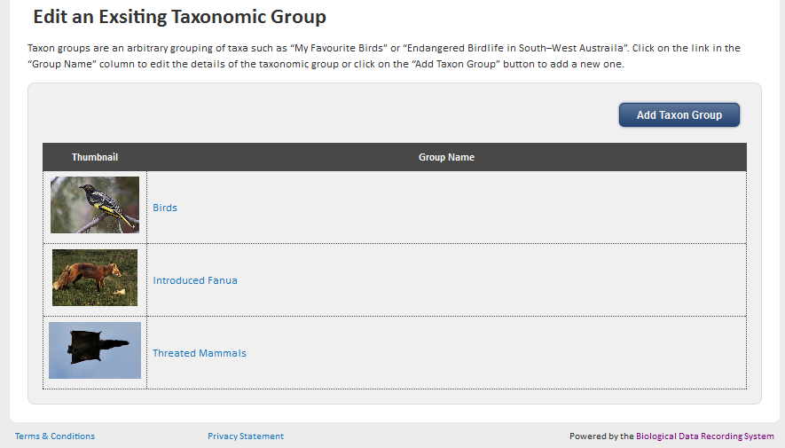

Three new taxon groups are shown here with a thumbnail image.

1. Select View Species Guide (or field guide - site dependent) to see the general user view of taxon groups.

## 

**Note**

You cannot DELETE a taxon group but you can rename it and all of the associated species will stay aligned with the new group name.

# 2: CREATING TAXONOMIC PROFILES – SPECIES PAGES

The **Taxonomic Page** is the BDRS equivalent of a **species profile** page in the Atlas and contains information about the particular species of interest including images, description, habitat, diet and so on – whatever you want to show to visitors to your site.

These profile pages can be developed for all levels of a taxonomic structure including sub-species, species, genus, subfamily, family etc to whatever level of detail you wish to go to and is appropriate for your audience and useful in surveys.

You will need to have created at least one Taxonomy Group to perform this action as all species pages have to be assigned to a group as they are created.

## Adding a BASIC Species Page

1. Log in to your web site as usual.
2. Click on Admin from the navigation menu and Select **Manage Portal**, then **Manage** **Taxonomy** on the sub-menu

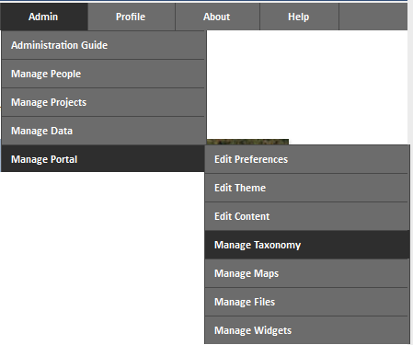

1. Select **Add a new taxon** from the Manage Taxonomy list



1. The **Add a new Taxon** screen opens

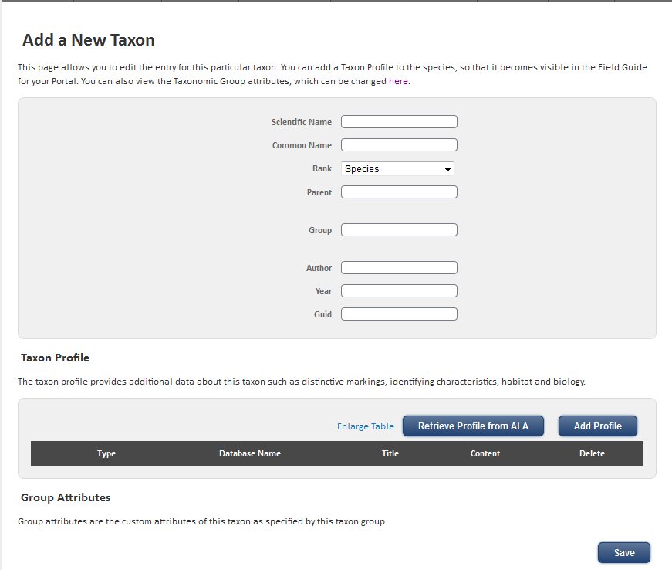

1. Enter species details into the **three mandatory fields**:

* **scientific** name
* **common** name,
* and select the **Taxon Group** you wish to associate this species with (start typing and auto complete will show groups containing the letters you have entered like birds in the image below)

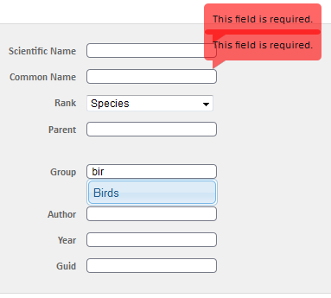

**Tips**

Error messages such as those red balloons in the above are generally all triggered at once meaning you may see error messages for fields you haven’t yet tried to enter data into.

**Please ignore**

Error messages sometime display against fields higher on the screen than you can currently see – you can usually tell because you won’t be able to submit the form.

**Workaround:** scroll up the page and make sure there isn’t anything you’ve missed

Change requests have been submitted to address these validation issues.

1. Leave the Rank as the species default – Advanced Admin addresses other options
2. Click the Save Button and you are returned to the **Edit an Existing Taxon** screen with a message stating “<your new species name> saved successfully”.

FYR - In our example the species name is “Species Scientific Name”

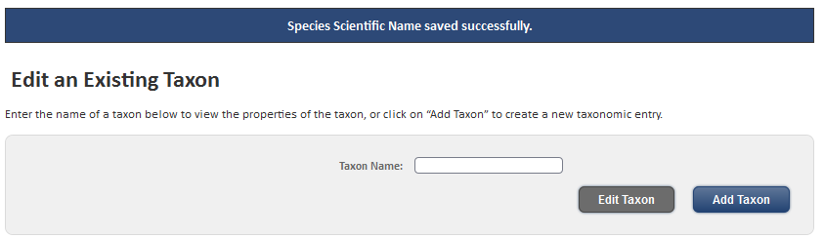

### Unformatted Basic Species Page Display – Admin View

1. The new Species Page will have no descriptive or rich multimedia information
2. In the **Edit an Existing Taxon** screen start typing your new species name into the taxon name field in and select it from the auto-complete field.

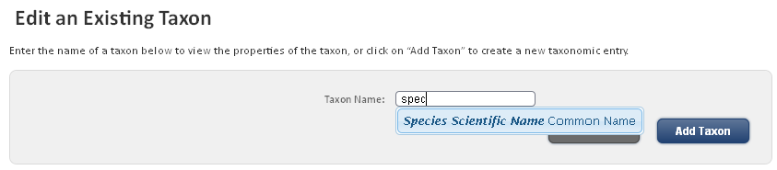

1. The minimal content available is displayed in place

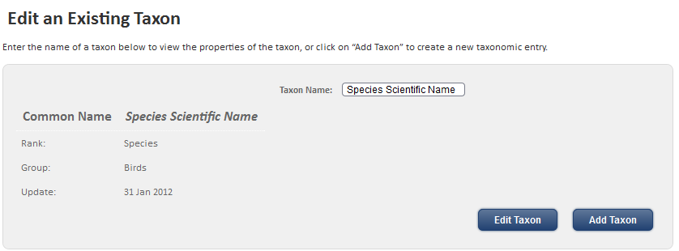

### Unformatted Basic Species Page Display – User View

1. Or open the field guide, select the taxon group and choose your new species

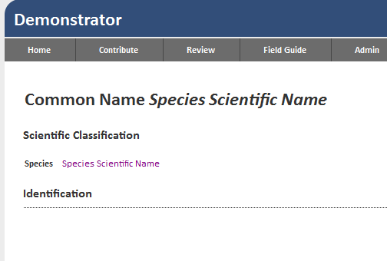

**Notes**

This instruction set only creates the most basic of species page with no descriptive information or images of the species.

**IT IS SUFFICIENT however to allow the species to be used in surveys.**

You cannot DELETE a species page but you can reuse it by renaming it but you will not need to edit any species data associated with the old name.

## Add RICH CONTENT to a Species Page - MANUALLY

1. Starting from Steps 9 / 10 above – open the **Edit an Existing Taxon** screen and click the Edit Taxon button
2. The Edit an Existing Taxon screen displays the content you entered previously including the scientific & common names and the taxon group details

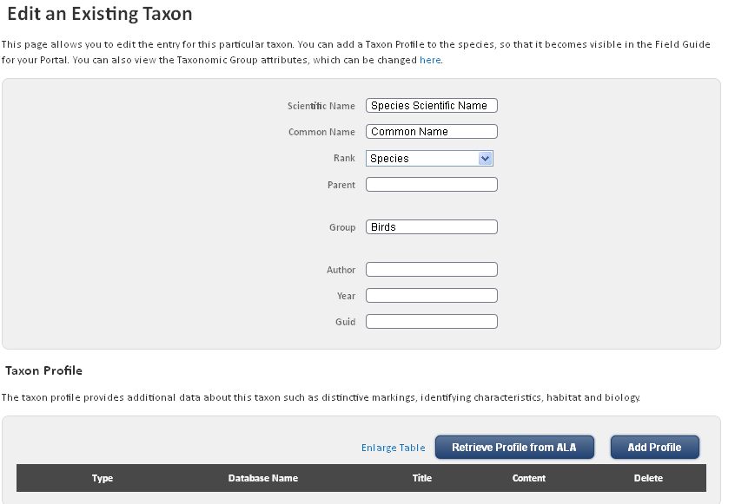

1. Scroll down the page to the Taxon Profile section and Click the Add Profile Button

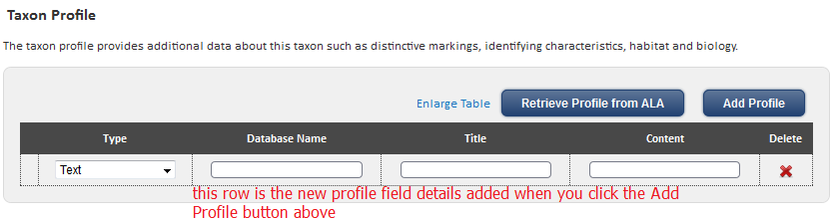

1. Select the type from the pick list.

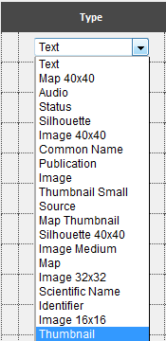

**Note**

Audio files can be added but playing is not yet supported

1. Enter the Database Name and title
2. Enter the appropriate content – see next section for detailed instructions
3. Save the species profile to see your new content displayed in the default species page template – lines all content up down the page

#### Special Types

1. If you select type as **Text** and click in the Content field the HTML Editor window pops up so you can create longer formatted text strings
2. If you select as type as one of **Image, map, or thumbnail** and click in the Content field a Managed File interface window pops up so you can easily add content to the page.
3. See Appendix A for more detail on the Manage Files option.

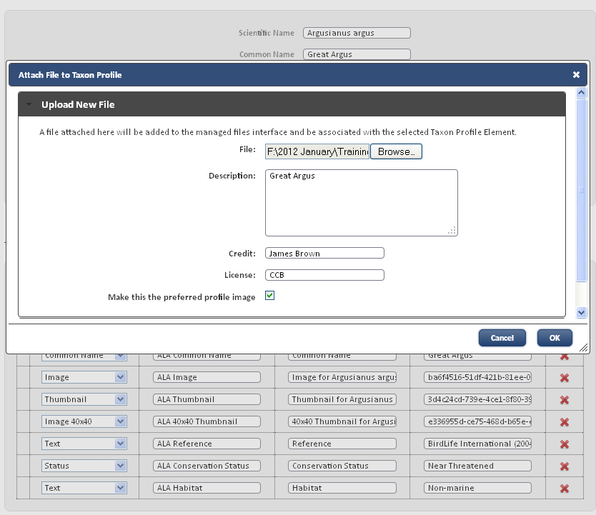

1. Adding an image file or HTML this way automatically populates the Content Field as shown.

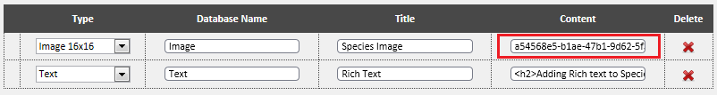

1. Complete and save the Species Page

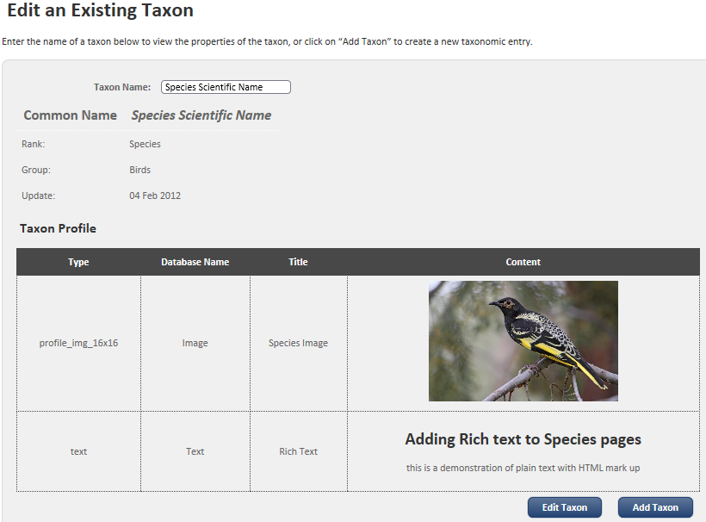

1. The example shows an image and HTML text associated with the species page – above Edit Taxon in admin: below species page from the Field Guide

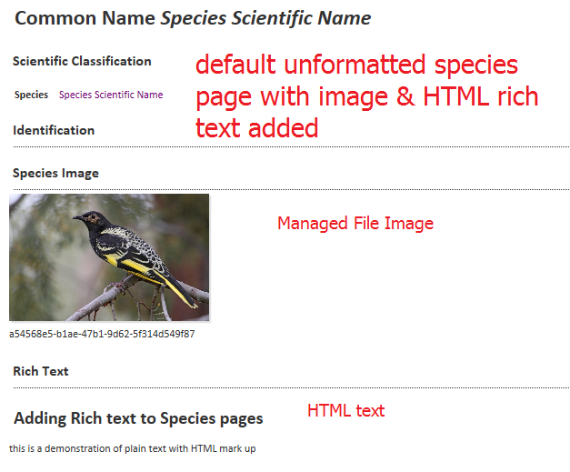

1. OPTION 2: You can also select Species Pages in the menu (as shown above in 2.) to open directly if your site has this option.
2. Click the Add Taxon button

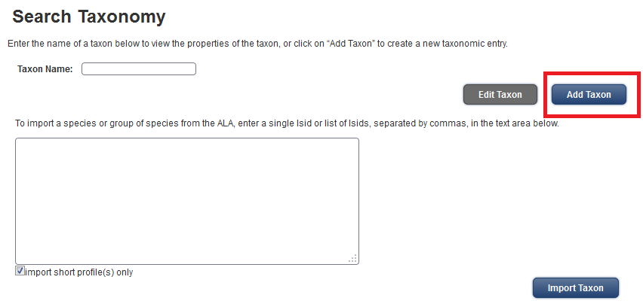

## Standardised Species Page – the Taxon Template

The process of adding one row of data at a time to a species page and then duplicating it repeatedly for ten’s, hundreds or even thousands of pages does not bear thinking about.

Even worse from a data and quality standardisation perspective – what guarantee that every field was filled in the same way by one person let alone a group and without making mistakes.

This is important because we have always planned for the BDRS to export Species Profiles to other systems. Including the Atlas, and different names would break things.

To address the problem before the advent of the Atlas species profile import for larger numbers **the taxon.profile.templa**te model was implemented.

#### What this means to you

A set of standard fields with fixed types, database names, and titles were able to be automatically added to every species profile page in a BDRS.

All you had to do was fill them.

## Creating Templated Species Pages

1. The following image shows the edit options for K2C Reptiles including the default fields established for this site as well as the Atlas species page importing functionality described in detail in . below

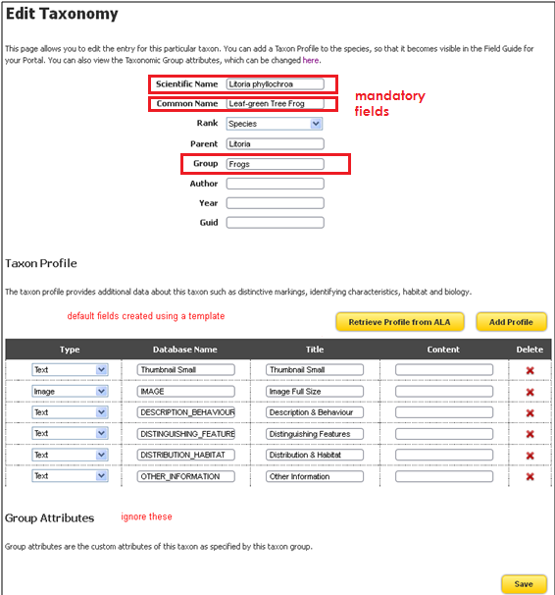

1. Note that the Scientific, Common and Group name fields highlighted in red are mandatory
2. **Add your content**
   1. The fields are limited in size while in edit mode as shown but can contain as much text as you like.
   2. We recommend you develop detailed text separately and paste into the appropriate fields
   3. The text supports HTML mark up such as <strong>this text will be shown bolded</strong>
   4. We also recommend that you **add at least one image** that can be displayed both in the species page and in the taxon group species list.
   5. Images need to be added first to the Managed Files list so you can reference the unique Identifier e.g. 02df8c72-ae25-4171-b5ad-401c793e11f4 which will be used to display the image
   6. The table row containing the image needs to be dragged up to the top of the table in order to display in the taxon group species list: this is more important when you have multiple images.

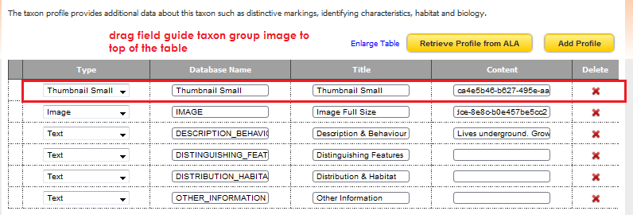

* 1. More complete details on how to create and manage field content and options are provided in the separate section - .

|  |
| --- |
| **TIP**  Browsers are notoriously reluctant to release cached page data so you may have to clear your browsers history in order to see the changes you have made.  This is especially so with images |

1. Click the Save button to complete the species profile.

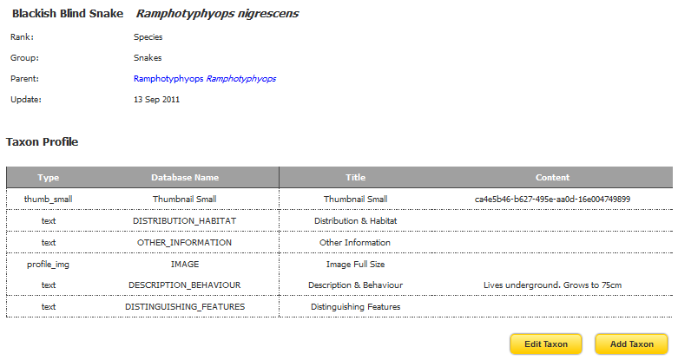

1. Select View Species Guide (or field guide - site dependent) and then the appropriate Taxonomy Group to see the results.

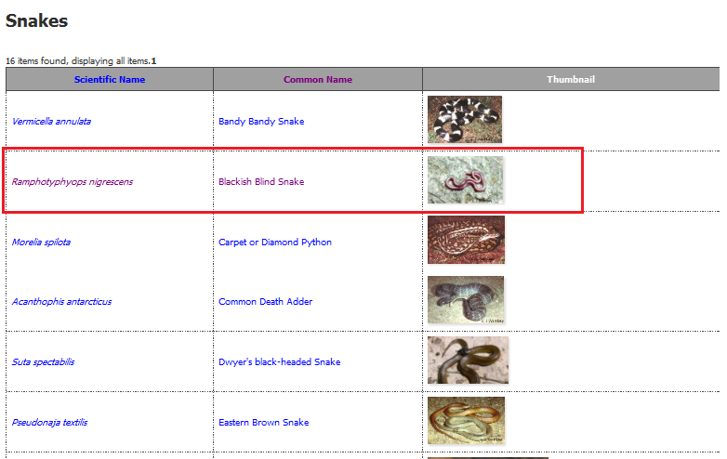

**Note for Administrators:**

Default fields such as those shown here in the otherwise naked species page (the default) are established using a “.json” template file which is added to managed files and then connected to the profiles.

This is important to understand as, without a set of standard fields, each species page you create will require the manual addition of every field required with the same name and data type if further formatting is to be applied.

By using the template you can substantially reduce the species profile creation workload and reduce errors.

See Part 4 for detailed instructions.

# 3: IMPORTING ALA TAXONOMY TO POPULATE THE BDRS

BDRS taxon groups and species pages can be created and updated quickly by populating them with Atlas of Living Australia data (where it available for that species).

This new functionality addresses one of the most difficult, complex and time consuming processes in setting up a new BDRS site.

This piece of the document is broken down into 3 sections – the first describes how you can update your existing pages with Atlas data, the second shows how you can use the import functionality to create new species profiles singly and in bulk, and the third explains how your own data and that form the Atlas are formatted in the Species Profile page.

## 1: IMPORTING A SPECIES PAGE

#### Instructions for updating a Taxon Profile/Species Page from the Atlas:

1. Log in to your web site as usual.
2. Click on Admin from the navigation menu and Select Manage Portal, then Manage Taxonomy on the sub-menu



1. Select Search Taxonomy from the list



Tip – you can also select Species Pages in the menu (as shown above) to open directly if your site has this option.

1. Type the name of the species you wish to edit/update in the **Taxon Name:** field

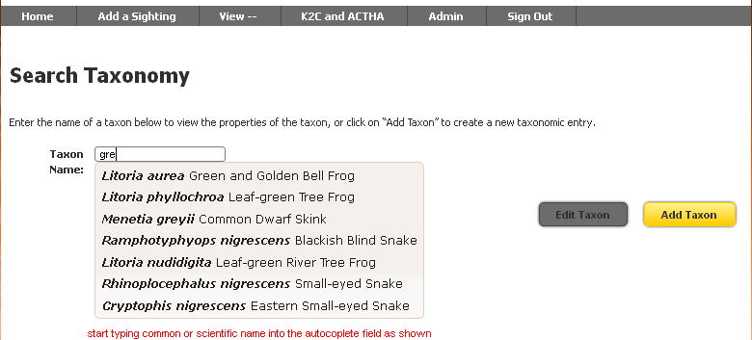

Species matching your in scientific or common name text in some way (including whole or part word matches) are displayed as list for your selection as shown.

The field uses auto-complete to list every profile matching the letters you type from about the 3rd onwards.

1. Select the species you wish to edit then click on the **Edit Taxon** button (which changes colour to show you it is active)

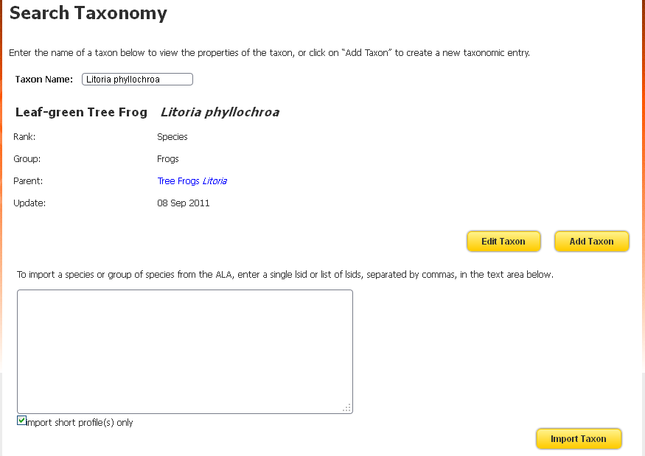

Where there is already information on the species it will be shown in the area between Update (last updated field) and the Edit Taxon button.

***Note*** the large text box at the foot of the page – you can use this for importing single and multiple species pages from the Atlas directly: described in more detail in section 2 below.

1. This image shows the edit options for K2C Reptiles including the default fields established for this site as well as the Atlas species page importing functionality.

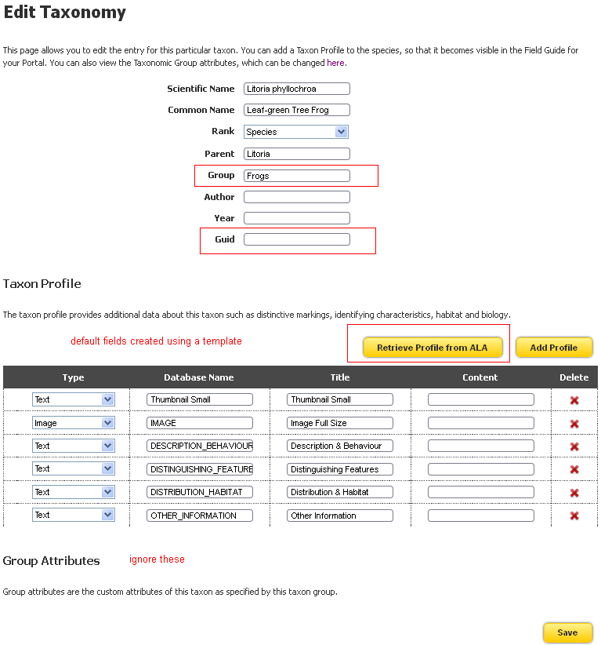

1. In order to import the data you will need to **add the Guid** (second field highlighted in red in the diagram above)

#### Instructions for getting a GUID or LSID from the Atlas of Living Australia:

* 1. Copy the scientific Name to clipboard
  2. Open the Atlas of Living Australia – [www.ala.org.au](http://www.ala.org.au) – in a new browser window or tab and paste the name into the Search field at the top of the page



* 1. Select the correct option from the list and click the search icon

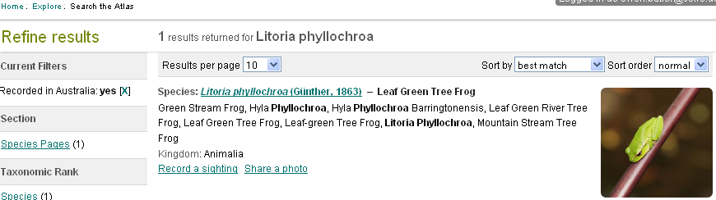

* 1. Click to open the correct species (there may be a list including sub-species, genus and other search results containing the species name you entered)

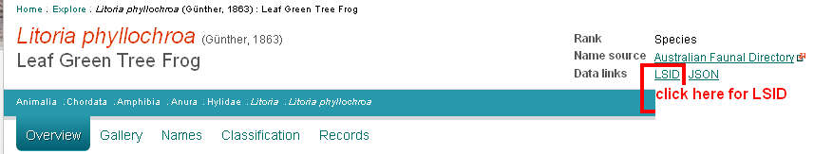

* 1. Click on the LSID data link as shown

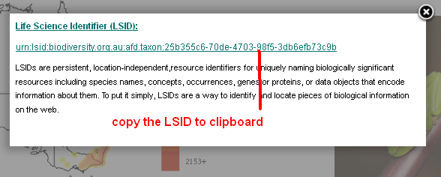

|  |
| --- |
| **TIP**  Do not right mouse click the LSID and select ‘copy link location’ or similar browser specific command.  It is better to drag the mouse over the link (select) and copy to clipboard  Done correctly the LSID will look like this -  [urn:lsid:biodiversity.org.au:afd.taxon:25b355c6-70de-4703-98f5-3db6efb73c9b](http://lsid.tdwg.org/summary/urn:lsid:biodiversity.org.au:afd.taxon:25b355c6-70de-4703-98f5-3db6efb73c9b)  Done incorrectly it will look like this and will not work in the BDRS  <http://lsid.tdwg.org/summary/urn:lsid:biodiversity.org.au:afd.taxon:25b355c6-70de-4703-98f5-3db6efb73c9b> |

1. Switch back to the BDRS Species page tab/window and paste the LSID into the GUID field
2. Then click the **Retrieve Profile from ALA** button.
   1. Click OK in the popup window to complete the import.

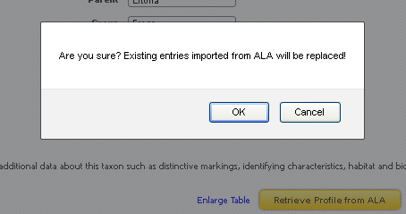

**Note** – if you have previously imported content **from the Atlas** this process will overwrite it.

1. Once the import process has completed you will see a long list of new data fields as well as new data in existing fields.

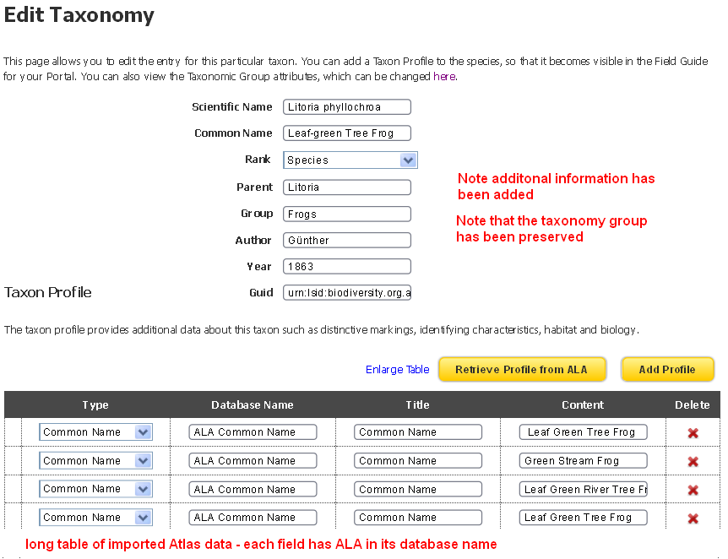

***Note:*** This image is truncated as the list can be quite long

Check that everything looks OK – is the species in the right taxonomy group? Has the original data manually loaded into non-ALA import fields been preserved?

1. Click the Save Button at the foot of the page and you are returned to where you started!

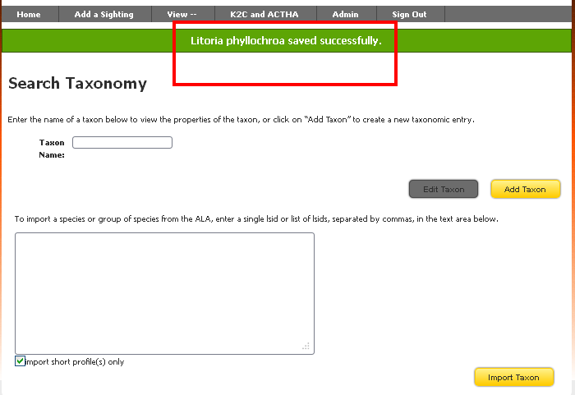

1. With a success message shown in green
2. Repeat as necessary to complete your import requirements.

See Part 3 below to learn about species profile formatting and answer the question:

*What will my newly added species data look like to users?*

## 2: IMPORTING MULTIPLE SPECIES PAGES

**Assumptions**

There is a current Taxonomy Grouping Structure you wish to maintain.

There may be existing BDRS species pages you wish to update – optional (i.e. not required as you can create new ones as needed).

You have access to the Atlas of Living Australia LSID of the species of interest.

**TIME SAVING TIP**

Where you have an existing set of taxon groups and species pages go to the list of species:

1. Select View Species Guide from the View menu
2. Click the taxon group of interest e.g. Lizard – Skinks

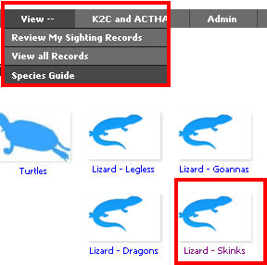

1. Select the three columns of the species list table and copy to clipboard

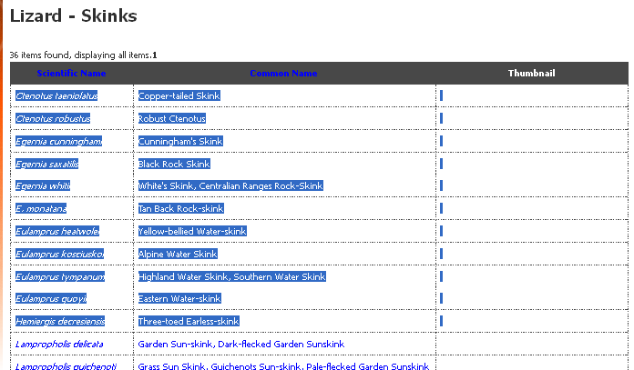

1. Paste into a Word document or Excel table (special paste as text to preserve columns)
2. Follow the instructions above on collecting the LSID for each of the selected species and paste them into the third column
3. This image shows a collection in Excel

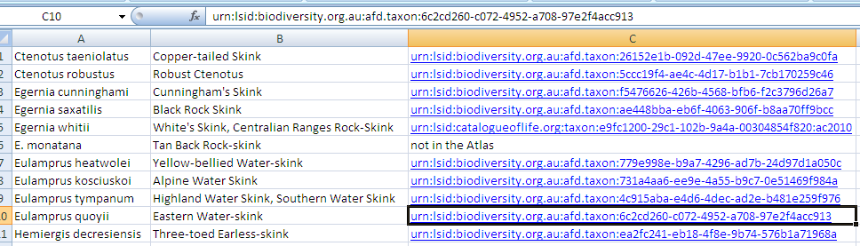

1. Copy the 3rd column to clipboard

#### Instructions:

1. Log in to your web site as usual.
2. Click on Admin from the navigation menu and Select Species Pages, then the Taxonomy sub-menu

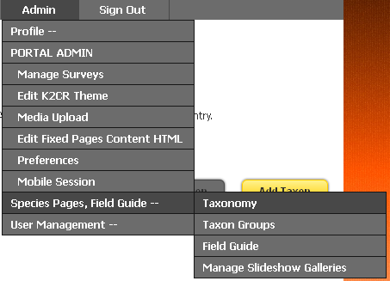

1. Paste the list of LSIDs you have collected (for example from Excel as described above) into the large table at the foot of the page

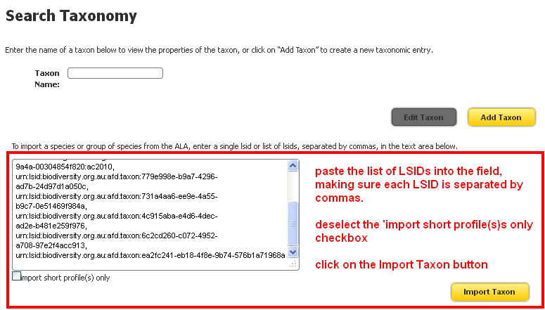

1. Answer OK to the check box

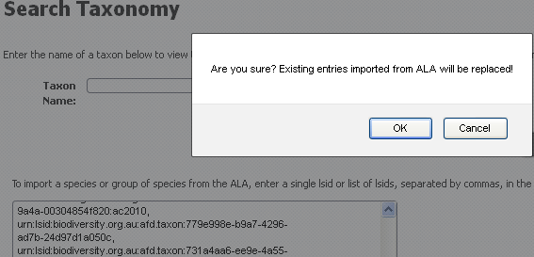

1. Species profiles are imported in Bulk

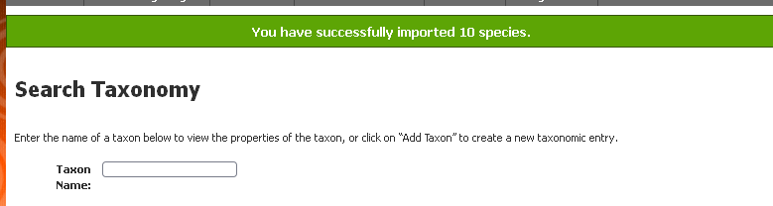

1. To confirm this select View Species Field Guide from the main menu, then (in this example) Lizard – Skinks
2. The list will now include new and/or updated species pages with ALA content.

**TIP**

It is very easy to get a comma in the wrong place which breaks the import process resulting in a 500 error page being displayed.

We did this several times for this help : )

**Solution:**

If you get the 500 error use browser go back to importing page; copy the contents of the large import field into clipboard; paste it into word; select it all and then turn it into a table with the comma as break – you can very clearly see when a column/row doesn’t start with **urn**!

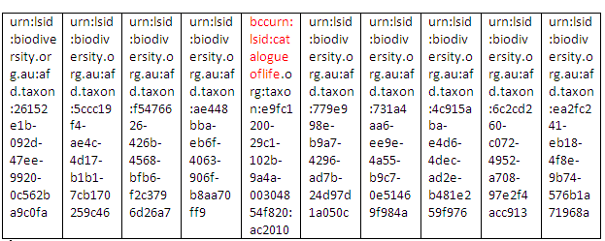

In this case pasting the text in again as a list and correcting the placement of the comma resulted in a successful import

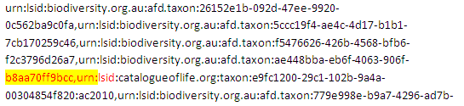

## 3: IMPACT ON SPECIES PAGE FORMATTING

The following images show what the unformatted new content looks like:

#### Example 1:

A new species profile page with no formatting from the myrtle rust bdrs:

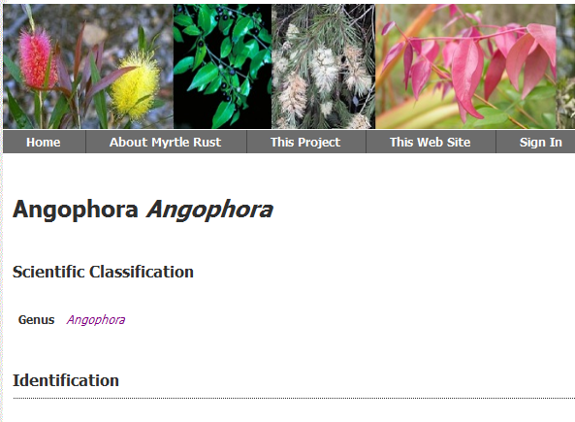

#### Example 2:

A new species profile page containing ALA data with no formatting from the K2C Reptiles site:

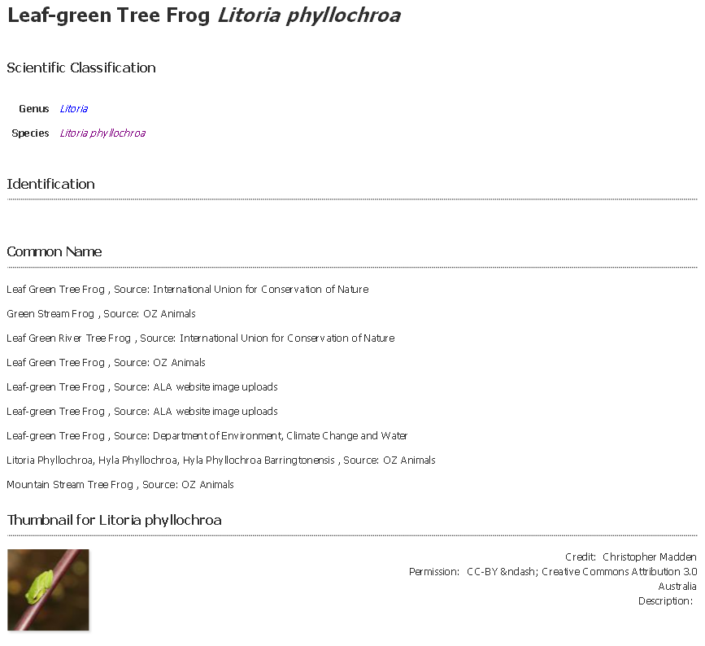

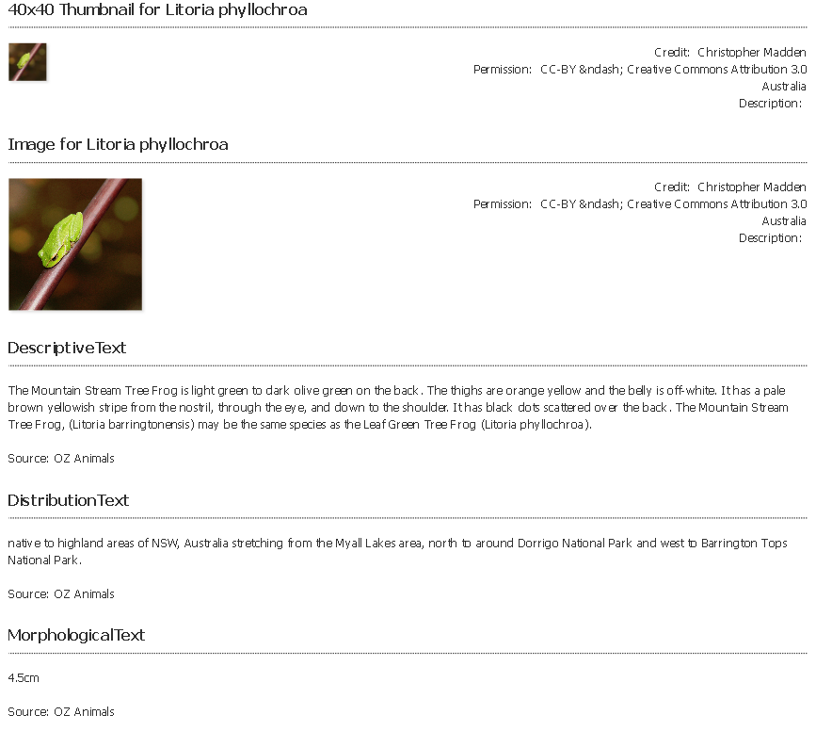

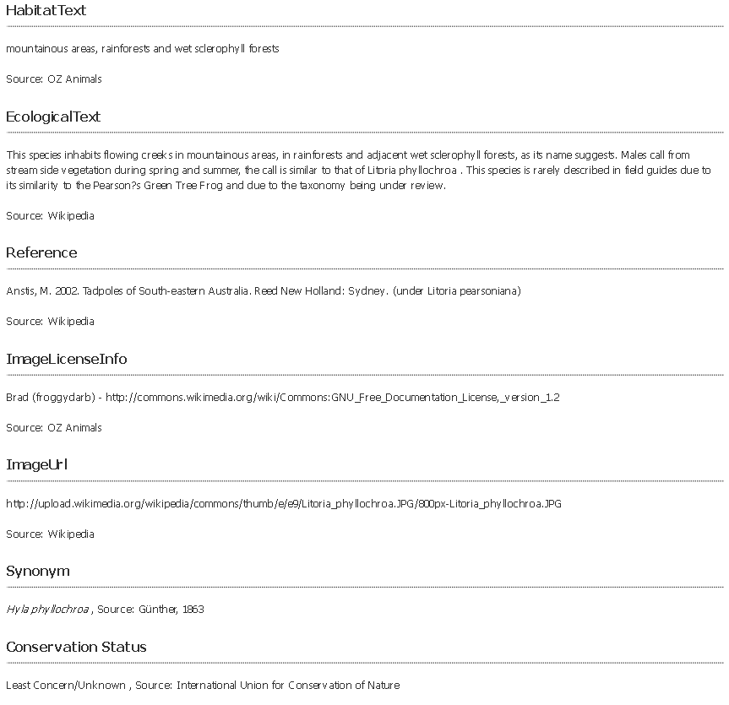

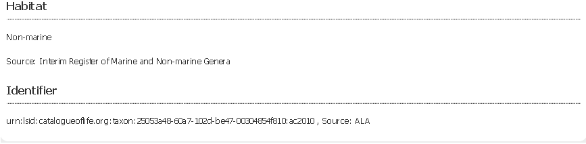

#### Example 3:

The same K2C Reptiles species profile page with formatting applied using a **theme template**

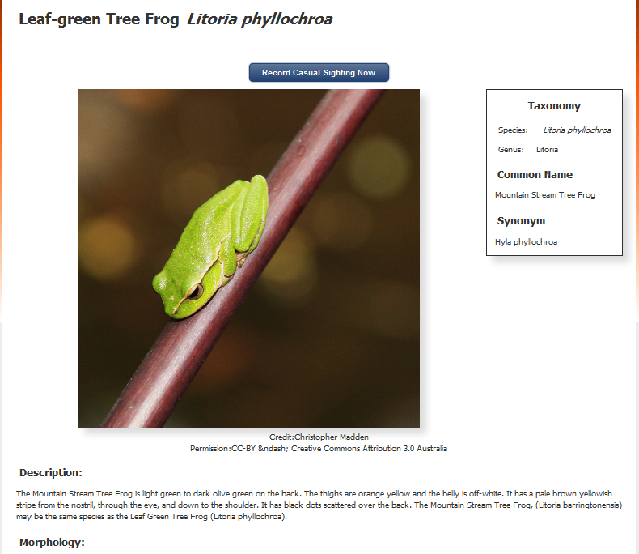

# PART 3: USING THE TAXON PROFILE TEMPLATE

To create a set of standard fields (names and data types) to direct data entry into manually created Species Profile pages

Developing a taxon profile template requires a reasonable level of experience with HTML, CSS, web design and the BDRS.

Subject is covered in more detail in the BDRS Managing Themes Manual.

### Taxon Profile Template Summary: WHY

1. users are able to add new fields when creating a taxon page
2. because they are annually entered rather than selected from lists the new fields can have different Database Name, Title and Type across different species pages, due to data error, multiple users with different ideas, spelling mistakes and so on.
3. This lack of controlled data entry makes standardisation extremely difficult within a BDRS let across multiple sites and between BDRS and other systems such a the Atlas – where we harvest locally added species profile content into the Atlas species pages to make them more rich, broad spectrum and representative of users needs/

### Taxon Profile Template Summary: HOW

1. The BDRS provides a mechanism to include standardised fields in every new and existing species page
2. The mechanism is a .json file called the taxon.profile.template.json
3. This file describes a flexible set of fields to be applied to a taxon groups species pages – meaning you can have different as well as common fields for different taxon groups where, for example, diet is not relevant to Fungi in the way it is to Fish.
4. The fields show as up defaults in the species page table – either alone in New entries or at the foot of the table in existing ones (and sometimes scattered throughout the table : )

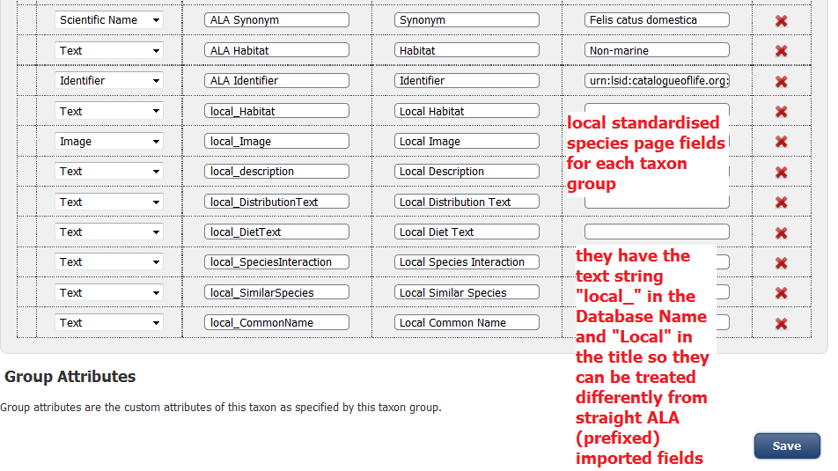

1. The Database Name is prefixed with “local_” and Title with “Local” so they can be treated differently
2. Specifically:
   1. The species page users see can have the Local content displayed differently to and/or instead of ALA derived content
   2. Species profiles with local content can be identified for harvesting into the Atlas species pages and only the contents of fields with the “local” prefix will be processed.
3. See the BDRS Managing Themes Manual for more detail.

# APPENDIX A:

## MANAGED FILES INTERFACE

The BDRS supports Managed Files through the managed fields interface.

These are files such as images, audio and video and include much of the content imported from the Atlas (see below).

Managed files can be referenced in many places within the BDRS including species pages.

In Version 1.1 March 2012 the managed files **interface** was superseded as the mechanism for entering and managing images in Species Pages by changes to the species page workings as described in above.

The interface is still used directly in managing themes, taxon profile templates and other areas of administration.

#### Instructions for creating and using a Managed File:

1. Open the Managed Files screen

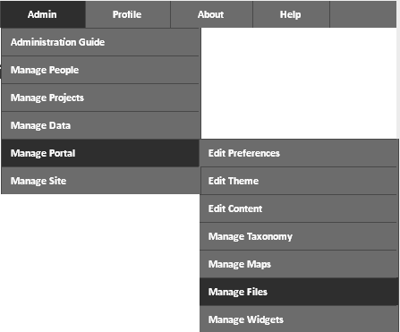

1. Click the Add Media button

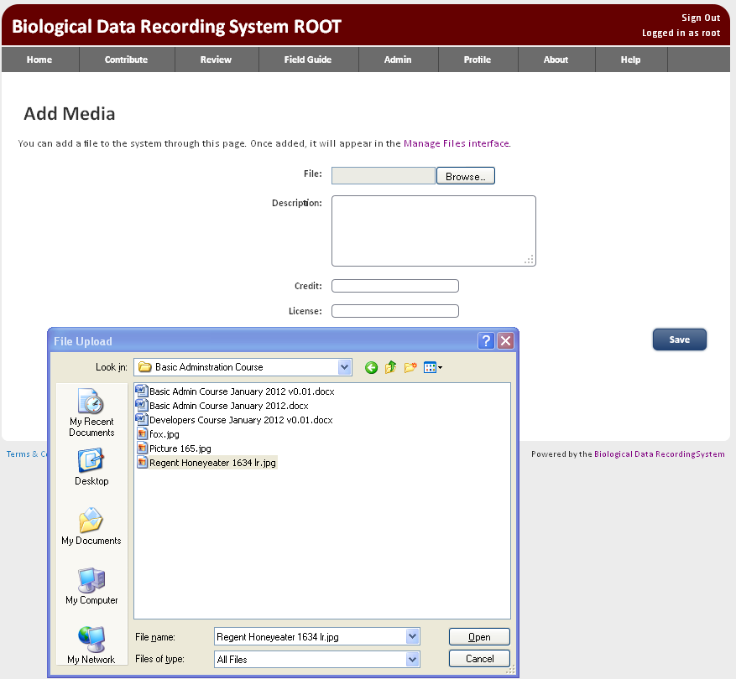

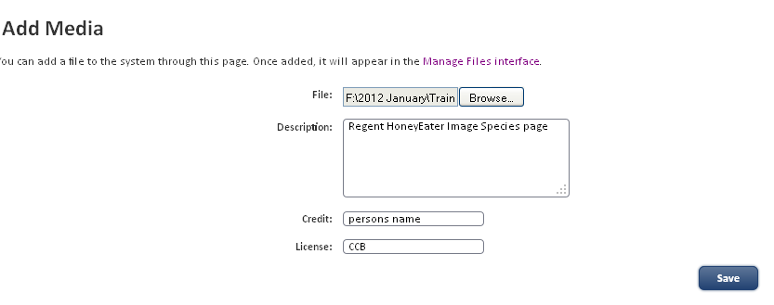

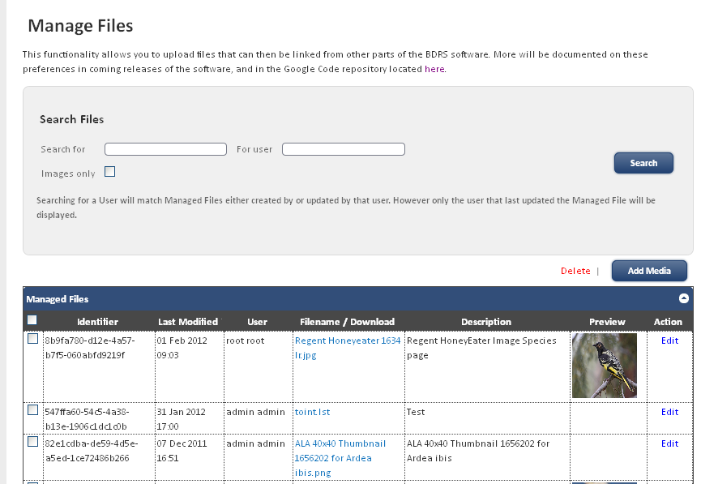

1. If you wish to update an image for example simply edit the managed file record, upload the new image and save.
2. The new version will be displayed wherever the image has been used
3. This same model works in the species pages – click on the Content you wish to change in the Species Page and upload the replacement image