Biological Data Recording System Themes

Notes

Understanding and using the built in theme engine to customise your own BDRS site

Document Information

|  |  |
| --- | --- |
| Prepared For: | Atlas of Living Australia  Administrators and developers off the Atlas Field Data Capture Software |

Publication History

|  |  |
| --- | --- |
| Edition | Date |
| DRAFT | March 2012 |

Contents

Introduction 4

Resource Applications 4

The BDRS ‘Vanilla’ Theme 5

Standard BDRS web presentation model 5

Enhanced version of the same model 6

Access Controls – Primary Control for BDRS Content and Functionality 7

Anonymous & General Users 7

Administrators 7

Types of Content 7

Vanilla BDRS Menus 8

Downloading & Exploring the ‘Vanilla’ Theme 9

Instructions for downloading a BDRS Theme 9

Exploring the Vanilla Theme 10

The standard folder structure 10

Table listing all content in the BDRS Vanilla theme 11

Vanilla Theme template folder .vm Files 14

Page structure 14

Tools 16

1. dashboard.vm 16

2. header.vm 16

3. footer.vm 17

4. menu.vm 17

5. page_footer.vm 17

Vanilla Theme template\public folder .vm Files 17

6. about.vm 17

7. help.vm 18

8. home.vm 18

9. signin.vm 20

10. userSignUp.vm 20

11. groupListing.vm 22

12. taxaListing.vm 23

13. taxonView.vm 24

14. base.css 25

15. config.json 25

More Theme Attributes 26

Managing Themes 26

Downloading a theme 26

Adding a theme 26

Editing a Theme Online 28

Edit Theme: Header 29

Edit Theme: Theme Elements 29

Edit Theme: Action buttons in footer 30

Edit Theme: Main Files edited in Custom Themes 32

Edit Theme: Editing a file in situ 33

Uploading a theme 34

Updating an Existing Theme 34

Reverting a theme 36

Revert: New Minor Theme Update 36

Revert: Upgrade Failed/undesirable consequences 36

Editing a Downloaded Theme 39

Custom Pages 45

BASIC 45

THEME COMPONENTS 45

Customising Species Pages: The Taxon Profile Template 46

Taxon Profile Template Summary: WHY 46

Taxon Profile Template Summary: WHAT THE USER SEES 46

Taxon Profile Template Summary: THE ACTUAL MECHANISM 47

Applying a taxon.profile.template 48

Customising Species Pages User Interface: Taxonview.vm Template 49

BDRS site integration 49

BDRS & the Atlas 49

Development Futures 50

# NOTES

This manual is incomplete as of 1 March but there has been sufficient demand to make it available on the Atlas web site immediately

It will be updated until complete.

# Introduction

Since the Vanilla BDRS is plain and impersonal by design every production site needs to be themed to some degree.

This manual provides a detailed overview of the BDRS theming engine functionality - its application and its limitations.

It covers how Themes can be applied to:

* presentation - look and feel
* navigation – how users discover site functionality and content
* static content – for users and as part of administration
* workflow – sequence of screens and events, and the available options and actions

We start by taking apart and reviewing the contents and application of the BDRS and Atlas ‘Vanilla’ Themes in order to understand how each component works and how they interact with each other.

Notes:

You will need to be an administrator to perform the actions described in this document.

## Resource Applications

The <http://bdrs-uat.ala.org.au/bdrs-core/portal/19/home.htm> Training BDRS on the Atlas User Acceptance Testing server has been set up for you to practice on.

We also recommend:

* if you do not have a site of your own please contact Atlas support - [support@ala.org.au](mailto:support@ala.org.au)  
  T (02) 6246 4108 to request the creation of a portal for your organisation,
* in the meantime Register with the Training site then log in as user ‘Administrator’ with password ‘password’ to assign administration rights to your new ID so that you can compare and contracts this manual with onscreen content .

There is also a Demonstration BDRS used during training at <http://bdrs-uat.ala.org.au/bdrs-core/portal/14/home.htm>

# The BDRS ‘Vanilla’ Theme

**Key Concepts**

*Every BDRS interface starts out using variations on the common theme*

*Access rights control menu options*

*The menu system shows you what you can do*

*EVERY BDRS needs to be themed for implementation*

Every new BDRS instance has a simple built-in standard theme applied providing the basic web site layout and look and feel, standard menu structure, access to functionality and some admin editable content.

This ‘out of the box’ BDRS interface is very simple and it is fairly self explanatory once you get used to it and know what the less obvious functions do – like ‘Manage Taxonomy’.

There is also plenty of on screen help to let you know what something is for or what you can do and which is constantly being improved

## Standard BDRS web presentation model

The vanilla theme uses a standard web page layout as shown here:

Header + Menu + Body + Footer are wrapped together over a background.

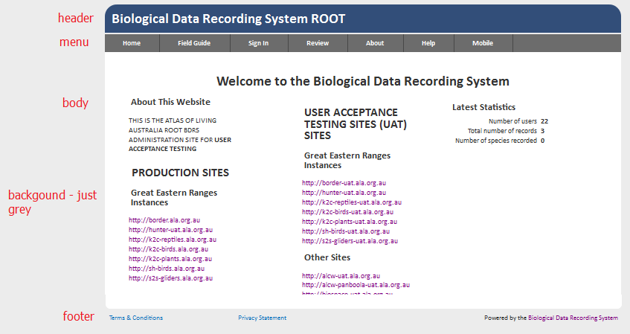

The same standard presentation model is common to all BDRS implementations.

## Enhanced version of the same model

The following screenshot shows a ‘Themed’ BDRS site for the Southern Highlands Region of the Great Eastern Ranges Initiative NRM.

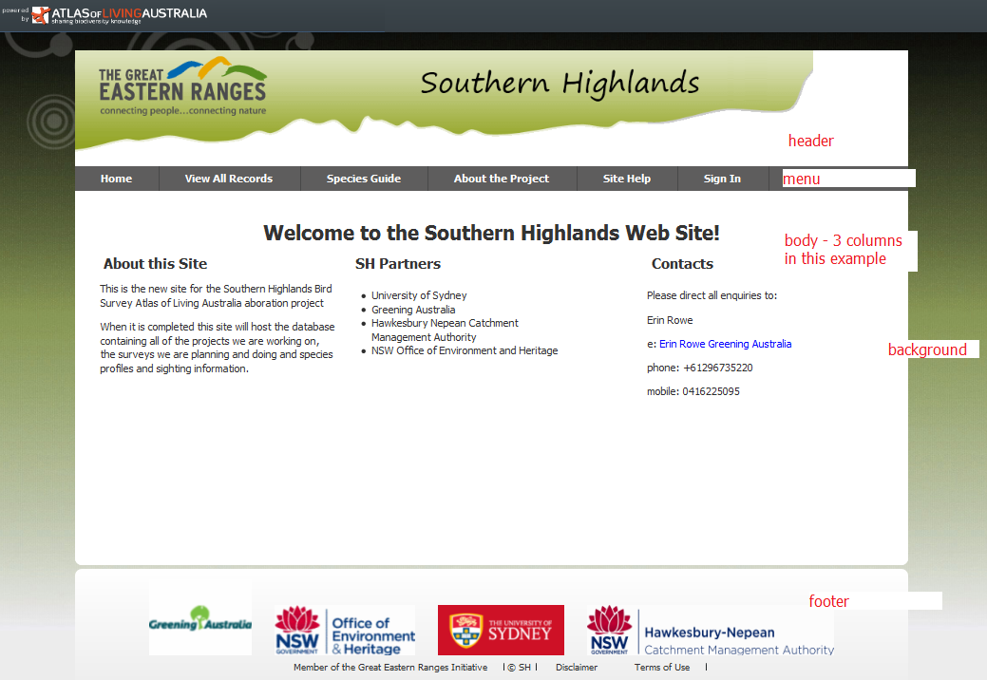

For comparison with the Teachwild and Vanilla BDRS home pages:

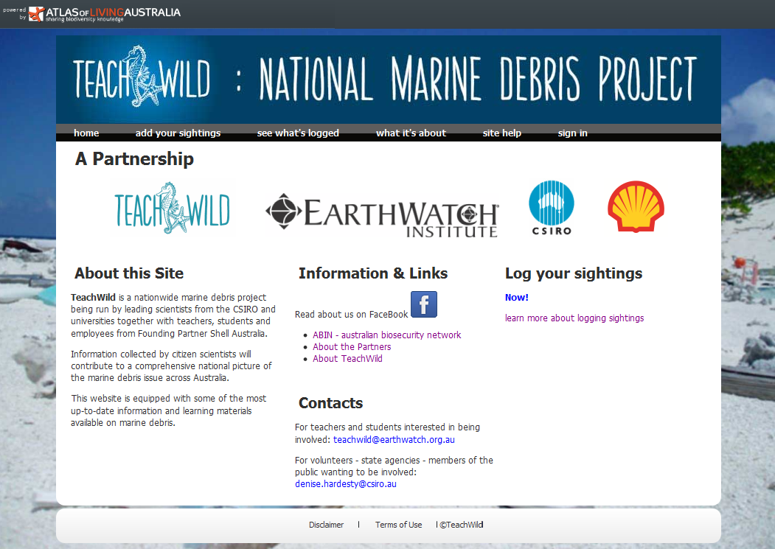

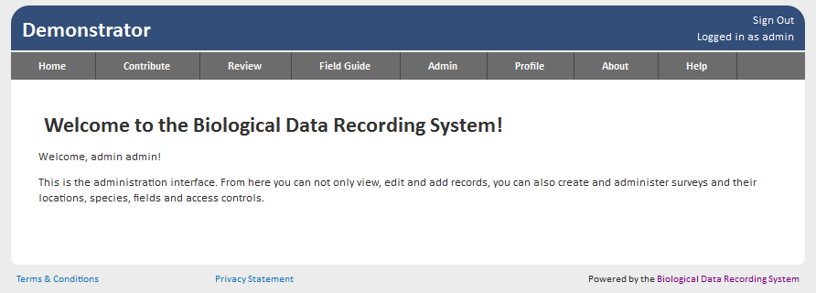

## Access Controls – Primary Control for BDRS Content and Functionality

Another instructive approach to understanding the BDRS – how it presents to different classes of user.

What an individual user can see and do is a function of being registered and signed in and whether they have been allocated an administration role.

*What can each type user see?*

*What can each type of user do?*

The 4 distinct BDRS user types or roles – 3 registered types and Anonymous – provide different levels of access to content and functionality.

The roles are:

1. Anonymous User – not registered and/or not signed in
2. Named User – known: registered and signed in
3. Supervisor – access to more functionality
4. Administrator – complete access to content and functionality

There is a 5th role – Power User (ROLE_POWER_USER) which has no equivalent menu or other functional definition that we are aware of and so has not been used within ALA portals .

### Anonymous & General Users

Most of the general (non-admin) content and functionality of the BDRS is visible to all users all of the time.

i.e. anonymous users can see most of what is on offer for them in a standard BDRS implementation.

Current versions of the BDRS show non-editable records to anonymous users.

In order to log or edit sightings or manage personal information the user has to be registered and activated.

### Administrators

The *administration* functionality of the BDRS is primarily exposed to the user via the available Menu options.

i.e. the inclusion and exclusion of menu items controls what an administration user can see and do - there is little visible differentiation in the main user focused system.

***explanation***: some systems provide extra controls or hidden areas of text or functionality on a page depending on your access rights – the BDRS does not do this.

*Known issue: anonymous users cannot read record details – rectified in V1.1: due end Feb 2012*

## Types of Content

Generally speaking all of the content available in the Vanilla Themed BDRS is generated by the system and an administrator requires at least basic HTML skills in order to edit the text of a number of pages and email messages.

While basic editing of system content – menu item ‘Edit (Static HTML) Content’ - is covered in the Advanced Administrator course the vanilla theme pages often call this content directly in system screens. These processes are explained and discussed in this document.

## Vanilla BDRS Menus

The Vanilla menu set shown here is consistent across the user types with options being visible or hidden depending on whether you are signed in or have high levels of administration access.

|  |  |  |  |
| --- | --- | --- | --- |
| Anonymous | Registered Users | Registered Supervisors | Administrators |
| **Home** | **Home** | **Home** | **Home** |
| **Sign In\***  *changes to Sign Out in Top Right Hand corner once signed in | **Contribute 1**  **<Surveys> 1**  **Bulk Data 1** | **Contribute 1**  **<Surveys> 1**  **Bulk Data 1** | **Contribute 1**  **<Surveys> 1**  **Bulk Data 1** |
| **Review**  **Advanced Review** | **Review**  **My Sightings 1**  **Advanced Review** | **Review**  **My Sightings 1**  **Advanced Review** | **Review**  **My Sightings 1**  **Advanced Review** |
| **Field Guide** | **Field Guide** | **Field Guide** | **Field Guide** |
| **About** | **About** | **About** | **About** |
| **Help** | **Help** | **Help** | **Help** |
| Menu items that only become visible to signed BDRS users **1** | **Profile 1**  **My Profile**  **My Locations** | **Admin 1**  **Admin Guide**  **Manage People**  **Manage Projects**  **Profile 1**  **My Profile**  **My Locations** | **Admin 1**  **Admin Guide**  **Manage People**  **Manage Projects**  **Manage Data**  **Manage Portal**  **Manage Site**  **Profile 1**  **My Profile**  **My Locations** |

# Downloading & Exploring the ‘Vanilla’ Theme

The best way to understand themes is to download and tease apart the Default BDRS Theme (vanilla).

## Instructions for downloading a BDRS Theme

1. Log in to your web site as an administrator.
2. Click on **Admin** from the navigation menu and select **Manage Portal**, then **Edit Theme** on the sub-menu

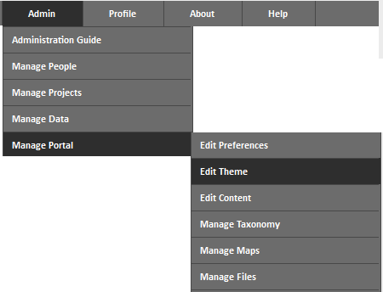

1. Click on the **Download** option for the Theme.

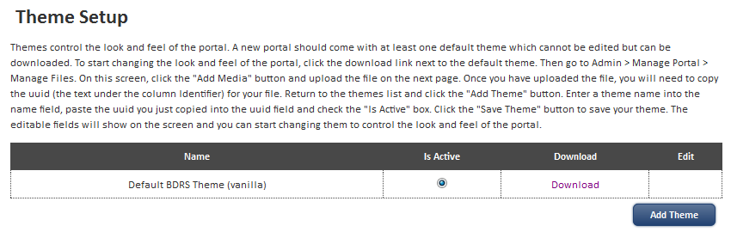

**Note**

The Vanilla Theme does not allow live, in situ editing within the BDRS.

Added themes do allow some in place editing of content which is described in this document.

1. Using your browsers downloading options save the theme zip file in a working folder.

**Note**

The On screen Help text in the Theme Setup page is fairly complete

“Themes control the look and feel of the portal. A new portal should come with at least one default theme which cannot be edited but can be downloaded. To start changing the look and feel of the portal, click the download link next to the default theme. Then go to Admin > Manage Portal > Manage Files. On this screen, click the "Add Media" button and upload the file on the next page. Once you have uploaded the file, you will need to copy the uuid (the text under the column Identifier) for your file. Return to the themes list and click the "Add Theme" button. Enter a theme name into the name field, paste the uuid you just copied into the uuid field and check the "Is Active" box. Click the "Save Theme" button to save your theme. The editable fields will show on the screen and you can start changing them to control the look and feel of the portal.”

## Exploring the Vanilla Theme

For a BDRS theme to work correctly it must follow a standard folder and file content structure and naming convention.

When the Theme is uploaded it is processed into the BDRS database theme engine and missing or defective files and incorrectly named files and folders will cause the upload processing to fail.

The resulting error messages do not usually explain the cause of the failure but there are several common issues discussed below.

Note too that sometimes errors are not detected and only become apparent when you have thoroughly tested the update.

### The standard folder structure

The downloaded theme zip has a date and time stamp – e.g. Default BDRS Theme (vanilla)_2012-02-15-12-45.zip

Extracting the contents shows the following folder structure:

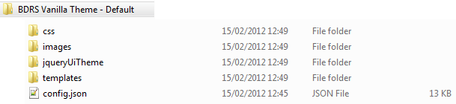

When a theme is uploaded it is unpacked from the zip file and processed into the BDRS database for this portal.

### Table listing all content in the BDRS Vanilla theme

[Current February 2012 – see notes below]

*Theme will not load if these default folders and contents are missing or defective.*

|  |  |  |
| --- | --- | --- |
| **Folder** | **Content *(files italicised)*** | **Description** |
| **css** | *base.css*  *base-ie7.css*  *base-ie8.css*  *buttonGradient.svg*  *buttonGradientHover.svg* | The .css files are Cascading Style Sheets and .svg files are scalable vector graphics which perform a similar role.  Styles are used to define how to **display** HTML elements – applying attributes such as colour, size, font, dimensions, border etc  The base.css contains the style guides governing all presentation aspects of the vanilla BDRS.  You will need to edit the base.css to add your own elements and/or change base element attributes (e.g. button colours) |
| **Images**  **bdrs** | Top level folder is empty  **bdrs** sub-folder contains  *arrow1.png, arrow2.png*  *atlasoflivingaust.png,*  *Gaia_transparent.png,*  *icon_cross_red12X12.png,*  *icon_tick_green12X12.png,*  *rightarrow.png* | **bdrs** sub-folder contains default images used across the vanilla BDRS |
| **jqueryUiTheme** | *jquery-ui-1.8.16.custom.css*  *jquery-ui-1.8.16.custom.min.js* | jQuery is a cross-browser JavaScript library designed to simplify the client-side scripting of HTML  The main folder contains JQuery CSS style sheet and javascript library files.  Do not usually need to be touched.  You can add and reference you own custom.js files if you need to separately. |
| **images** | **images** sub-folder contains  *12 .png standard images* | These standard files are used across the vanilla interface.  They will not usually need to be touched. |
| **templates** | *dashboard.vm*  *footer.vm*  *header.vm*  *menu.vm*  *page_footer.vm* | These 4 templates are both required AND form the basis of most of your theme modifications.  The .vm files are velocity mark up template files used to create web pages – see <http://velocity.apache.org/engine/releases/velocity-1.5/user-guide.html>  They are required. |
| **admin**  **public**  **user** | **admin** and **user** sub-folders both contain:  *home.vm*  the **public** sub-folder contains:  *about.vm*  *help.vm*  *home.vm*  *signin.vm*  *userSignUp.vm*  *groupListing.vm*  *taxaListing.vm*  *taxonView.vm* | Each .vm file in the theme is reviewed in detail in the materials following.  A complete file level reference table is also provided later.  The public folder contents must contain the templates shown or the theme upload will fail.  **Note**  The admin and user sub-folder home.vm files refer internally redirect to the public sub-folder home.vm – i.e. the same home page is displayed for users, admin’s and the public and so can be left out of your theme if desired. |
| config.json |  | The BDRS uses .json files in several areas to configure the system.  The config.json file tells the theme engine where to find key files and also provides some base styling element overrides – these latter are displayed in the Theme Elements section of the Edit Theme page.  The config.json file is editable with a text editor such as notepad++ see <http://notepad-plus-plus.org/> |

*The files coloured blue above are the most edited in developing a new theme*

**Notes**

You will see in the following material that the above table does not list all of the elements necessary for you to theme your own site.

Further the number and naming of folders and their contents has changed over time resulting in backwards compatibility problems with software upgrades.

Generally speaking such issues are usually a) fairly easy to resolve, b) should form part of a normal upgrade strategy, and c) have become less frequent as the product matures.

Ideally the release notes and upgrade procedures for new versions will explain what changes have been made and any provisions you will need to make to avoid issues.

**Recommendation**

The modified ALA Vanilla Theme should be the main guide for developing your own theme but it is useful to understand what has been changed and why in order to both reuse default options and resolve upgrade issues.

## Vanilla Theme template folder .vm Files

The main group of editable and so themable files are found in the **template** directory.

Each of the files is a template that describes a web page or component of a web page.

It is useful to understand the structure of a standard BDRS web site page so you can see how the objects integrate together to deliver the user experience.

### Page structure

Cascading style sheets are used to define how to **display** HTML elements – applying attributes such as colour, size, font, dimensions, border etc

Well designed web pages are usually built as a collection of nested objects within the containing browser window. Much like the Russian Matryoshka dolls within dolls (aka as Babushka dolls)

Each object contains other objects within it and applies its own style rules to things it contains. Each contained object can then do the same, including overriding the style rules from containers higher up the nesting order.

Div class=**wrapper** is encloses all of the default content displayed within the portal

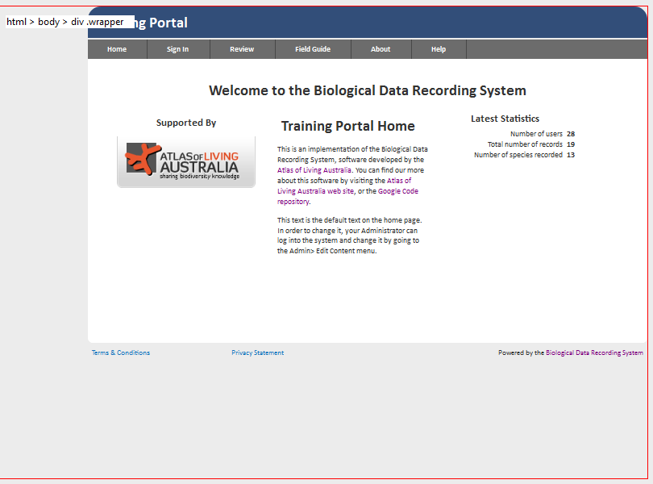

Within wrapper is the div=header



This is the next level down div .dashboardContainer in blue here. Notice how the header & footer are outside it.

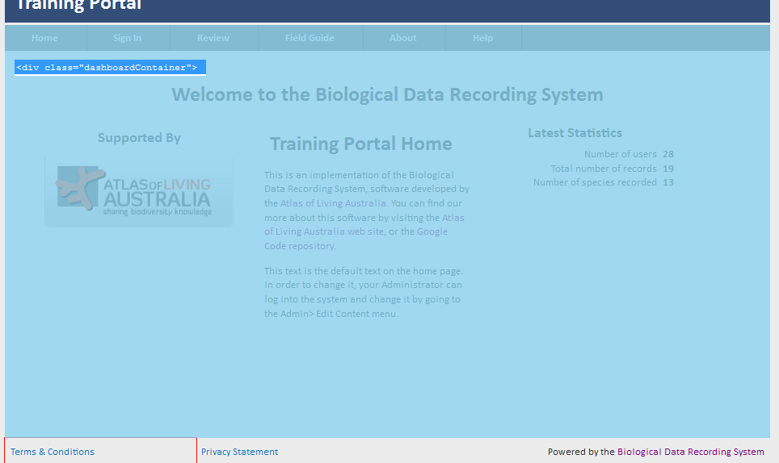

Div horiz-menu .suckerfish is inside the dashboardContainer div as is all other content expect the footer.



This diagram shows the nesting effect:

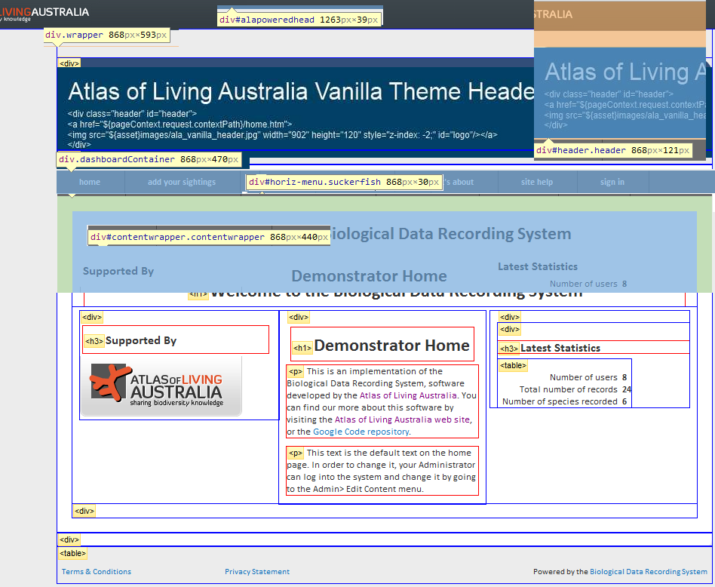

### Tools

The tools being used to display the structure include a Firefox and Chrome plug-in/add on called Web Developer from <http://chrispederick.com/work/web-developer/>. I also use the Firebug add on - <http://getfirebug.com/> - check layout tab against a page element for dimensions and other attributes.

Most browsers use F12 to access their built in tools

These tools help you format and style your content and fix layout issues.

### dashboard.vm

The div class=”dashboardContainer” wraps all of the content in a page (including the menu) between the header and footer.

The .contentwrapper div wraps all of the content in a page below the menu and above the footer.

Adding content to dashboard.vm displays a small green box floating left of and above (and outside) .content container.

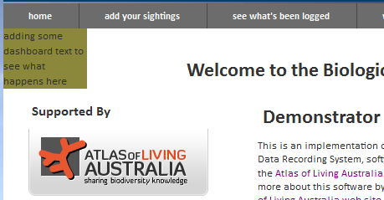

**Note**

We are unclear of the role planned for this file.

Given the existence of the .message class and container not sure what this is for.

### header.vm

Adds the name of the portal ${context.portal.name} – here ALCW-Panboola Wetlands



And, when the user is logged in;

* the Sign Out link – signs user out
* and Logged in as ${context.user.name} – a link which clicked opens the user’s personal profile

### footer.vm

Adds the contents of the footer to the page – Terms & Conditions, Privacy Statement and Powered by the Biological Data Recording System links.

Creates a table below and aligned in size with the div class=”contentwrapper”



### menu.vm

**Dynamically** **creates** the default menu options.

Adds any user created surveys automatically but the majority of menu items are compiled from within the java web app in the Vanilla Theme.

### page_footer.vm

This is a new V1.1 file addition.

Works in much the same way as footer.vm but spans the whole default width of the screen rather than being constrained to be the width of the wrapper container:

## Vanilla Theme template\public folder .vm Files

The next group themable files are found in the **public** sub-directory of **templates**.

### about.vm

The default about page for the web site.

While titled ‘About this site’ it is really about the BDRS and its origins.

In themed sites it is usually replaced with a page more specifically about the web site in question.

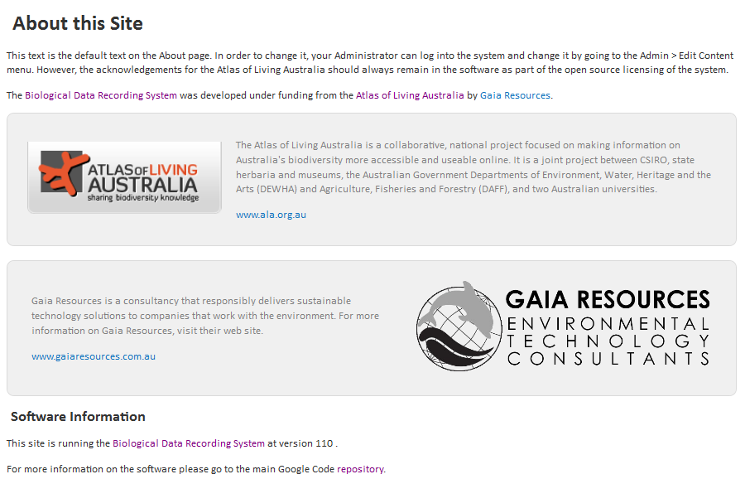

### help.vm

The default help page for the web site.

As with the about page it is usually replaced in themed with sites with more specific and relevant material.

### home.vm

The default home page.

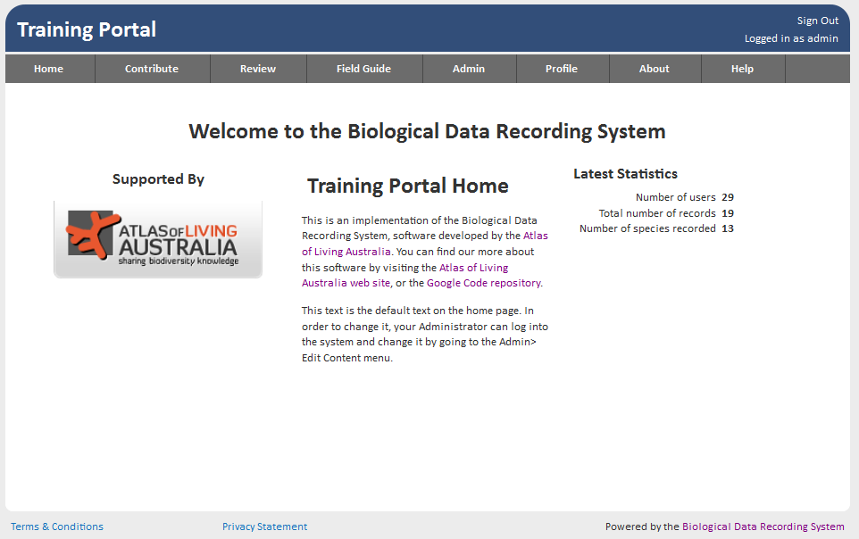

This page is compiled from three objects.

* Atlas reference

<div class="left_col">

<h3>Supported By</h3>

<a href="http://www.ala.org.au/">

<img src="${asset}images/bdrs/atlasoflivingaust.png" alt="Atlas of Living Australia"/>

</a>

</div>

* Static page content edited via the Edit Content interface

<div class="center_col">

${bdrs.getContent("public/home")}

</div>

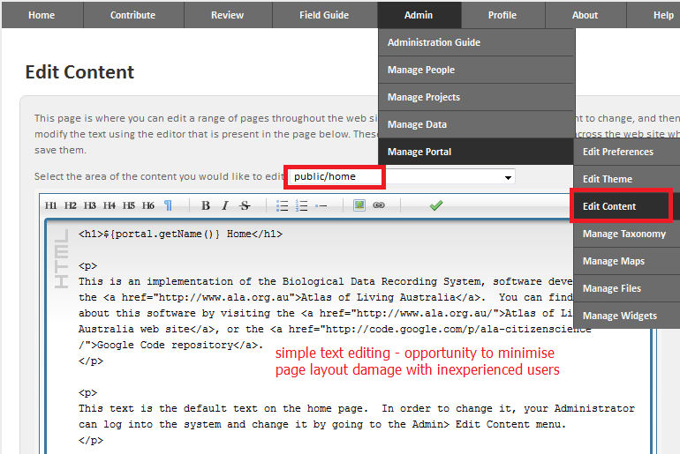

The admin home page has – ${bdrs.getContent("admin/home")}

And the user home page - ${bdrs.getContent("user/home")}

**Notes**

The same model is used for the other TWO home pages – the BDRS can present different home pages to public/anonymous), administrator and registered (non-admin) users

Both administrators and users have their own home.vm files in templates\admin and templates\user where they are in fact the only files present.

Generally most themes do away with the admin and user home pages.

**Tip**

You can use this compiled model to build your own themed public, admin and user home pages where some of your admin’s can be trained to update text based content within the standard **Edit Content** options.

* The Latest Statistics widget (begins as follows..)

<div class="right_col">

<div id="statistics">

<h3>Latest Statistics</h3>

When developing your own theme you could continue to use this compiled approach or just build your own page as you see fit. This latter path gives you much greater flexibility.

### signin.vm

The default user sign in and registration page.

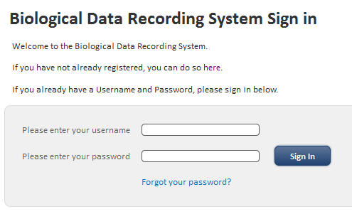

You can personalise this page and make it easier to use.

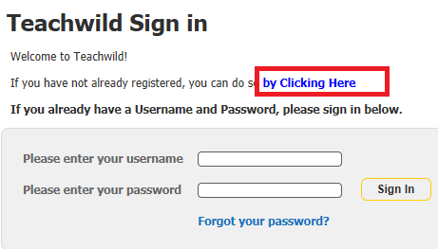

**Note**

At this time you cannot add fields to this or other registration pages.

### userSignUp.vm

The User registration process default page.

Registration is a two step process starting with the captcha robot test

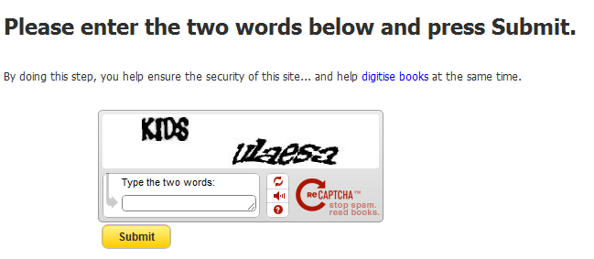

And finishing with the registration details screen – userSignUp.htm: vanilla shown below.

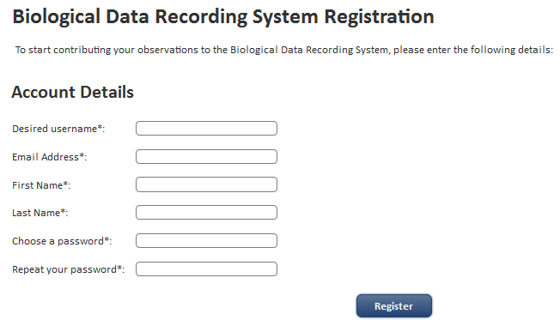

Themed versions of the **userSignUp.vm** showing more helpful and instructive content.

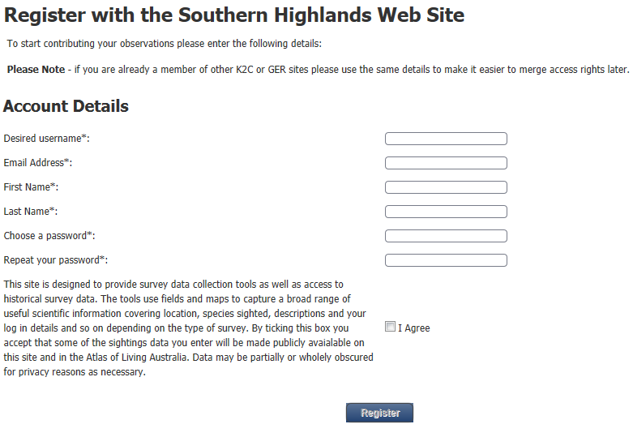

The’ I agree’ checkbox makes the Register button active in these implementations.

### groupListing.vm

groupListing.vm is the template for the BDRS Field Guide.

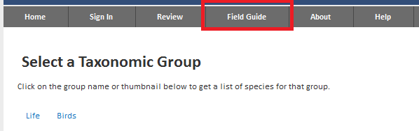

Explained in a lot more detail in the BDRS Managing Taxonomy Manual the field or species guide collects all of the taxon groups that have been created in the BDRS in one page.

If there are no taxon groups then the screen displays:

Your portal currently has no species in the Field Guide. Your administrator can change this and add in species manually or import them from the [Atlas of Living Australia](http://www.ala.org.au/).

If Taxon groups have associated images they are automatically displayed in the default field guide:

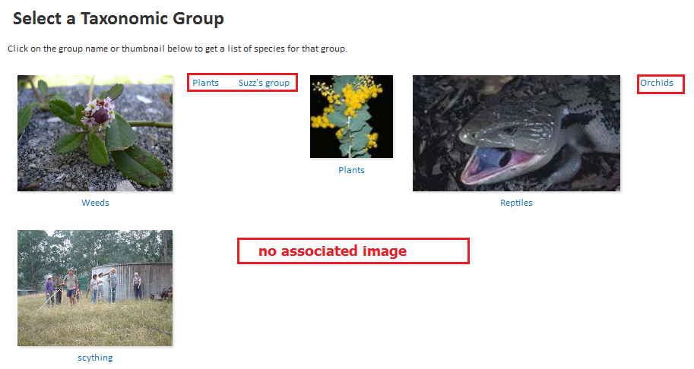

### taxaListing.vm

BDRS Species are assigned to Taxon groups. Selecting a taxon group name in the field guide opens the taxaListing page <http://bdrs-uat.ala.org.au/bdrs-core/fieldguide/taxa.htm?groupId=164>.

By default this page lists the species in a paginated table.

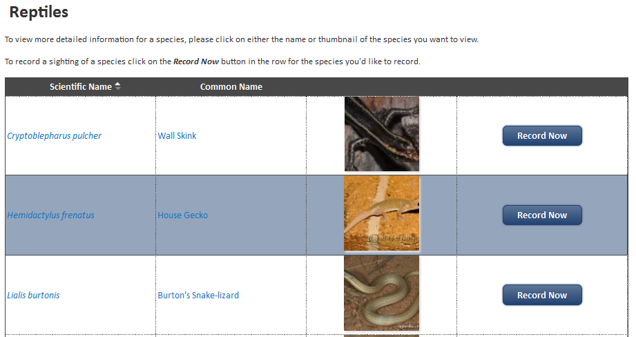

This image shows the current version look and feel applied by the query cascading style sheet - *jquery-ui-1.8.16.custom.css.*

Themed example where the record now buttons have been removed.

This example applies an earlier version of the query cascading style sheet - *jquery-ui-1.8.11.custom.css* with different colours and look and feel.

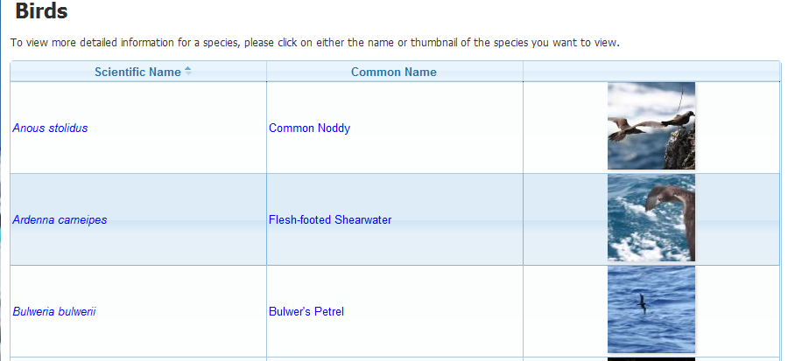

**Tip**

You can see that a change of this type may cause problems with your own theme – check every key system template generated page when upgrading from one version to another.

### taxonView.vm

The taxonView template forms the species pages.

A default species page with no content as displayed to any user.

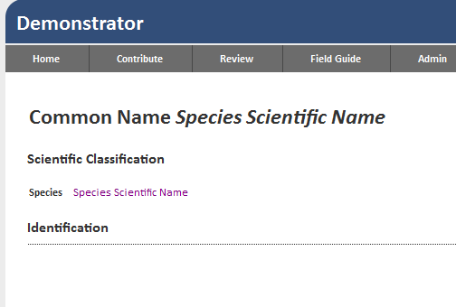

This next image shows the default theme applied to a species page with only slightly more detail added through the edit taxon profile process (no theme).

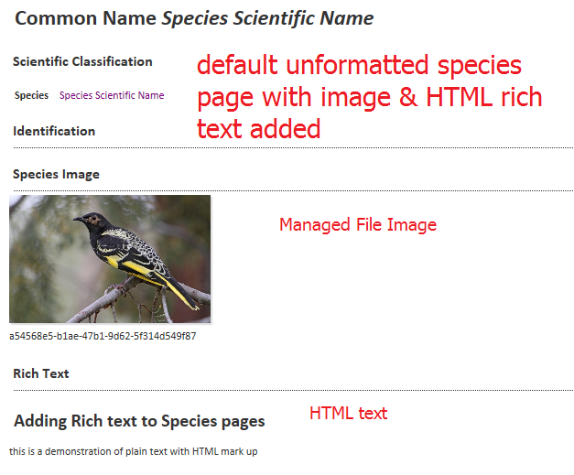

This one has a modified **taxonView** template applied.

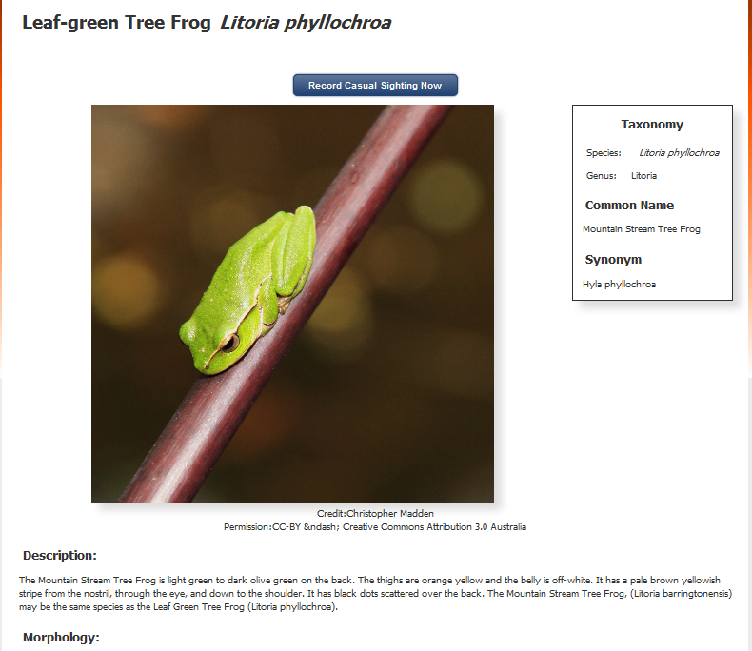

### base.css

The base.css contains the style templates governing almost all presentation aspects for all types of BDRS including the vanilla.

CSS styles are used to define how to **display** HTML elements – applying attributes such as colour, size, font, dimensions, border etc

As noted above the *jquery-ui-1.8.16.custom.css* template also influences presentation so keep it in mind when looking for causes and also when theming your own sites.

### config.json

The BDRS uses .json files in several areas to configure the system.

The config.json file tells the theme engine where to find key files and also provides some base styling element overrides – these latter are displayed in the Theme Elements section of the Edit Theme page (next section).

**Notes**

The config.json file directs the Theme import process to the correct FOLDERS as well as identifying the appropriate files.

If the files are named incorrectly in config.json vs. actual file names or vice versa – and this includes the use of capital/non-capital letters i.e. case sensitivity – then the theme may load but you will get various kinds of errors or the default theme for that component may be applied instead of your modified version depending on context.

The config.json file is editable with a text editor such as notepad++ see <http://notepad-plus-plus.org/>

### More Theme Attributes

The Managing themes section following explores other theming options and tools in detail.

# Managing Themes

This section provides instructions on how to manage themes using the Admin - Edit Theme interface.

An instructive way of exploring themes is to download the non-editable Default BDRS Theme (vanilla) and then upload it back into the BDRS to allow you to edit the component files in situ and see its construction.

## Downloading a theme

Select **Admin > Manage Portal > Manage Files** on the menu and click the download link on the desired theme.

## Adding a theme

To add a theme zip file first select **Admin > Manage Portal > Manage Files** on the menu

The Manage Files screen allows you to add, edit search and delete files of many types.

For example species profile data imported from the Atlas is stored as separately named files in the managed file space.

The most often used attributes of a managed file are its name in searching and the Identifier – a unique serial number assigned by the BDRS when the file is added that is used to access the file when required.

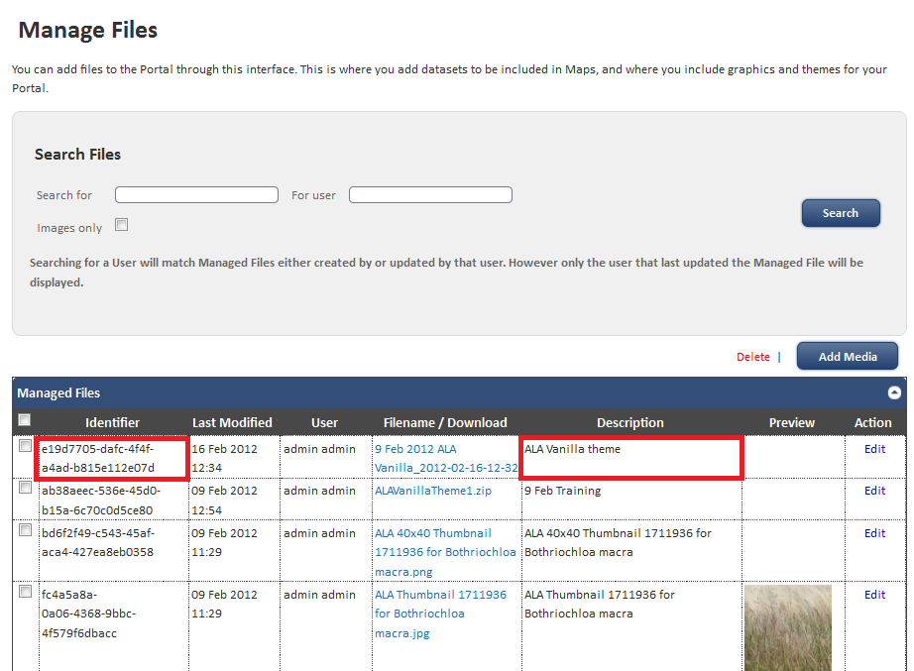

Click the **Add Media** button and upload the file.

Notice that you in addition to the file and a description (we recommend that you explain what why, when this file was added for other users and yourself later) you can also assign Credit and Licence conditions.

These are displayed in species pages for example.

Typically they are the name of the person or supplying institution and Creative Commons By Attribution licence. See the Atlas site and <http://creativecommons.org.au/> for more details.

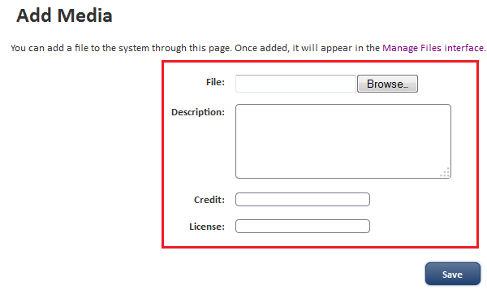

On save you are returned to the Managed files screen.

**Select and copy the uuid** (the text under the column Identifier) for your file.

Select **Admin > Manage Portal > Edit Theme** on the menu which displays the list of available themes.

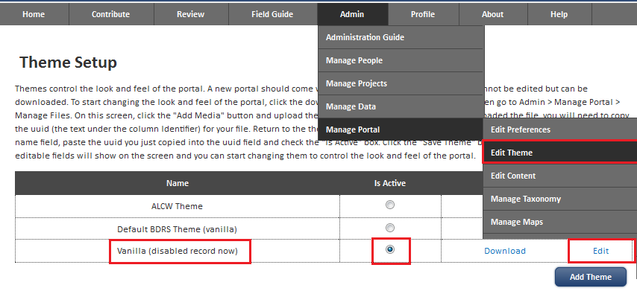

Click the **Add Theme** button

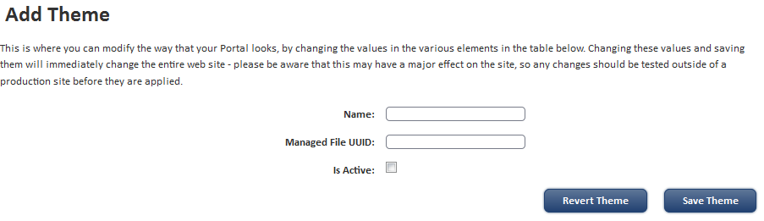

Enter a theme name into the name field, paste the uuid you just copied into the uuid field and check the "Is Active" box.

Click the **Save Theme** button.

**Note**

Ignore the **revert theme** button – it is not relevant at this stage.

Your newly active theme will apply any Theme template changes to your site.

## Editing a Theme Online

There are two ways to edit a theme.

One is on-line/in situ and the second assumes you are have downloaded the vanilla theme and are editing in situ.

We start with on line and then cross over to downloaded.

#### Instructions

Select **Admin > Manage Portal > Edit Theme** on the menu to display the list of available themes.

Select the target theme and click the **Edit** link.



Click on the Edit theme link outlined in red.

There are several parts to the **Edit Theme** screen.

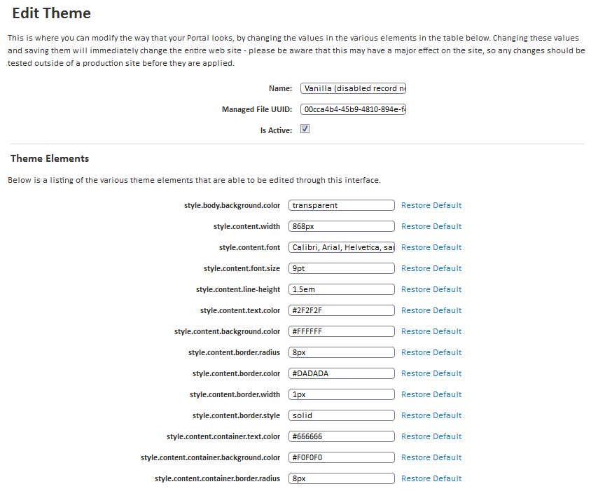

### Edit Theme: Header

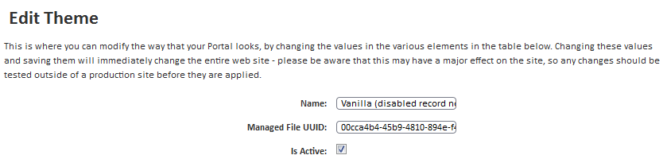

Name of the theme; the managed file unique ID (uuid) and a checkbox showing whether the theme is active.

### Edit Theme: Theme Elements

This is a long list of CSS style and other key configuration elements that vary in length according to the version of the BDRS software (getting longer on each new version) and the new default templates that area added with new releases.

The template elements and their values are set via the **config.json** file in the root of the theme zip file (or by the java web app itself in a new portal).

The rest come from both the default web app as well as the config.json file (may duplicate/override some – haven’t tested)

**Note**

They are directly editable in this interface – you can play with menu text colours and so on – BUT changes here do not get written back to the **config.json** file until it is downloaded so watch for this if you don’t want to lose them or if you have an ‘unexplained’ problem later.

The key elements to be aware of are those governing templates:

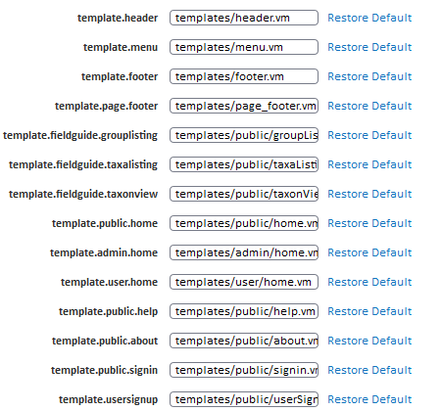

**Tip**

Notice here that the admin, user and public homes have all been set to the same template – originally used to save effort in either creating and maintaining separate pages or using a URL redirect (e.g. setting window.location on load) to go to the same page.

Subsequently admin and user homes use this model in default mode:

* admin home page – ${bdrs.getContent("admin/home")}
* user home page - ${bdrs.getContent("user/home")}

The Static page content is pulled from ‘pages’ edited via the Edit Content interface – see **8.home.vm** above for screen shots notes and tips.

### Edit Theme: Action buttons in footer

There are three buttons and action link at the foot of the page.

Two – **Download Theme** and **Save Theme** are self explanatory. **Revert** is explained in more detail below but when clicked reloads the complete Theme as processed from the original zip file – i.e. any and all changes will be lost!



Click the **Advanced Editing** link

The display shows ALL of the files that are included in the theme – whether the default just re-uploaded OR your theme.

Most of the files are editable in situ – just click on the file you wish to edit and a rich text editor screen is presented (see below).

**Note** - this image is not a complete list.

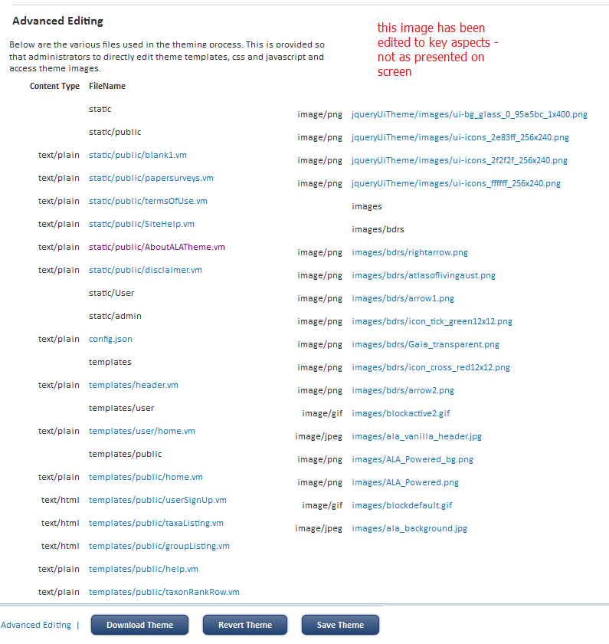

### Edit Theme: Main Files edited in Custom Themes

The following list of files contains those typically modified in developing your own customised theme.

**Note**

The two files and the static\public folder have been added to the BDRS Default (vanilla) theme to show a working vanilla Theme for you to edit

See for details.

The files are listed grouped together into associated components to highlight relationships rather than by folder as on the Edit Theme screen.

##### Theme Controller

* + config.json – while listed you will not usually have to make changes here unless you are adding custom CSS or JS files.

##### Page container – component present on every page

* + templates\**header.vm**
  + templates\**footer.vm**
    - static/public/termsOfUse.vm
    - static/public/disclaimer.vm
  + templates\**menu.vm**

##### Pages you have added and/or modified – mainly in static/public

* + templates\public\**home.vm**
  + static/public … pages added to the menu such as ‘About my Organisation’ and ‘how to use this web site’ and so on
  + static/public is the global container for added page content

##### Taxonomy – Species information

* + templates/public/**groupListing.vm** – Field Guide
  + templates/public/**taxaListing.vm** – taxon Group list
  + templates/public/**taxonView.vm** – species page template

##### Registration

* + Templates\public\**userSignup.vm**
  + Templates\public\**signin.vm**

##### Overall presentation controls

* + css/**base.css** – main theme look & feel controls
  + jqueryUiTheme/**jquery-ui-1.8.16.custom.css** – new to V1.0+ control key table display attributes such as in taxon group lists in the Field Guide and all admin tables.

##### images/bdrs container

* + this is where you will put your own images for header, background and on page display (such as partners logos) for content that will not change frequently and which is ‘portable’ between BDRS servers using themes.

### Edit Theme: Editing a file in situ

You **can** edit:

* Any .vm template file
* Any .json configuration file
* Any .css style sheet file

You **can not**:

* You **cannot** **add** new content of **any type** into the theme from the Edit Theme interface
* You can **view** images but **not** edit and **save** back to the Theme

**Note** *These last two are important limitations to understand.*

Together they mean that to add new pages, and change, delete or add new images you must download, modify and then upload the Theme.

#### Editing a file

Click on the file of interest – e.g. templates/menu.vm – to open the **Edit Theme Element** screen:

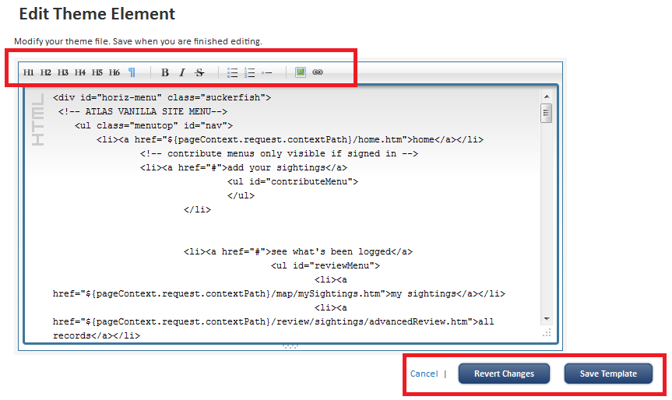

The screen has a resizable HTML editor and three buttons/links in the footer.

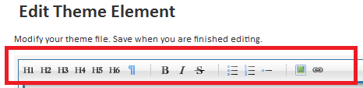

The HTML editor allows you to edit text in standard HTML format. It includes some basic tools:

* Header types 1 – 6 which are formatted per base.css
* Insert Paragraph tags – <p></p>
* Bold/ Italicise/ strikethrough selected text
* Bulleted - <ul></ul> & numbered <ol></ol> lists as well as list elements - <li></li>
* Add picture
* Add link

The three Buttons/link at the foot do as expected – save your changes, cancel/do not save and Revert – remove **all previously saved changes** by reverting back to the originally uploaded zip file data.



**Tips**

It is generally easier to edit your content elsewhere in a WYSIWYG editor and paste back into the screen when ready.

Notice that you can grab the bottom right hand corner (some browsers show handles but not all) and drag the editable screen area open to make it easier to edit.

As noted before this is a good way to add new content and to test and debug it. We strongly recommend that you then download and ‘re-upload’ the Theme template so that any reversions will go to a safe, complete and working theme.

See next section for details.

## Uploading a theme

There are two scenarios involved in uploading themes – adding a new one as explained above in where you use the Managed Files interface to first add the new Theme to the BDRS and is already explained.

### Updating an Existing Theme

The second is where you are updating an existing theme.

In order to keep the number of entries in the Theme Setup screen under control, and to more clearly differentiate between major and minor changes use the Manage Files interface again but this time just update the file entry.

Select **Admin > Manage Portal > Manage Files** on the menu



Locate your Theme template file and click edit

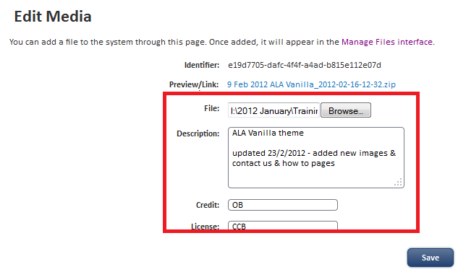

Add the updated template – it can have a different file name and we recommend you add explanatory comments and Save.

Go to next section to activate the new theme.

## Reverting a theme

There are two primary reasons for completely reverting a theme.

1. you have uploaded a new minor version of a current theme – perhaps to add new pages and images
2. an upgrade failed

### Revert: New Minor Theme Update

After following the instructions in **Uploading a theme** (immediately above) select **Admin > Manage Portal > Edit Theme** on the menu.

**Note**

You can do this with both active & inactive themes

In the Theme setup page click the **Edit** link in the right hand side (RHS) column)



Scroll down the page (Cntrl+End works on windows) and click the **Revert Theme** button in the footer



All of the Theme content will be updated to match that just uploaded.

### Revert: Upgrade Failed/undesirable consequences

We always recommend that you trial any changes but especially significant changes to Themes on the UAT (or other separate from production) instance of your BDRS portal before migrating to your production environment.

Where you have made major changes upload the new zip Theme file as before but **add as a new theme** rather than updating an existing one (first revert case above) – this positions it as a new major version AND gives you a full back out process if it goes wrong on a new server.

How?

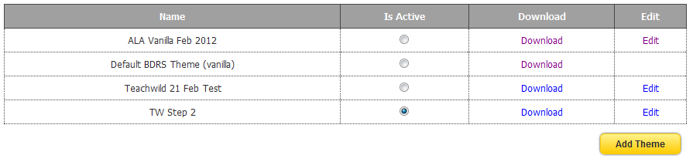

If you click on one of the other theme Is Active radio buttons its templates and content are immediately applied to the site – if anything has gone wrong you can instantly back out.

#### Frequently Asked Questions

So what can go wrong or cause confusion?

##### No Static Pages Folder

The default BDRS vanilla theme does not include a static pages folder which needs to be added with the correct format of static\public

We recommend you download the ALA vanilla theme from the training <http://bdrs-uat.ala.org.au/bdrs-core/portal/19/home.htm> or demonstration <http://bdrs-uat.ala.org.au/bdrs-core/portal/14/home.htm> portals or the Atlas web site <http://www.ala.org.au/get-involved/citizen-science/fielddata-software/fielddata-training-materials/>.

##### BDRS Upgrades

The simplest example is the recent upgrade from BDRS V1.0 to BDRS V1.1

This upgrade restructured and renamed the Theme folders, added new templates in various places, changed the way some templates worked, and upgraded & updated the jqury-ui CSS and javascript files.

*The net result?*

Template errors relating to the new page_footer.vm template, surprising and unwanted changes to the taxon group pages in the form or Record Now buttons, and changes to both user and admin interface that conflicted with current themes and in some cases made it harder to read text in table rows.

The **jquery-ui-1.8.16.custom.css** file had new colours for table headers, footer, text, link/element mouse over etc that implemented the changes.

##### Before:

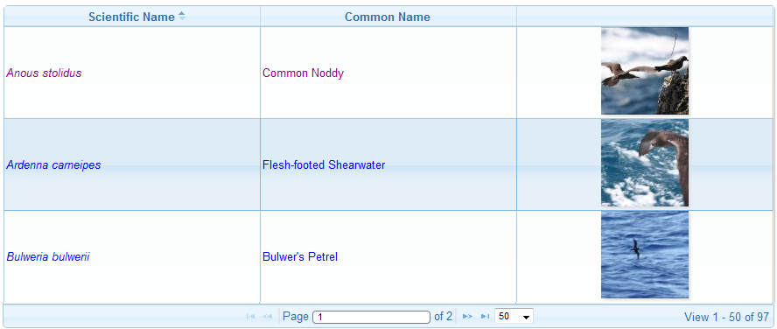

This presentation aligns nicely with the overall site theme including the blues, easy to read row text and rounded table corners

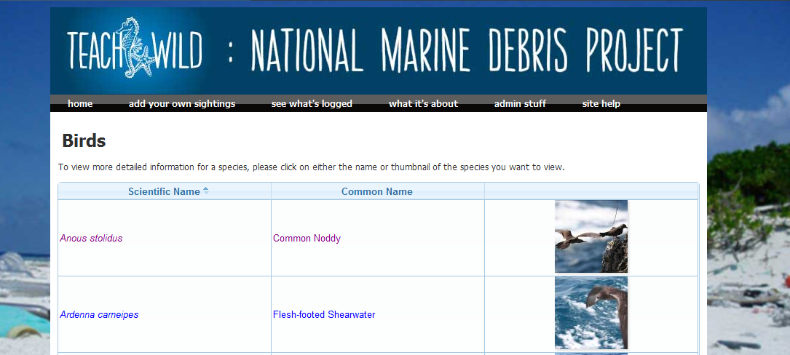

##### After:

The look and feel clashed with the overall theme with rows becoming difficult to read, dark headers and footers and square shaped tables.

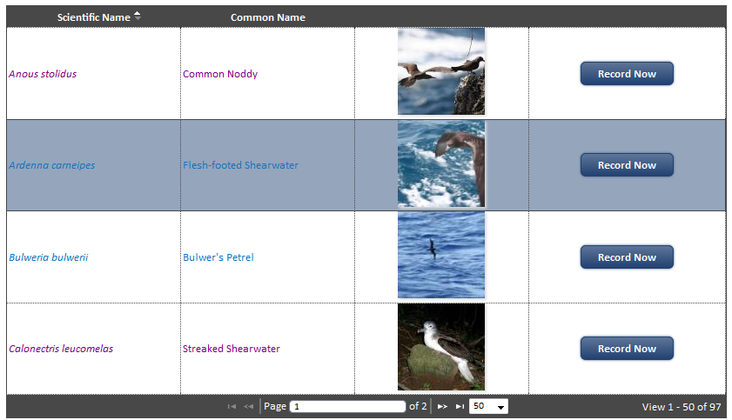

This is actually a subsequently modified version of the vanilla theme – original V1.1 base.css defaults for link text were blue and the table header/footer backgrounds dark blue so you couldn’t read the column headers or footers.

**Note**

Notice also that that in the before shot (live theme) the **taxaListing.vm** template has been edited to remove the **Record Now** button.

The button was removed because it only works where there is a single published survey which has the species in question selected into its allowed taxonomy.

Otherwise you get situations like this where very survey a user can see is presented to them to choose from.

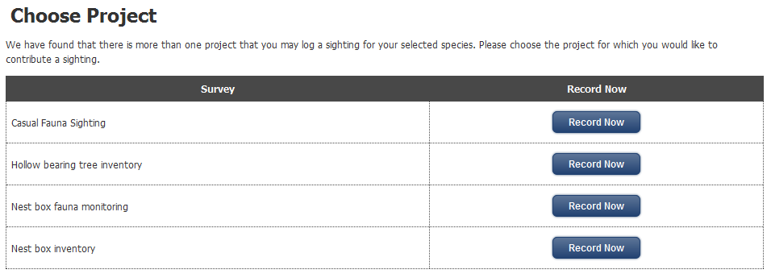

Some BDRS instances have 10 or more surveys which can become very confusing for a non-admin user!

**Tip**

You could also edit taxaListing.vm and make the record now button open a specific survey – **BUT** because surveys are opened based on ID’s you would a) need include any associated and mandatory Census Methods in the URL and b) remember that survey (and indeed all UUID type numbers) are unique to a BDRS server requiring he template be modified if you apply it to another e.g. production instance.

## Editing a Downloaded Theme

To demonstrate a working approach to creating a new theme we will create an Atlas of Living Australia Vanilla Theme from the Default BDRS Theme (vanilla) in a newly created portal.

1. Download the default theme into a working folder and rename it.

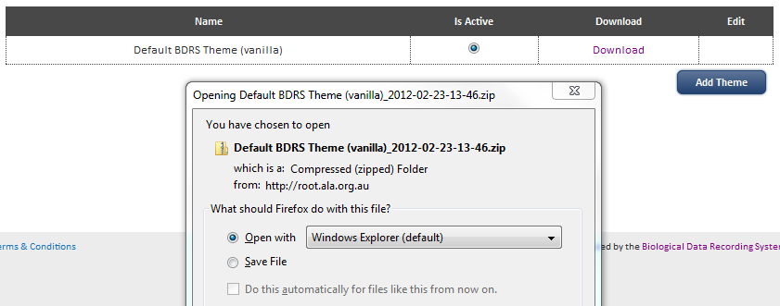

2. Create the static\public folders

The one shown here has several standard page templates added:

* static/public/termsOfUse.vm
* static/public/disclaimer.vm
* static/public/.. AboutThisProject, AboutOurPartners, HowToUseThisSite, ContactUs as examples of the sorts of pages being added to BDRS sites.

3. Update the Theme with the powered by the Atlas of Living Australia banner materials.

3.1 Edit base.css file and add the required CSS content.

In notepad++ file begins with

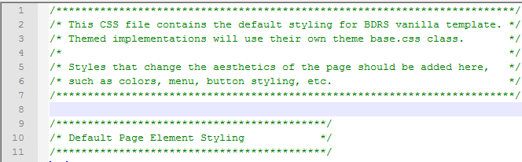

After adding the powered by styles it starts like this:

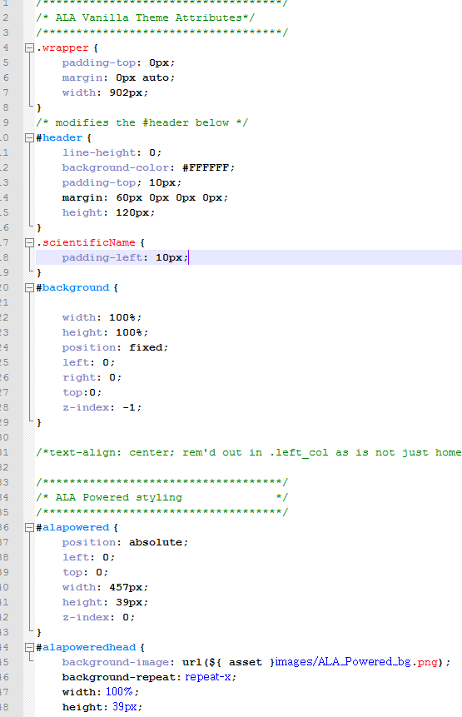

Notice the #header CSS override – need to edit in the default Header Styling css as well.

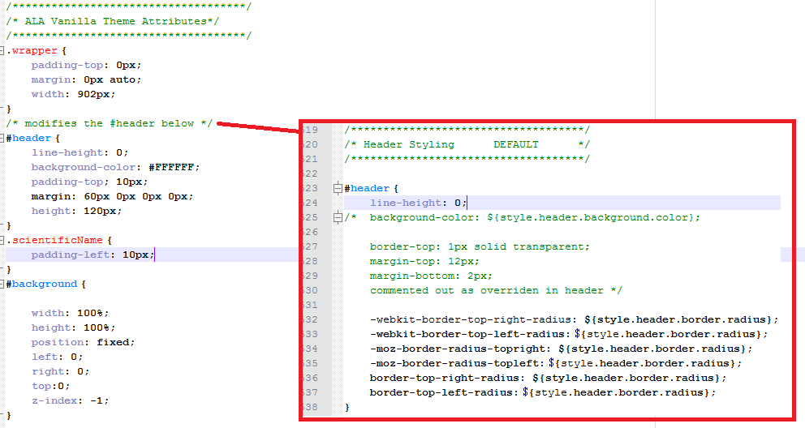

3.2 Add the powered by ALA images to the images folder

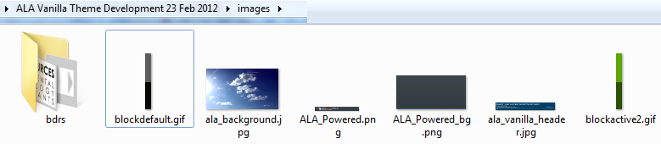

3.3 Save the default header as default_header and rework the header.vm file to display the desired attributes.

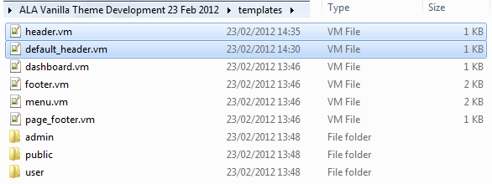

See training <http://bdrs-uat.ala.org.au/bdrs-core/portal/19/home.htm> or demonstration <http://bdrs-uat.ala.org.au/bdrs-core/portal/14/home.htm> portals or the Atlas web site <http://www.ala.org.au/get-involved/citizen-science/fielddata-software/fielddata-training-materials/> for the complete zip file.

The main changes are to replace this header:



With this one:

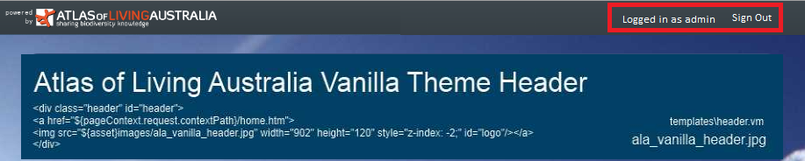

Using the new **‘Logged in as ${context.user.name}’** helper code from the V1.1 default.

3.4 Edit the default menu.vm (old retained) to a ‘hand made’ version removing all of ‘in-development’ menu item pop-ups and some of the others that are currently not desirable.

The default menu is completely compiled by the BDRS web application.

Its replacement is almost completely hand coded in order to make the necessary changes. The only menu option not coded is the survey menu item – a list with the reserved id = “contributeMenu”

<li><a href="#">add your sightings</a>

<ul id="contributeMenu">

</ul>

</li>

The javascript required to load the menus found at the foot of the file also changes

From the fully compiled:

<div id="horiz-menu" class="suckerfish">

<ul class="menutop" id="nav">

#foreach($rootItem in ${context.menu})

#addMenuItem(${rootItem})

#end

</ul>

</div>

<script type="text/javascript">

bdrs.menu.initHover();

</script>

To the partially compiled – only the contribute menu:

<script type="text/javascript">

jQuery(function() {

bdrs.menu.initHover();

#{if}(${context.user.isUser()} || ${context.user.isAdmin()})

bdrs.menu.populateSurveyItems('${context.user.registrationKey}', "#contributeMenu");

#{end}

bdrs.menu.populateMapMenu("#reviewMenu");

});

</script>

Notice the contribute menu is only compiled and presented when the user is logged in – either as a regular user or an administrator - ${context.user.isUser()} and ${context.user.isAdmin()}

There is a 3rd user type - ${context.user.isSuperVisor()} but, like isAdmin, it is applied incrementally to isUser and so supervisors too can see surveys on the menu.

3.1 The **config.json** file is also edited to set user and admin home pages to be the same as the public ones.

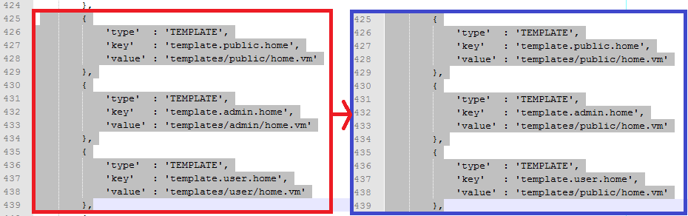

4. The package of files is zipped and uploaded into the portal following the add theme instructions above.

5. The newly applied theme looks like this:

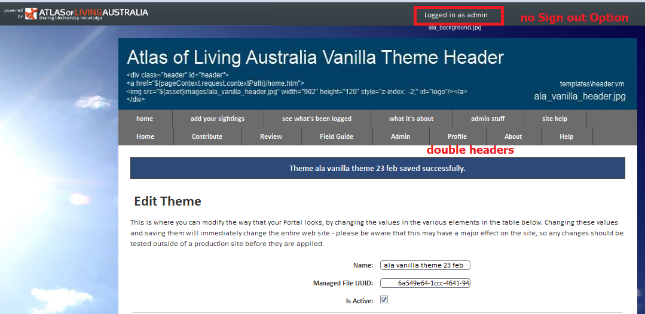

Notice the absence of a sign out option and the double menu’s – both of the menu options were left in place to demonstrate the outcome.

By editing the menu template menu.vm as explained above to remove the compiled option the image changes to show:

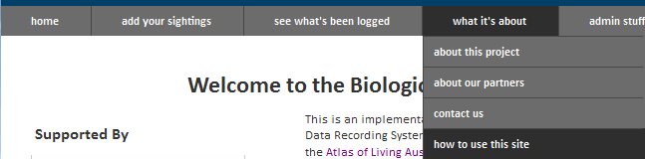

Notice the new pages that have been added to the site

In the **menu vm** template they are new list items under a parent “what it’s about” list -

<li><a href="#">what it's about</a>

<ul>

<li><a href="${pageContext.request.contextPath}/bdrs/public/static/AboutThisProject.htm">about this project</a></li>

<li><a href="${pageContext.request.contextPath}/bdrs/public/static/AboutOurPartners.htm">about our partners</a></li>

<li><a href="${pageContext.request.contextPath}/bdrs/public/static/ContactUs.htm">contact us</a></li>

<li><a href="${pageContext.request.contextPath}/bdrs/public/static/HowToUseThisSite.htm">how to use this site</a></li>

</ul>

</li>

It is important that the names of each of the added **page.vm** templates in the menu have exactly the same case i.e. **page.htm** in this example otherwise and the path be public/static as shown (yes – we know it is reversed – has been forever) otherwise the links will throw 404 errors.

As you can see from the provided **meu.vm** file menus are simply lists of lists in HTML with a smattering of javascript and jquery variables like ${context.user.isUser()}.

## Custom Pages

### BASIC

Required structural elements

Adding images – template vs. managed file

Context sensitive jquery helper fields – work some places and not others

Currently in the emails as well as widgets and almost all system pages

Where do and don’t work

And so on

Examples:

Home

Customer sites

### THEME COMPONENTS

Customising the **Field Guide**

* formatting species lists
* taxon group lists
* Species pages

Customising **Survey forms**

* Adding map layers
* Zooming in on maps
* Hiding maps
* Adding species selectors
* Alternative Moderation
* Display
* Data entry field standardisation using the

# Customising Species Pages

Data entry, user displays

## Customising Species Pages: The Taxon Profile Template

To create a set of standard fields (names and data types) to direct data entry into manually created Species Profile pages

Developing a taxon profile template requires a reasonable level of experience with HTML, CSS, web design and the BDRS.

### Taxon Profile Template Summary: WHY

1. users are able to add new fields when creating a taxon page
2. because they are annually entered rather than selected from lists the new fields can have different Database Name, Title and Type across different species pages, due to data error, multiple users with different ideas, spelling mistakes and so on.
3. This lack of controlled data entry makes standardisation extremely difficult within a BDRS let across multiple sites and between BDRS and other systems such a the Atlas – where we harvest locally added species profile content into the Atlas species pages to make them more rich, broad spectrum and representative of users needs/

### Taxon Profile Template Summary: WHAT THE USER SEES

1. The BDRS provides a mechanism to include standardised fields in every new and existing species page
2. The mechanism is a .json file called the taxon.profile.template.json
3. This file describes a flexible set of fields to be applied to a taxon groups species pages – meaning you can have different as well as common fields for different taxon groups where, for example, diet is not relevant to Fungi in the way it is to Fish.
4. The fields show as up defaults in the species page table – either alone in New entries or at the foot of the table in existing ones (and sometimes scattered throughout the table : )

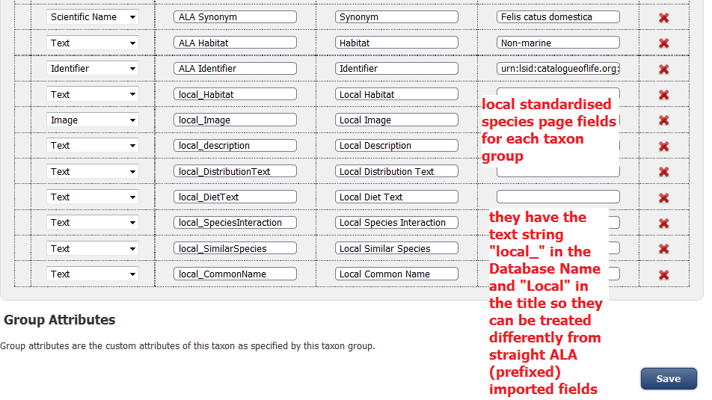

1. The Database Name is prefixed with “local_” and Title with “Local” so they can be treated differently
2. Specifically:
   1. The species page users see can have the Local content displayed differently to and/or instead of ALA derived content
   2. Species profiles with local content can be identified for harvesting into the Atlas species pages and only the contents of fields with the “local” prefix will be processed.

### Taxon Profile Template Summary: THE ACTUAL MECHANISM

The taxon.profile.template file lists the required details for each field to be added to a species page as follows:

|  |  |
| --- | --- |
| JSON Text | Notes |
| **[**  **{**'group_name': 'Birds',  'profile_template': [  { 'description': 'Local Habitat',  'header': 'local_Habitat',  'type': 'text'},  {'description': 'Local Image',  'header': 'local_Image',  'type': 'profile_img'},  {'description': 'Local Description',  'header': 'local_description',  'type': 'text'},  {'description': 'Local Distribution Text',  'header': 'local_DistributionText',  'type': 'text'},  {'description': 'Local Diet Text',  'header': 'local_DietText',  'type': 'text'},  {'description': 'Local Species Interaction',  'header': 'local_SpeciesInteraction',  'type': 'text'},  {'description': 'Local Similar Species',  'header': 'local_SimilarSpecies',  'type': 'text'},  {'description': 'Local Common Name',  'header': 'local_CommonName',  'type': 'text'}  ]  **},**  **]** | Opening and closing Square brackets [ ] enclose ALL of the taxon groups being specified.  The text shown deals with a SINGLE taxon group by NAME – 'group_name': 'Birds',  Spelling the name wrongly, changing names, introducing disallowed characters will break this facility.  Changes however will NOT affect existing saved records.  Opening and closing curly brackets { } enclose each group_name and associated field definitions  Profile template declaration and Opening and closing Square brackets [ ] enclose the field definitions – 'profile_template': [  Each field definition is enclosed in curly brackets { }  Being explained in detail because this is where errors creep in resulting in failure to display species pages.  **FIELD TYPE - critical**  Type may not be what you see in the list available in a species page    For example Image in the list requires type = ‘profile_img’ in the template |

Tips

Tailor the taxon profile template to your site and apply it to make life simpler in the future.

Take the provided SIMPLE taxon.template file and edit it to work with one of your name groups. The COMPLEX example just extends the same basic model.

Remember that every group, specification etc has to have open and closing brackets

**[Open** json string

**{ open** 'group_name': 'Birds',

'profile_template': [

{ **open** 'description':……….**close** description },

{ **open** 'description':……….**close** description }

**Close** profile template]

**Close** group name},

**Close** ] whole json string

Use the ‘local_’ and ‘Local’ prefixes as described to make your species page information available to the Atlas.

### Reference list Correct types for the json Type

SPECIES_PROFILE_IMAGE, "Image" = > "profile_img"  
SPECIES_PROFILE_IMAGE_MEDIUM, "Image Medium" => "profile_img_med"  
SPECIES_PROFILE_IMAGE_40x40, "Image 40x40" => "profile_img_40x40"  
SPECIES_PROFILE_IMAGE_32x32, "Image 32x32" => "profile_img_32x32"  
SPECIES_PROFILE_IMAGE_16x16, "Image 16x16" => "profile_img_16x16"  
SPECIES_PROFILE_THUMBNAIL, "Thumbnail" => "thumb"  
SPECIES_PROFILE_THUMBNAIL_SMALL, "Thumbnail Small" => "thumb_small"  
SPECIES_PROFILE_TEXT, "Text" => "text"  
SPECIES_PROFILE_MAP, "Map" => "map"  
SPECIES_PROFILE_MAP_THUMB, "Map Thumbnail" => "map_thumb"  
SPECIES_PROFILE_MAP_40x40, "Map 40x40" => "map_40x40"  
SPECIES_PROFILE_AUDIO, "Audio" => "audio"  
  
SPECIES_PROFILE_SILHOUETTE, "Silhouette" => "silhouette"  
SPECIES_PROFILE_SILHOUETTE_40x40, "Silhouette 40x40" => "silhouette_40x40"  
SPECIES_PROFILE_STATUS, "Status" => "status"  
SPECIES_PROFILE_COMMONNAME, "Common Name" => "common_name"  
SPECIES_PROFILE_IDENTIFIER, "Identifier" => "identifier"  
SPECIES_PROFILE_PUBLICATION, "Publication" => "publication"  
SPECIES_PROFILE_SCIENTIFICNAME, "Scientific Name" => "scientificname"  
SPECIES_PROFILE_SOURCE, "Source" => "source"

Current 1/3/2012

## Applying a taxon.profile.template

1. The json template file is added to the BDRS instance as a managed file.

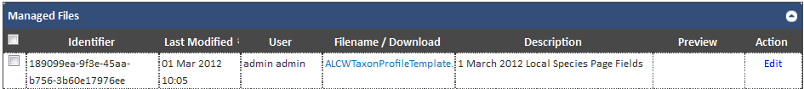

1. The uuid is added into preferences –

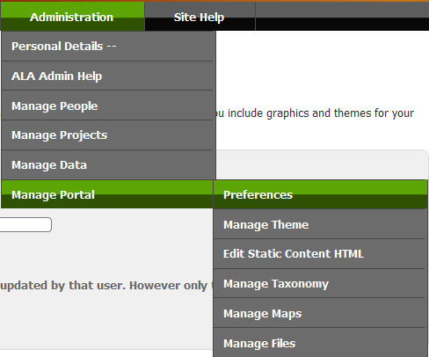

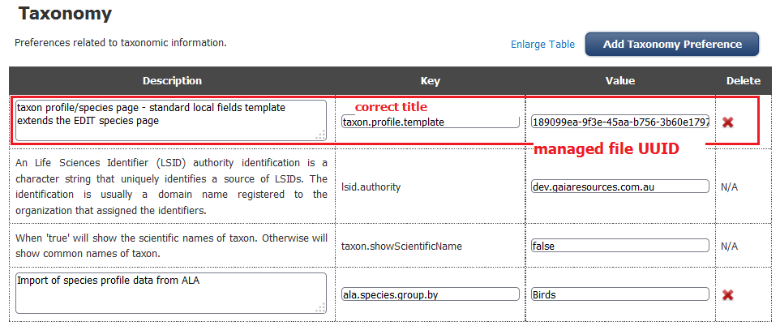

1. Changes to the taxon template need to be uploaded into the managed file interface and will apply immediately.

## Customising Species Pages User Interface: Taxonview.vm Template

To create a set of standard fields (names and data types) to direct data entry into manually created Species Profile pages

# BDRS site integration

* Monolithic
* Side-by-side complementary
* Integrated
  + Frames
  + AJAX
  + Security?

Theme troubleshooting

# BDRS & the Atlas

* Occurrence records to the Atlas
* Species pages to & from the Atlas
* Controls over these processes
  + Published
  + Authority
  + Survey
  + ?

# Development Futures

* Requirements matrix – Google Code issues <http://code.google.com/p/ala-citizenscience/issues/list>
* requirements documents
* contribution into Code
* caveats
  + reloading to ‘reset’ system (Hunter 8/2/2012)
  + changing content – download first before change: manage edits
  + cant add images/pages/files directly into theme engine
* image management
* add images via theme - **${asset}images/ala_background.jpg**
  + cross server portability
* add images via media file –

<img src="${pageContext.request.contextPath}/files/downloadByUUID.htm?uuid=40448d8f-887a-4003-b2f1-78b1c3c15712”>

* Reference List
* ${portal.getName()} Home
* ${taxon.getScientificName()}

*Additional benefits eg image management/cross server consistency*

*TIPS clone database & maintain = same survey numbers, etc*