Document Information

|  |  |
| --- | --- |
| Prepared For: | Atlas of Living Australia  Administrators and developers off the Atlas Field Data Capture Software |

Publication History

|  |  |
| --- | --- |
| Edition | Date |
| FINAL | March 2012 |

# Google Maps API Key: Not Displaying

This issue occurs on new FieldData/BDRS portals where implementation has not been completed.

## Issue:

Survey Maps will not load

Error message

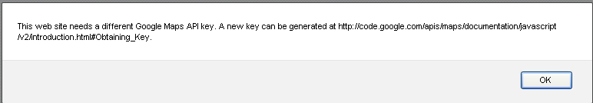

## Fix:

Navigate to Admin > Manage Portal > Edit Preferences

Click Add API Keys Reference

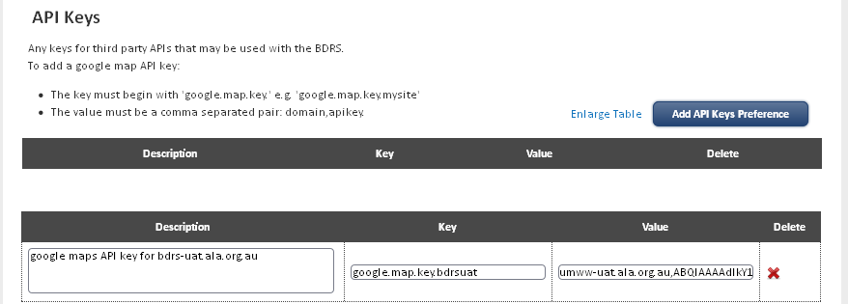

Add the following:

|  |  |
| --- | --- |
| Description | google maps API key for bdrs-uat.ala.org.au |
| Key | google.map.key.bdrsuat |
| Value | umww-uat.ala.org.au,ABQIAAAAdIkY1hdL06bwR3W3WGL2lBTywzZ2Wb6D2-BxLGvg54t676eSkhTikAURtyN02ZrDmslYq8cI7Q4kUA |

**Notes**

The same key is used on production and User Acceptance Testing servers.

Description and prefix to value can be anything - the **real** key is the value ala.org.au,ABQIAAAAdIkY1hdL06bwR3W3WGL2lBTywzZ2Wb6D2-BxLGvg54t676eSkhTikAURtyN02ZrDmslYq8cI7Q4kUA

This value makes the maps behave correctly

Save the preference

Test the map