Choose one of the birds from the list. Look at the images of the bird.

The bird I have chosen is ______________________

Circle the picture of bird feet that looks most like your bird.

seagullfeet.jpg

parrotfeet.jpg

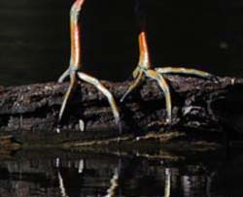

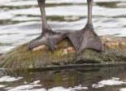

Circle the picture of bird beaks that looks most like your bird.

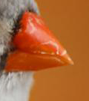

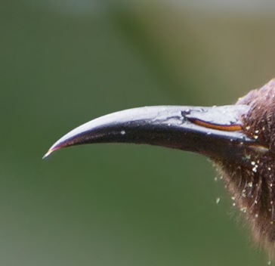

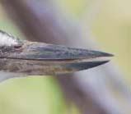

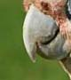

The thing I like most about my bird is ________________________________________________________________________________________________________________________________________________________________________________________________________