**What’s in your local area?**

On your field trip, record and identify the living things you find.

If you have trouble indentifying a specimen, the Species Identification page on the Atlas of Living Australia website has some suggestions.

Log these sightings on the Atlas of Living Australia. For instructions on how to do this, see ALA Teacher Guide 4 – How to log a sighting.

Compare your group’s sightings in the area to those already logged on the ALA. An example is shown below

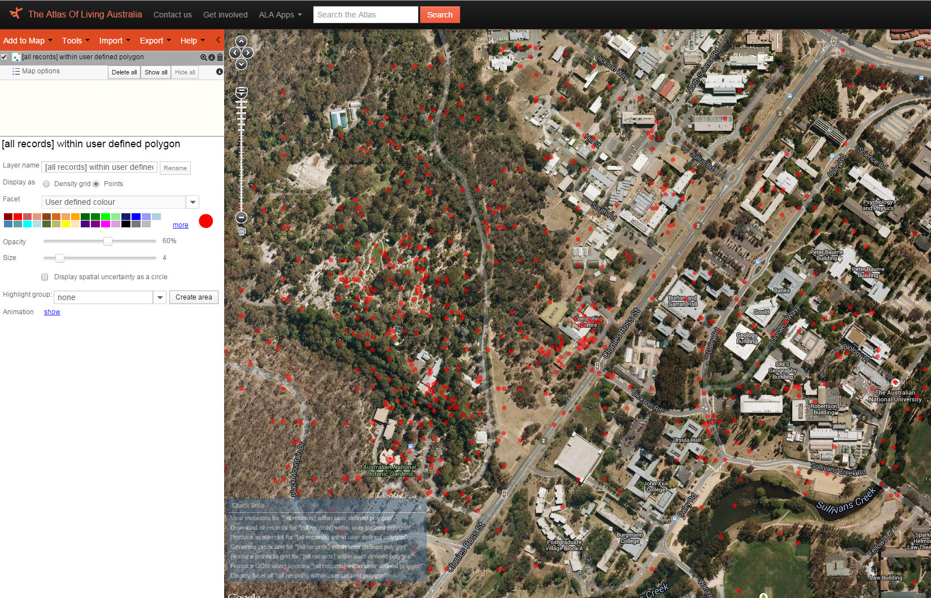

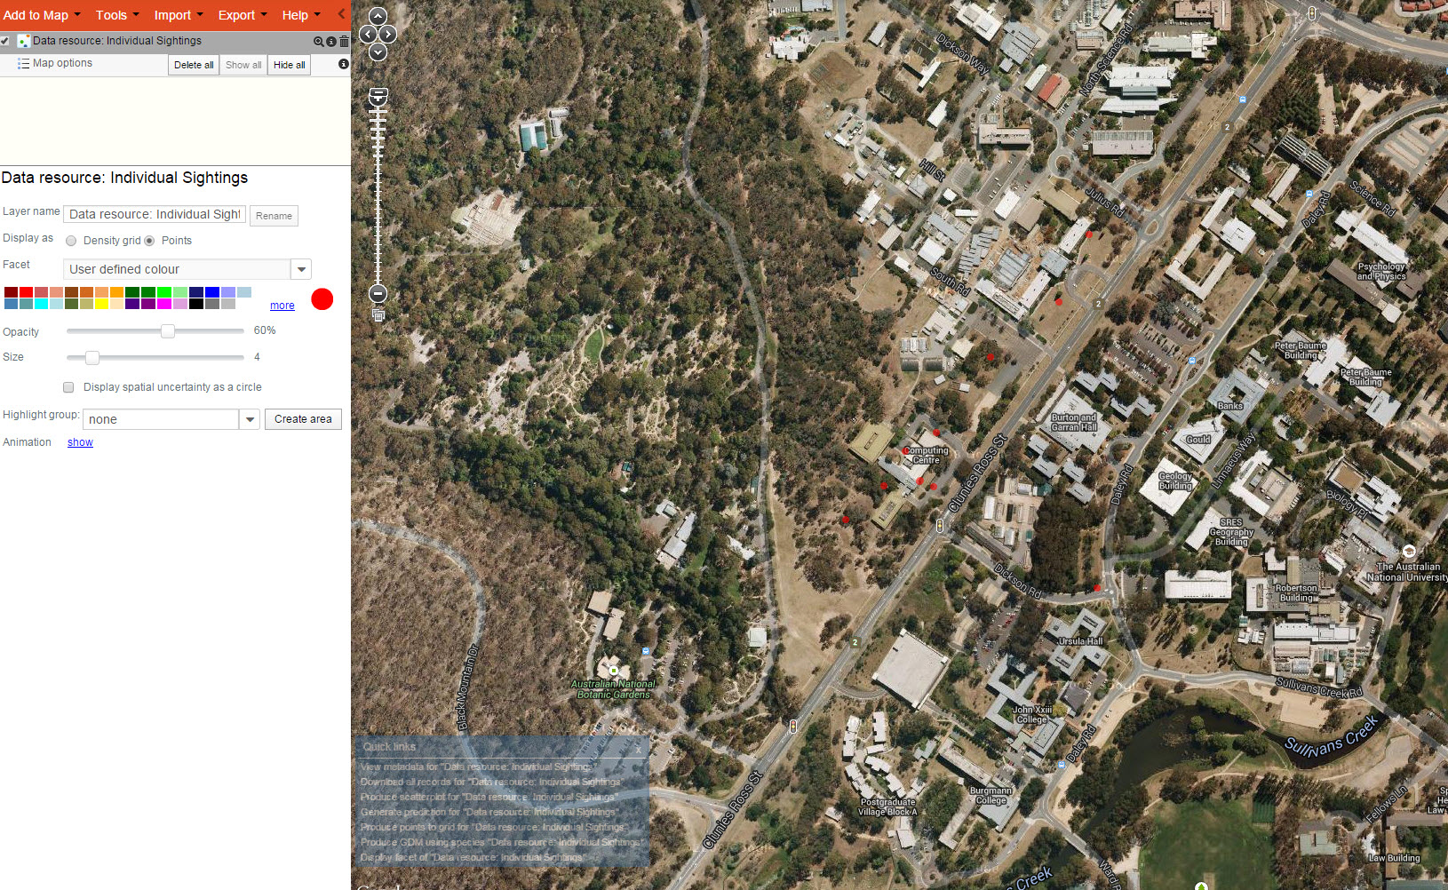

Sightings of one person in an area

Whole set of sightings in the same area

Comment on the similarities and differences between your data and the whole data set.

Use the ALA to compare the differences between your area and another nearby one.