**1. Food webs and food chains**

Find a map like this with your school in the middle. For instructions see ALA Teacher Guide 1 – Finding the species recorded in your area.

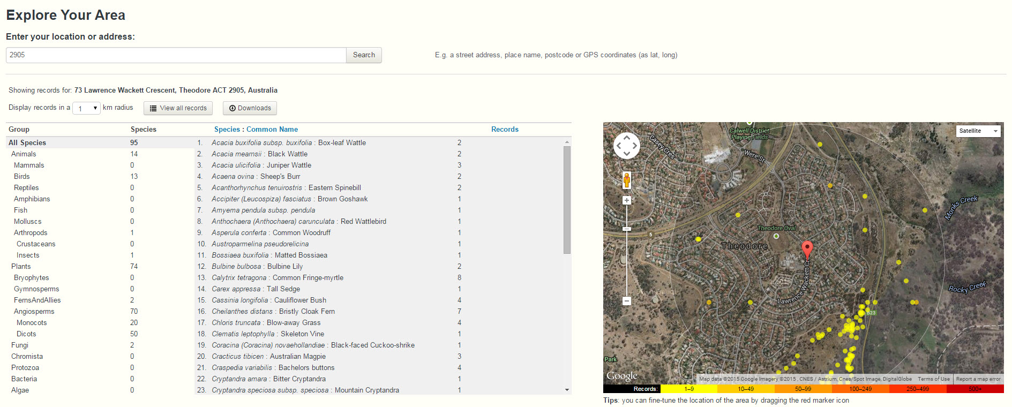

* Describe an example of each of the following kinds of relationships evident in the ecosystem
  + Predator – prey
  + Consumer - producer
* From the species sighted, identify a food chain and food web from this ecosystem.
* In terms of food chains and food webs, is anything missing from the list? Why might it be missing from the list?
* What might happen if a predator was introduced to the region?
* Describe the impact of human activities on this ecosystem.
* How could the quality of this ecosystem be improved, maintained or preserved?
* Identify the bioregion your area belongs in. Was the list from your area representative of the whole bioregion? Why/why not?
* Was there anything on the list, or missing from the list that you have seen? Find 2 species in the area. Identify them and log the sightings on the ALA. See Species Identification page and Teacher Guide 4 – How to log a sighting.

