**2. Native species pests**

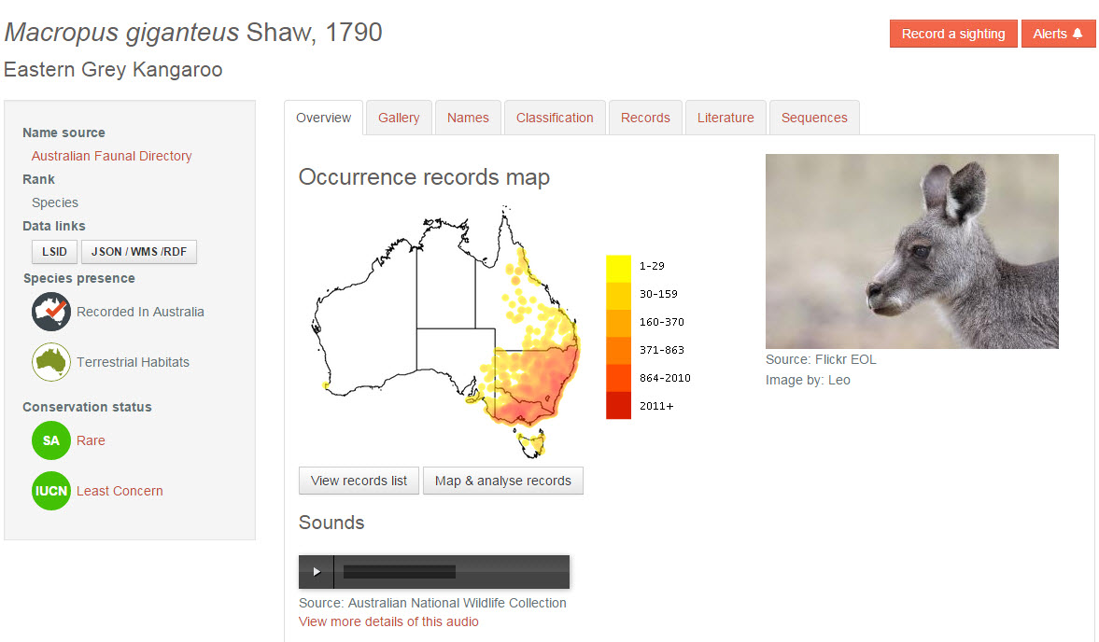

Use the ALA to find an example of a native animal species that has become a pest.

* Where does the species occur now? Use ALA maps to illustrate this. For instructions on how to do this, see ALA Teacher Guide 2 – Species distributions on a map
* What circumstances allowed it to become a pest?
* What is being done to control it?
* Outline possible consequences of leaving it uncontrolled
* Given its current range, where could it inhabit if left uncontrolled?
* What other species does it affect now? What potential species could it affect if left uncontrolled?
* If it is successfully controlled, what consequences could this have for the environment and other species?