**3. Ecosystem classification**

Use the spatial portal of the ALA to plot the layer with the IBRA 7 bioregions of Australia. For instructions on how to do this, see ALA Teacher Guide 10 – Finding the species recorded in your region

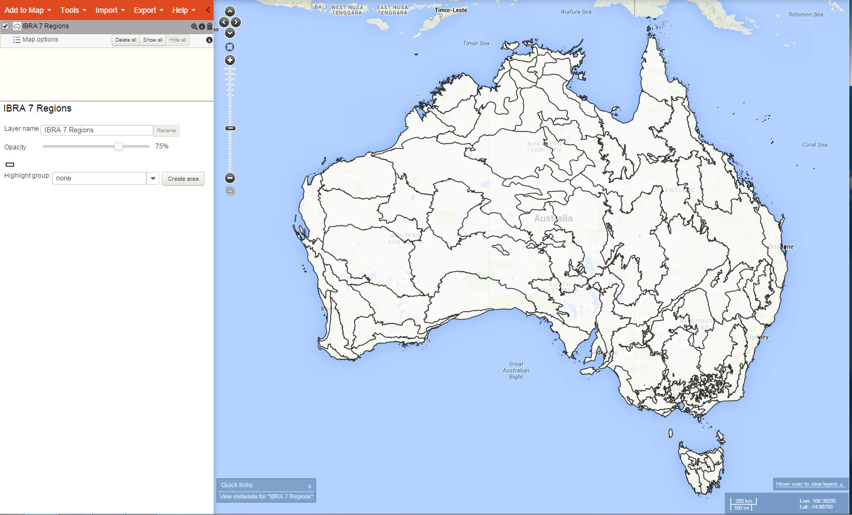

* Plot a few other simple layers over the top and comment on some of the reasons that the bioregional borders may have been mapped as they were.