**Feeding relationships in your local area**

Using the ALA, look at the species that are found in your local area. For instructions about how to do this, see ALA Teacher Guide 1 – Finding the species located in your area.

An example is shown below.

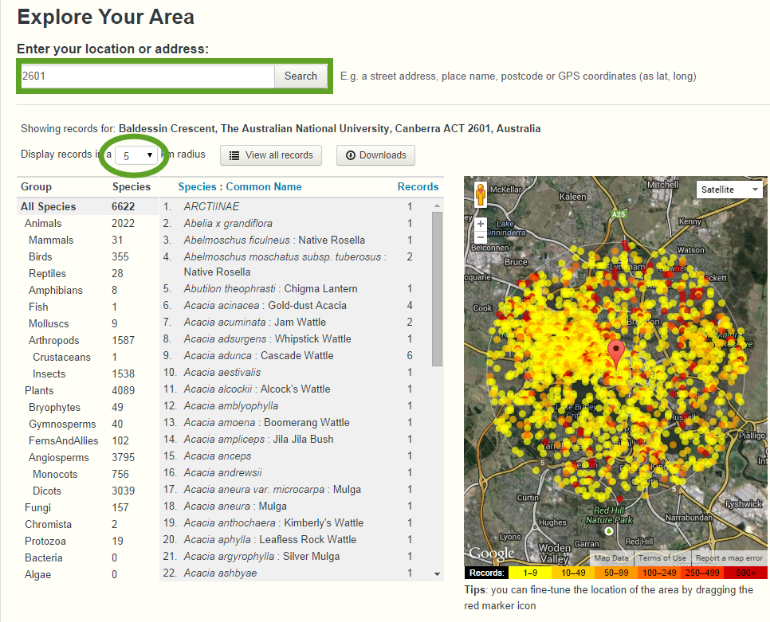

A map showing sightings in a particular area and a list of the species

From the species information on the ALA for your area, list 3 producers, 3 first order consumers and 3 second order consumers. You will need to consult the species pages (See ALA Teacher Guide 6 – Finding information about a species) and other sources to find these.

Complete the following food chain from the ALA species information in your area:

Producer 🡪 First order consumer 🡪 Second order consumer 🡪 Third order consumer

Producer 🡪 First order consumer 🡪 Second order consumer 🡪 Third order consumer

Are there any species on the list that could be both a first and a second order consumer?

Are there any species on the list that could be both a second and a third order consumer?

Complete a food web from the ALA species information in your area:

Is there anything missing from the species for your list that makes it difficult to complete your food web? Why might this be missing?