**Three Maps Activity**

For each of the three species, find another map of their range online and save it. Remember to include the source of the map.

Compare the maps you found to the maps from the Atlas of Living Australia.

For each of the three pairs of maps, make a comment about how well they match each other.

What is one reason that the maps from the ALA and the other source may not match each other?

Map 1 -Mountain Pygmy Possum

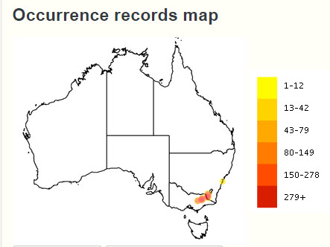

Map 3 - Tasmanian Devil

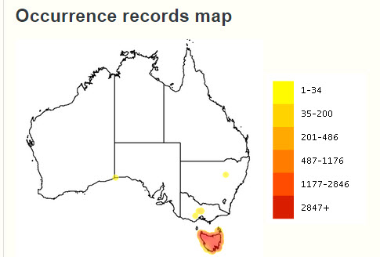

Map 2 - Koala

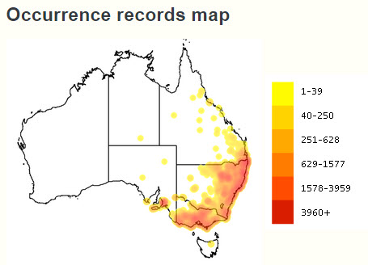

These are the occurrence records maps generated by the Atlas of Living Australia for three species, the Mountain Pygmy Possum, the Koala and the Tasmanian Devil.