**Rabbits and kangaroos in urban areas**

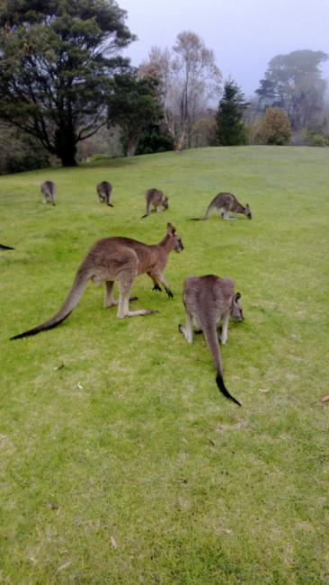

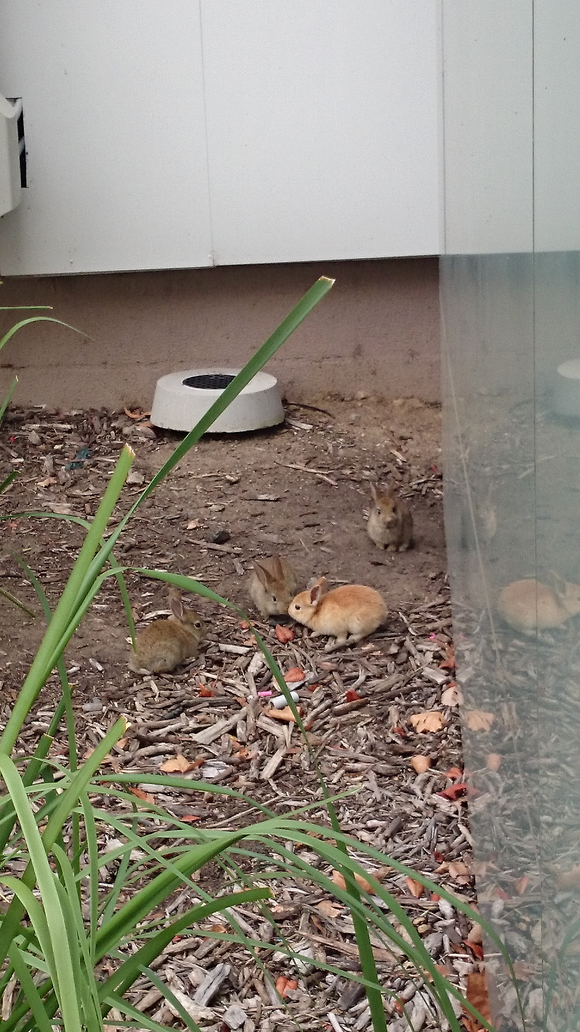

Eastern Grey Kangaroo. Image by Hayden Forrest – ALA Individual Sightings

European Rabbit. Image by Pippa Hambling

* Using the ALA and other sources, research and show on a map areas in the ACT where both of these animals have become overpopulated.

* Explain some ways that have been implemented to control populations of these animals.
* How could controlling the numbers of these animals affect other local species? Think about both positive and negative consequences.
* Looking at the occurrence records of the kangaroo and the rabbit in the ACT, why might these records not accurately reflect the current populations and spread of these species?
* Rabbits are an introduced species to Australia, whereas the kangaroos are native. Do you think this fact should affect how the populations of each animal are controlled? Explain your answer.