Web Technologies Module 3 Assignment 2

Atman Shastri, FYMCA-C, 182

1. Aim:

To know about how to get directory name, base name and extension name of a file

Theory:

To be able to manipulate paths in order to write a program

Code:

*const* { join, resolve } = require('path');

*var* path = require('path');

*const* filepath = 'C:/Users/admin/Desktop/Batch C Roll No 182/WT/Module 3/data.txt'

console.log("Directory Name: " + path.dirname(filepath));

console.log("Base Name: " + path.basename(filepath));

console.log("Extension Type: " + path.extname(filepath));

*var* name = 'mca'

console.log(path.join("User Defined Path: ","/","users",name,'data.txt'));

console.log("Actual Path: " + path.resolve("data.txt"));

Output: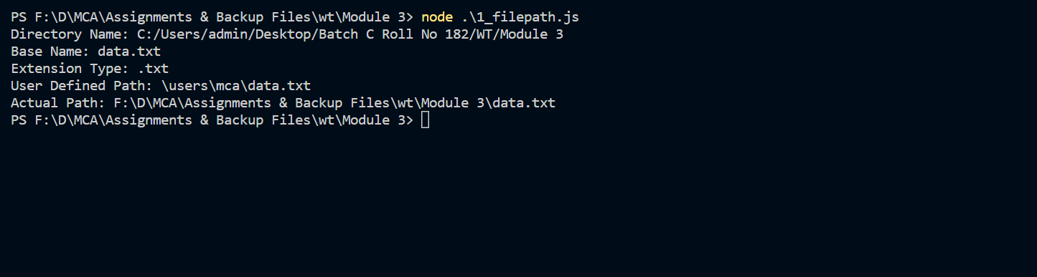

1. Aim:

To create an asynchronous function using the await keyword

Theory: To understand the asynchronous nature and understand when to use the await keyword in the program.

Code:

*var* fs=require('fs').promises;

async *function* readFile(*FilePath*) {

    try {

*var* data = await fs.readFile(*FilePath*);

    console.log(data.toString());

    }

    catch(error) {

    console.log("Error Occurred while reading");

    }

}

readFile("data.txt");

Output:

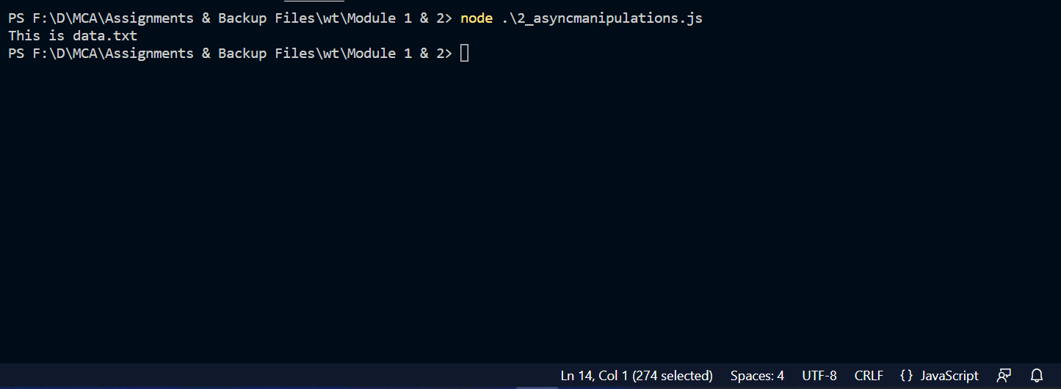

1. Aim:

To write data in a csv file using node js program

Theory:

Using Promise based API to implement asynchronous write operations

Code:

*var* fs=require('fs').promises;

async *function* writetocsv(){

    try{

*const* csvheader = "Name,Quantity,Cost";

        await fs.writeFile("Groceries.csv",csvheader);

    } catch(error) {

        console.log("Error Occured"+error);

    }

}

async *function* additems(*Name*,*Quantity*,*Cost*){

    try{

*var* csvline= `\n${*Name*},${*Quantity*},${*Cost*}`;

        await fs.writeFile("Groceries.csv",csvline,{flag:'a'})

    }catch(error){

        console.log("Error Occurred while appending"+error);

    }

}

writetocsv();

additems("Bread",2,60);

additems("Butter",1,50);

Output:

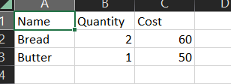

1. Aim:

To read data from a file using a buffer

Theory:

To learn how to create and read a buffer in order to program better

Code:

*var* fs = require('fs');

fs.open("data.txt",'r',(*err*,*fd*)*=>*{

    if (*err*) {

        console.log("Error Occurred"+*err*);

    }

    else{

*var* buffer = new Buffer.alloc(1024);

        fs.read(*fd*,buffer,0,buffer.length,0,(*err*,*bytes*)*=>*{

            console.log(buffer.slice(0,*bytes*).toString())

        });

    }

    fs.close(*fd*);

});

Output:

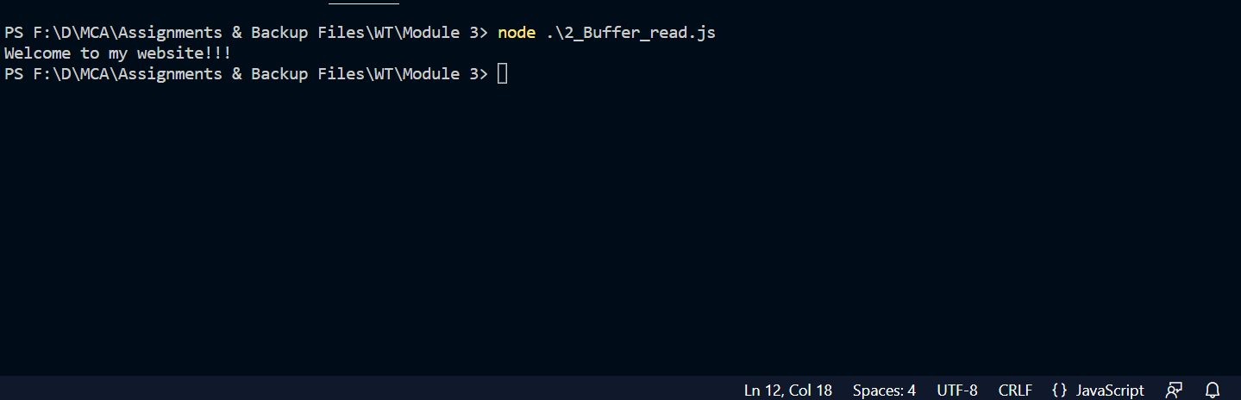

1. Aim:

To write data to a file using a buffer

Theory:

To learn how to create and write to a buffer in order to program better

Code:

*var* fs = require('fs');

fs.open("data.txt",'a',(*err*,*fd*)*=>*{

    if (*err*) {

        console.log("Error Occurred"+*err*);

    }

    else{

*var* buffer = new Buffer.alloc(1024);

        buffer.write("New Data is here");

        fs.write(*fd*,buffer,0,buffer.length,null,(*err*,*bytes*)*=>*{

            console.log("Wrote " + *bytes* + " bytes")

        });

    }

    fs.close(*fd*);

})

Output:  
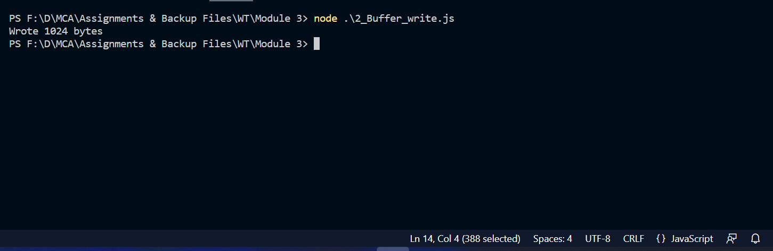

1. Aim: Read and write data from a file using stream

Theory: To learn the implementation of streams in node js

Code:

*var* fs = require('fs');

*var* readstream = fs.createReadStream("data.txt");

*var* writestream =fs.createWriteStream("writefile.txt")

readstream.on("data",*function*(*filedata*){

    writestream.write(*filedata*);

    console.log(*filedata*.toString())

});

Output:

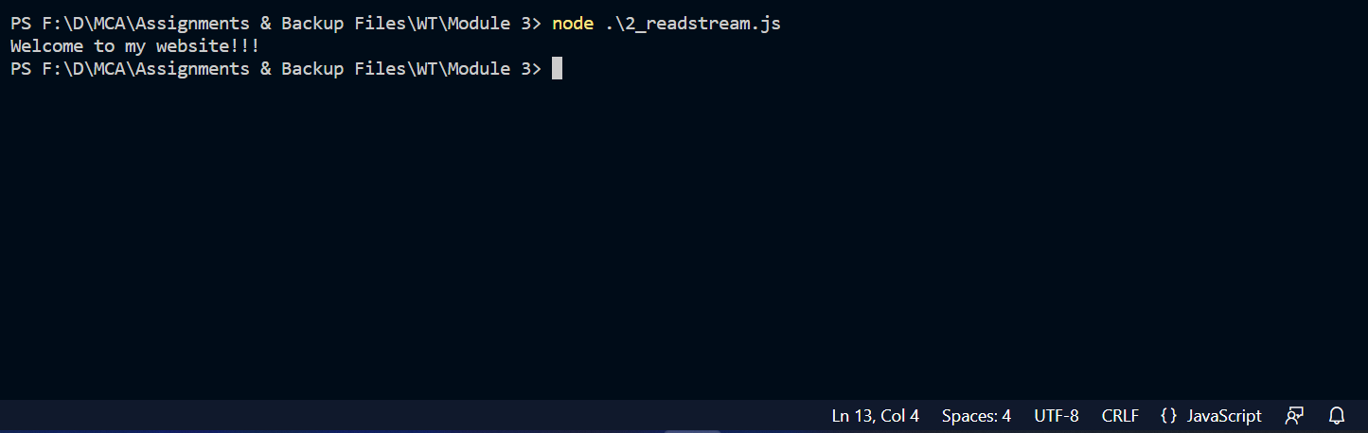

1. Aim:

To pipe a text file as a response

Theory:

Understanding to pipe text files in order to achieve same output with less code

Code:

*var* http = require('http');

*var* fs = require('fs');

*var* server = http.createServer((*req*,*res*)*=>* {

*res*.writeHead(200,{'Content-Type':'text/plain'});

*var* datastream = fs.createReadStream("data.txt");

    datastream.pipe(*res*);

});

server.listen(3000);

Output:





1. Aim:

To pipe a html file as a response

Theory:

Understanding to pipe files other than .txt files in order to achieve same output with less code

Code:

*var* http = require('http');

*var* fs = require('fs');

*var* server = http.createServer((*req*,*res*)*=>* {

*res*.writeHead(200,{'Content-Type': 'text/html'});

*var* readstream= fs.createReadStream("module_3_index.html");

    readstream.pipe(*res*);

});

server.listen(8500);

Output:  


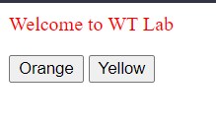

1. Aim: To close server after a set timeout

Theory:

To implement a timeout function in order to close a server that is not in use anymore within the execution of program

Code:

*var* http = require('http');

*var* server = http.createServer((*req*,*res*)*=>* {

   //

});

server.listen(9000);

setTimeout(()*=>* {

    server.close();

    server.unref();

},10000);

Output:  
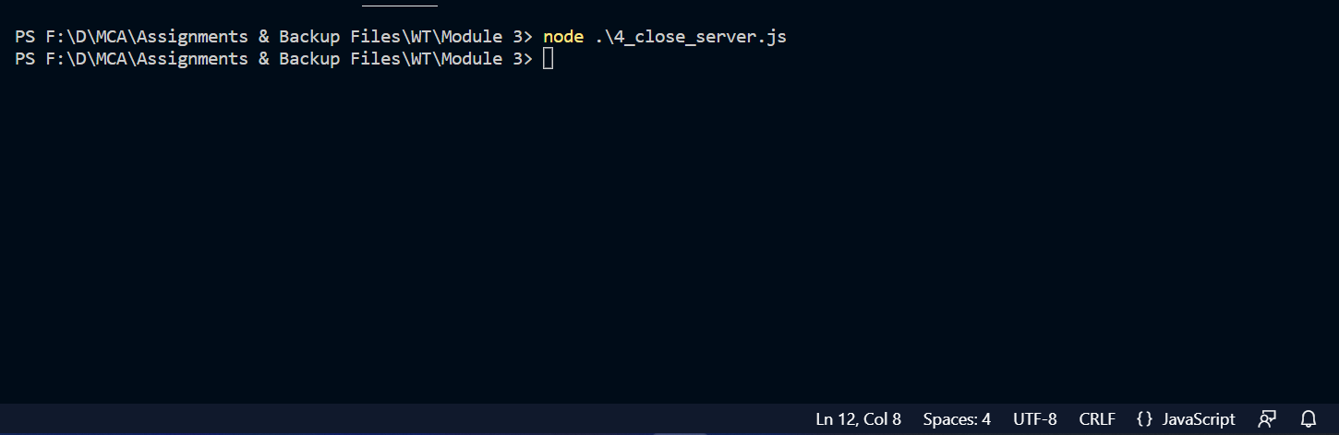

1. Aim: To read data from a file and send it as response when “data” event is triggered

Theory:

To output data from file when “data” event is triggered

Code:

*var* fs = require('fs');

*var* http = require('http');

*var* readstream = fs.createReadStream("data.txt");

readstream.on("data",*function*(*filedata*){

    console.log(*filedata*.toString())

});

Output:

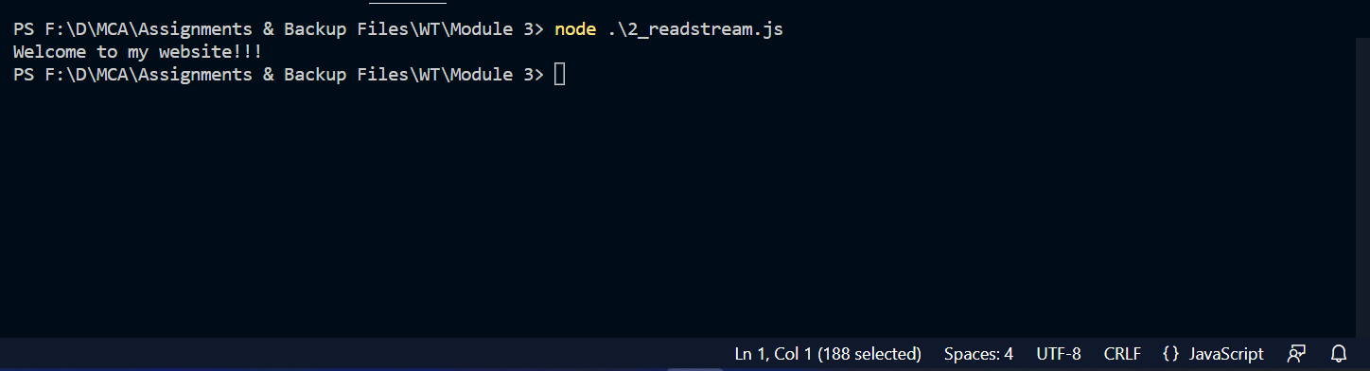

1. Aim: To redirect user to different pages based on conditions in url

Theory:

To redirect user to dashboard if url has “/dashboard” or else respond with 404 not found message

Code:

*var* http = require('http');

*var* fs = require('fs');

*var* server = http.createServer();

server.on("request",(*req*,*res*)*=>*{

*var* url = *req*.url;

        console.log("Fetched URL=" + url);

        if(url==("/dashboard")) {

*res*.writeHead(200,{'Content-Type' : 'text/html'});

            //res.write("This is my dashboard");

*var* DashboardRead = fs.createReadStream("dashboard.html");

            DashboardRead.pipe(*res*);

        } else {

           // res.writeHead(404,{'Content-Type': 'text/plain'})

*res*.write("404 \n Page not found");

*res*.end();

        }

});

server.listen(5000);

Output:

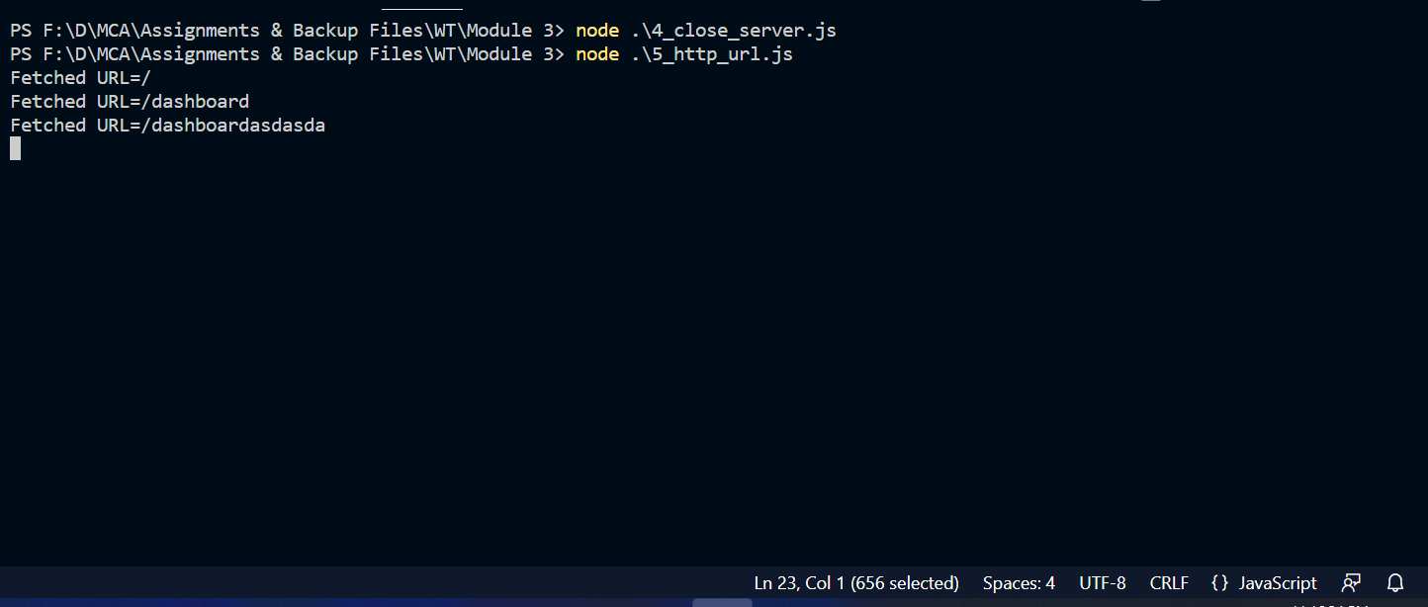

1. Aim: Take input data from user using “post” and display the data entered by the user

Theory:

To display form, take input and show data to user after input

Code:

*var* http = require('http');

*var* fs = require('fs');

*var* qs = require('querystring');

*var* mysql = require('mysql');

*var* con = mysql.createConnection({

    host: "localhost",

    port: "3308",

    user: "root",

    password: "",

    database: "college"

});

*var* server = http.createServer((*req*, *res*) *=>* {

*var* body = "";

    if (*req*.method == 'GET') {

*res*.writeHead(200, { 'Content-Type': 'text/html' })

        fs.createReadStream("register.html").pipe(*res*);

    }

    else if (*req*.method == 'POST') {

*var* formdata = "";

*req*.on("data", (*chunk*) *=>* {

            formdata += *chunk*;

*var* data = qs.parse(formdata);

            body = "\n Name: " + data.sname + "\n Phone no: " + data.scontact + "\n Address: " + data.saddress;

            con.connect((*err*) *=>* {

                if (*err*) throw *err*;

*var* sql = "Insert into student(Name,Contact,Address) values('" + data.sname + "','" + data.scontact + "','" + data.saddress + "')";

                con.query(sql, (*error*, *result*) *=>* {

                    if (*error*) throw *error*;

                    console.log(*result*);

                });

            });

        });

    }

*req*.on("end", () *=>* {

*res*.writeHead(200, { 'Content-Type': 'text/html' });

*res*.end(body);

    })

});

server.listen(5000);

Output:



