Web Technologies Module 4 Assignment 3

Atman Shastri, FYMCA-C, 182

1. Aim:

Write a program to get data from a web page and insert into a database.  
  
Theory:

To install and configure XAMPP Control Panel, MySQL, create webpage and learn to install and use new modules like mysql and querystring

Code:

*var* http = require('http');

*var* fs = require('fs');

*var* qs = require('querystring');

*var* mysql = require('mysql');

*var* con = mysql.createConnection({

    host: "localhost",

    port: "3306",

    user: "root",

    password: "",

    database: "college"

});

*var* server = http.createServer((*req*, *res*) *=>* {

*var* body = "";

    if (*req*.method == 'GET') {

*res*.writeHead(200, { 'Content-Type': 'text/html' })

        fs.createReadStream("register.html").pipe(*res*);

    }

    else if (*req*.method == 'POST') {

*var* formdata = "";

*req*.on("data", (*chunk*) *=>* {

            formdata += *chunk*;

*var* data = qs.parse(formdata);

            body = "\n Name: " + data.sname + "\n Phone no: " + data.scontact + "\n Address: " + data.saddress;

            con.connect((*err*) *=>* {

                if (*err*) throw *err*;

*var* sql = "Insert into student(Name,Contact,Address) values('" + data.sname + "','" + data.scontact + "','" + data.saddress + "')";

                con.query(sql, (*error*, *result*) *=>* {

                    if (*error*) throw *error*;

                    console.log(*result*);

                });

            });

        });

    }

*req*.on("end", () *=>* {

*res*.writeHead(200, { 'Content-Type': 'text/html' });

*res*.end(body);

    })

});

server.listen(5000);

Output:  
  
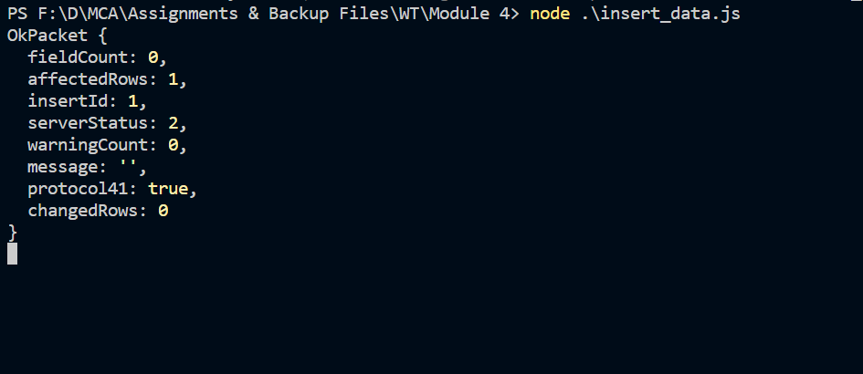

1. Aim:

Write a program to insert multiple students and also update and delete them wrt name

Theory: To modify data in mySQL using nodejs

Code:

*var* mysql = require('mysql');

*var* con = mysql.createConnection({

    host: "localhost",

    user: "root",

    password: "",

    database: "college"

});

*function* insert_multiple_data(){

    con.connect((*err*)*=>*{

*var* data_items = [["sandhya","123456789","Thane"],["Souleh",'9876543231',"Mumbai"]];

*var* sql = "Insert into student(Name,Contact,Address) values ?";

        con.query(sql,[data_items],(*error*,*result*)*=>*{

            if(*error*) throw *error*;

            console.log(*result*);

        });

    });

}

insert_multiple_data();  
  
*function* update_data(*contact*,*Address*) {

*var* sql_update = "Update student set contact='"+*contact*+"',address='"+*Address*+"' where name='sandhya'";

    con.query(sql_update,(*result*,*err*)*=>*{

        if(*err*) throw *err*;

        console.log("Data Updated"+ *result*);

    });

}

update_data("654654654","abc");

*function* delete_data(*name*) {

*var* del_sql="Delete from student where name='"+*name*+"'";

    con.query(del_sql,(*result*,*err*)*=>*{

        if(*err*) throw *err*;

        console.log("Data Deleted"+ *result*);

    });

}

delete_data("Souleh");

Output:

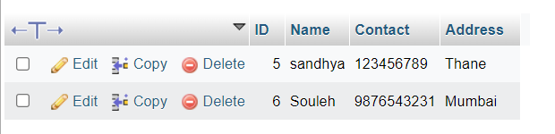

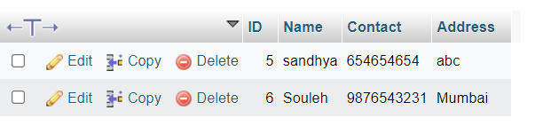

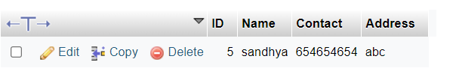

1. Aim:

Write a program to display data of students

1. Create a file to fetch data and render html content
2. Create ejs file to display data

Theory:

To use ejs to view data from SQL Database

Code:

*var* mysql = require('mysql');

*var* ejs = require('ejs');

*var* express = require('express');

*var* app = express();

app.set("view engine","ejs");

*var* con = mysql.createConnection({

    host: "localhost",

    user: "root",

    password:"",

    database: "college"

});

app.get("/data",(*req*,*res*)*=>*{

    con.connect((*err*)*=>*{

        if (*err*) throw *err*;

*var* get_sql="select * from student";

        con.query(get_sql,(*error*,*data*,*fields*)*=>*{

            if (*error*) throw *error*;

*res*.render("./../student-list",{title:"Students Data",studentdata:*data*});

        });

    });

});

app.listen(3333);

EJS File:

<html>

    <head>

        <body>

            <table border="4">

                <tr>

                    <th>Name</th>

                    <th>Phone No</th>

                  <!--  <th>Address</th> -->

                </tr>

                <% if(studentdata.length!=0) {

                    studentdata.forEach(*function*(*data*){

                        %>

                        <tr>

                            <td><%=data.Name %></td>

                            <td><%=data.Contact %></td>

                         <!--   <td><%=data.Address %></td> -->

                        </tr>

                        <%

                    })

                } else {

                    %>

                    <tr><td>No Records Found</td></tr>

                    <%

                }

            %>

            </table>

        </body>

    </head>

</html>

Output:  
  
