Web Technologies Module 5,6 Assignment 4

Atman Shastri, FYMCA-C, 182

1. Aim:

Write a program to demonstrate Angular JS Number and String Expression.  
  
Theory:

Using Expressions “{{ }}” to demonstrate Numbers & String in angular

Code:

<html>

<head>

        <title> 1_directives.html</title>

</head>

<body>

    <script src="https://ajax.googleapis.com/ajax/libs/angularjs/1.8.2/angular.min.js" type="text/javascript"> </script>

    <div ng-app="" ng-init="age=16;price=10;quantity=5">

        <p>Name: <input type="text" ng-model="name"/></p>

        <p ng-bind="name"></p>

        <p>{{ "Age = " + age }}</p>

        <p>{{"5+5 = " + 5+5}}</p>

        <p>{{ "Total = " + price * quantity }}</p>

</div>

</body>

</html>

Output:  
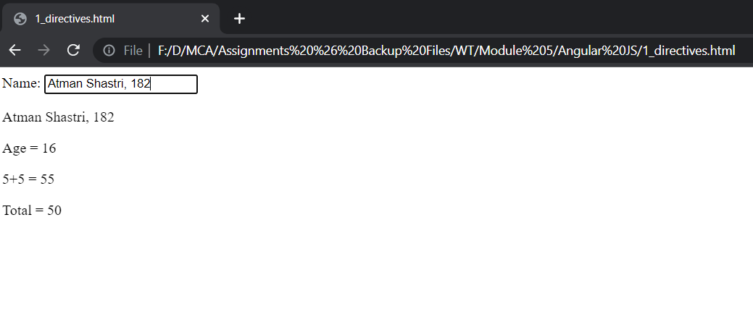

1. Aim:

Write a program to insert the user name in the textbox and greet the user with a

welcome message on the same page.  
Theory: To show the dynamic nature of Angular

Code:

<html>

<head>

        <title> Q2.html</title>

</head>

<body ng-app>

    <script src="https://ajax.googleapis.com/ajax/libs/angularjs/1.8.2/angular.min.js" type="text/javascript"> </script>

        <p>Name: <input type="text" ng-model="name"/></p>

        <h3>{{ "Welcome to this Angular webpage " + name }}</h3>

</body>

</html>

Output:

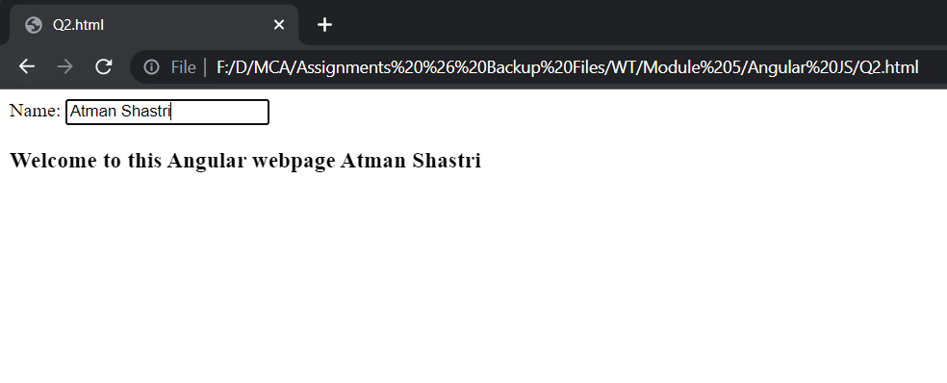

1. Aim:

Write a program to create an array of your favourite food items and display it in list

Theory:

To understand the use of ng-repeat directive

Code:

<html>

    <head>     </head>

    <body>

        <script src="https://ajax.googleapis.com/ajax/libs/angularjs/1.8.2/angular.min.js" type="text/javascript"></script>

        <div ng-app="" ng-init="names=['Khichdi','Salad','Curd','Spinach']">

           <ul>

            <li ng-repeat="x in names">

             {{x}}

            </li>

           </ul>

        </div>

    </body>

</html>

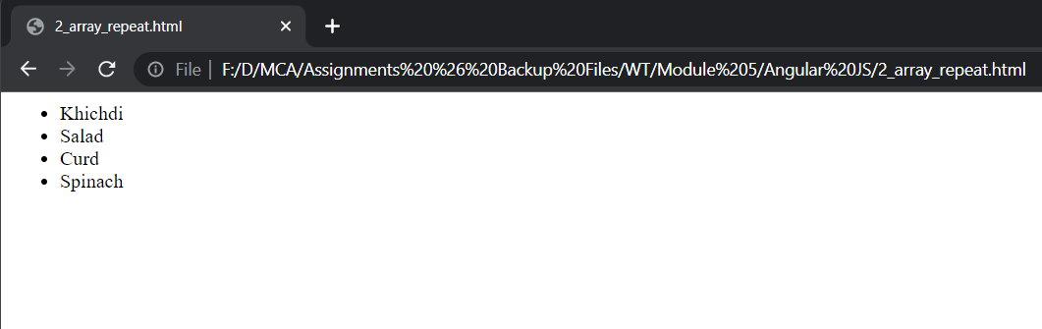**Output:**

1. Aim:

Write a program to display a list of terms and conditions after checking “Yes I Agree” it

will enable “Install” Button.

Theory:

To understand the use of ng-if directive

Code:

<html>

    <head></head>

    <body>

        <script src="https://ajax.googleapis.com/ajax/libs/angularjs/1.8.2/angular.min.js" type="text/javascript"> </script>

        <body ng-app>

        <h1>Terms and policies</h1>

        <ol>

            <li>You will click the I agree button</li>

            <li>You will be there for sure</li>

            <li>You will listen carefully</li>

        </ol>

        Click me: <input type="checkbox" ng-model="checked"></checkbox>

        <input type="submit" value="install" ng-if="checked"/>

    </body>

</html>

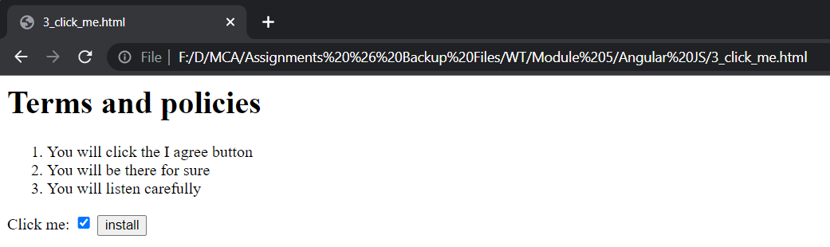**Output:**

1. Aim:

Write a program to accept the values from the user to calculate simple interest by

clicking on a button it will display an answer.

Theory:

To understand the use of ng-click directive

Code:

<html>

    <head></head>

    <script src="https://ajax.googleapis.com/ajax/libs/angularjs/1.8.2/angular.min.js" type="text/javascript"> </script>

    <body ng-app>

        Enter Principal: <input type="number" ng-model="principal">

        <br><br>

        Enter Years: <input type="number" ng-model="years">

        <br><br>

        Interest rate: <input type="number" ng-model="rate">

        <br><br>

        <input type="submit" value="Calculate Interest"

        ng-click="si=(principal*years*rate)/100">

        {{"Simple interest is "+ si }}

    </body>

</html>

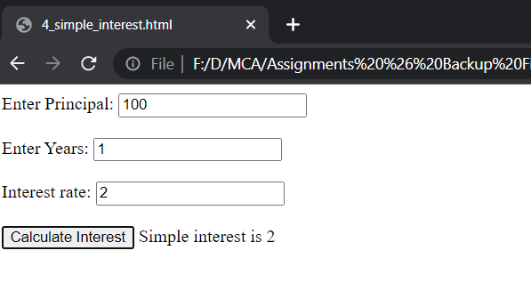**Output:**

1. Aim:

Write a program to demonstrate module and controller.

Theory:

To learn how to create application and controller in script tag in order add functionality directly in HTML in angular js

Code:

<html>

    <head></head>

    <script src="https://ajax.googleapis.com/ajax/libs/angularjs/1.8.2/angular.min.js" type="text/javascript"> </script>

    <body ng-app="myapp" ng-controller="myctrl">

       {{"First Name: " + firstname}}

        <br><br>{{"Last Name: " + lastname}}

    </body>

    <script>

        var app= angular.module("myapp",[])

        app.controller("myctrl",function($scope){

            $scope.firstname = "Sandhya";

            $scope.lastname = "Santosh";

        });

    </script>

</html>

**Output:**

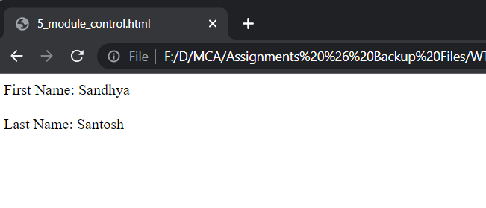

1. Aim:

Write a program to create Employee object in the controller and also create properties

like name,address and salary.

Theory:

To learn how to create and use a collection of objects within a controller and how to write it in an expression in angular js as well

Code:

<html>

    <head></head>

    <script src="https://ajax.googleapis.com/ajax/libs/angularjs/1.8.2/angular.min.js" type="text/javascript"> </script>

    <body ng-app="myapp" ng-controller="myctrl">

        <div ng-repeat="emp in Employee">

            <p>Name: {{emp.Name}}</p>

            <p>Address: {{emp.Address}}</p>

            <p>Salary: {{emp.Salary}}</p>

        </div>

    </body>

    <script>

        var app=angular.module("myapp",[])

        app.controller("myctrl",function($scope){

            $scope.Employee=[{Name:"Rakesh",Address:"Mulund",Salary:100},

            {Name:"Sandhya",Address:"Kandivali",Salary:450},

            {Name:"Souleh", Address:"Malad",Salary:350}

            ]

        });

    </script>

</html>

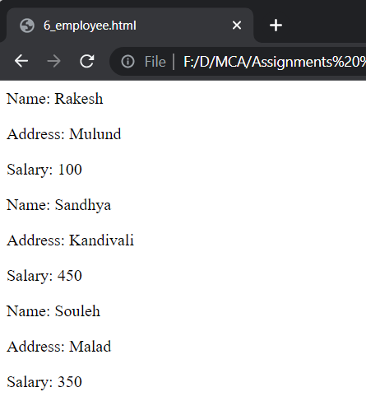**Output:**

1. Aim:

Write a program to enter Book Details like Book Name (Use Uppercase only), Price (In

Rupees), Current Date (in YYYY/MM/DD) use different filters and print data on click

event.

Theory:

To learn about filters in angular js as well the “new Date()” in built method in angular js

Code:

<html>

    <head></head>

    <script src="https://ajax.googleapis.com/ajax/libs/angularjs/1.8.2/angular.min.js" type="text/javascript"> </script>

    <body ng-app="myapp" ng-controller="myctrl">

        Enter Name: <input type="text" ng-model="name">

        Enter Amount: <input type="text" ng-model="amount">

        <input type="submit" value="show" ng-click="data()">

        <br><br>   Name: {{ n | uppercase }}

        <br><br>  Amount: {{amt | currency:"₹ ":4}}

        <br><br>  Date: {{date | date: "yyyy/MM/dd" }}

    </body>

    <script>

        var app= angular.module("myapp",[]);

        app.controller("myctrl",function($scope){

            $scope.data = function(){

                $scope.n=$scope.name;

                $scope.amt=$scope.amount;

                $scope.date= new Date();

            }

        });

    </script>

</html>

**Output:**

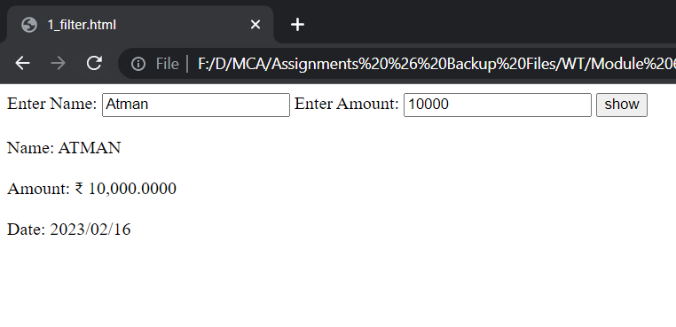

1. Aim:

Write a program to generate an array of your favourite cars and also provide searching

functionality.

Theory:

To learn about the filter filter which is used to select and return a subset of collection of items matching the comparator or an expression itself in the angular js code

Code:

<html>

    <title></title>

    <script src="https://ajax.googleapis.com/ajax/libs/angularjs/1.8.2/angular.min.js" type="text/javascript"> </script>

    <body ng-app="myapp" ng-controller="myctrl">

        Find Car: <input type="text" ng-model="search">

        {{cars|filter:search}}

    </body>

    <script>

        var app = angular.module("myapp",[]).controller("myctrl",function($scope){

            $scope.cars=["Ferrari","Fortuner","Maruti Suzuki"]

        });

    </script>

</html>

**Output:**

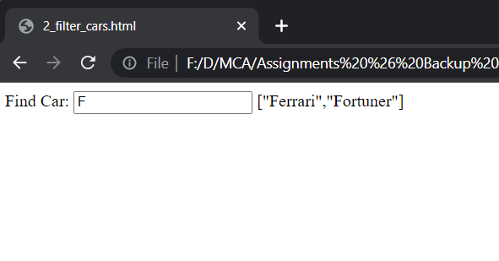

1. Aim:

Write a program to generate student object which will hold at least 5 student data (Id,

Name). Display all the data in tabular format and also provide ascending sort facility in

column header.

Theory:

To create a function in app controller as well use the filter ‘orderBy’ in combination with ng-repeat and ng-click in order to sort columns ascending order based on click on the column headers

Code:

<html>

    <script src="https://ajax.googleapis.com/ajax/libs/angularjs/1.8.2/angular.min.js" type="text/javascript"> </script>

    <title>Arrange Table</title>

    <body ng-app="myapp" ng-controller="myctrl">

        <table border="4">

            <tr>

                <th ng-click="orderby('Name')">Name</th>

                <th ng-click="orderby('rollno')">Roll No</th>

            </tr>

            <tr ng-repeat="s in students | orderBy:orderbyme ">

                <td>{{s.Name}}</td>

                <td>{{s.rollno}}</td>

            </tr>

        </table>

    </body>

    <script>

        angular.module("myapp",[]).controller("myctrl",function($scope){

            $scope.students = [{Name:"Sandhya",rollno:100},

                                {Name:"Ayesha",rollno:15},

                                {Name:"Rita",rollno:31},

                                {Name:"Seema",rollno:41},

                                {Name:"Mahima",rollno:101},

                                {Name:"Sana",rollno:151},

                                {Name:"Reema",rollno:110},

                                {Name:"Ayushi",rollno:1}];

                                $scope.orderby=function(x){

                                $scope.orderbyme=x;

         }

        });

    </script>

</html>

**Output:**

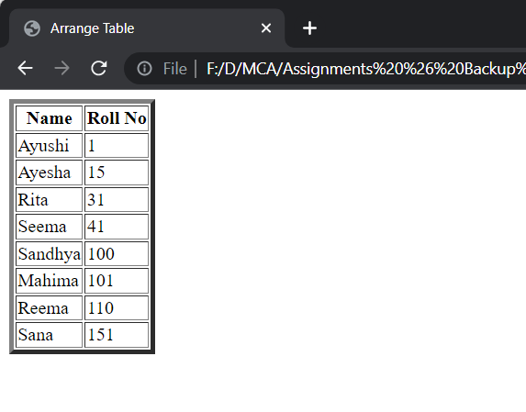

1. Aim:

Write a program to demonstrate mouse events in angular.js

Theory:

To simulate mouse events and change color of a div using ng-mouseenter and ng-mouseleave

Code:

<html>

    <title></title>

    <script src="https://ajax.googleapis.com/ajax/libs/angularjs/1.8.2/angular.min.js" type="text/javascript"> </script>

    <head>

        <style>

                .redblock{

                    height: 100px;

                    width: 100px;

                    background-color: red;

                }

                .yellowblock{

                    height: 100px;

                    width: 100px;

                    background-color: yellow;

                }

        </style>

    </head>

    <body ng-app>

        <div ng-class="{redblock:enter,yellowblock:exit}"

        ng-mouseenter="enter=true;exit=false"

        ng-mouseleave="enter=false;exit=true">

            Mouse<span ng-show="enter">

                <br><br>

                Entered</span>

                <br><br>

            <span ng-show="exit">Left the block</span>

        </div>

        <br><br>

        <button type="button">Click Me!</button>

        </br><br>

    </body>

</html>

**Output:**

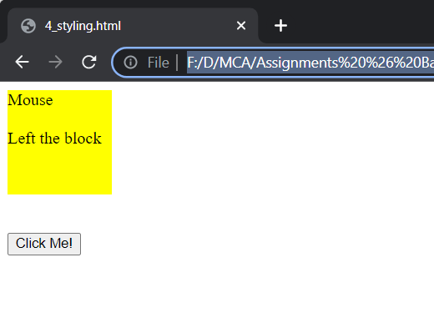

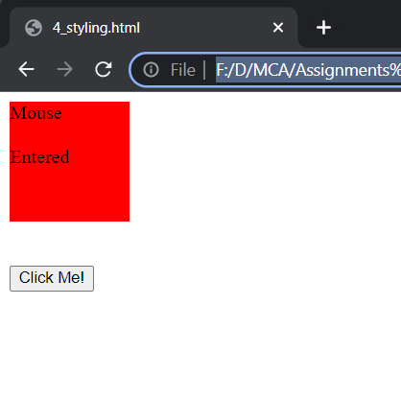

1. Aim:

Write a program to select any one subject from the drop-down list and display the

content of the selected subject (use switch directive)

Theory:

To learn and use ng-switch and ng-switch-when along with the option tag in html

Code:

<html>

<title></title>

<script src="https://ajax.googleapis.com/ajax/libs/angularjs/1.8.2/angular.min.js" type="text/javascript"> </script>

<head></head>

<body ng-app>

    <form>

    Select Subject:

    <select ng-model="subject">

        <option value=""> Java </option>

        <option value="wt"> Web Technologies </option>

        <option value="adms"> ADBMS </option>

        <!-- <option value="ai"> Artificial Intelligence </option> -->

    </select>

    <hr>

    <div ng-switch="subject">

        <div ng-switch-default>

            <h1>Java Programming</h1>

            <p>It consists of Advanced Java Topics</p>

        </div>

        <div ng-switch-when="wt">

            <h1>Web Technologies</h1>

            <p>It consists of Node Js and Angular JS</p>

        </div>

        <div ng-switch-when="adms">

            <h1>ADBMS</h1>

            <p>It consists of Data Warehousing and Management</p>

        </div>

    </div>

    <hr>

</form>

</body>

</html>

**Output:**

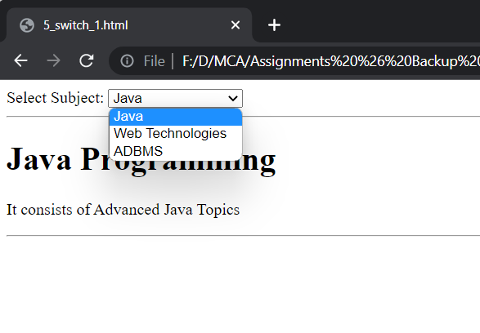

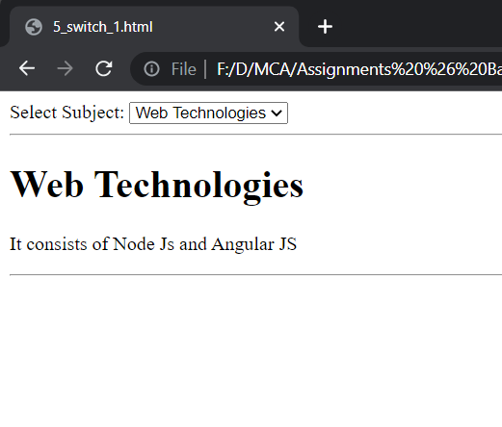

1. Aim:

Write a program to type text in a textbox provide the functionality of bold, italic and

underline and also display color options in dropdown list

Theory:

To learn the use of bold, underline and italics html tags “b”,”i”,”u”, and using ng-switch in combination of style html attribute

Code:

<html>

<title></title>

<script src="https://ajax.googleapis.com/ajax/libs/angularjs/1.8.2/angular.min.js" type="text/javascript"> </script>

<head></head>

<body ng-app>

    <form >

        Enter Some Text: <input type="text" ng-model="data">

        <br><br>

        Select Styling:

        <select ng-model="styling">

            <option value=""> Bold and Blue </option>

            <option value="i"> Italic and Green </option>

            <option value="u"> Underline and red </option>

        </select>

        <div ng-switch="styling">

            <b ng-switch-default style="color:blue" >

            {{data}}</b>

            <i ng-switch-when="i" style="color:green">

            {{data}}</i>

            <u ng-switch-when="u" style="color:red">

            {{data}}</u>

        </div>

    </form>

</body>

</html>

**Output:**

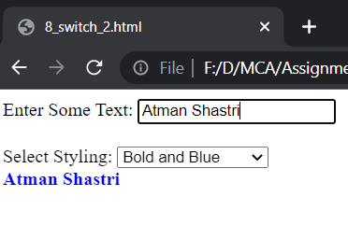

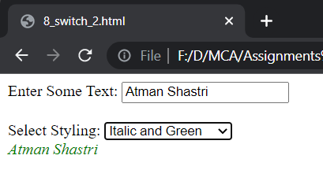

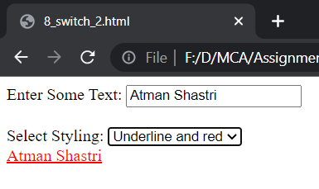

1. Aim:

Write a program to demonstrate how many characters are entered in the textbox. (use

ng-keypress)

Theory:

To learn and use keyboard events, ng-keypress directive to log the number of keypresses and update it dynamically on the webpage

Code:

<html>

    <title></title>

    <script src="https://ajax.googleapis.com/ajax/libs/angularjs/1.8.2/angular.min.js" type="text/javascript"> </script>

    <head></head>

    <body ng-app>

        Enter Text: <input type="text" ng-keypress="count=count+1" ng-init="count=0">

        <h1>Key Presses: {{count}} times</h1>

    </body>

</html>

**Output:**

