Web Technologies Module 7,8 Assignment 5

Atman Shastri, FYMCA-C, 182

1. Aim:

Write a program to enter the radius of a circle and calculate area of circle in controller

and display this area in alert by clicking on button.  
  
Theory:

To learn the usage of alert and ng-click in angular js

Code:

<html>

    <head></head>

    <script src="https://ajax.googleapis.com/ajax/libs/angularjs/1.8.2/angular.min.js" type="text/javascript"> </script>

    <body ng-app="myapp" ng-controller="myctrl">

        Enter Radius: <input type="text" ng-model="radius">

        <input type="submit" value="calculate Area" ng-click="calc(radius)">

    </body>

    <script>

        var app = angular.module("myapp",[])

        app.controller("myctrl",function($scope){

            $scope.calc = function(radius){

            $scope.area=Math.PI*$scope.radius*$scope.radius;

            alert("Area "+ $scope.area);

         }

        });

    </script>

</html>

Output:  
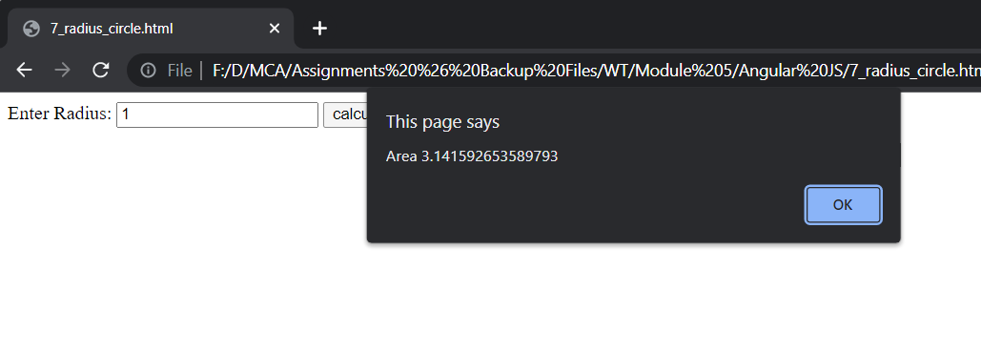

1. Aim:

Write a program to create a Student Object which holds at least 3 student information

like Roll No., Name and Percentage and display it in tabular form.

Theory: To learn how to create an object and the usage of ng-repeat in a tabular form in angular js

Code:

<html>

    <head>   </head>

    <script src="https://ajax.googleapis.com/ajax/libs/angularjs/1.8.2/angular.min.js" type="text/javascript"> </script>

    <body ng-app="myapp" ng-controller="myctrl">

     <table border="1">

        <tr>

            <th>Name</th>

            <th>Roll No</th>

            <th>Percentage</th>

        </tr>

        <tr ng-repeat="student in students">

            <td>{{ student.Name }}</td>

            <td>{{ student.RollNo }}</td>

            <td>{{ student.Percentage }}</td>

        </tr>

     </table>

    </body>

    <script>

        var app = angular.module("myapp",[]);

        app.controller("myctrl",function($scope){

            $scope.students = [{Name:"Sandhya",RollNo:110,Percentage:"87%"},

                              {Name:"Sandeep",RollNo:120,Percentage:"90%"},

                              {Name:"Ronak",RollNo:56,Percentage:"89%"}]

        });

    </script>

</html>

Output:

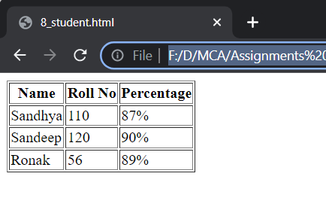

1. Aim:

Write a program to create a form with the following fields and validations.

Name (required)

email (required/email format)

Age (required, between 18 to 60 years)

Theory:

To learn form validation, its attributes and implementation in angular js code

Code:

<html>

    <title></title>

    <script src="https://ajax.googleapis.com/ajax/libs/angularjs/1.8.2/angular.min.js" type="text/javascript"> </script>

    <head></head>

    <body ng-app>

        <form novalidate name="DataForm">

            Enter Name: <input type="text" ng-model="username" name="username" required>

            <span ng-show="DataForm.username.$error.required && DataForm.username.$touched">Kindly Enter the name</span>

            <br><br>

            Email: <input type="email" ng-model="email" name="email" required>

            <span ng-show="DataForm.email.$error.email">Enter Email in proper format</span>

            <span ng-show="DataForm.email.$error.required && DataForm.email.$touched">Kindly Enter the email</span>

            <br><br>

            Enter Age: <input type="number" ng-model="age" name="age" min="18" max="60" required>

            <span ng-show="DataForm.age.$error.required && DataForm.age.$touched">Kindly Enter the age</span>

            <span ng-show="DataForm.age.$error.min">Age is very low</span>

            <span ng-show="DataForm.age.$error.max">Age is very high</span>

            <br><br>

            <input type="submit">

        </form>

    </body>

</html>

**Output:**

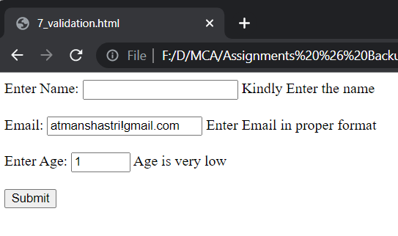

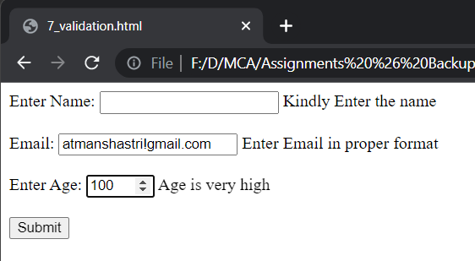

1. Aim:

Write a program that shows the following functionality. Initially all the controls will have a

yellow background. If a user enters a valid value then it will change the background color

to green, otherwise it will turn to red if there is a validation error

Theory:

To learn to implement colors to form validation attributes by defining them in style tag

Code:

<html>

    <title></title>

    <script src="https://ajax.googleapis.com/ajax/libs/angularjs/1.8.2/angular.min.js" type="text/javascript"> </script>

    <head>

        <style>

                input.ng-pristine {

                    background: yellow;

                }

                input.ng-touched.ng-valid{

                    background: green;

                }

                input.ng-touched.ng-invalid {

                    background: red;

                }

        </style>

    </head>

    <body ng-app>

        <form novalidate name="DataForm">

            Enter Name: <input type="text" ng-model="username" name="username" required>

            <span ng-show="DataForm.username.$error.required && DataForm.username.$touched">Kindly Enter the name</span>

            <br><br>

            Email: <input type="email" ng-model="email" name="email" required>

            <span ng-show="DataForm.email.$error.email">Enter Email in proper format</span>

            <span ng-show="DataForm.email.$error.required && DataForm.email.$touched">Kindly Enter the email</span>

            <br><br>

            Enter Age: <input type="number" ng-model="age" name="age" min="18" max="60" required>

            <span ng-show="DataForm.age.$error.required && DataForm.age.$touched">Kindly Enter the age</span>

            <span ng-show="DataForm.age.$error.min">Age is very low</span>

            <span ng-show="DataForm.age.$error.max">Age is very high</span>

            <br><br>

            <input type="submit">

        </form>

    </body>

</html>

**Output:**

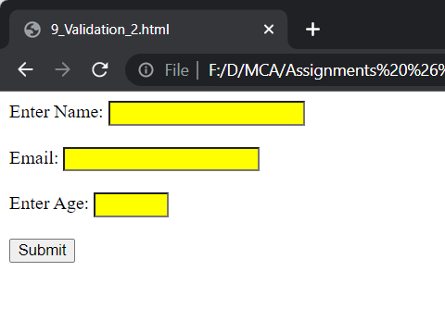

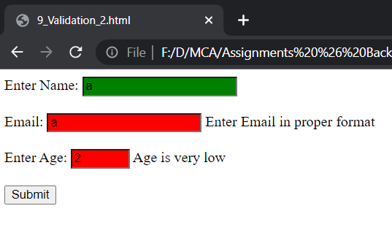

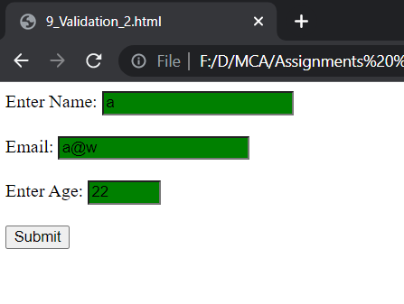

1. Aim:

Write a program to demonstrate a custom model update trigger.

Theory:

To understand the use of ng-model-options to override the normal behavior of ng-model

Code:

<html ng-app>

    <title></title>

    <script src="https://ajax.googleapis.com/ajax/libs/angularjs/1.8.2/angular.min.js" type="text/javascript"> </script>

    <head>

    </head>

    <body>

        <form novalidate name="modelform">

            Enter Last Name: <input type="text" name="name" ng-model="user.lastname" ng-model-options="{updateOn: 'blur'}">

            <br><br>

            {{user.lastname}}

        </form>

    </body>

</html>

**Output:**

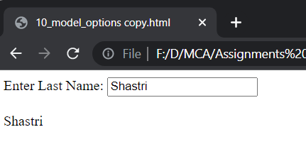

1. Aim:

Write a program that accepts a string which is having an ‘abc’ character in sequence;

otherwise display error messages using custom validation.

Theory:

To learn to make a user defined directive to implement custom validation in a html form

Code:

<html>

    <title></title>

    <script src="https://ajax.googleapis.com/ajax/libs/angularjs/1.8.2/angular.min.js" type="text/javascript"> </script>

    <head>

    </head>

    <body ng-app="myApp">

        <form name="dataForm" novalidate>

        Enter Value = <input type="text" name="myData" my-directive="abcValidation" ng-model="myData">

        <h1 ng-show="!dataForm.myData.$valid">Please Enter String "abc"</h1>

    </form>

    </body>

    <script>

        var app = angular.module("myApp",[]);

        app.directive("myDirective",function(){

            return {

                require:"ngModel",

                link: function(scope,element,attr,mctrl){

                    function myValidation(value){

                        if(value.indexOf("abc")>-1){

                            mctrl.$setValidity("abcValidation",true);

                        }else{

                            mctrl.$setValidity("abcValidation",false);

                        }

                        return value;

                    }

                    mctrl.$parsers.push(myValidation);

                }

            }

        });

    </script>

</html>

**Output:**

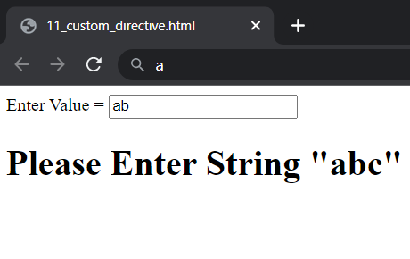

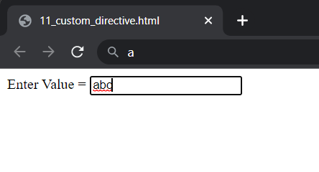

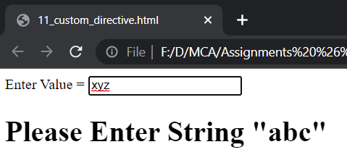

1. Aim:

Write a program to create an SPA application.

Theory:

To learn to create a single page application in angular js as well as import and use the ngRoute module

Code:

<html>

    <head>

        <script src="https://ajax.googleapis.com/ajax/libs/angularjs/1.8.2/angular.min.js" type="text/javascript"></script>

        <script src="https://cdnjs.cloudflare.com/ajax/libs/angular-route/1.8.3/angular-route.min.js" type="text/javascript"></script>

    </head>

    <body ng-app="myApp">

        <script type="text/ng-template" id="homeContent">

            <h1>Home</h1>

            <h3>{{message}}</h3>

        </script>

        <script type="text/ng-template" id="aboutUsContent">

            <h1>About Us</h1>

            <h3>{{message}}</h3>

        </script>

        <script type="text/ng-template" id="blogsContent">

            <h1>Blogs</h1>

            <h3>{{message}}</h3>

        </script>

        <a href="#!">Home</a>

        <a href="#!aboutus">About Us</a>

        <a href="#!blogs">Blogs</a>

        <div ng-view></div>

        <script>

            var app = angular.module("myApp",['ngRoute']);

            app.config(function($routeProvider){

                $routeProvider.when("/",{

                    templateUrl: "homeContent",

                    controller: "homeController"

                }).when("/aboutus",{

                    templateUrl: "aboutUsContent",

                    controller: "aboutUsController"

                }).when("/blogs",{

                    templateUrl: "blogsContent",

                    controller: "blogsController"

                }).otherwise({redirectTo:"/"})

            });

            app.controller("homeController",function($scope){

                $scope.message="Hello This is Homepage";

            });

            app.controller("aboutUsController",function($scope){

                $scope.message="Hello This is About us page";

            });

            app.controller("blogsController",function($scope){

                $scope.message="Hello This is Blog page";

            });

        </script>

    </body>

</html>

**Output:**

