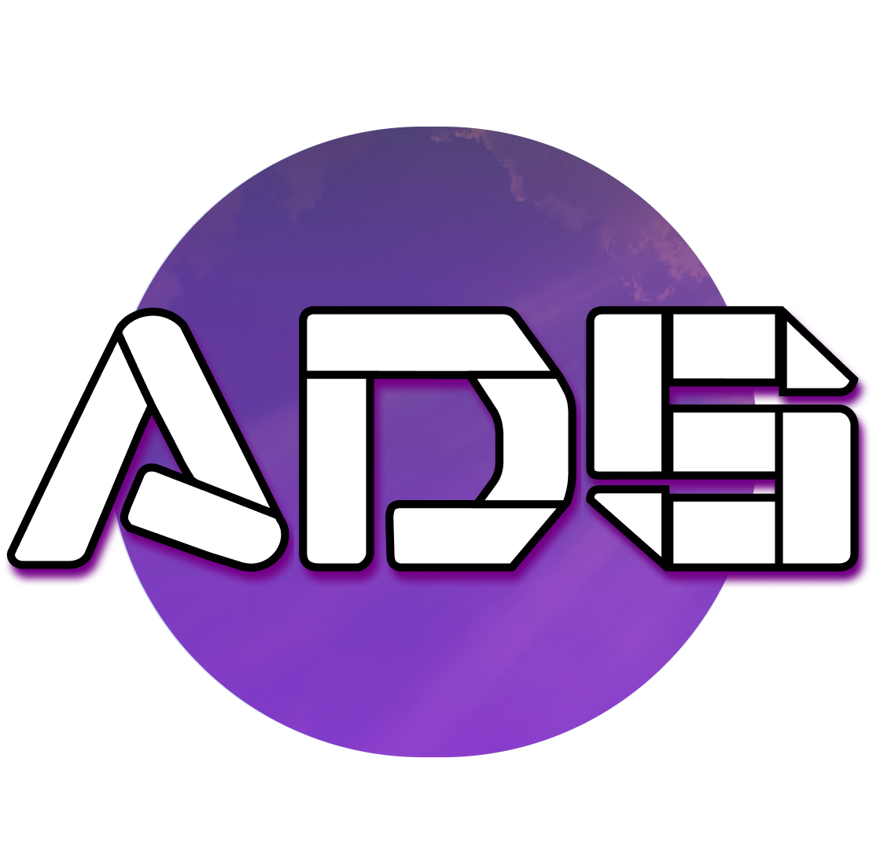

# Terms of Service - Atmos Design Studio

Atmos Design Studio  
Address: Forskningsringen 94, 174 61 Sundbyberg, Stockholm, Sweden  
Phone: +46 70 123 4567  
Email: contact@atmosdesignstudio.se

## 1. Contract Agreement & Initial Payment

Upon signing the contract, a non-refundable initial payment (deposit) is required to secure the project. This payment confirms the start of work and is non-refundable under any circumstances.

## 2. Project Support & Maintenance

After project completion, we provide support based on the terms outlined in the contract. The support period varies depending on the service package selected. Additional support or maintenance services outside the included period may incur extra costs, which will be quoted based on the scope of the requested changes.

## 3. Security & Hosting

We prioritize the security of your website and collaborate with one.com, a trusted hosting provider, to ensure the highest level of protection. Our services include:  
- SSL Certificates to secure your website's data.  
- Daily Backups to prevent data loss.  
- DDoS Protection to shield your site from potential threats.

## 4. Changes & Modifications

Any changes or modifications to the website post-launch that are not covered in the original agreement will incur additional costs. These costs depend on the complexity and size of the changes required and will be quoted beforehand.

## 5. Contract Termination

In the event of a contract breach, the matter will be escalated to legal authorities for resolution. Any expenses arising from legal proceedings will be the responsibility of the party found to be in breach of contract.

## 6. Liability & Disclaimer

While we take all necessary precautions to ensure the stability and security of your website, Atmos Design Studio is not liable for any direct or indirect damages arising from the use of our services. This includes, but is not limited to, website downtime, security breaches, or data loss.

## 7. Ongoing Support & Updates

We offer ongoing support services upon request. The cost for ongoing support, updates, or content changes will be determined based on the required work and quoted separately.

## 8. Payment Terms

All invoices must be settled within 30 days of the issue date unless otherwise agreed upon in writing. Failure to pay may result in the suspension of services until full payment is received.

## 9. Confidentiality & Data Protection

We maintain strict confidentiality regarding any client data shared during the project. Your data is securely hosted with one.com, which complies with current data protection regulations.

## 10. Governing Law

These terms are governed by Swedish law. Any disputes arising from these terms will be settled in the courts of Stockholm, Sweden.

## 11. Acknowledgment

By accepting this document, you agree to the terms and conditions set forth by Atmos Design Studio.  
  
Client Name: ____________________  
Date: ____________________  
Client Signature: ____________________