Quick Start guide – get the POJO sample running on Glassfish V3 (and gain a basic understanding of how it works)

Even quicker start…
The quick start below contains descriptions to provide a bit more background for anyone who wants it, but if you simply need to get the atmosphere sample chat application up and running ASAP, just follow the numbered steps in this quick start section and ignore everything else.

For those new to COMET as well as to Atmosphere…
It is probable that you have a general idea of what COMET is if you are reading this document, but just to set the scene for those who may not, COMET is a name that has been given to a group of programming techniques that allow a Web Server push information to a browser (or in reality to simulate PUSH behavior).
Traditionally the web has been a ‘client server’, ‘request response’ environment – a client (browser) will request something (a web page for example) from a server and the server will respond back to the client.
COMET allows the web server also ‘push’ information to the client . It is important to understand that for this to work the client must have told the server that it is prepared to accept COMET messages (this is often referred to as opening a COMET connection), and it must have some functionality included in it to accept and act on messages received from the server.
There are two common COMET techniques, both of which are supported by Atmosphere, long polling and HTTP streaming.
Both effectively ‘trick’ the server into thinking that the client is simply making a standard HTTP request to it – in the former case the HTTP request is not responded to until the server has something to tell the browser (and as soon as it is responded to another request is opened to wait for the next message from the server), and in the latter case the server only partially responds and thus never ‘finishes’ the response, hence never closing the request/response interaction.
There are many good COMET overviews on the web – a quick web or Wikipedia search is a good place to start to learn more.
Note that in the future the HTML5 specification is evolving to include ‘PUSH’ functionality as standard. Although standards are not complete yet , it is pretty much beyond doubt that this will use a technology called Web Sockets. Again a web or Wikipedia search will provide some background on this technology, and it is worth understanding to allow you consider future evolution of any web application you may be considering adding PUSH functionality to. Note also that Atmosphere is intended to support Web Socket functionality also, which should ease any migration from COMET to Web Sockets in your web applications.

Downloading the Atmosphere POJO chat sample
The latest tested and released version of the POJO Atmosphere Chat application is available on the Atmosphere home page. Its name has the format:
JavaScript Chat using POJO
And the WAR file name has the format:
atmosphere-chat-0.5.3.war
To download the application follow these steps:
- Got to the Atmosphere home page at “https://atmosphere.dev.java.net/”
- Go to the ‘Download our samples’ section of the Atmosphere home page and choose the binary download link for “JavaScript Chat using POJO”:
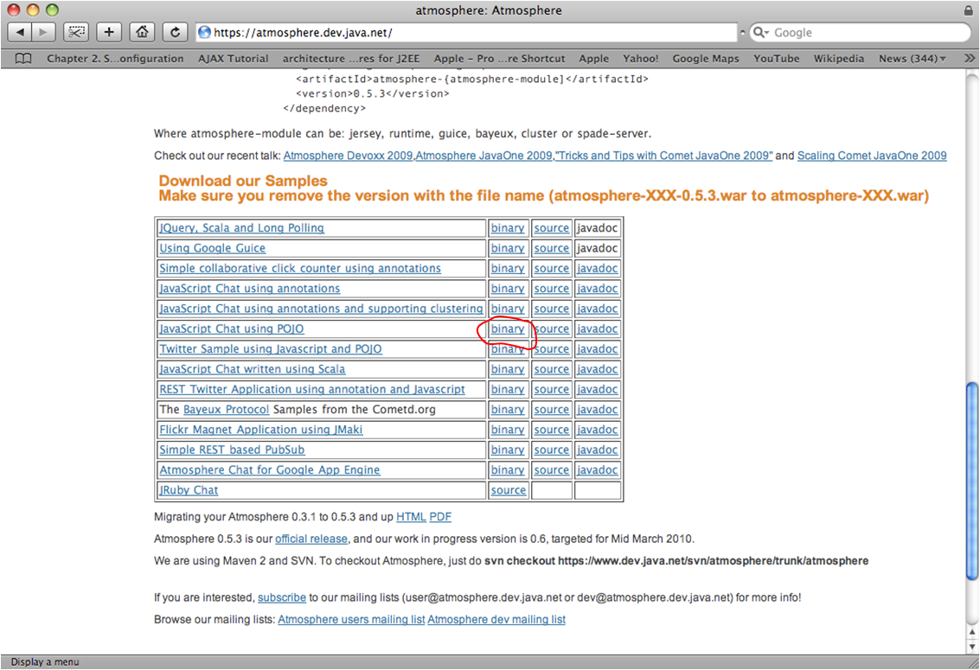

- You will either be prompted to save the file or a download will start depending on your operating system and environment – either way save the war file (e.g. atmosphere-chat-0.5.3.war) in a place you can subsequently retrieve it.
- The version number must now be removed before you deploy the application – to do this rename the war file, removing the version number part – i.e. for this example rename from “atmosphere-chat-0.5.3.war” to “atmosphere-chat.war”.

Deploying the Atmosphere POJO chat sample on Glassfish V3
It is assumed that you know how to install and start the Glassfish webserver – if not there is good documentation available on the Glassfish home page: “https://glassfish.dev.java.net/”
- Go to the admin consul on your Glassfish V3 installation and select “deploy an application”:

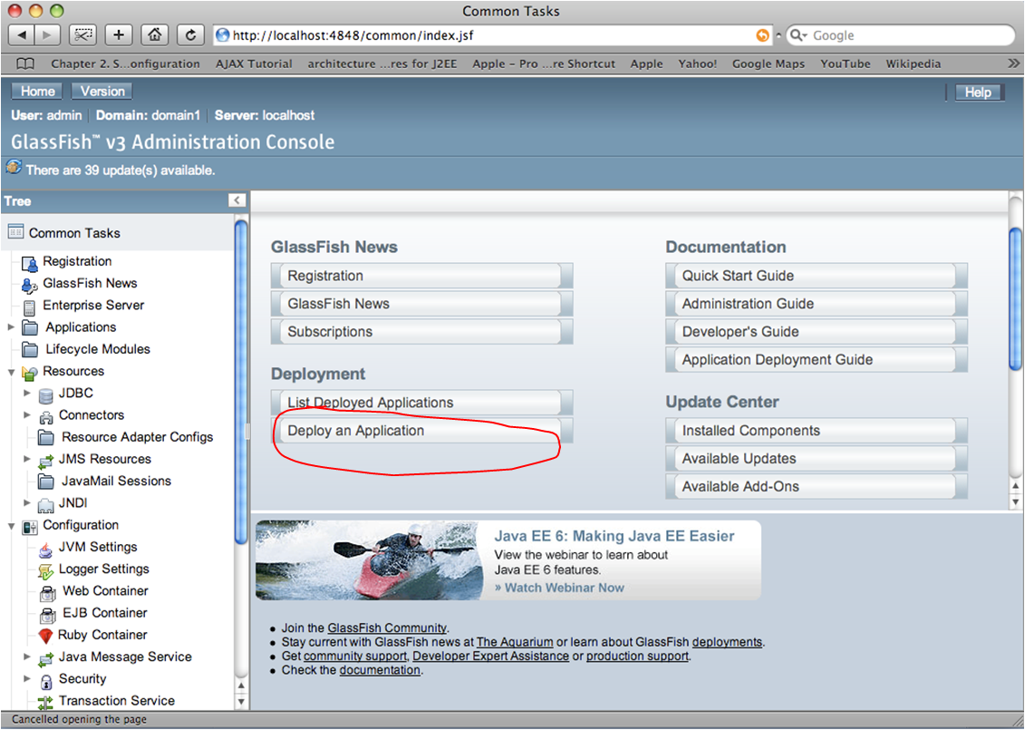
- Use the ‘browse’ button to find the renamed ‘atmosphere-chat.war’ file you saved.
- Select other options as desired – if you have no preferences or are new to Glassfish just stick with defaults.
- Now put a tick against the application name and click the launch button:
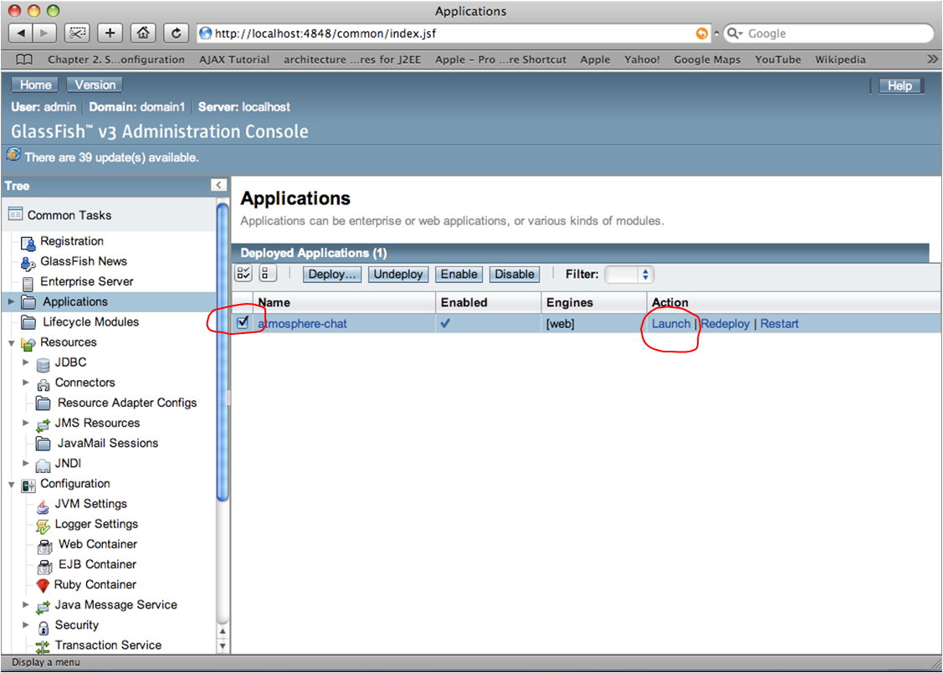
- A new browser should now open with the Glassfish sample chat application running:
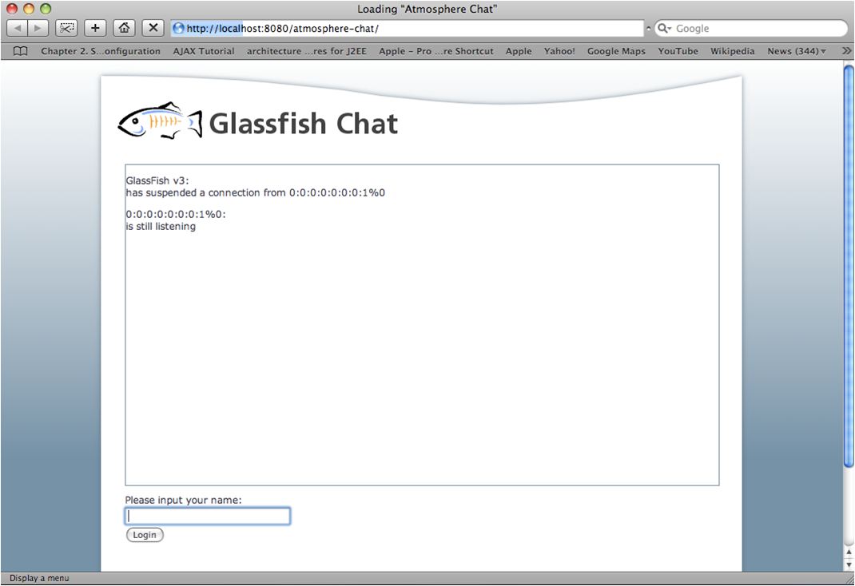

Using the chat sample application on a single machine – client and server

- In the browser enter a name and hit the login button. Note that the URL for the sample chat program is ‘http://localhost:8080/atmosphere-meteor-chat/’
- Post a message and hit the post button – the message will appear in the main screen:
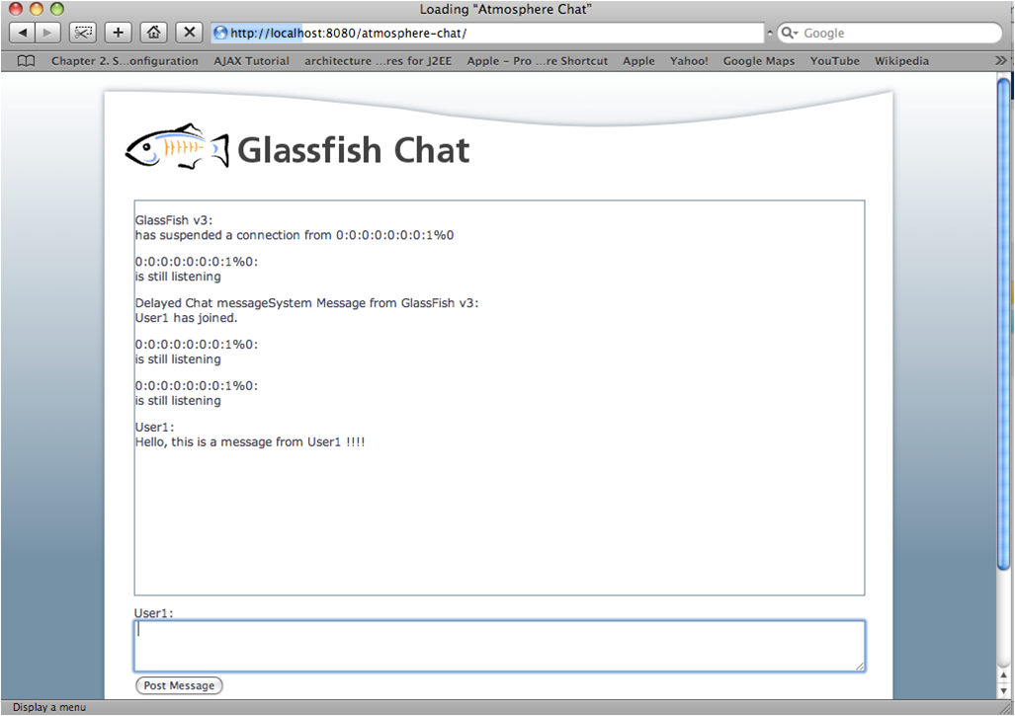
So far here we are simply chatting with ourselves on a single browser which is not really demonstrating the application. To send messages between different browser windows open a separate browser (a different ‘brand’ of browser, not just a new window or tab) and point it towards the same URL (‘http://localhost:8080/atmosphere-meteor-chat/’).
- Open a browser window from a different browser application and point it towards the same URL as the first browser (‘http://localhost:8080/atmosphere-meteor-chat/’). This will mean you have two different browser running on your desktop (e.g. Internet Explorer and Firefox, or Safari and Firefox etc). Using a new window or a tab in an existing browser will generally not work.
- Login to the chat application on the new browser window with a new user name – i.e. different than the one you used in the first browser window.
- Post a message in either browser now and you will see it displayed in both windows.

Using the chat sample application on two or more client machines
If you want to see how the chat application works over two or more client machines (i.e. a single server but separate computers using their browser to access the server) the easiest way to do this is to run the server and browser on a single machine as above, and then run just a browser on a different machine. The browser on the second machine can be any browser – it does not have to be different than the one on the first computer (as it had to be with the second browser example on a single machine above).
- Find the IP address of the computer which is hosting the first browser and the Glassfish server. It is assumed that you know how to do this – if not there are many web resources which will show you how for your particular operating system. Note that this example assumes your two computers are on the same LAN and the IP traffic will not traverse a NAT (a device which typically translates IP addresses on a local private network to a public IP address). This will be the case for most people testing with two computers on the same desk or in the same room, which is probably the typical use case. If your use case is not like this you will either need to speak to your network administrator or simply move a computer to the same network as your first computer temporarily.
- Start up any browser on the second computer and point it at the URL made up of the IP address of the first computer followed by : ‘:8080/atmosphere-meteor-chat/’. For example, if the IP address of the first computer is 192.168.0.51 the URL would be ‘http://192.168.0.51:8080/atmosphere-meteor-chat/’
- Now login and post messages as above.

How does it work – what is happening when I start up, login and post messages?
The easiest way to understand how the sample application works is probably to use client and server side debuggers to set tracepoints, step through the sample line by line, and view messages being sent backwards and forwards.
On the server side an IDE such as NETBEANS or ECLIPSE will allow you import the WAR file (as the WAR file includes the source code) and on the client side a browser debugger such as Firebug on Firefox will allow you view messages and set tracepoints in the client side Javascript.
Note that this guide will not attempt to explain how to import a war file into your favorite IDE, or how to use your favorite browser debugging tool as these will have their own release schedules independent of Atmosphere and this guide could quickly become out of date. Most major IDEs and browser tools will have plenty of web resources available to explain these basic operations.
To get your investigations started, and to explain one or two tricky bits which may be difficult to follow when looking through the code, the following gives an overview of how the sample application works from initial start it up, to the point where you post and exchange chat messages.

What happens when you start up the sample application in the server initially?
- Glassfish will load the sample application, creating the Atmosphere Servlet and set up its URL mapping to reflect the pattern matching contained in the web-xml config for the Atmosphere servlet.
- The Atmosphere servlet will look at the atmosphere config and customize any behavior accordingly
- The server is now ready to accept HTTP requests from the client

What happens when you first point your browser towards the URL of the sample application?
- The browser will send an initial HTTP GET request to the sample application with a URL of ‘http://localhost:8080/atmosphere-chat/’ (assuming the server is hosted on your local machine).
- The server will respond with the index.html.
- The index.html page contains instructions to download javacsript files which the client will now do also. Most of these are library files (prototype.js, behavior.jx , moo.fx.js, moo,fx.pack.js) but the last one is the sample chat application specific java script file (application.js).
- The application.js file contains an instruction to run some code when the page loads. This code initializes the application and calls a function to create an iFrame (app.lsiten function). This iFrame is given a source URL which causes the client to send a GET request to the atmosphere handler in the sample chat application on the server. This request is the COMET connection that is never finally responded to by the server side – i.e. it is always left open. It can however, as will be seen below, receive partial or progress responses back to it and these are effectively the COMET push messages that the server sends to the browser. This is getting ahead of the flow a little but is mentioned here as it is important to understanding how an iFrame is used for COMET ‘HTTP streaming’ if you are to understand how the sample application works on the client side. If you re not familiar with iFrames and this use of them it is recommended you do some research on the web before proceeding.
- One question you may have at this point is where the ‘listener’ or ‘callback’ function is for this COMET GET request – i.e. the function to listen for and handle responses from the server (the server PUSH messages). The answer is tied up in the way that an iFrame works – the iFrame can be thought of as a separate browser sub-window that is forever loading a very long and very slowly delivered HTML file , or maybe more accurately a HTML file that is delivered in chunks with big time gaps between the chunks. When a chunk arrives the browser display the HTML in this separate sub-window as it would in a normal window… except that the iframe is never visible and that the HTML sent down is actually a piece of Javascript. This Javascript calls a function in the parent window. The function in the parent window is then effectively the missing or hidden ‘callback’ or ‘listener’ function – it interprets and handles the message from the server and acts on it. So for our sample chat application a typical server PUSH message might be:
<script type='text/javascript'>
window.parent.app.update({ name: "User1", message: "Hi, this is my message!" });
</script>
The browser will call the update function in the sample chat app, because it is told to in the Javascript above. The function it will call is ‘window.parent.app.update(…)’, and if you look in the application.js file you will see that this function in turn updates the main chat display window with the message that has been passed, which in this example above is “Hi, this is my message”.

What happens now that everything is started up and the user wants to login and send messages?
- We have jumped ahead somewhat in the above bullets to try to explain how the iFrame concept works, so to move back a little, lets assume that the GET message is sent from the iFrame to the sample chat applcitaion in the server. This message will be passed to the ChatAtmosphereHandler and this in turn will identify it as a GET request and suspend the connection and send a message to anyone using the application that this server has suspended a session from this browser. The ChatAtmosphereHandler is now done with this request and finishes.
- The user must first log into the Glass Fish Chat application – the user enters their name in the dialogue box at the bottom of the screen and hits the login button. This causes javascript code in the applcitaion.js file to call the app.login function which in turn builds an AJAX POST message containing the message the user has typed in and sends it to the server. If you are not familiar with AJAX messages you need to do some more web research, I‘m afraid, but AJAX is very well covered in many sources and is a key technology for any WEB application using COMET so you will want to be familiar with it.
- The Sever will receive this POST message and send it to the ChatAtmosphereHandler which will identify it as a POST message and extract the message, and the ‘action’ parameter which tells it is a login message. It buildsa system message to broadcast to all users telling them that a new user has joined. This message is built into a Javascript update message for the iFrame on the client side and is broadcast to all clients associated with this chat application (over their open COMET connections). The ChatAtmosphereHandler now responds with a success message to the POST message (as this is a standard AJAX XMLHTTPRequest message and not one that it being kept alive for COMET purposes) and it is now done with this request and finishes.
- The ‘broadcast’ to all users of the application is in reality a series of individual messages that are sent to each client that is ‘logged in’. You will remember that when a client first starts up it establishes a COMET connection (using the iFrame in the case of this sample application as described above). The Atmosphere broadcaster maintains a record of all these individual COMET connections, and when a message is to be broadcast it sends that message individually to each client over its ‘open’ COMET connection.
- Lets assume the user now decides to send a message to the chat application – the user enters the message in the dialogue box at the bottom of the screen and hits the post button. This causes javascript code in the applcitaion.js file to call the app.post function which once again builds an AJAX POST message containing the message the user has typed in and sends it to the server.
- The Sever will receive this POST message and send it to the ChatAtmosphereHandler which will again identify it as a POST message and extract the message, but unlike the login case above the action parameter this time indicates that this is a user posting a message to the chat application. This message is extracted and built into a Javascript update message for the iFrame on the client side and then broadcast to all clients associated with this chat room. Once again ChatAtmosphereHandler now responds with a success message to the POST message (as again this is a standard AJAX XMLHTTPRequest message and not one that it being kept alive for COMET purposes) and it is now done with this request and finishes.

