Data Loading to Mong DB

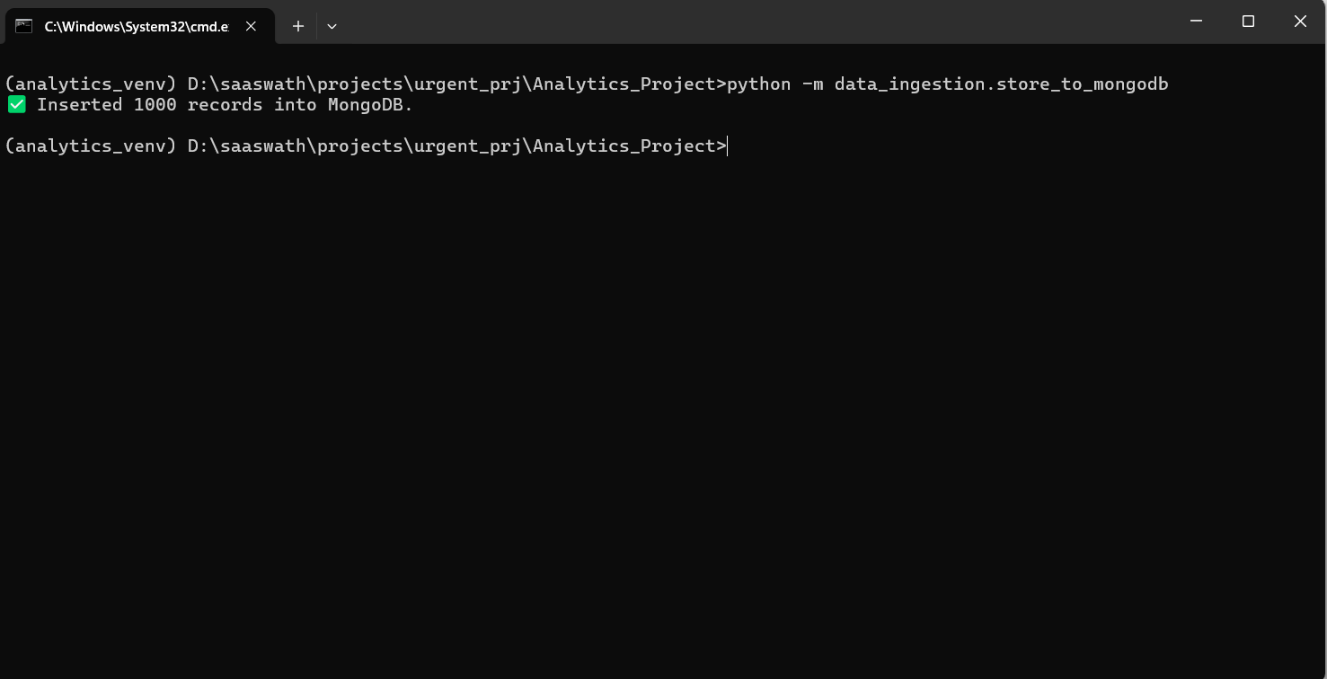

Running ETL Process and saving that to PostgresSQL

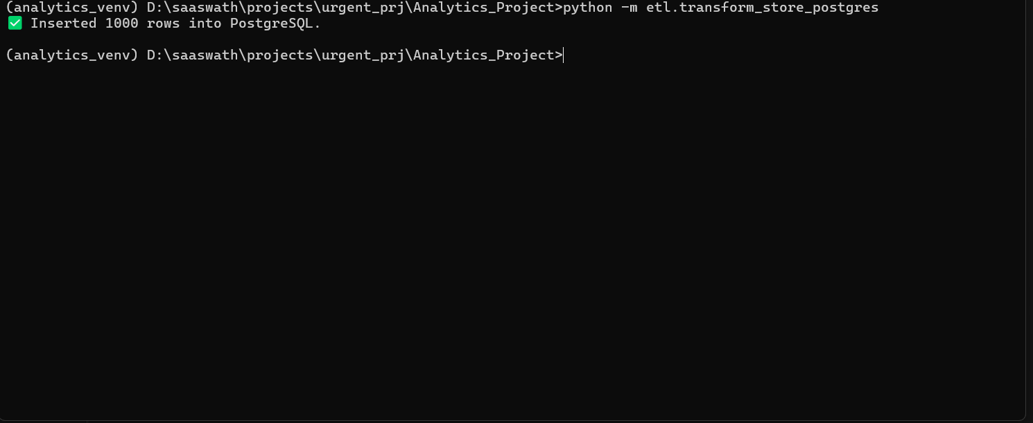

Training K Means Cluster

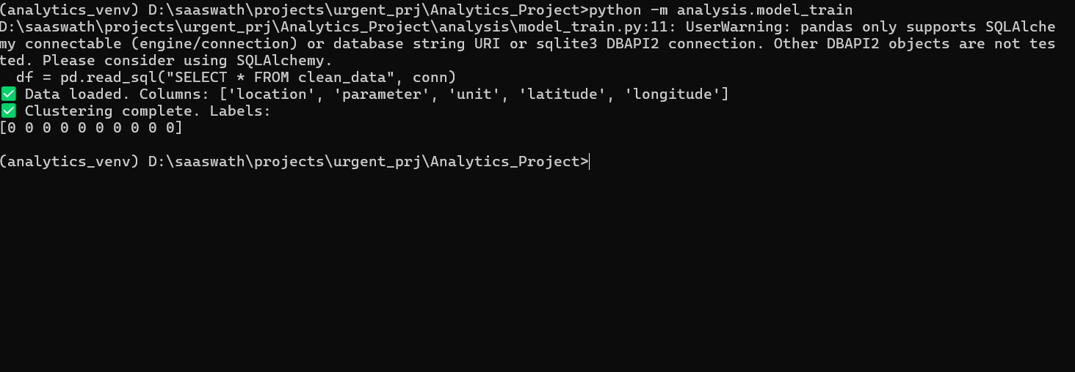

Running a Visualization Application using Flask

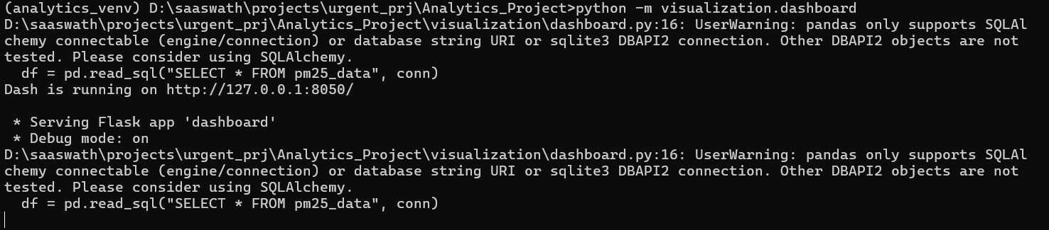

Final Visualization

