BUILDING A NSW WIN 7 MACHINE

SVHA Builds 5.0.0

The process to build a Windows 7 machine for NSW has changed slightly with the introduction of the MaterSyd Domain option.

When presented with the UI, ensure you choose “Sydney” as the final location for the PC. The “Development System” option is no longer required unless the device has a non-standard name and cannot be built using the new standard.

A second screen will be triggered upon proceeding requesting the build type required. The resulting builds will be as below:

**Windows 10 Fall Creators Update**

* SVHA Domain
* Workstations 🡪 svhanational.org.au
* Office per selection on first screen

**Windows 7 – MaterSyd**

* MaterSyd Domain
* Computers Windows 7 🡪 OU=Managed Objects 🡪 Matersyd Custom Objects 🡪 matersyd.matersydney.com.au
* Office 2013 ProPlus x86

**Windows 7 - SVMHS**

* SVMHS Domain
* Computers Win7 🡪 Managed Objects 🡪 SVMHS Custom Objects 🡪 svmhs.stvincents.com.au
* 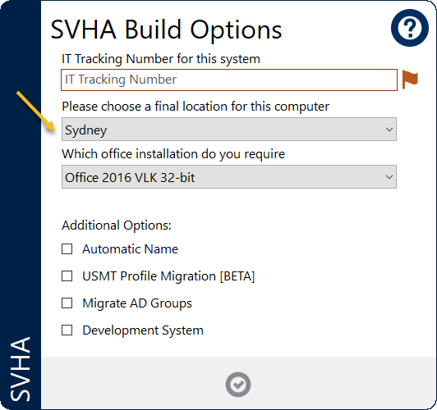Office 2013 ProPlus x86

