**BUILD OPTION: USMT RESTORE**

A new option is now included in the SVHA National Build that will allow you to migrate user profiles and data from a machine either “in-place” (rebuilding the same device) or “side-by-side” (the user is getting a new PC).

While the feature is still considered BETA, it is extremely important to back up any critical data as you usually would in case of issue.

**How do I initiate a data migration?**

When the build UI shows in a 4.3.0 and higher build you will now see an extra option on the main page titled “USMT Profile Migration [BETA]”, ticking this option will indicate you wish to perform a migration.

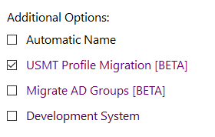

**How to migrate data (in-place and side by side)**

Once you continue you will be presented with the following screen, this is where you choose whether the migration is an “in-place” migration or a “side-by-side” migration.

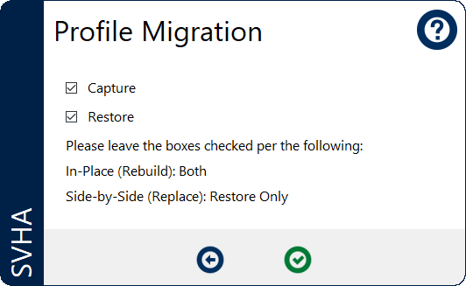

**In-Place**

An “In-Place” migration is used when the device is being “rebuilt” (there is a problem with the windows install and it is being reimaged with Windows).

To perform an in-place upgrade, simply check the “USMT Migration” option on the first page and then leave both the “Capture” and “Restore” options ticked on the “Profile Migration” page.

This will then back up any data within Windows prior to reformatting the drive and will restore the data before the rebuild is complete.

**USMT Migrations back up data to a network location. Due to the time it takes to back up all user profiles and data on a PC, this can significantly increase the time it takes to rebuild. Please consider the amount of data and the sites link speed when deciding if an in-place migration is appropriate.**

**Side-by-Side**

A “side-by-side” migration is used when the users’ device is being replaced with a new machine. A side-by-side migration is more complex and (currently) requires the involvement of the End User Computing team due to some manual work required within SCCM.

If you wish to perform a side-by-side migration please let the EUC team know by sending through the old and new asset number.

Once received we will run the “Capture” portion of the migration in the background on the current PC and set up an association that tells SCCM where the new data needs to go.

Once done, use the steps above, ensuring you untick “Capture” on the Profile Migration page.

**Data Retention**

Data is automatically stored for a set number of days after a successful migration (currently 1 month/30 days) if for any reason the new device fails we have 30 days within which we can re-restore the data.

Should a migration fail, the data is stored until deleted and can be manually retrieved by the EUC team.