

**<<FUSwap system>>**

**Software Requirement Specification**

– Hochiminh, June 2024 –

Record of changeS

|  |  |  |  |
| --- | --- | --- | --- |
| Date | A* M, D | In charge | Change Description |
| 30/06/24 | A | Gia Bao | Add Non-Functional Requirements section |
| 30/06/24 | A | Hai Anh | Add User Interfaces section |
| 30/06/24 | A | Nguyen Anh | Add Technical Requirements section |
|  |  |  |  |
|  |  |  |  |
|  |  |  |  |
|  |  |  |  |
|  |  |  |  |
|  |  |  |  |
|  |  |  |  |
|  |  |  |  |

*A - Added M - Modified D - Deleted

Table of Contents

I. Overview 4

1. Introduction 4

2. Use case 5

a. Use case diagram 5

b. Use case list 5

3. Swimlane 6

a. Swimlane diagram 6

a. User Authorization 8

c. Non-Screen Functions 9

4. Entity Relationship diagram 10

II. Functional Requirements 11

1. Feature list and authorization 11

2.Functional Requirement Table 12

III. Non-Functional Requirements 22

1. Usability 22

2. Security 22

3. Performance 22

IV. User Interfaces 14

V. Technical Requirements 14

# I. Overview

## 1. Introduction

Currently, students have to purchase many new study materials each year. This creates a significant financial burden for students, especially those with limited economic means. However, many of these materials remain in good condition after just one semester but are not reused. This situation not only increases the cost of education but also leads to unnecessary waste of resources. Students often lack convenient methods to exchange or resell these materials to other students, resulting in the need to buy completely new items at the start of each semester. Moreover, the continuous production and consumption of new materials contribute to the depletion of natural resources. Therefore, there is a need for a solution that maximizes the use of used study materials, reduces costs for students, and contributes to environmental protection.

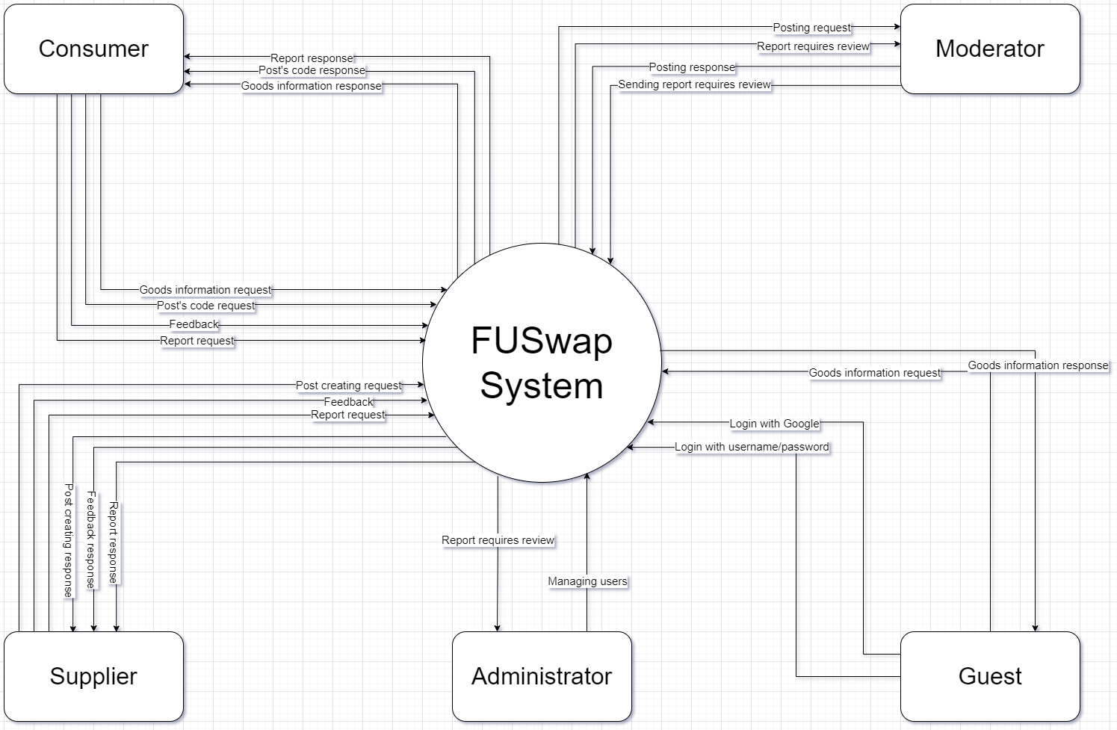

## 2. Use case

Our system offers a wide range of features that help users interact easily and effectively. Below is a use case of the system

### a. Use case diagram

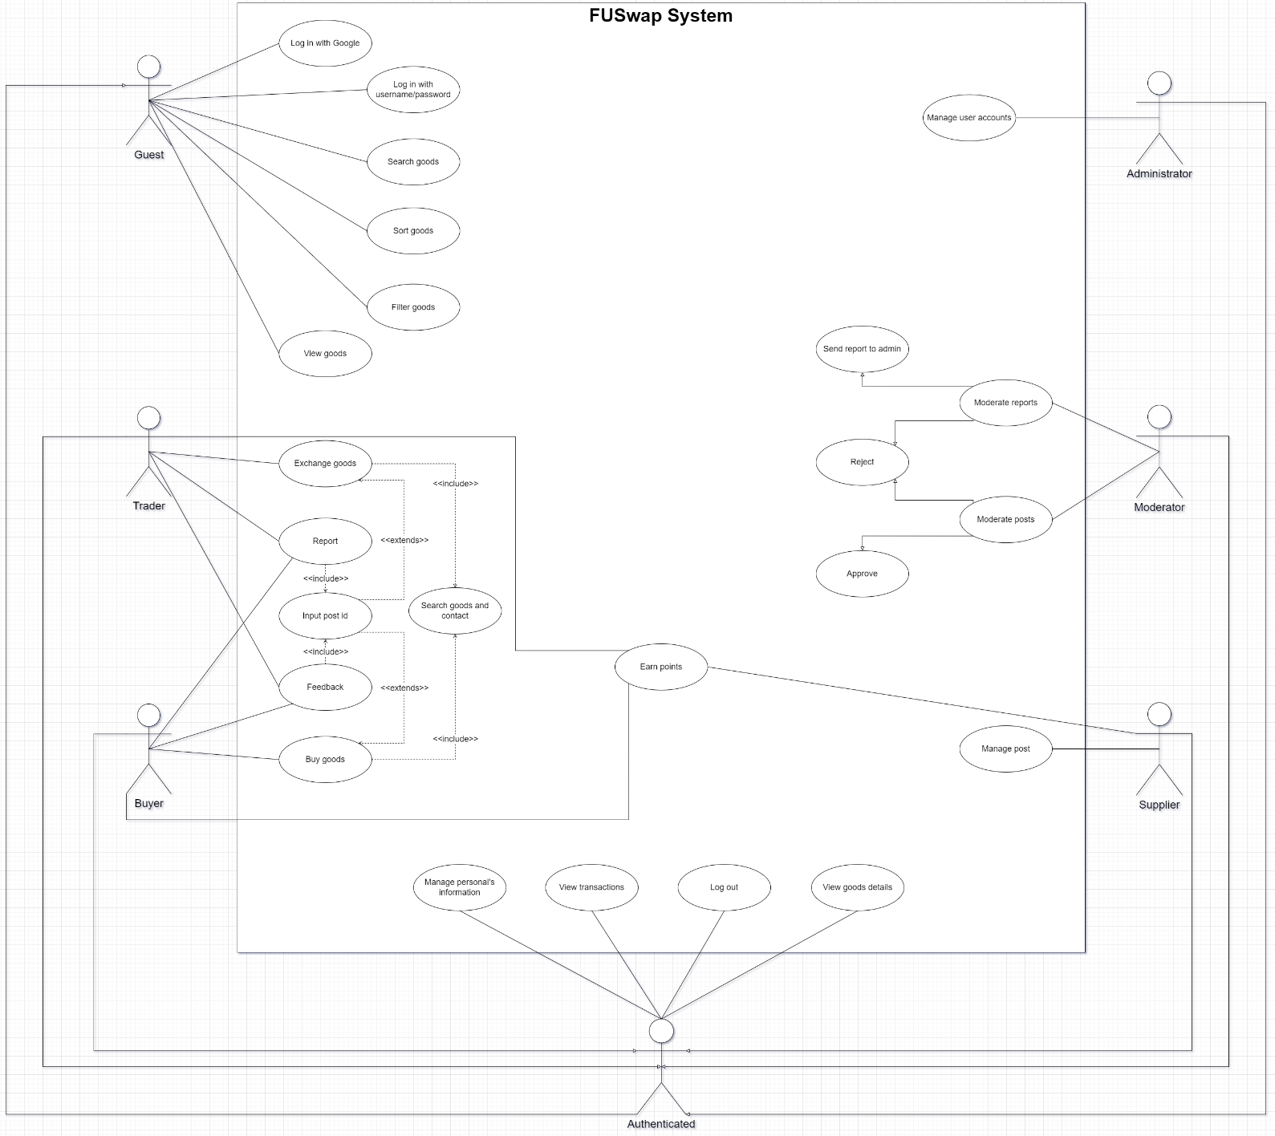

### b. Use case list

|  |  |
| --- | --- |
| UC01 | Log in with Google |
| UC02 | Log in with username/password |
| UC03 | Log out |
| UC04 | Search goods |
| UC05 | View goods |
| UC06 | View contact information |
| UC07 | Manage posts |
| UC08 | Make transactions |
| UC09 | View transactios |
| UC10 | Feedback |
| UC11 | Report |
| UC12 | Sort goods |
| UC13 | Filter goods |
| UC14 | Authorization |
| UC15 | Manage personal's information |
| UC16 | Moderate posts |
| UC17 | Moderate reports |
| UC18 | Manage user accounts |

## 3. Swimlane

### a. Swimlane diagram

#### i. Making a goods post

Users create posts about goods they want to sell or exchange. They enter product details, upload image and set a price if it's for sale. Once completed, the post will be moderated, then appear on the platform for other users to view, buy or exchange goods.

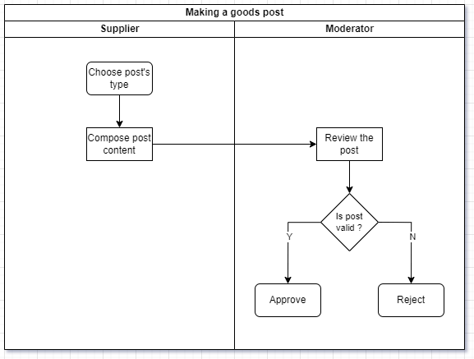

#### ii. Searching, Buying and Trading

Users search for goods. After finding the desired product, they contact the goods supplier and conduct the transaction without going through the system. After the transaction is completed, the supplier will provide the consumer with the post id to open feedback, reporting functions and receive accumulated points.

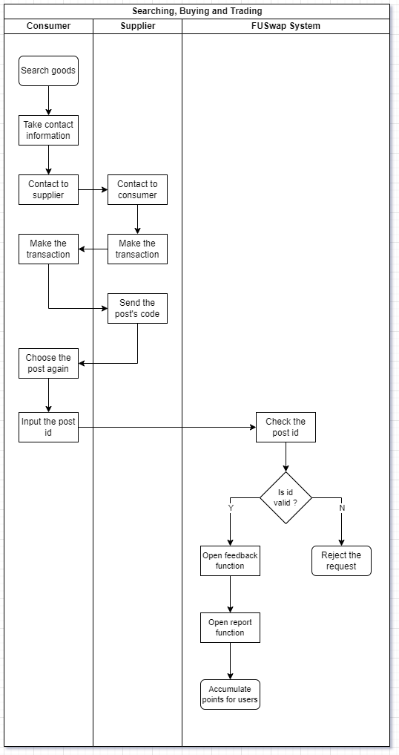

#### iii. Maing a feedback or report

Users provide feedback or report issues related to products or services. They fill out a feedback form, including detailed information about their experience or the issues encountered, and submit this report to the customer support system.

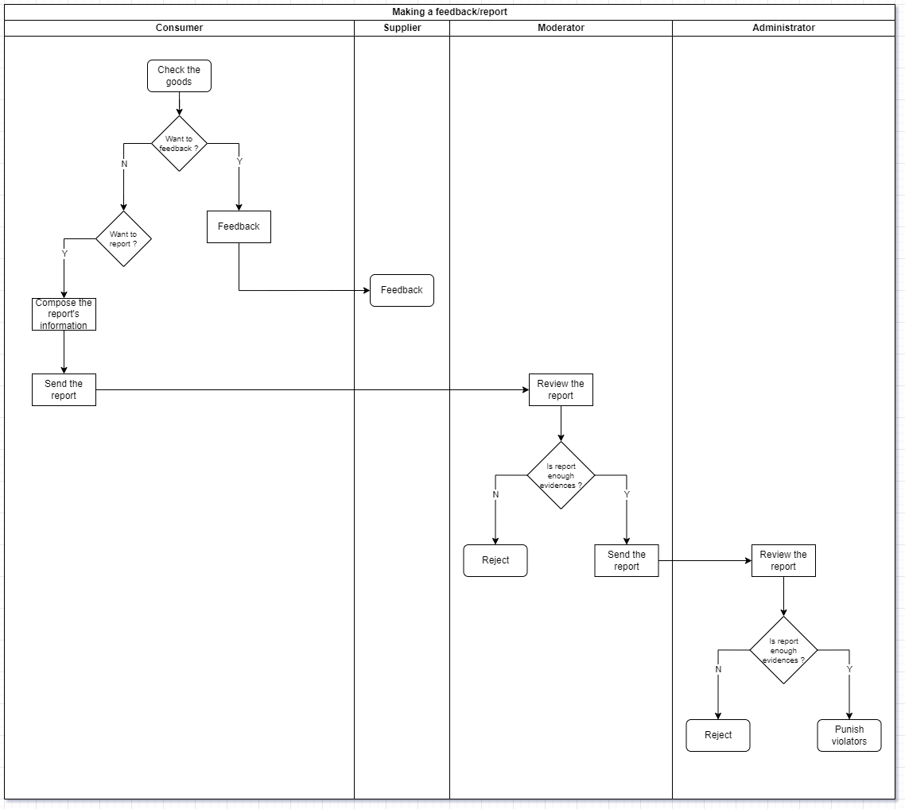

### b. User Authorization

|  |  |  |  |  |  |
| --- | --- | --- | --- | --- | --- |
| **Screen** | **Guest** | **Admin** | **Mod** | **Consumer** | **Supplier** |
| Log in page | X | X | X | X | X |
| Home page | X | X | X | X | X |
| Create an account |  | X |  |  |  |
| Create a post |  |  |  |  | X |
| Feedback |  |  |  | X |  |
| Report |  |  |  | X | X |
| Goods details page |  |  |  | X | X |
| Profile page |  | X | X | X | X |
| Goods management page |  |  |  |  | X |

In which:

* ***Guest:*** a user who is browsing the platform without being logged in. They can view content and search for goods but have limited access to features such as purchasing or posting items.
* ***Admin:*** a user with the highest level of access, responsible for managing the entire platform. They can oversee user activities, manage content, handle complaints.
* ***Mod:*** a user with special privileges to monitor and manage community interactions. Moderators can review and moderate content, handle user reports, enforce platform rules, and support the admin in maintaining a safe and orderly environment.
* ***Consumer:*** a registered user who buys goods or services on the platform. They can search for products, make transactions, leave feedback or report.
* ***Supplier:*** a registered user who sells goods or services on the platform. They can create posts for their products, manage their listings.

### c. Non-Screen Functions

|  |  |  |  |
| --- | --- | --- | --- |
| **#** | **Feature** | **System Function** | **Description** |
| 1 | Login with Google | The application allows users to log in with their Google account instead of creating a new account or logging in with a separate email and password | This function helps users save time and remember passwords by allowing them to use login information stored on their Google account. This also increases security by using protections and verification from Google |
| 2 | Earning points | The application automatically accumulates points for users every time they make a transaction | This function motivates users to continue using the application. Accumulated points can be used to upgrade account types |

## 4. Entity Relationship Diagram

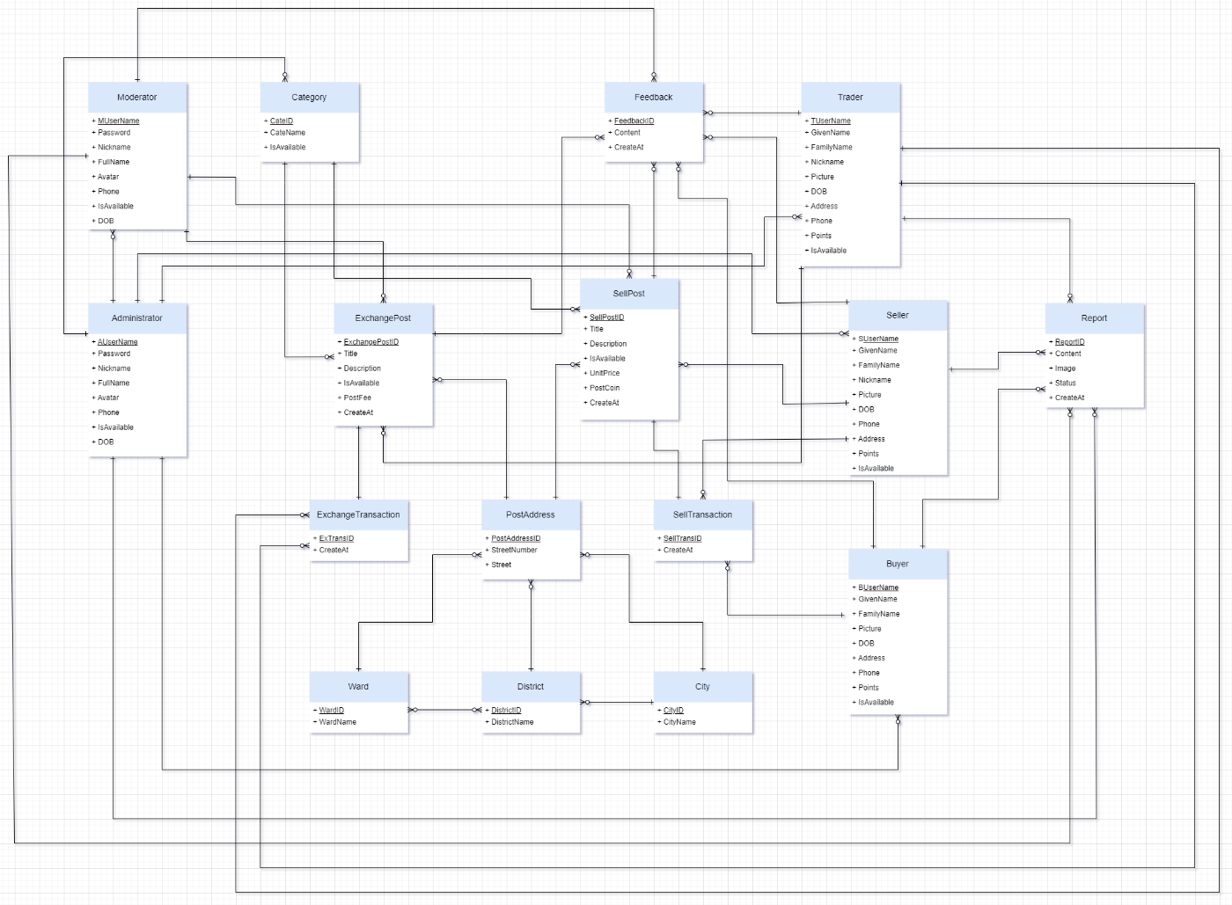

**Entities Description**

|  |  |  |
| --- | --- | --- |
| **#** | **Entity** | **Description** |
| 1 | Administrator | An individual with full access to the platform's backend, responsible for managing users, content |
| 2 | Moderator | A user with permissions to oversee and regulate platform interactions. Moderators review content, address user reports, enforce rules, and maintain a respectful community environment |
| 3 | Category | A classification used to organize goods and services on the platform. Categories help users easily navigate and find specific types of products or services |
| 4 | Feedback | Comments or reviews provided by users regarding their experience with products, services, or the platform. Feedback helps improve quality and customer satisfaction |
| 5 | Report | A formal notification submitted by users to highlight issues or violations on the platform. Reports are reviewed by moderators or administrators for appropriate action |
| 6 | Trader | A user who engages in both trading and posting a trading post |
| 7 | Seller | A user who lists and sells goods on the platform. Sellers create posts, manage goods posts |
| 8 | Buyer | A user who purchases goods on the platform. Buyers search for products, make transactions, and can leave feedback on their purchases |
| 9 | City | A major geographic division within the platform's address system. Cities contain multiple districts and wards |
| 10 | District | A subdivision of a city, containing multiple wards. Districts help further pinpoint locations within the broader city area |
| 11 | Ward | The smallest administrative unit within a district, representing specific neighborhoods or communities. Wards provide detailed address information |
| 12 | SellTransaction | The process and record of a buyer purchasing goods or services from a seller. This includes information of transaction makers and transaction status |
| 13 | ExchangeTransaction | The process and record of trading goods or services between users. This includes information of transaction makers and transaction status |
| 14 | PostAddress | The location details provided in a user's post, including city, district, and ward, to specify where the goods or services are available |
| 15 | ExchangePost | A user-generated post listing items available for trade. Exchange posts specify what items are being offered and what the user is seeking in return |
| 16 | SellPost | A user-generated post listing goods or services for sale. Sell posts include product details, pricing, and availability for buyers to consider |

# II. Functional Requirements

***1. Feature list and authorization***

|  |  |  |  |  |  |  |
| --- | --- | --- | --- | --- | --- | --- |
| **#** | **Guest** | **Admin** | **Mod** | **Consumer** | **Supplier** | **System** |
| Log in with Google | X |  |  |  |  |  |
| Log in with username/password | X |  |  |  |  |  |
| Log out |  | X | X | X | X |  |
| Search goods | X | X | X | X | X |  |
| View goods | X | X | X | X | X |  |
| View contact information |  | X | X | X | X |  |
| Manage posts |  |  |  |  | X |  |
| Make transactions |  |  |  | X | X |  |
| View transactions |  |  |  | X | X |  |
| Input post id |  |  |  | X |  |  |
| Feedback |  |  |  | X |  |  |
| Report |  |  |  | X | X |  |
| Sort goods | X | X | X | X | X |  |
| Filter goods | X | X | X | X | X |  |
| Authorization |  |  |  |  |  | X |
| Manage personal’s information |  | X | X | X | X |  |
| Moderate posts |  |  | X |  |  |  |
| Moderate reports |  | X | X |  |  |  |
| Manage user account |  | X |  |  |  |  |

## 2. Functional Requirement Table

### a. Log in with Google

|  |  |  |  |
| --- | --- | --- | --- |
| ID and Name: | **UC01 -** Log in with Google | | |
| Created By: | Gia Bao | Date Created: | 30/06/2024 |
| Primary Actor: | Guest | Secondary Actors: | FUSwap System |
| Description: | This use case describes the process of logging in to the FUSwap platform using a Google account | | |
| Trigger: | A user selects the "Log in with Google" option | | |
| Preconditions: | The user must have a Google account | | |
| Postconditions: | The user is logged in and redirected to their dashboard | | |
| Normal Flow: | 1. The user clicks on the "Log in with Google" button  2. The system redirects the user to the Google login page  3. The user enters their Google credentials and consents to data sharing  4. Google authenticates the user and redirects them back to the FUSwap platform  5. The system logs the user in and displays their dashboard | | |
| Priority: | High | | |
| Business Rules: | **The user's Google account must be FPT Student email ( @fpt.edu.vn )** | | |

### b. Log in with username/password

|  |  |  |  |
| --- | --- | --- | --- |
| ID and Name: | **UC02 -** Log in with username/password | | |
| Created By: | Gia Bao | Date Created: | 30/06/2024 |
| Primary Actor: | Guest | Secondary Actors: | FUSwap System |
| Description: | This use case describes the process of logging in to the FUSwap platform using a username and password | | |
| Trigger: | A user attempts to log in with their username and password | | |
| Preconditions: | The user must have an existing account on the platform | | |
| Postconditions: | The user is successfully logged in and redirected to their dashboard | | |
| Normal Flow: | 1. The user navigates to the login page  2. The user enters their username and password  3. The system verifies the credentials  4. If the credentials are valid, the user is logged in and redirected to the dashboard  5. If the credentials are invalid, the system displays an error message | | |
| Priority: | High | | |
| Business Rules: | **Username/password must meet requirements (e.g., minimum length, complexity)** | | |

### c. Log out

|  |  |  |  |
| --- | --- | --- | --- |
| ID and Name: | **UC03 – Log out** | | |
| Created By: | Gia Bao | Date Created: | 30/06/2024 |
| Primary Actor: | Users (Admin, Mod, Consumer, Supplier) | Secondary Actors: | FUSwap System |
| Description: | This use case describes the process of logging out of the FUSwap platform | | |
| Trigger: | A user selects the log out option | | |
| Preconditions: | The user must be logged in | | |
| Postconditions: | The user is logged out and redirected to the homepage | | |
| Normal Flow: | 1. The user clicks the "Log out" button  2. The system terminates the user's session  3. The system redirects the user to the homepage | | |
| Priority: | High | | |
| Business Rules: | **User sessions must be securely terminated to prevent unauthorized access** | | |

### d. Search goods

|  |  |  |  |
| --- | --- | --- | --- |
| ID and Name: | **UC04 – Search goods** | | |
| Created By: | Gia Bao | Date Created: | 30/06/2024 |
| Primary Actor: | All users | Secondary Actors: | FUSwap System |
| Description: | This use case describes the process of searching for goods on the FUSwap platform | | |
| Trigger: | A user initiates a search for goods | | |
| Preconditions: | The user must be on the FUSwap platform | | |
| Postconditions: | The user is presented with a list of goods that match the search criteria | | |
| Normal Flow: | 1. The user navigates to the search bar  2. The user enters search criteria (keywords, categories, etc.)  3. The user submits the search query  4. The system retrieves and displays a list of goods matching the search criteria | | |
| Priority: | Medium | | |
| Business Rules: | **Search results should be relevant and sorted by relevance**  **Users can filter and sort search results** | | |

### e. View goods

|  |  |  |  |
| --- | --- | --- | --- |
| ID and Name: | **UC05 – View goods** | | |
| Created By: | Gia Bao | Date Created: | 30/06/2024 |
| Primary Actor: | All users | Secondary Actors: | FUSwap System |
| Description: | This use case describes the process of viewing goods on the FUSwap platform | | |
| Trigger: | A user go to the homepage or search a goods list | | |
| Preconditions: | The user must be on the FUSwap platform | | |
| Postconditions: | The user views general information about each goods | | |
| Normal Flow: | 1. The user search and view a goods list  2. The system displays general information about goods (title, price, images, etc.)  3. The user submits the search query  4. The system retrieves and displays a list of goods matching the search criteria | | |
| Priority: | Medium | | |
| Business Rules: | **General information must be accurate and up-to-date** | | |

### f. View contact information

|  |  |  |  |
| --- | --- | --- | --- |
| ID and Name: | **UC06 – View contact information** | | |
| Created By: | Hai Anh | Date Created: | 30/06/2024 |
| Primary Actor: | Users ( Admin, Mod, Consumer, Supplier ) | Secondary Actors: | FUSwap System |
| Description: | This use case describes the process of viewing contact information on the FUSwap platform | | |
| Trigger: | A user selects to view the contact information of another users | | |
| Preconditions: | The user must have permission to view contact information | | |
| Postconditions: | The user views the contact information of the selected user | | |
| Normal Flow: | 1. The user selects to view contact information  2. The system retrieves and displays the contact information | | |
| Priority: | Medium | | |
| Business Rules: | **Contact information must be kept secure and only displayed to authorized users** | | |

### g. Manage posts

|  |  |  |  |
| --- | --- | --- | --- |
| ID and Name: | **UC07 – Manage posts** | | |
| Created By: | Hai Anh | Date Created: | 30/06/2024 |
| Primary Actor: | Supplier | Secondary Actors: | FUSwap System and Moderator |
| Description: | This use case describes the process of managing posts for goods on the FUSwap platform | | |
| Trigger: | A supplier creates, updates, or deletes a post for a good | | |
| Preconditions: | The user must be logged in as a supplier | | |
| Postconditions: | The post is successfully created, updated, or deleted | | |
| Normal Flow: | 1. The supplier navigates to the manage posts section  2. The supplier chooses to create, update, or delete a post  ***For creating a post:***  3. The supplier enters details about the good (title, description, price, images, etc.)  4. The supplier submits the post and waiting for moderate  5. The system saves the post and displays it in the listings  ***For updating a post:***  6. The supplier selects an existing post to update  7. The supplier modifies the details of the post  8. The supplier submits the changes  9. The system updates the post and displays the changes  ***For deleting a post:***  10. The supplier selects an existing post to delete  11. The supplier confirms the deletion  12. The system deletes the post from the listings | | |
| Priority: | High | | |
| Business Rules: | **Posts must meet content guidelines and not contain prohibited goods** | | |

### h. Make transactions

|  |  |  |  |
| --- | --- | --- | --- |
| ID and Name: | **UC08 – Make transaction** | | |
| Created By: | Hai Anh | Created By: | Hai Anh |
| Primary Actor: | Consumer | Primary Actor: | Consumer |
| Description: | This use case describes the process of inputting a post ID for opening feedback, report function and earn points | | |
| Trigger: | A user needs to input a post ID | | |
| Preconditions: | The user must have the necessary permissions | | |
| Postconditions: | The specified action is completed based on the input post ID | | |
| Normal Flow: | 1. The user navigates to the post ID input section  2. The user enters the post ID  3. The system retrieves the post associated with the ID | | |
| Priority: | High | | |
| Business Rules: | **The post id must be 5 characters long** | | |

### i. View transactions

|  |  |  |  |
| --- | --- | --- | --- |
| ID and Name: | **UC09 – View transactions** | | |
| Created By: | Hai Anh | Date Created: | 30/06/2024 |
| Primary Actor: | Users ( Consumer, Supplier ) | Secondary Actors: | FUSwap System |
| Description: | This use case describes the process of viewing transaction history on the FUSwap platform | | |
| Trigger: | A user chooses to view their past transactions | | |
| Preconditions: | The user must be logged in | | |
| Postconditions: | The user views a list of past transactions with details | | |
| Normal Flow: | 1. The user navigates to the transaction history section  2. The system retrieves and displays a list of past transactions | | |
| Priority: | Medium | | |
| Business Rules: | **Transaction data must be kept secure and accessible only to authorized users** | | |

### j. Feedback

|  |  |  |  |
| --- | --- | --- | --- |
| ID and Name: | **UC10 – Feedback** | | |
| Created By: | Hai Anh | Date Created: | 30/06/2024 |
| Primary Actor: | Consumer | Secondary Actors: | FUSwap System |
| Description: | This use case describes the process of providing feedback on the FUSwap platform | | |
| Trigger: | A user decides to provide feedback | | |
| Preconditions: | The user must be logged in | | |
| Postconditions: | The feedback is successfully submitted and recorded | | |
| Normal Flow: | 1. The user navigates to the feedback section  2. The user enters their feedback in the provided form  3. The user submits the feedback  4. The system records the feedback and notifies the relevant parties | | |
| Priority: | High | | |
| Business Rules: | **Feedback must be constructive and adhere to community guidelines** | | |

### k. Report

|  |  |  |  |
| --- | --- | --- | --- |
| ID and Name: | **UC11 – Report** | | |
| Created By: | Nguyen Anh | Date Created: | 30/06/2024 |
| Primary Actor: | Consumer, Supplier | Secondary Actors: | FUSwap System, Admin and Mod |
| Description: | This use case describes the process of reporting an issue on the FUSwap platform or issue about an user, post | | |
| Trigger: | A user encounters an issue or violation and decides to report it | | |
| Preconditions: | The user must be logged in | | |
| Postconditions: | The report is successfully submitted and investigated | | |
| Normal Flow: | 1. The user navigates to the report section  2. The user fills out the report form with details of the issue  3. The user submits the report  4. The system records the report and notifies the moderators for investigation | | |
| Priority: | High | | |
| Business Rules: | **Reports must be genuine and include sufficient details for investigation** | | |

### l. Sort goods

|  |  |  |  |
| --- | --- | --- | --- |
| ID and Name: | **UC12 – Sort goods** | | |
| Created By: | Nguyen Anh | Date Created: | 30/06/2024 |
| Primary Actor: | All users | Secondary Actors: | FUSwap System |
| Description: | This use case describes the process of sorting goods on the FUSwap platform | | |
| Trigger: | A user wants to organize the search results or listings by specific criteria | | |
| Preconditions: | The user must be on the FUSwap platform | | |
| Postconditions: | The goods are sorted according to the selected criteria | | |
| Normal Flow: | 1. The user selects the sort option from the search results or listings  2. The user chooses the criteria for sorting (e.g., price, date)  3. The system sorts the goods based on the selected criteria and displays the updated list | | |
| Priority: | Medium | | |
| Business Rules: | **Sorting options must be relevant and useful to the user** | | |

### m. Filter goods

|  |  |  |  |
| --- | --- | --- | --- |
| ID and Name: | **UC13 – Filter goods** | | |
| Created By: | Nguyen Anh | Date Created: | 30/06/2024 |
| Primary Actor: | All users | Secondary Actors: | FUSwap System |
| Description: | This use case describes the process of filtering goods on the FUSwap platform | | |
| Trigger: | A user wants to narrow down the search results or listings based on specific criteria | | |
| Preconditions: | The user must be on the FUSwap platform | | |
| Postconditions: | The goods are filtered according to the selected criteria | | |
| Normal Flow: | 1. The user selects the filter option from the search results or listings  2. The user chooses the criteria for filtering (e.g., category, price range, location)  3. The system filters the goods based on the selected criteria and displays the updated list | | |
| Priority: | Medium | | |
| Business Rules: | **Filtering options must be relevant and useful to the user** | | |

### n. Authorization

|  |  |  |  |
| --- | --- | --- | --- |
| ID and Name: | **UC14 – Authorization** | | |
| Created By: | Nguyen Anh | Date Created: | 30/06/2024 |
| Primary Actor: |  | Secondary Actors: | FUSwap System |
| Description: | This use case describes the process of managing user permissions and roles on the FUSwap platform | | |
| Trigger: | System decides to update user permissions or roles | | |
| Preconditions: | The user must be logged in | | |
| Postconditions: | The user permissions or roles are successfully updated | | |
| Normal Flow: | 1. The user logged in  2. The system updates the user's permissions or roles | | |
| Priority: | High | | |
| Business Rules: | **No one can modify user permissions or roles** | | |

### o. Manage personal’s information

|  |  |  |  |
| --- | --- | --- | --- |
| ID and Name: | **UC15 – Manage personal’s information** | | |
| Created By: | Nhat Phi | Date Created: | 30/06/2024 |
| Primary Actor: | Users ( Admin, Mod, Consumer, Supplier ) | Secondary Actors: | FUSwap System |
| Description: | This use case describes the process of managing personal information on the FUSwap platform | | |
| Trigger: | A user decides to update their personal information | | |
| Preconditions: | The user must be logged in | | |
| Postconditions: | The personal information is successfully updated | | |
| Normal Flow: | 1. The user navigates to the personal information section  2. The user updates their personal information (e.g., name, address)  3. The user saves the changes  4. The system updates the personal information | | |
| Priority: | Medium | | |
| Business Rules: | **Personal information must be kept secure and accurate** | | |

### p. Moderate posts

|  |  |  |  |
| --- | --- | --- | --- |
| ID and Name: | **UC16 – Moderate posts** | | |
| Created By: | Nhat Phi | Date Created: | 30/06/2024 |
| Primary Actor: | Mod | Secondary Actors: | FUSwap System |
| Description: | This use case describes the process of moderating posts on the FUSwap platform | | |
| Trigger: | A moderator reviews posts for compliance with platform guidelines | | |
| Preconditions: | The user must be logged in as a moderator | | |
| Postconditions: | The post is either approved or rejected | | |
| Normal Flow: | 1. The moderator navigates to the post moderation section  2. The moderator reviews the post content  3. The moderator approves or rejects the post  4. The system updates the post status | | |
| Priority: | High | | |
| Business Rules: | **Posts must comply with platform guidelines** | | |

### q. Moderatore reports

|  |  |  |  |
| --- | --- | --- | --- |
| ID and Name: | **UC17 – Moderate reports** | | |
| Created By: | Nhat Phi | Date Created: | 30/06/2024 |
| Primary Actor: | Mod | Secondary Actors: | FUSwap System |
| Description: | This use case describes the process of moderating reports on the FUSwap platform | | |
| Trigger: | A moderator reviews user reports for compliance with platform guidelines | | |
| Preconditions: | The user must be logged in as a moderator | | |
| Postconditions: | The report is either resolved or escalated for further action | | |
| Normal Flow: | 1. The moderator navigates to the report moderation section  2. The moderator reviews the report details  3. The moderator resolves the report or escalates it for further action  4. The system updates the report status | | |
| Priority: | High | | |
| Business Rules: | **Reports must be handled promptly and fairly** | | |

### r. Manage user accounts

|  |  |  |  |
| --- | --- | --- | --- |
| ID and Name: | **UC18 – Manage user accounts** | | |
| Created By: | Nhat Phi | Date Created: | 30/06/2024 |
| Primary Actor: | Admin | Secondary Actors: | FUSwap System |
| Description: | This use case describes the process of managing user accounts on the FUSwap platform | | |
| Trigger: | An admin decides to create an account or update user account details | | |
| Preconditions: | The user must be logged in as an admin | | |
| Postconditions: | The user account details are successfully updated or created | | |
| Normal Flow: | 1. The admin navigates to the user account management section  ***For update an account:***  2. The admin selects a user to update  3. The admin modifies the user account details  4. The admin saves the changes  5. The system updates the user account details  ***For create an account:***  6. The admin input information of the mod account  7. The admin click submit  8. The system save the account | | |
| Priority: | High | | |
| Business Rules: | **Only admins can modify user account details and create accounts** | | |

# III. Non-Functional Requirements

## 1. Usability

### a. Intuitive Interface

The platform should have a clean and straightforward layout that allows users to easily find and use features such as searching for goods, posting items, and managing personal information***.***

### b. User Assistance

Include help sections, tooltips, and FAQs to assist users in navigating the platform and resolving common issues.

## 2. Security

### a. Data Protection

Ensure that all personal and transactional data is encrypted both in transit and at rest.

### b. Authentication & Authorization

Implement strong authentication mechanisms and ensure proper authorization controls to restrict access to sensitive features.

## 3. Performance

### a. Scalability

The platform should be designed to scale seamlessly to accommodate increasing numbers of users and transactions.

### b. Response Time

Ensure that the system responds quickly to user interactions, with minimal latency for actions such as searching for goods, loading pages, and processing transactions.

# IV. User Interfaces

# V. Technical Requirements

|  |  |  |  |  |
| --- | --- | --- | --- | --- |
| Usecase | Title | Prefix | No. | Description |
| UC01 | Log in with Google | GG | 01 | Verify email suffix that must have @fpt.edu.vn |
| 02 | Redirect to localhost:8080 when clicking “Login with Google” |
| UC02 | Log in with username/password | UP | 03 | Username is required |
| 04 | Password is required |
| UC03 | Log out | LO | 05 | User cannot access pages that require authentication after logging out |
| UC04 | Search goods | SEG | 06 | Search keywords must match the title or content of the post |
| 07 | Empty search query displays default results |
| 08 | Search results pagination works correctly |
| 09 | Special characters in search query must limit the data returned |
| UC05 | View goods | VG | 10 | Users can view all goods posts |
| 11 | Users can view post details |
| UC06 | View contact information | CI | 12 | Users can view the post’s contact information |
| UC07 | Manage posts | MP | 13 | Post type is required |
| 14 | Title must not be blank |
| 15 | Title must be 5 – 50 alphanumeric characters long |
| 16 | Content must not be blank |
| 17 | Content must be 10 – 200 alphanumeric characters long |
| 18 | Unit price (for sell post only) must be a positive number |
| 19 | Image must not be blank |
| 20 | System must display a QR code to pay for the post |
| 21 | Users cannot update post type |
| UC08 | Make transactions | MT | 22 | Users can enter post id |
| 23 | Users can feedback/report if the post id is valid |
| 24 | Users can earn points if the post id is valid |
| 25 | Post id must have 5 characters |
| UC09 | View transactions | VT | 26 | Users can view their transactions |
| UC10 | Feedback | FB | 27 | Feedback content must be 10 – 50 characters long |
| 28 | Users cannot submit blank feedback content |
| 29 | Submitting feedback displays a confirmation message |
| 30 | Feedback cannot be edited once submitted |
| UC11 | Report | RP | 31 | Report content must be 10 – 200 characters long |
| 32 | Report image must not be blank |
| 33 | Submitting report displays a confirmation message |
| UC12 | Sort goods | SOG | 34 | Returns a sorted list from lowest price to highest price |
| 35 | Returns a sorted list from highest price to lowest price |
| 36 | Returns a sorted list from newest date to oldest date |
| 37 | Returns a sorted list from oldest date to newest date |
| UC13 | Filter goods | FG | 38 | Returns goods by price range |
| 39 | Returns goods by post type |
| 40 | Returns goods by city |
| 41 | Returns goods by district |
| 42 | Returns goods by ward |
| UC14 | Authorization | AZ | 43 | Guests cannot access the customer, administrator and moderator pages |
| 44 | Customers cannot access the admin and moderator pages |
| 45 | Moderators cannot access the administrator pages |
| 46 | Admins can access the customer, administrator and moderator pages |
| 47 | Guests cannot access the customer, administrator and moderator pages |
| UC15 | Manage personal’s information | PI | 48 | Users can view their profiles |
| 49 | Users can update their profile |
| 50 | Customers cannot update email address |
| 51 | Manager cannot update username |
| UC16 | Moderate posts | MP | 52 | Moderators can view posts that have been approved and need approval |
| 53 | Moderators can reject a post |
| 54 | Moderators can approve a post |
| UC17 | Moderate reports | MR | 55 | Moderators can view reports have been approved and need approval |
| 56 | Moderators can reject a report |
| 57 | Moderators can approve ( send to admin ) a post |
| UC18 | Manage user accounts | UA | 58 | Administrator can create moderator accounts |
| 59 | Check that the username of the moderator account already exists |
| 60 | Administrator can ban accounts |