

**FUSwap**

**Software Requirement Specification**

– Ho Chi Minh, June 2024 –

**Record of changeS**

|  |  |  |  |
| --- | --- | --- | --- |
| **Date** | **A* M, D** | **In charge** | **Change Description** |
|  |  |  |  |
|  |  |  |  |
|  |  |  |  |
|  |  |  |  |
|  |  |  |  |
|  |  |  |  |
|  |  |  |  |
|  |  |  |  |
|  |  |  |  |
|  |  |  |  |
|  |  |  |  |

*A - Added M - Modified D - Deleted

**Table of Contents**

I. Overview 5

1. Introduction 5

2. System Functions 6

3. Entity Relationship Diagram 13

4. Usecase List 14

5. Technical Requirement 15

# I. Overview

## 1. Introduction

The first issue is when students have old items that they no longer use or when certain subjects require students to have specialised equipment. These situations clearly highlight that students have items they don't need but other students might need. In these cases, they can choose to exchange or sell these items.

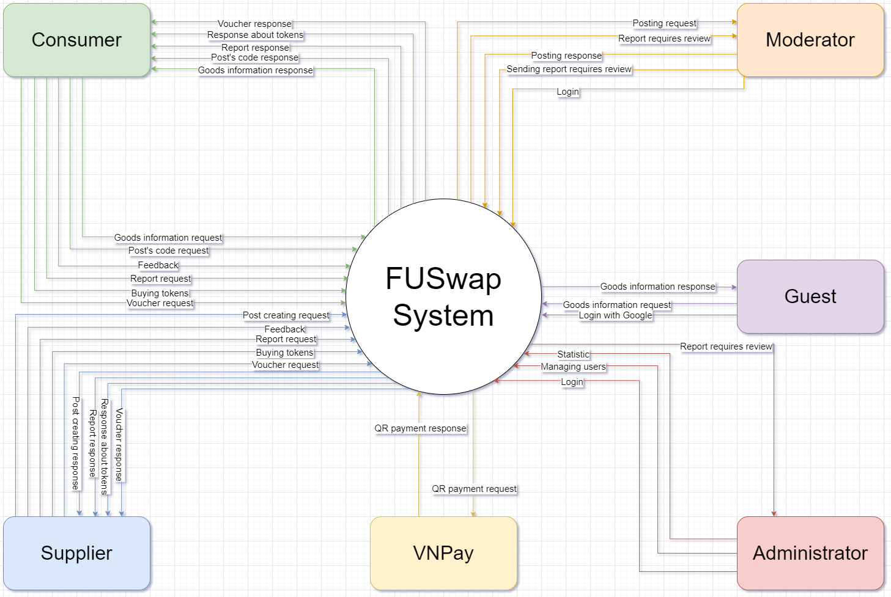

## 

## 

## 

## 

## 

## 

## 

## 

## 

## 

## 

## 2. System Functions

#### a. Swimlane Diagram

* Posting

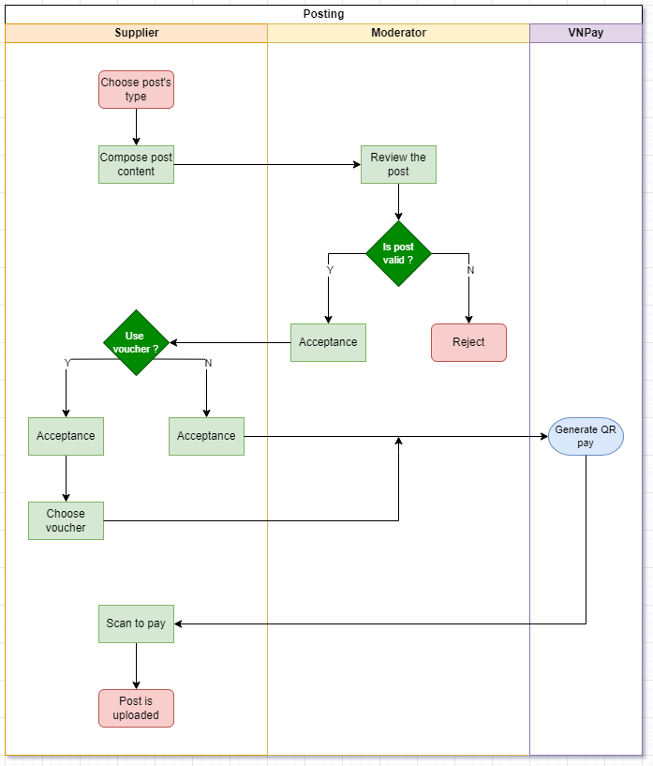

* Search, Buy or Exchange goods

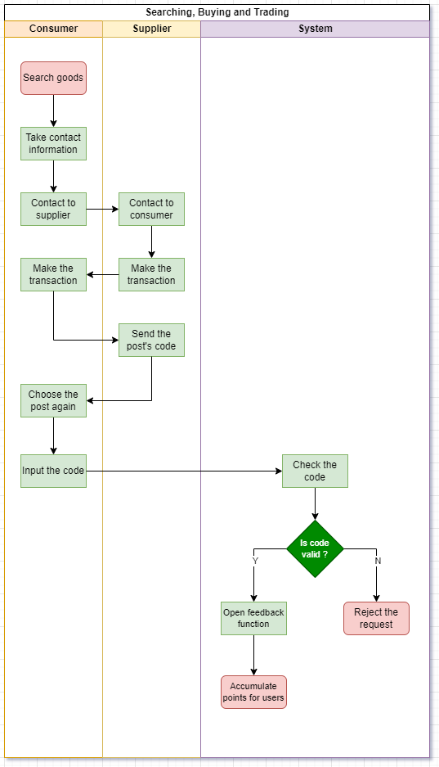

* Buying service for a post

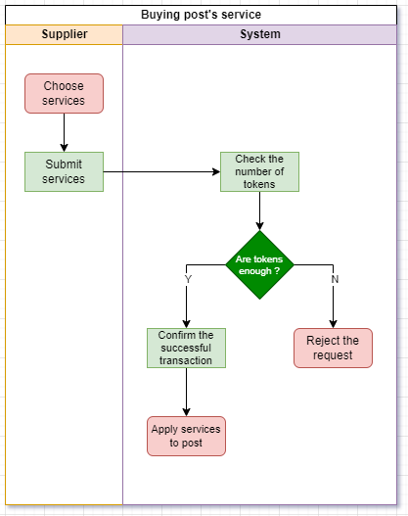

* Tokens

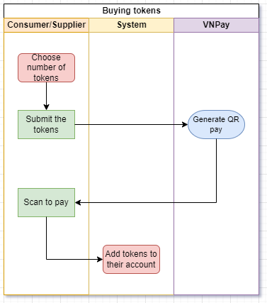

* Feedback/Report

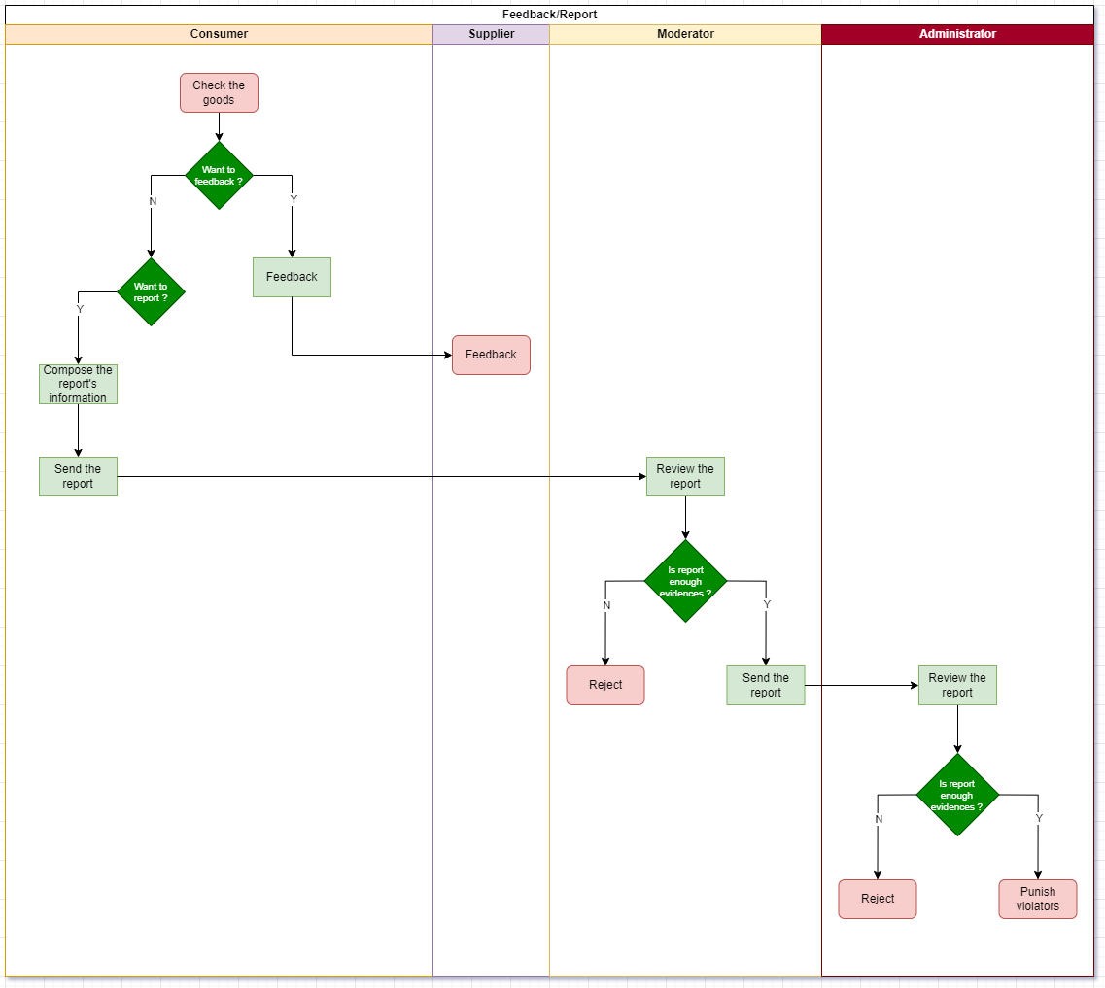

* Voucher

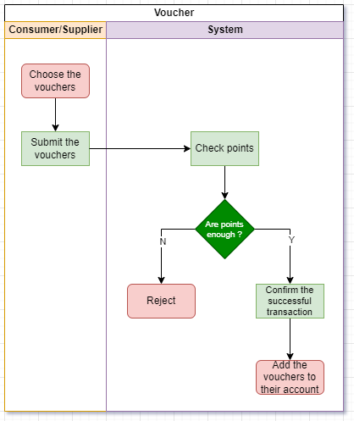

#### b. Screen Details

*Guest*

|  |  |  |  |
| --- | --- | --- | --- |
| **#** | **Feature** | **Screen** | **Description** |
| 1 | View goods | Home page | All goods for sale and exchange are shown in the middle. |
| 2 | Search goods | Home page | The header has a search bar for searching for goods. |
| 3 | Login | Login Page | Guests have to choose a role first and then click login by Google button. Next, they input their username and password. Then they receive and input the authorization code that has been sent to their email. |

*Consumer*

|  |  |  |  |
| --- | --- | --- | --- |
| **#** | **Feature** | **Screen** | **Description** |
| 1 | Buy goods | Home page | Choose goods to buy |
| 2 | Buy goods | Goods’s post page | All information about goods shows up with contact to the seller and buy button. |
| 3 | Buy goods | Chat page | Buyer can contact the seller before buying those goods. |
| 4 | Buy goods | Purchase page | After clicking the buy button, the buyer has two options: pay by scanning a VNPay QR code or pay by cash after receiving the goods. |
| 5 | Buy goods | Order page | The buyer confirmed receiving the goods. Then they can provide feedback or report the seller. |

*Supplier*

|  |  |  |  |
| --- | --- | --- | --- |
| **#** | **Feature** | **Screen** | **Description** |
| 1 | post goods | Post page | Suppliers can input all goods information to post on the web. Then choose type of post: sell or trade. |
| 2 | Post goods | Noti page | If the type of post is sold, the supplier has to accept a fee to post. |

*Trader*

|  |  |  |  |
| --- | --- | --- | --- |
| **#** | **Feature** | **Screen** | **Description** |
| 1 | Trade goods | Home page | Choose goods to trade. |
| 2 | Trade goods | Goods’s post page | All information about goods shows up with contact to the other trader and trade button. |
| 3 | Trade goods | Chat page | Trader can contact the other trader before trading both goods. |
| 4 | Trade goods | order page | After both traders receive goods, the trader who posts will confirm receiving goods. |

*Feedback/Report*

|  |  |  |  |
| --- | --- | --- | --- |
| **#** | **Feature** | **Screen** | **Description** |
| 1 | Send feedback | Feedback page | After buying goods, buyer can send feedback to the seller |
| 2 | Send Report | Report page | If the buyer encounters a fraudulent seller, they can report it. |

*Moderator*

|  |  |  |  |
| --- | --- | --- | --- |
| **#** | **Feature** | **Screen** | **Description** |
| 1 | Review report | Manager Report page | The moderator can see and review all reports from customers to check if they are true and send them to the administrator. |
|  |  |  |  |

*Administrator*

|  |  |  |  |
| --- | --- | --- | --- |
| **#** | **Feature** | **Screen** | **Description** |
| 1 | Review report | Manager Report page | The administrator can review all reports that the moderator sends to punish by level or reject. |
| 2 | Manage user | User management page | The administrator can see all the user information. They can click on any user information to view, delete, or update it. |

#### c. User Authorization

|  |  |  |  |  |  |  |
| --- | --- | --- | --- | --- | --- | --- |
| Screens | Guest | Trader | Seller | Customer | Admin | Moderator |
| Login Page | x | x | x | x | x | x |
| Home Page | x | x | x | x | x | x |
| User Profile Pages |  | x | x | x | x |  |
| Dashboard Page |  | x | x | x | x | x |
| Admin Managing Page |  |  |  |  | x |  |
| User_Management |  |  |  |  | x |  |
| Product_Management Page |  | x | x |  | x | x |
| Feedback & Report Page |  | x | x | x |  | x |
| Trade_Product Page | x | x | x | x |  | x |
| Sell_Product Page | x | x | x | x |  | x |
| Billing_Page |  | x | x | x |  |  |

In which:

|  |
| --- |
| Guest: who can Access to see and search the product that they want to buy or Exchange |
| Trader: who can post and Exchange with customers, see the feedback & report |
| Seller: who can post and selling with customers, see the feedback & report and billing |
| Customer: who can buying product from sellers or Exchange with trader, feedback & report and billing |
| Admin: who oversee the system and manage users and products |
| Moderator: person with authority to approve posts and resolve reports or feedback issues from customers and products |

#### d. Non-Screen Functions

|  |  |  |  |
| --- | --- | --- | --- |
| **#** | **Feature** | **System Function** | **Description** |
| 1 | VNPay | VNPay allows users to pay quickly and conveniently by scanning the automatically generated QR code when the consumer clicks submit order. | This function helps users save time when paying without having to use cash. |
| 2 | Login by Google | The application allows users to log in with their Google account instead of creating a new account or logging in with a separate email and password. | This function helps users save time and remember passwords by allowing them to use login information stored on their Google account. This also increases security by using protections and verification from Google. |
| 3 | Get points | The application automatically accumulates points for users every time they make a transaction. | This function motivates users to continue using the application. Accumulated points can be redeemed for offers, discounts or other rewards to encourage user loyalty. |

## 3. Entity Relationship Diagram

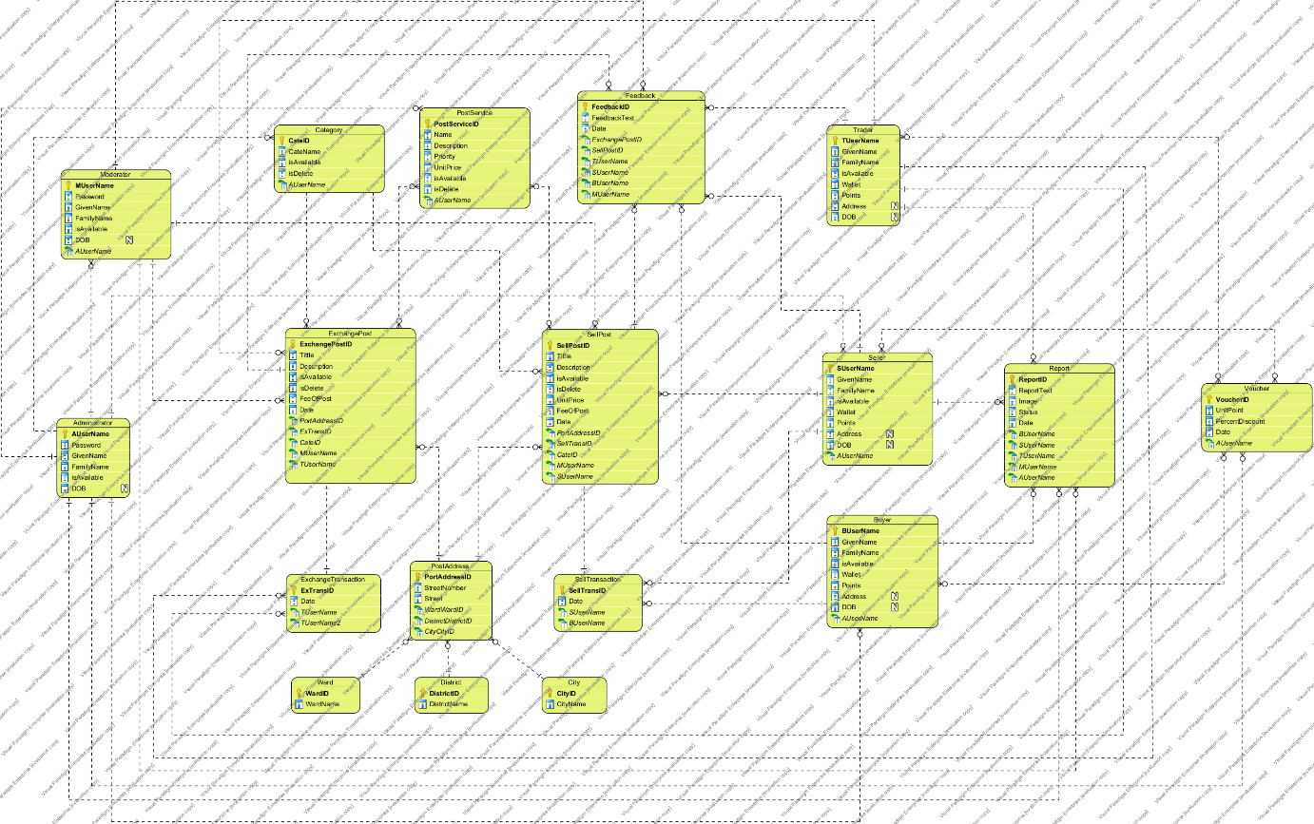

**Entities Description**

|  |  |  |
| --- | --- | --- |
| **#** | **Entity** | **Description** |
| 1 | Manager | Include 2 roles: Administrator and Moderator   1. Administrator:  * Admin manages the entire system  1. Moderator:  * Moderator manages posts and reports |
| 2 | Student | Include 2 roles: Supplier and Consumer   1. Supplier:  * Supplier provides and manages goods * Suppliers can post and manage their posts * Supplier can confirm transaction and update the transaction status * Supplier can reply feedback’s Consumer * Supplier can report Consumer  1. Consumer:  * Consumer can view post or search goods * Consumer can exchange or buy goods * Consumer can feedback for Supplier * Consumer can report Supplier |
| 3 | Post | * The post shows the Supplier’s description of the goods and some necessary information about the goods |
| 4 | Goods | * Describe all the information of the goods |

**4. Usecase List**

|  |  |
| --- | --- |
| NO. | Usecase's name |
| UC-01 | Log in with Google |
| UC-02 | Search goods information |
| UC-03 | View goods information |
| UC-04 | Exchange goods |
| UC-05 | Buy goods |
| UC-06 | Input post's code |
| UC-07 | Get contact information |
| UC-08 | Feedback |
| UC-09 | Report |
| UC-10 | Pay by VNPay |
| UC-11 | Voucher |
| UC-12 | Buy coins |
| UC-13 | Manage posts |
| UC-14 | Review goods post |
| UC-15 | Approve post |
| UC-16 | Reject post |
| UC-17 | Search goods post's list approved |
| UC-18 | View goods post's list approved |
| UC-19 | View goods post's list need approval |
| UC-20 | Search goods post's list need approval |
| UC-21 | Review report |
| UC-22 | Reject report |
| UC-23 | Send report to admin |
| UC-24 | Log in by username&password |
| UC-25 | View statistic |
| UC-26 | Manage user accounts |
| UC-27 | Manage personal's information |
| UC-28 | View transaction |
| UC-29 | Log out |

5. Technical Requirement

# 