

<<FUSwap system>>
Software Requirement Specification

– Hochiminh, June 2024 –

Record of changeS
Date | A*  M, D | In charge | Change Description
30/06/24 | A | Gia Bao | Add Non-Functional Requirements section
30/06/24 | A | Hai Anh | Add User Interfaces section
30/06/24 | A | Nguyen Anh | Add Technical Requirements section
*A - Added M - Modified D - Deleted

Table of Contents
I. Overview 4
1. Introduction 4
2. Use case 5
a. Use case diagram 5
b. Use case list 5
3. Swimlane 6
a. Swimlane diagram 6
a. User Authorization 8
c. Non-Screen Functions 9
4. Entity Relationship diagram 10
II. Functional Requirements 11
1. Feature list and authorization 11
2.Functional Requirement Table 12
III. Non-Functional Requirements 22
1. Usability 22
2. Security 22
3. Performance 22
IV. User Interfaces 14
V. Technical Requirements 14

I. Overview

1. Introduction
Currently, students have to purchase many new study materials each year. This creates a significant financial burden for students, especially those with limited economic means. However, many of these materials remain in good condition after just one semester but are not reused. This situation not only increases the cost of education but also leads to unnecessary waste of resources. Students often lack convenient methods to exchange or resell these materials to other students, resulting in the need to buy completely new items at the start of each semester. Moreover, the continuous production and consumption of new materials contribute to the depletion of natural resources. Therefore, there is a need for a solution that maximizes the use of used study materials, reduces costs for students, and contributes to environmental protection.
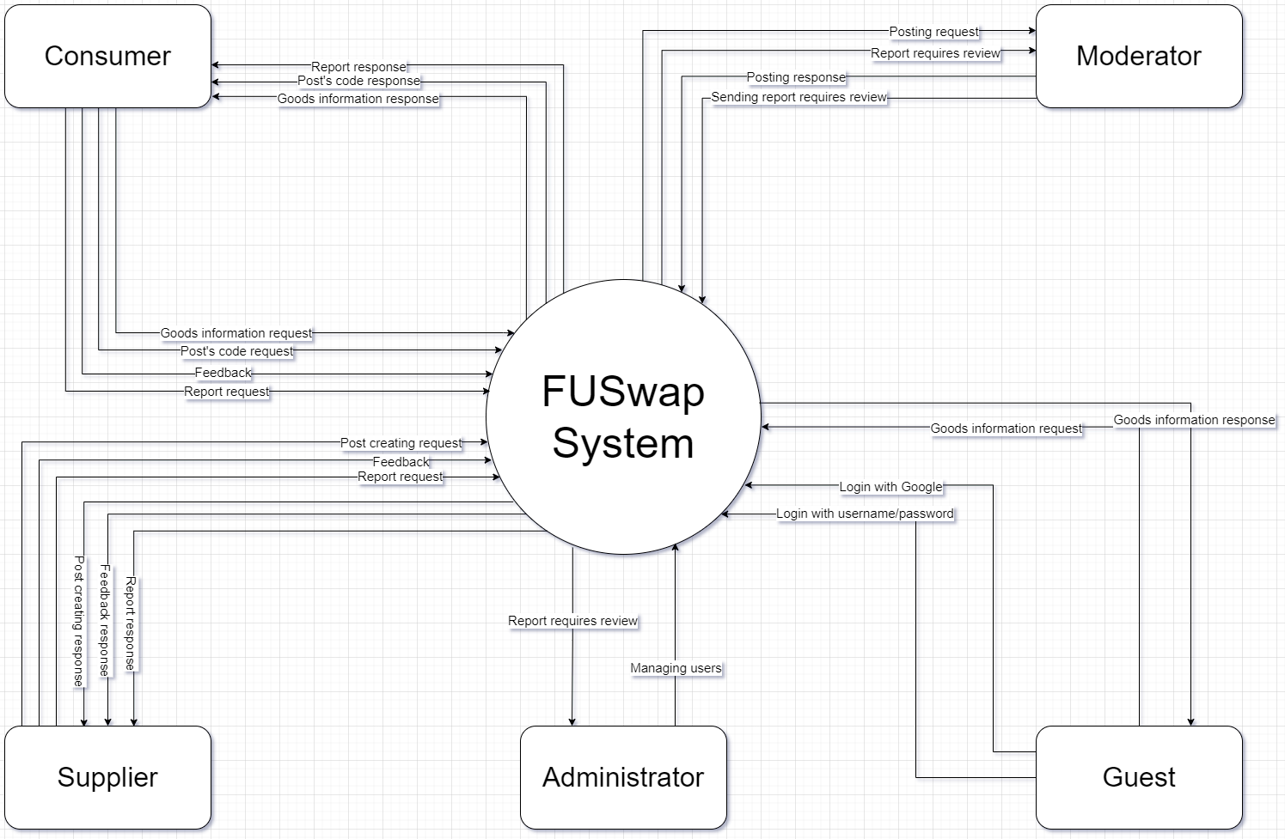

2. Use case
Our system offers a wide range of features that help users interact easily and effectively. Below is a use case of the system

a. Use case diagram
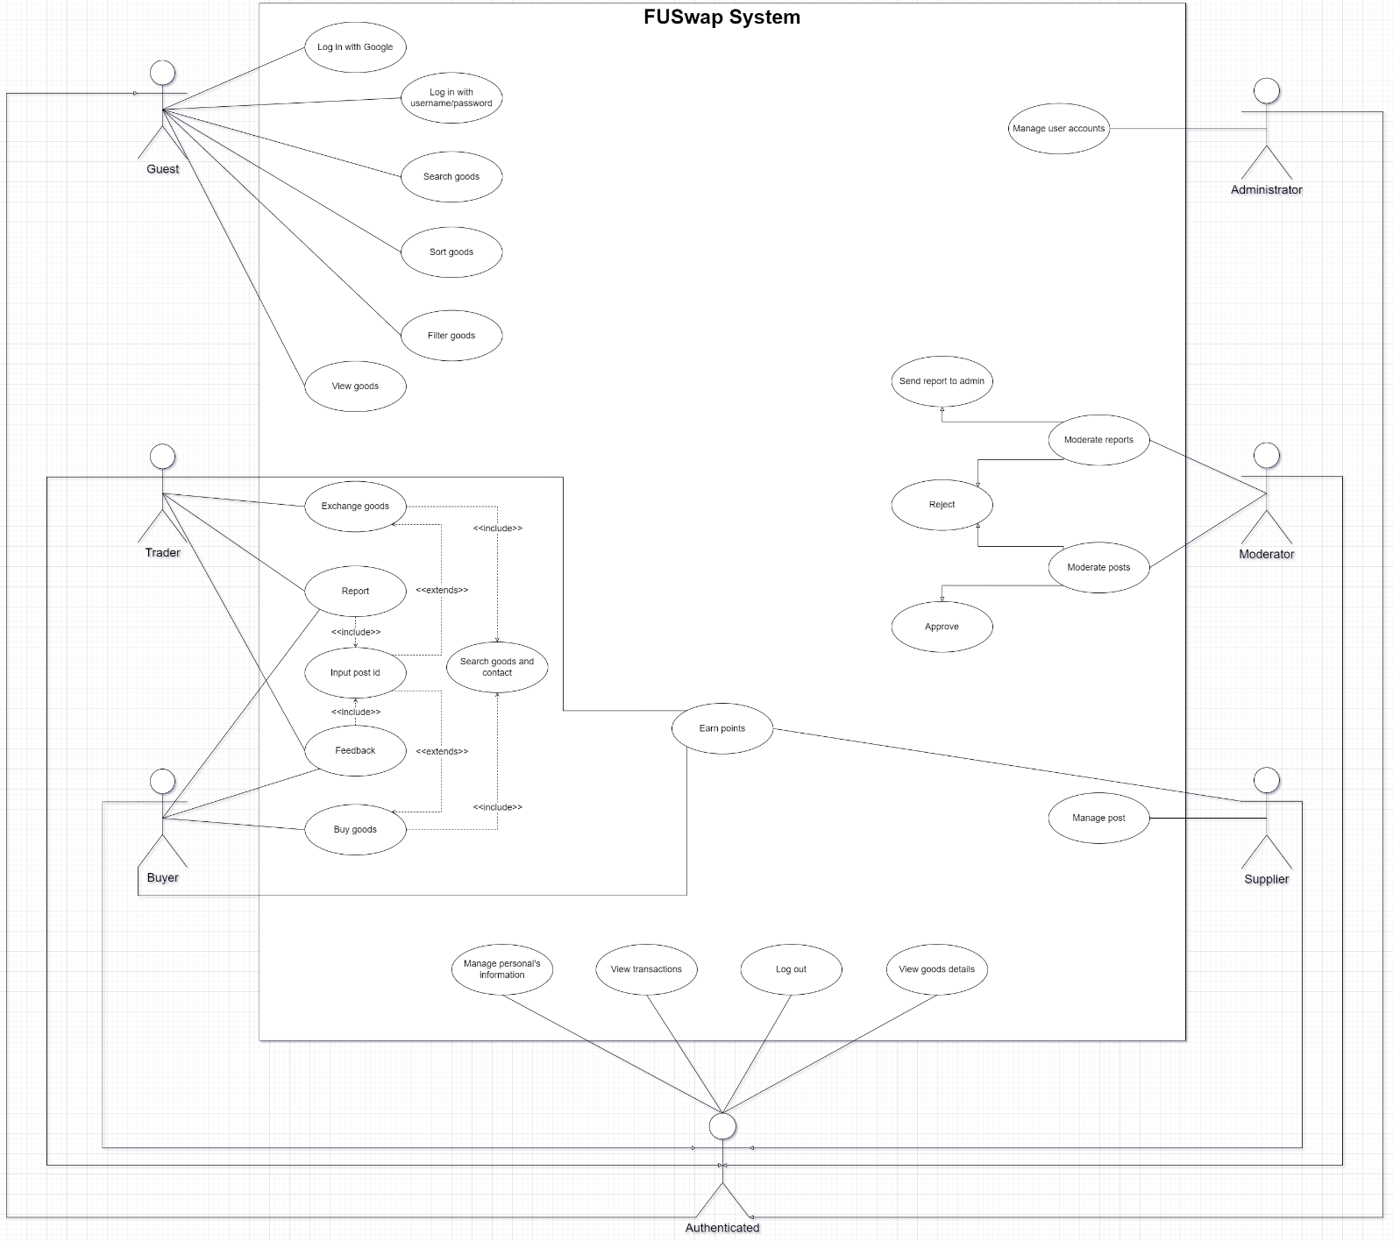

b. Use case list
UC01 | Log in with Google
UC02 | Log in with username/password
UC03 | Log out
UC04 | Search goods
UC05 | View goods
UC06 | View contact information
UC07 | Manage posts
UC08 | Make transactions
UC09 | View transactios
UC10 | Input post id
UC11 | Feedback
UC12 | Report
UC13 | Sort goods
UC14 | Filter goods
UC15 | Authorization
UC16 | Manage personal's information
UC17 | Moderate posts
UC18 | Moderate reports
UC19 | Manage user accounts

3. Swimlane

a. Swimlane diagram

i. Making a goods post
Users create posts about goods they want to sell or exchange. They enter product details, upload image and set a price if it's for sale. Once completed, the post will be moderated, then appear on the platform for other users to view, buy or exchange goods.
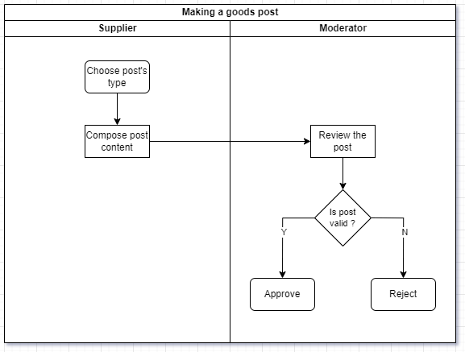

ii. Searching, Buying and Trading
Users search for goods. After finding the desired product, they contact the goods supplier and conduct the transaction without going through the system. After the transaction is completed, the supplier will provide the consumer with the post id to open feedback, reporting functions and receive accumulated points.
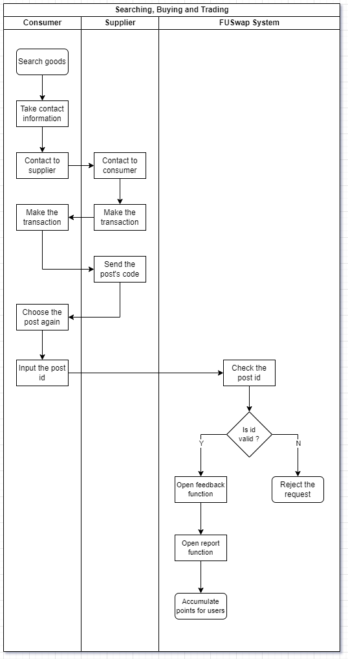

iii. Maing a feedback or report
Users provide feedback or report issues related to products or services. They fill out a feedback form, including detailed information about their experience or the issues encountered, and submit this report to the customer support system.
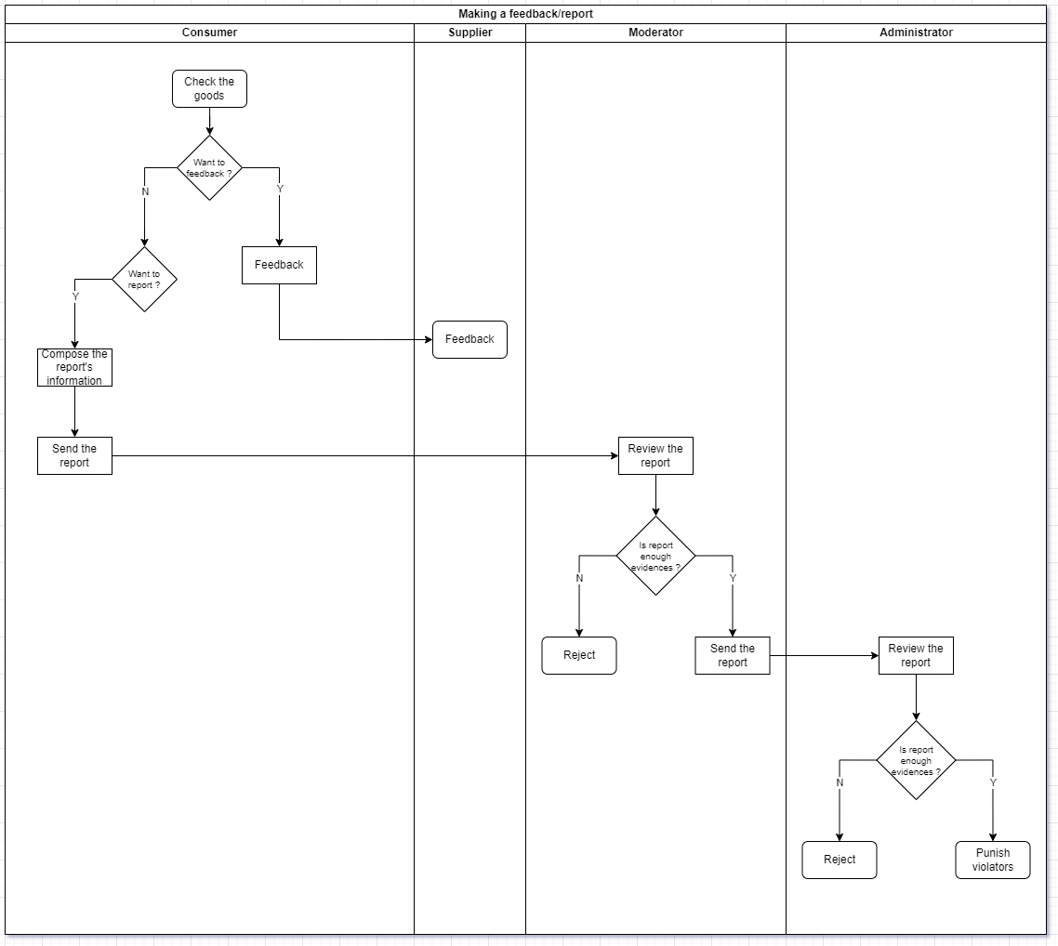

b. User Authorization
Screen | Guest | Admin | Mod | Consumer | Supplier
Log in page | X | X | X | X | X
Home page | X | X | X | X | X
Create an account |  | X
Create a post |  |  |  |  | X
Feedback |  |  |  | X
Report |  |  |  | X | X
Goods details page |  |  |  | X | X
Profile page |  | X | X | X | X
Goods management page |  |  |  |  | X

In which:
- Guest: a user who is browsing the platform without being logged in. They can view content and search for goods but have limited access to features such as purchasing or posting items.
- Admin: a user with the highest level of access, responsible for managing the entire platform. They can oversee user activities, manage content, handle complaints.
- Mod: a user with special privileges to monitor and manage community interactions. Moderators can review and moderate content, handle user reports, enforce platform rules, and support the admin in maintaining a safe and orderly environment.
- Consumer: a registered user who buys goods or services on the platform. They can search for products, make transactions, leave feedback or report.
- Supplier: a registered user who sells goods or services on the platform. They can create posts for their products, manage their listings.

c. Non-Screen Functions
# | Feature | System Function | Description
1 | Login with Google | The application allows users to log in with their Google account instead of creating a new account or logging in with a separate email and password | This function helps users save time and remember passwords by allowing them to use login information stored on their Google account. This also increases security by using protections and verification from Google
2 | Earning points | The application automatically accumulates points for users every time they make a transaction | This function motivates users to continue using the application. Accumulated points can be used to upgrade account types

4. Entity Relationship Diagram
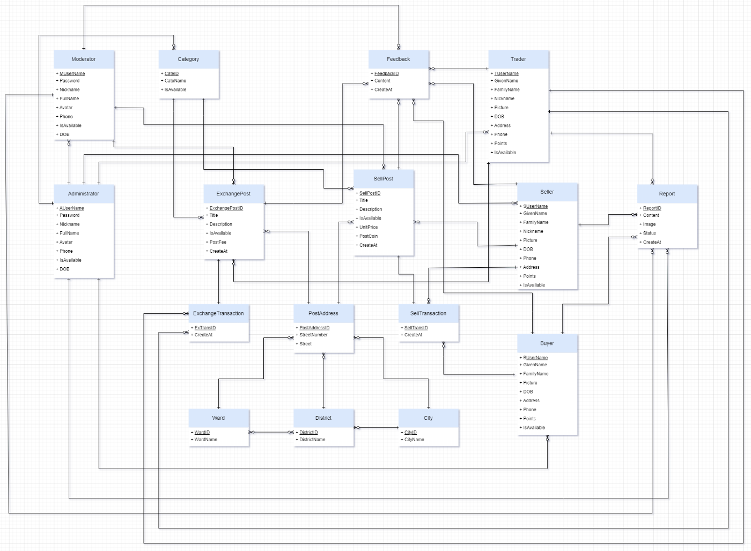
Entities Description
# | Entity | Description
1 | Administrator | An individual with full access to the platform's backend, responsible for managing users, content
2 | Moderator | A user with permissions to oversee and regulate platform interactions. Moderators review content, address user reports, enforce rules, and maintain a respectful community environment
3 | Category | A classification used to organize goods and services on the platform. Categories help users easily navigate and find specific types of products or services
4 | Feedback | Comments or reviews provided by users regarding their experience with products, services, or the platform. Feedback helps improve quality and customer satisfaction
5 | Report | A formal notification submitted by users to highlight issues or violations on the platform. Reports are reviewed by moderators or administrators for appropriate action
6 | Trader | A user who engages in both trading and posting a trading post
7 | Seller | A user who lists and sells goods on the platform. Sellers create posts, manage goods posts
8 | Buyer | A user who purchases goods on the platform. Buyers search for products, make transactions, and can leave feedback on their purchases
9 | City | A major geographic division within the platform's address system. Cities contain multiple districts and wards
10 | District | A subdivision of a city, containing multiple wards. Districts help further pinpoint locations within the broader city area
11 | Ward | The smallest administrative unit within a district, representing specific neighborhoods or communities. Wards provide detailed address information
12 | SellTransaction | The process and record of a buyer purchasing goods or services from a seller. This includes information of transaction makers and transaction status
13 | ExchangeTransaction | The process and record of trading goods or services between users. This includes information of transaction makers and transaction status
14 | PostAddress | The location details provided in a user's post, including city, district, and ward, to specify where the goods or services are available
15 | ExchangePost | A user-generated post listing items available for trade. Exchange posts specify what items are being offered and what the user is seeking in return
16 | SellPost | A user-generated post listing goods or services for sale. Sell posts include product details, pricing, and availability for buyers to consider

II. Functional Requirements

1. Feature list and authorization
# | Guest | Admin | Mod | Consumer | Supplier | System
Log in with Google | X
Log in with username/password | X
Log out |  | X | X | X | X
Search goods | X | X | X | X | X
View goods | X | X | X | X | X
View contact information |  | X | X | X | X
Manage posts |  |  |  |  | X
Make transactions |  |  |  | X | X
View transactions |  |  |  | X | X
Input post id |  |  |  | X
Feedback |  |  |  | X
Report |  |  |  | X | X
Sort goods | X | X | X | X | X
Filter goods | X | X | X | X | X
Authorization |  |  |  |  |  | X
Manage personal’s information |  | X | X | X | X
Moderate posts |  |  | X
Moderate reports |  | X | X
Manage user account |  | X

2. Functional Requirement Table

a. Log in with Google
ID and Name: | UC01 - Log in with Google
Created By: | Gia Bao | Date Created: | 30/06/2024
Primary Actor: | Guest | Secondary Actors: | FUSwap System
Description: | This use case describes the process of logging in to the FUSwap platform using a Google account
Trigger: | A user selects the "Log in with Google" option
Preconditions: | The user must have a Google account
Postconditions: | The user is logged in and redirected to their dashboard
Normal Flow: | 1. The user clicks on the "Log in with Google" button  2. The system redirects the user to the Google login page  3. The user enters their Google credentials and consents to data sharing  4. Google authenticates the user and redirects them back to the FUSwap platform  5. The system logs the user in and displays their dashboard
Priority: | High
Business Rules: | The user's Google account must be FPT Student email ( @fpt.edu.vn )

b. Log in with username/password
ID and Name: | UC02 - Log in with username/password
Created By: | Gia Bao | Date Created: | 30/06/2024
Primary Actor: | Guest | Secondary Actors: | FUSwap System
Description: | This use case describes the process of logging in to the FUSwap platform using a username and password
Trigger: | A user attempts to log in with their username and password
Preconditions: | The user must have an existing account on the platform
Postconditions: | The user is successfully logged in and redirected to their dashboard
Normal Flow: | 1. The user navigates to the login page  2. The user enters their username and password  3. The system verifies the credentials  4. If the credentials are valid, the user is logged in and redirected to the dashboard  5. If the credentials are invalid, the system displays an error message
Priority: | High
Business Rules: | Username/password must meet requirements (e.g., minimum length, complexity)

c. Log out
ID and Name: | UC03 – Log out
Created By: | Gia Bao | Date Created: | 30/06/2024
Primary Actor: | Users (Admin, Mod, Consumer, Supplier) | Secondary Actors: | FUSwap System
Description: | This use case describes the process of logging out of the FUSwap platform
Trigger: | A user selects the log out option
Preconditions: | The user must be logged in
Postconditions: | The user is logged out and redirected to the homepage
Normal Flow: | 1. The user clicks the "Log out" button  2. The system terminates the user's session  3. The system redirects the user to the homepage
Priority: | High
Business Rules: | User sessions must be securely terminated to prevent unauthorized access

d. Search goods
ID and Name: | UC04 – Search goods
Created By: | Gia Bao | Date Created: | 30/06/2024
Primary Actor: | All users | Secondary Actors: | FUSwap System
Description: | This use case describes the process of searching for goods on the FUSwap platform
Trigger: | A user initiates a search for goods
Preconditions: | The user must be on the FUSwap platform
Postconditions: | The user is presented with a list of goods that match the search criteria
Normal Flow: | 1. The user navigates to the search bar  2. The user enters search criteria (keywords, categories, etc.)  3. The user submits the search query  4. The system retrieves and displays a list of goods matching the search criteria
Priority: | Medium
Business Rules: | Search results should be relevant and sorted by relevance  Users can filter and sort search results

e. View goods
ID and Name: | UC05 – View goods
Created By: | Gia Bao | Date Created: | 30/06/2024
Primary Actor: | All users | Secondary Actors: | FUSwap System
Description: | This use case describes the process of viewing goods on the FUSwap platform
Trigger: | A user go to the homepage or search a goods list
Preconditions: | The user must be on the FUSwap platform
Postconditions: | The user views general information about each goods
Normal Flow: | 1. The user search and view a goods list  2. The system displays general information about goods (title, price, images, etc.)  3. The user submits the search query  4. The system retrieves and displays a list of goods matching the search criteria
Priority: | Medium
Business Rules: | General information must be accurate and up-to-date

f. View contact information
ID and Name: | UC06 – View contact information
Created By: | Gia Bao | Date Created: | 30/06/2024
Primary Actor: | Users ( Admin, Mod, Consumer, Supplier ) | Secondary Actors: | FUSwap System
Description: | This use case describes the process of viewing contact information on the FUSwap platform
Trigger: | A user selects to view the contact information of another users
Preconditions: | The user must have permission to view contact information
Postconditions: | The user views the contact information of the selected user
Normal Flow: | 1. The user selects to view contact information  2. The system retrieves and displays the contact information
Priority: | Medium
Business Rules: | Contact information must be kept secure and only displayed to authorized users

g. Manage posts
ID and Name: | UC07 – Manage posts
Created By: | Gia Bao | Date Created: | 30/06/2024
Primary Actor: | Supplier | Secondary Actors: | FUSwap System and Moderator
Description: | This use case describes the process of managing posts for goods on the FUSwap platform
Trigger: | A supplier creates, updates, or deletes a post for a good
Preconditions: | The user must be logged in as a supplier
Postconditions: | The post is successfully created, updated, or deleted
Normal Flow: | 1. The supplier navigates to the manage posts section  2. The supplier chooses to create, update, or delete a post  For creating a post:  3. The supplier enters details about the good (title, description, price, images, etc.)  4. The supplier submits the post and waiting for moderate  5. The system saves the post and displays it in the listings  For updating a post:  6. The supplier selects an existing post to update  7. The supplier modifies the details of the post  8. The supplier submits the changes  9. The system updates the post and displays the changes  For deleting a post:  10. The supplier selects an existing post to delete  11. The supplier confirms the deletion  12. The system deletes the post from the listings
Priority: | High
Business Rules: | Posts must meet content guidelines and not contain prohibited goods

h. Make transactions
ID and Name: | UC08 – Make transactions
Created By: | Hai Anh | Date Created: | 30/06/2024
Primary Actor: | Consumer | Secondary Actors: | Supplier
Description: | This use case describes the process of making transactions on the FUSwap platform
Trigger: | A user decides to purchase a good
Preconditions: | 1. The user must be logged in as a Consumer  2. The user must have selected a good to purchase
Postconditions: | The transaction is successfully completed, and the good or service is marked as sold
Normal Flow: | 1. The user find the contact of supplier  2. The user conducts transaction
Priority: | High
Business Rules: | Transaction records must be accurate and up-to-date

i. View transactions
ID and Name: | UC09 – View transactions
Created By: | Hai Anh | Date Created: | 30/06/2024
Primary Actor: | Users ( Consumer, Supplier ) | Secondary Actors: | FUSwap System
Description: | This use case describes the process of viewing transaction history on the FUSwap platform
Trigger: | A user chooses to view their past transactions
Preconditions: | The user must be logged in
Postconditions: | The user views a list of past transactions with details
Normal Flow: | 1. The user navigates to the transaction history section  2. The system retrieves and displays a list of past transactions
Priority: | Medium
Business Rules: | Transaction data must be kept secure and accessible only to authorized users

j. Input post id
ID and Name: | UC10 – Input post id
Created By: | Hai Anh | Date Created: | 30/06/2024
Primary Actor: | Consumer | Secondary Actors: | FUSwap System
Description: | This use case describes the process of inputting a post ID for opening feedback, report function and earn points
Trigger: | A user needs to input a post ID
Preconditions: | The user must have the necessary permissions
Postconditions: | The specified action is completed based on the input post ID
Normal Flow: | 1. The user navigates to the post ID input section  2. The user enters the post ID  3. The system retrieves the post associated with the ID
Priority: | High
Business Rules: | The post id must be 5 characters long

k. Feedback
ID and Name: | UC11 – Feedback
Created By: | Hai Anh | Date Created: | 30/06/2024
Primary Actor: | Consumer | Secondary Actors: | FUSwap System
Description: | This use case describes the process of providing feedback on the FUSwap platform
Trigger: | A user decides to provide feedback
Preconditions: | The user must be logged in
Postconditions: | The feedback is successfully submitted and recorded
Normal Flow: | 1. The user navigates to the feedback section  2. The user enters their feedback in the provided form  3. The user submits the feedback  4. The system records the feedback and notifies the relevant parties
Priority: | High
Business Rules: | Feedback must be constructive and adhere to community guidelines

l. Report
ID and Name: | UC12 – Report
Created By: | Hai Anh | Date Created: | 30/06/2024
Primary Actor: | Consumer, Supplier | Secondary Actors: | FUSwap System, Admin and Mod
Description: | This use case describes the process of reporting an issue on the FUSwap platform or issue about an user, post
Trigger: | A user encounters an issue or violation and decides to report it
Preconditions: | The user must be logged in
Postconditions: | The report is successfully submitted and investigated
Normal Flow: | 1. The user navigates to the report section  2. The user fills out the report form with details of the issue  3. The user submits the report  4. The system records the report and notifies the moderators for investigation
Priority: | High
Business Rules: | Reports must be genuine and include sufficient details for investigation

m. Sort goods
ID and Name: | UC13 – Sort goods
Created By: | Nguyen Anh | Date Created: | 30/06/2024
Primary Actor: | All users | Secondary Actors: | FUSwap System
Description: | This use case describes the process of sorting goods on the FUSwap platform
Trigger: | A user wants to organize the search results or listings by specific criteria
Preconditions: | The user must be on the FUSwap platform
Postconditions: | The goods are sorted according to the selected criteria
Normal Flow: | 1. The user selects the sort option from the search results or listings  2. The user chooses the criteria for sorting (e.g., price, date)  3. The system sorts the goods based on the selected criteria and displays the updated list
Priority: | Medium
Business Rules: | Sorting options must be relevant and useful to the user

n. Filter goods
ID and Name: | UC14 – Filter goods
Created By: | Nguyen Anh | Date Created: | 30/06/2024
Primary Actor: | All users | Secondary Actors: | FUSwap System
Description: | This use case describes the process of filtering goods on the FUSwap platform
Trigger: | A user wants to narrow down the search results or listings based on specific criteria
Preconditions: | The user must be on the FUSwap platform
Postconditions: | The goods are filtered according to the selected criteria
Normal Flow: | 1. The user selects the filter option from the search results or listings  2. The user chooses the criteria for filtering (e.g., category, price range, location)  3. The system filters the goods based on the selected criteria and displays the updated list
Priority: | Medium
Business Rules: | Filtering options must be relevant and useful to the user

o. Authorization
ID and Name: | UC15 – Authorization
Created By: | Nguyen Anh | Date Created: | 30/06/2024
Primary Actor: |  | Secondary Actors: | FUSwap System
Description: | This use case describes the process of managing user permissions and roles on the FUSwap platform
Trigger: | System decides to update user permissions or roles
Preconditions: | The user must be logged in
Postconditions: | The user permissions or roles are successfully updated
Normal Flow: | 1. The user logged in  2. The system updates the user's permissions or roles
Priority: | High
Business Rules: | No one can modify user permissions or roles

p. Manage personal’s information
ID and Name: | UC16 – Manage personal’s information
Created By: | Nguyen Anh | Date Created: | 30/06/2024
Primary Actor: | Users ( Admin, Mod, Consumer, Supplier ) | Secondary Actors: | FUSwap System
Description: | This use case describes the process of managing personal information on the FUSwap platform
Trigger: | A user decides to update their personal information
Preconditions: | The user must be logged in
Postconditions: | The personal information is successfully updated
Normal Flow: | 1. The user navigates to the personal information section  2. The user updates their personal information (e.g., name, address)  3. The user saves the changes  4. The system updates the personal information
Priority: | Medium
Business Rules: | Personal information must be kept secure and accurate

q. Moderate posts
ID and Name: | UC17 – Moderate posts
Created By: | Nhat Phi | Date Created: | 30/06/2024
Primary Actor: | Mod | Secondary Actors: | FUSwap System
Description: | This use case describes the process of moderating posts on the FUSwap platform
Trigger: | A moderator reviews posts for compliance with platform guidelines
Preconditions: | The user must be logged in as a moderator
Postconditions: | The post is either approved or rejected
Normal Flow: | 1. The moderator navigates to the post moderation section  2. The moderator reviews the post content  3. The moderator approves or rejects the post  4. The system updates the post status
Priority: | High
Business Rules: | Posts must comply with platform guidelines

r. Moderatore reports
ID and Name: | UC18 – Moderate reports
Created By: | Nhat Phi | Date Created: | 30/06/2024
Primary Actor: | Mod | Secondary Actors: | FUSwap System
Description: | This use case describes the process of moderating reports on the FUSwap platform
Trigger: | A moderator reviews user reports for compliance with platform guidelines
Preconditions: | The user must be logged in as a moderator
Postconditions: | The report is either resolved or escalated for further action
Normal Flow: | 1. The moderator navigates to the report moderation section  2. The moderator reviews the report details  3. The moderator resolves the report or escalates it for further action  4. The system updates the report status
Priority: | High
Business Rules: | Reports must be handled promptly and fairly

s. Manage user accounts
ID and Name: | UC19 – Manage user accounts
Created By: | Nhat Phi | Date Created: | 30/06/2024
Primary Actor: | Admin | Secondary Actors: | FUSwap System
Description: | This use case describes the process of managing user accounts on the FUSwap platform
Trigger: | An admin decides to create an account or update user account details
Preconditions: | The user must be logged in as an admin
Postconditions: | The user account details are successfully updated or created
Normal Flow: | 1. The admin navigates to the user account management section  For update an account:  2. The admin selects a user to update  3. The admin modifies the user account details  4. The admin saves the changes  5. The system updates the user account details  For create an account:  6. The admin input information of the mod account  7. The admin click submit  8. The system save the account
Priority: | High
Business Rules: | Only admins can modify user account details and create accounts

III. Non-Functional Requirements

1. Usability

a. Intuitive Interface
The platform should have a clean and straightforward layout that allows users to easily find and use features such as searching for goods, posting items, and managing personal information.

b. User Assistance
Include help sections, tooltips, and FAQs to assist users in navigating the platform and resolving common issues.

2. Security

a. Data Protection
Ensure that all personal and transactional data is encrypted both in transit and at rest.

b. Authentication & Authorization
Implement strong authentication mechanisms and ensure proper authorization controls to restrict access to sensitive features.

3. Performance

a. Scalability
The platform should be designed to scale seamlessly to accommodate increasing numbers of users and transactions.

b. Response Time
Ensure that the system responds quickly to user interactions, with minimal latency for actions such as searching for goods, loading pages, and processing transactions.

IV. User Interfaces

V. Technical Requirements
Usecase | Title | Prefix | No. | Description
UC01 | Log in with Google | GG | 01 | Verify email suffix that must have @fpt.edu.vn
 |  |  | 02 | Redirect to localhost:8080 when clicking “Login with Google”
UC02 | Log in with username/password | UP | 03 | Username is required
 |  |  | 04 | Password is required
UC03 | Log out | LO | 05 | User cannot access pages that require authentication after logging out
UC04 | Search goods | SEG | 06 | Search keywords must match the title or content of the post
 |  |  | 07 | Empty search query displays default results
 |  |  | 08 | Search results pagination works correctly
 |  |  | 09 | Special characters in search query must limit the data returned
UC05 | View goods | VG | 10 | Users can view all goods posts
 |  |  | 11 | Users can view post details
UC06 | View contact information | CI | 12 | Users can view the post’s contact information
UC07 | Manage posts | MP | 13 | Post type is required
 |  |  | 14 | Title must not be blank
 |  |  | 15 | Title must be 5 – 50 alphanumeric characters long
 |  |  | 16 | Content must not be blank
 |  |  | 17 | Content must be 10 – 200 alphanumeric characters long
 |  |  | 18 | Unit price (for sell post only) must be a positive number
 |  |  | 19 | Image must not be blank
 |  |  | 20 | System must display a QR code to pay for the post
 |  |  | 21 | Users cannot update post type
UC08 | Make transactions | MT | 22 | Users can enter post id
 |  |  | 23 | Users can feedback/report if the post id is valid
 |  |  | 24 | Users can earn points if the post id is valid
UC09 | View transactions | VT | 25 | Users can view their transactions
UC10 | Input post id | IPI | 26 | Post id must have 5 characters
UC11 | Feedback | FB | 27 | Feedback content must be 10 – 50 characters long
 |  |  | 28 | Users cannot submit blank feedback content
 |  |  | 29 | Submitting feedback displays a confirmation message
 |  |  | 30 | Feedback cannot be edited once submitted
UC12 | Report | RP | 31 | Report content must be 10 – 200 characters long
 |  |  | 32 | Report image must not be blank
 |  |  | 33 | Submitting report displays a confirmation message
UC13 | Sort goods | SOG | 34 | Returns a sorted list from lowest price to highest price
 |  |  | 35 | Returns a sorted list from highest price to lowest price
 |  |  | 36 | Returns a sorted list from newest date to oldest date
 |  |  | 37 | Returns a sorted list from oldest date to newest date
UC14 | Filter goods | FG | 38 | Returns goods by price range
 |  |  | 39 | Returns goods by post type
 |  |  | 40 | Returns goods by city
 |  |  | 41 | Returns goods by district
 |  |  | 42 | Returns goods by ward
UC15 | Authorization | AZ | 43 | Guests cannot access the customer, administrator and moderator pages
 |  |  | 44 | Customers cannot access the admin and moderator pages
 |  |  | 45 | Moderators cannot access the administrator pages
 |  |  | 46 | Admins can access the customer, administrator and moderator pages
 |  |  | 47 | Guests cannot access the customer, administrator and moderator pages
UC16 | Manage personal’s information | PI | 48 | Users can view their profiles
 |  |  | 49 | Users can update their profile
 |  |  | 50 | Customers cannot update email address
 |  |  | 51 | Manager cannot update username
UC17 | Moderate posts | MP | 52 | Moderators can view posts that have been approved and need approval
 |  |  | 53 | Moderators can reject a post
 |  |  | 54 | Moderators can approve a post
UC18 | Moderate reports | MR | 55 | Moderators can view reports have been approved and need approval
 |  |  | 56 | Moderators can reject a report
 |  |  | 57 | Moderators can approve ( send to admin ) a post
UC19 | Manage user accounts | UA | 58 | Administrator can create moderator accounts
 |  |  | 59 | Check that the username of the moderator account already exists
 |  |  | 60 | Administrator can ban accounts

