<http://newsgento.com/tips-for-building-the-perfect-website-for-your-personal-brand/>

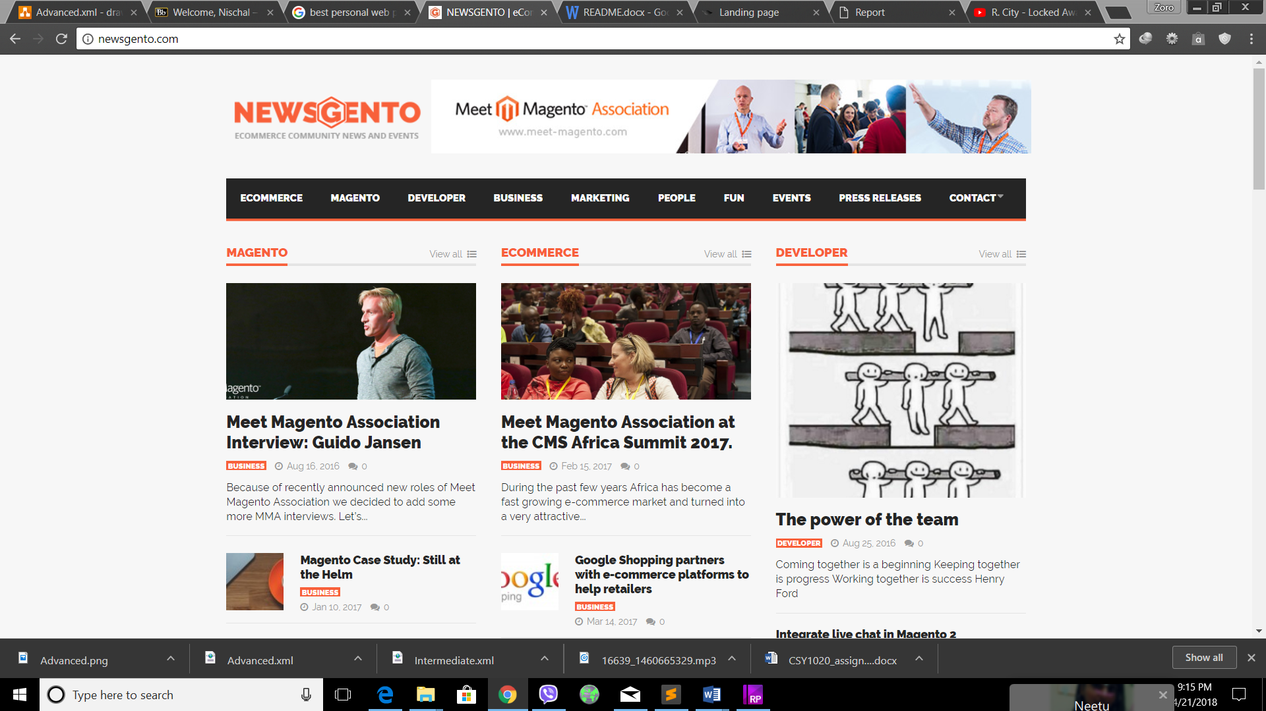

<https://www.mint.com/>

