

_____________________________________________________________________
Siku
Sea Ice Discrete Element Method Model0 Sea Ice Discrete Element Method Model
Final Report and Documentation0 Final Report and Documentation

_____________________________________________________________________
Authors:
Anton V Kulchitsky
Jennifer Hutchings
Jerome B Johnson

June 04, 2013 – December 11, 2016
branch: physreorg
version: 0.1.0
This study is sponsored by the University of Alaska Coastal Marine Institute. Study collaboration and funding were provided by the U.S. Department of the Interior, Bureau of Ocean Energy Management, Environmental Studies Program under Agreement Number M13AC00001.
The matching funds are provided by Institute of Northern Engineering, University of Alaska Fairbanks and by Oregon State University.
Contents

Chapter 1

Introduction

1.1 Basic Information
Siku is written on a subset of C++ language. Please, see Sec. 1.3 for strict programming policy.

1.2 Software Requirements
To compile and use the model, the following packages are required:
1. Python 3.0 or higher
(a) mathutils from blender project. See https://code.google.com/p/blender-mathutils/.
(b) netcdf4-python (recommended if you need import NetCDF4 forcing files).
(c) numpy
(d) shapefile (known also as pyshp).
2. HDF5 version 1.8 or higher.
3. NetCDF4 version 4.1.1 or higher.
4. GSL version 1.16 or higher.
5. Boost library version 1.53 or higher.
6. OpenGL Mathematics (GLM) version 0.9.6.1 or higher.
7. LATEX for creating documentation.
The packages that are necessary to compile the core are checked during the configuration step. Python libraries are not checked.

1.3 Programming Policy
A strict programming policy is enforced to keep the code clean and rational. This policy is strictly enforced in particular due to usage of such an obscure, overloaded and heavy language as C++.

1.4 Development Policy
Chapter 2

Ice Element Location and Position

2.1 Introduction
Let an ice element be considered as a flat (2D) rigid body in a form of convex polygon moving on a spherical surface. The goals of this chapter are
• Find a suitable description of position and orientation of the ice element;
• Derive position integraion equations;
• Build an integration numerical algorithm to update position and orientation of the ice element;
• Describe coordinate transformations used in the model.

2.2 Equivalence to 3D Rigid Body Rotations
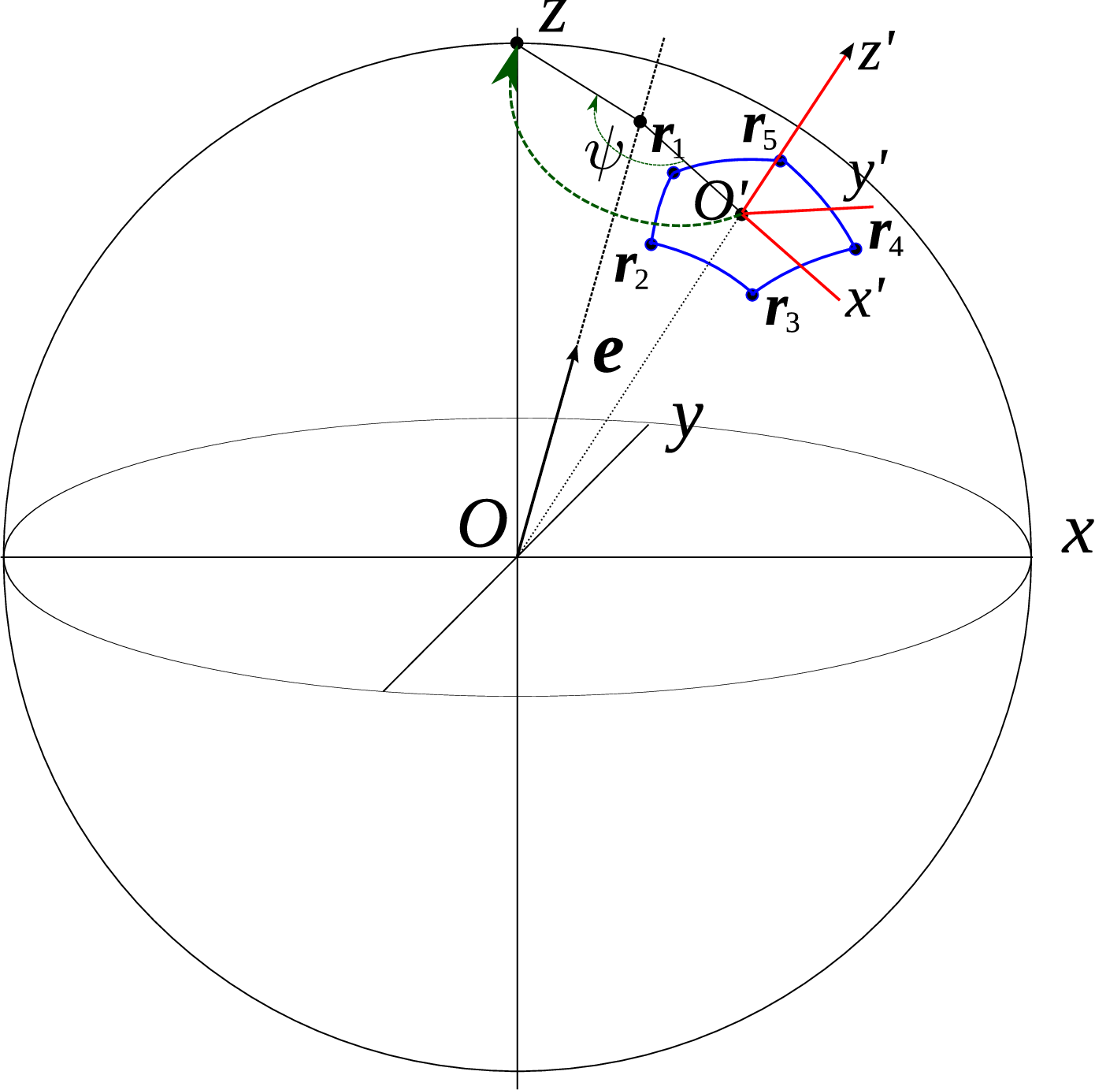
Figure 2.1: Coordinates
It is easy to see (but not so easy to find out) that the motion of an ice element on the surface of a sphere is equivalent to a rotation of a rigid body around the center of the sphere. Such a rigid body can be considered to be a pendulum with a massive weight to be a material polygon which center of mass is connected to the center of the sphere by a massless rod. The center of the sphere does not move and is a center of the rotation. This set up is shown in Figure. 2.1.
It also can be visualized as a rotation of the rigid sphere shell around its center with all the mass concentrated inside a single polygon patch – an ice element.
The representation of an ice element as a 3D constrained rotating rigid body provides a useful instrument to describe exact position and orientation of an ice element. The rigid body rotation around a point can be described by unit quaternions a.k.a versors [Graf, 2008, Waldvogel, 2008, Arribas et al., 2006, Nemes and Mikóczi, 2013]. The main advantage of using quaternions instead of, say, spherical coordinates with a rotation angle is that every point on a sphere is treated exactly the same way as any other point. The density of coordinate lines do not change from point to point and no critical points are present. The quaternion representation also allows to perfom many coordinate transformations without involving trigonometry, store orientation information very compactly, and the formulas of all necessary operations are simple and short. A single quaternion is sufficient to uniqly describe the position and orientation of an ice element.

2.3 Coordinate Systems and Frames
When describing different values such as positions or vectors we use 2 different types of reference points or “frames” depending on convenience:
• Global Frame, connected to the Earth and rotating with the Earth;
• Local Frames, a reference point connected to a particular ice element.
For describing elements in Global Frame, we use 3 different coordinate system:
• Geographical coordinates (latitude ϕ and longitude λ). They used only for import or export elements and never used internally. We provide trasformation from and to geographical coordinates.
• Spherical coordinates (φ=λ, Θ=π/2−ϕ).
• 3D extrinsic Cartesian coordinates (x',y',z'). Its center coincides with the center of the Earth O, z' is directed along Earth’s axis of rotation towards the North, x' direction is a direction to 0 meridian, and y' direction is chosen perpendicular to x' and z' to form a right coordinate system. These coordinates satisfy the constrain .
• 3D normalized (dimensionless) extrinsic Cartesian coordinates (x,y,z). Same as above but all projected to a unit sphere such that . These are the main global coordinates internally used in the Core for all the computations.
We use Global Frame only when considering interaction between two ice elements. In all other cases we transform global coordinates into a local frame first and then produce the computations.
The transformation between extrinsic coordinates and geographic/spherical coordinates are performed using the following formulas:

[Sorry. Ignored \begin{aligned} ... \end{aligned}]
) \b \lc\{ ([Sorry. Ignored \begin{aligned} ... \end{aligned}]
) (2.1)Local coordinates (X,Y,Z) are the coordinates that have its center in the center of mass of the ice element. The axis are directed such that they would coincide with global frame normalized extrinsic coordinates (x,y,z) after application of the rotation described by the quaternion ̂q linked to the ice element.
Global extrinsic coordinates for any point ⃗p are restored from local coordinates ⃗P by applying the rotation matrix recovered from quaternion:
⃗p=R(̂q)⋅⃗P (2.2)
Rotation matrix can be recovered from quaternion as described in Section C.2.

2.4 Initial Frame Relation
To relate two different frames, we have to introduce initial quaternion . Later we will provide a first order differential equation for the evolution of the quaternion. However, we have to find this initial quaternion to be able to resolve the evolution.
We found a simple way to set this initial position quaternion. Initially, we have initial coordinates of the polygon representing the ice elements in some of Global Frame coordinates. To find initial quaternion we will do the following
1. Find center of mass of the polygon in global frame.
2. Find a quaternion such that when applied, it moves the center of mass into the North Pole. There are an infinite number of such rotation quaternions, so we pick one.
3. We introduce initial local coordinates based on this initial quaternion such that they will coincide with extrinsic coordinates after the transformation. All vertices coordinates are computed then. They will never change with time.
There is an uncertainty in quaternion choice that initially would transpose the center of ice element into North pole. Let us choose the quaternion that transpose the center of the ice element as follows.
Suppose we have coordinates of the center of mass in Global Frame in Extrinsic coordinates: , then we restore the transformation as a rotation along big circle to match ⃗c with North Pole as follows:
(2.3)
Θ is spherical coordinates of ⃗c. The rotation axis is perpendicular to ⃗c and direction to the North. Reminder: we use a convention that vectors and scalars are all a subset of quaternions and can be added to each other to make a new quaternion.

2.5 Position Update Equation
Suppose we know the vector of angular velocity of our “pendulum” ⃗ω. Please, notice that this is 3D angular velocity vector, not a rotation rate of the ice element. Later we will see how to calculate it from the velocity and rotation rate of the ice element itself. In this case we have the following expression for updating orientation quaternion
(2.4)
Where ̇q=dq/dt. Let ⃗Ω be the same angular velocity vector expressed in Local frame coordinates. Using (3.10) we can derive the main position equation:
(2.5)
While developing couπ we created a very neat scheme to solve this type of equations. This scheme will be described here later based on couπ documentation.

2.6 Placement Numerical Integration
Let us describe the numerical solution of the equation (2.5).
Let (and this value we will actually find on the dynamic stage), , . The 2nd order scheme for the equation above will be
(2.6)
Collecting all next step values on the left side and taking into account that quaternion product is not commutative, we have
(2.7)
We removed index n+1/2 from ⃗Ω to make it easier to read. Brackets in (2.7) are conjugate quaternions. Using relation we have
(2.8)
(2.9)
(2.10)
For any vector ⃗a using product Eq. (3.3) we have
(2.11)
Then, we have
(2.12)
Let us introduce the following quaternion
(2.13)
then integration formula will have the form
(2.14)
Computation wise it is a significant improvement over [Walton and Braun, 1993] quaternion integration formula or trigonometric approach like in [Harada, 2008].
It is easy to see that |̂p|=1 and hence this formula does not change the absolute value of unit quaternion. However, round-off errors might accumulate in time shifting the absolute value of ̂q from 1. To ensure we are working within unit quaternion algebra, a renormalization should be done occasionally
(2.15)
Chapter 3

Dynamics

3.1 Introduction
The main problem in dynamics is to calculate 3D “pendulum” angular velocity ⃗Ω in ice-element reference frame. This vector can be calculated exactly using 3D dynamics of a rigid body with constraints. However, it is not necessary. A much simpler way should be sufficient if we suppose that the ice-element size is much smaller than the radius of the Earth. This is equivalent to the assumption that the ice element is flat.
In spite of this assumptions we are not solving 2D cartesian problem. All we are saying is that we are considering the dynamics on a sphere with locally flat ice elements.

3.2 Dynamics in ice-element reference frame
As ice-element reference frame is a standard cartesian coordinates and we assume that the ice-element is a flat 2D ridig body, its velocity and rotation rate can be calculated simply by the following equations
(3.1)
where are external forces that include all driving forces, integral forces from interaction with other ice-elements, and Earth Coriolis force, m is the total mass of the ice element, I is a moment of inertia around Z axis, and N is a total torque calculated in the center of mass ⃗C that includes a torque from interaction with other ice elements and possible torque that can be calculated from the integral of the driving forces over the ice element (TODO: discuss with Jenny).

3.3 Restoring 3D angular velocity
It is pretty clear that if we know , , and , we can restore ⃗Ω as follows:
(3.2)
Indeed, is directed normal to Z and tends to rotate the “pendulum” around Y axis with rate. The rotation direction is “right” and that is exactly . Same considerations show that and we need to choose “-” as a sign to take into account the right direction.
Taking this into account, we can rewrite the dynamics ecuations for global angular velocity vector in Local frame:
(3.3)

3.4 Dynamics Integration
A straightforward 2nd order in time scheme is applicable for Eq. (3.3):

[Sorry. Ignored \begin{aligned} ... \end{aligned}]
) (3.4)
Or in vector form:
(3.5)
Thus, the numerical scheme for integration of motion of the ice element is completed in terms of rotational quaternions.
Chapter 4

Ice Element Polygon

4.1 Introduction
Each ice element is represented by simple convex polygon. Siku core accepts polygons with many precomputed values described in this chapter. Thus, all following computations are performed on Python side of the model.
Initially, the polygon is given as a set of its extrinsic Cartesian coordinates in Global Frame. If the coordinates are given in Geographic coordinates, they are recalculated to extrincsic Cartesian coordinates using (2.1). Thus, we just suppose here that all vertices are given in Global frame as a set of extrinsic Cartesian radius-vectors: , j=0,1,…N−1, total N vertices.

4.2 Center of Mass, Area, Moment of Inertia
The center of mass ⃗c (CM) is a center of local Frame. Given coordinates of vertices, the center of mass is calculated in assumption that the polygon is flat. Otherwise, complicated intergration would be necessary to accurate computations.
First, we introduce geometrical pseudo-center ⃗q by a formula:
(4.1)
Although, it is not a CM, it is a convenient point that resides inside the polygon and allows to split it in triangles as shown in Fig. 4.1.
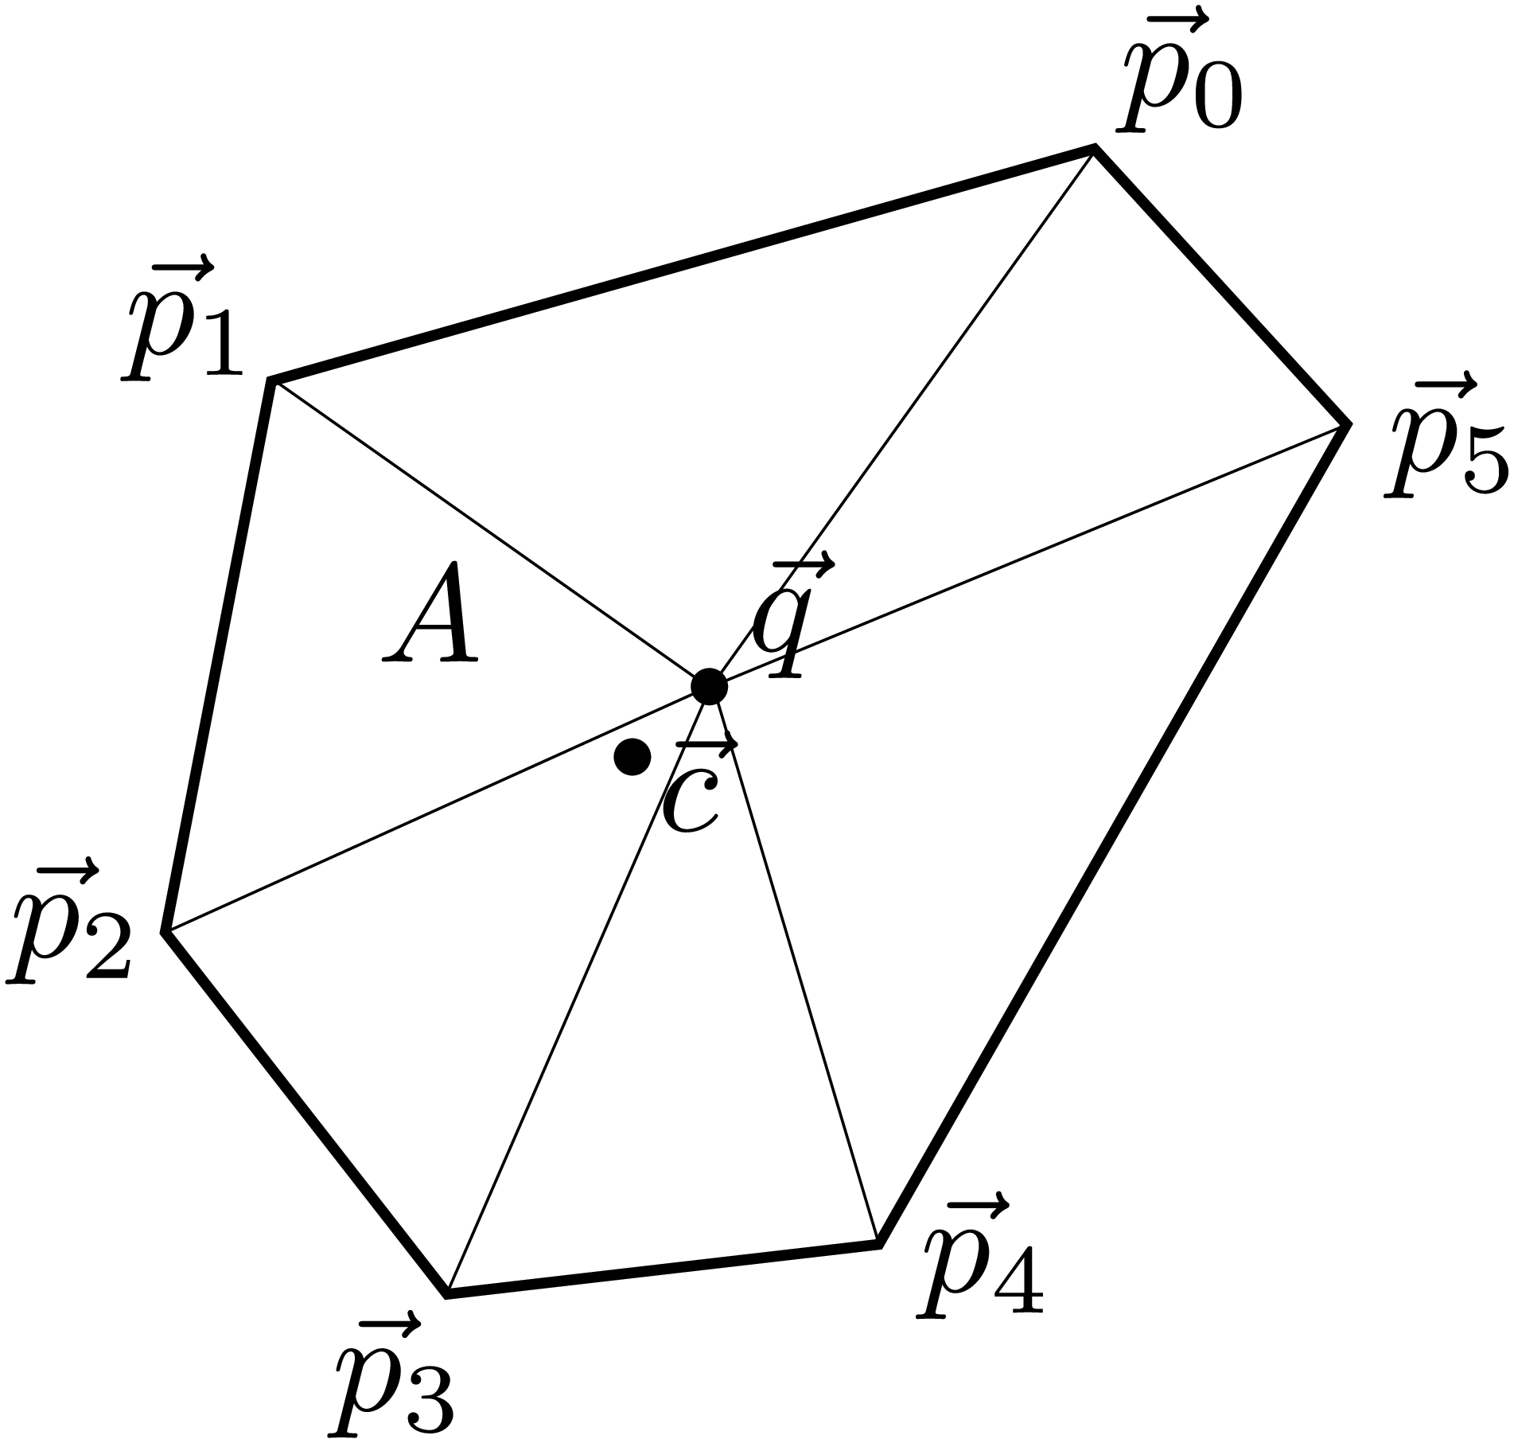
Figure 4.1: Polygon main properties computations
Now we can calculate the centers of mass of each triangle as
(4.2)
And areas of each triangle and total area A.
(4.3)
Now, the center of mass can be computed as a sum of area-weighted center of masses for each triangles:
(4.4)
Total geometric moment of inertia (it is a moment of inertia divided by mass) around center of mass is computed by same weighted approach:
(4.5)

4.3 Mass
Total mass need to be calculated up to at each timestep using the ice thickness distribution function g(h). General formula is
(4.6)
where is the density of ice of thickness .
Chapter 5

Wind Interpolation

5.1 Introduction
The wind data is given in a mesh and, possibly, in some set of random points. We have to be able to restore the proper wind vector for any ice element on a sphere. We also would like to have a few analytical testing fields that we can use. This chapter describes all that related to the wind.

5.2 Analytical Testing Fields
First field to use is taken from [Fuselier and Wright, 2009], field 1, pp. 3233–3234.

5.3 NCEP/NCAR Reanalysis grids
Most part of testing and generic [? ] wind interpolations is based on NCEP/NCAR Reanalysis data grids.
The data is represented as a values distributed upon the regular grid in latitude-longitude coordinates.

5.3.1 Basic interpolation method
As the grid is guaranteed to be regular and the wind field itself is pretty smoth - basic interpolation is made as if it is simple Cartesian coordinate system. The simpliest method to obtain the interpolated value in two dimensional space is bilinear interpolation. This method is based on the assumption that the value should smothly change along the distance between two known values. Saying ’smothly’ means that the interpolated value should be calculated with the heuristic function, which defines the proportion law. The methed consists of next steps:
1. Constructing regular grid with all needed values in the nodes.
2. Find the grid cell, that matches to interpolation value position.
3. With heuristic proportion - calculating two additional values, tha are located on the same lattitude with interpolated value, but at the same time on cell‘ right and left boarders..
4. With that very heuristic propotion - calculating the value we were searching for.
This procedure means that proportion function shall be called three times in a raw. More then that - in most cases the result that is based on ’same latitude’ additionel boarder values will differ from the result based on ’same longitude’ additional boarder values.

5.3.2 Proportion functions
All circumstances described in previous section mean that proportion function should be as simple as possible, but at the same time it should preserve such field attributes as curl and divergence.
For satisfying such various conditions we provide several functions, that bestly suit for differents cases.
• Generic proportion and interpoation.
The wind vector is represented as range-azimuth pair. Both values are considered to change linearily.
(5.1)
(5.2)
Where is interpolated velocity vector, φ is it‘s azimuth, t is scalar value (t∈[0,1])
• Simple proportion and interpolation.
The wind vector is represented as east-north components pair. Both values are considered to change linearily.
(5.3)
• SLERP proportion and interpolation.
According to https://en.wikipedia.org/wiki/Slerp.
(5.4)
Where Ω is the angle between and

5.4 Advanced interpolation (expected soon)
For more accurate and meaningfull interpolation several more complicated methods are going to be provided.
The main aim is to take into account such parameters as wind‘s first (and maybe second) derivative, that could be calculadet in the nodes, and additional random distributed wind data from various other sources.
Chapter 6

Force Balance on Ice Elements
During the Arctic Ice Dynamics Joint Experiment (AIDJEX) it was found that long term mean ice motion, in the summer when ice concentration is low, results from the balance of four forces on the ice [Error: Reference source not found, Error: Reference source not found]. In free drift the significant forces on the ice are wind stress, ocean stress, the Coriolis force and acceleration down the sea surface tilt. Inertial terms were found to be an order of magnitude smaller than these on daily or longer time scales [Error: Reference source not found], however are important on shorter time scales and accumulative impact of the inertial motion of the ocean and ice maybe significant in the sea ice mass balance [Error: Reference source not found]. The residual term in the measured force balance is found to be comparable to the Coriolis force, and an order of magnitude smaller than the wind stress [Error: Reference source not found]. This residual is attributed to interactions between ice floes. In areas of ice convergence, resistance to compression becomes important, and ice can no longer be considered to be in free drift. For climatological studies small time scale forcing may be ignored. Contributions to the force balance from tidal motion, pressure gradients and inertial terms are considered to be small when averaged over time scales greater than a day [Error: Reference source not found]. For short term ice drift estimation, and in regions with strong tides the tidal and inertial terms may become important.
The force balance on the ice, per unit area, is given by: *** This needs to be replaced with force balance on an ice element. It needs to be integrated over the element area for surface forces and volume for body forces. We need to replace ∇⋅σ with contact forces.***.
(6.1)
where m is the ice mass, U is the ice velocity, and are the wind stress and ocean stress on the ice, f is the Coriolis parameter, ̂k is a unit vector normal to the surface, g is the acceleration due to gravity and H is the sea surface dynamic height. The remaining term ∇⋅σ is a force due to sub-scale interactions between ice floes. A constitutive law defining the ice stress σ will be outlined in section Error: Reference source not found. By scale analysis [Error: Reference source not found] it can be shown that the advection of momentum, ∇⋅(mUU) is two orders of magnitude smaller than the coriolis and gravitational terms and may be neglected. The inertial term is also small on time scales greater than a day. The momentum may be found from the balance between external forces and ∇⋅σ, which is the form [Error: Reference source not found] take for their model. The two largest terms, and , are of the order , and tend to oppose each other. The Coriolis, gravitational and interaction terms are of the same order of magnitude, and typically an order of magnitude smaller than and .
*** Need to re-write the above to reflect the shorter timescale we will resolve with Siku. And to write in terms of contact mechanics rather than continuum form. We also need to discuss inertial motion. The ice/ocean does manifest inertial oscillations in response to storms, it is the motion of the massive ocean that is causing the ice to oscillate. Which is not possible to model with out a coupled ice/ocean model. ***

6.1 Surface Forcing
The force balance on an ice element includes stresses to the upper (atmosphere) and lower (ocean) surfaces that must be prescribed.
The stress applied over a unit area of ice by the wind and ocean current is modelled with a quadratic boundary layer model [Error: Reference source not found, Error: Reference source not found, Error: Reference source not found]. Ice velocity is an order of magnitude smaller than the wind velocity and insignificant when calculating the wind stress over the ice,
(6.2)
(6.3)
The drag laws require the air velocity, , at a known height in the atmosphere and the ocean current, , usually below the surface Ekman layer, to be known. It is possible to take these as geostrophic velocities, though they could equally well be provided at heights within the boundary layer by atmospheric and oceanic models. The other variables are the density of air, ; density of water, ; the drag coefficients for the air and water interfaces, and ; and the turning angles across the boundary layers, and . The magnitude of the drag parameters and turning angle is dependent upon the height (depth) that winds (currents) are provided for.
*** Let’s start with the simplist implimentation for drag coefficients and turning angles, assuming they are constant. and could be modeled as a function of ice morphology following [Error: Reference source not found], and they can be adjusted to better fit observed ice drift following [Error: Reference source not found]. I also need to consider a version of the atmospheric stress parameterisation that allows for an unstable atmosphere boundary layer. This will take me a couple of days to sort out in my head. So beware, we may be replacing the wind stress equation with something else.
For testing it is appropriate to start with the default values for the parameterisations. These are , , and . We are assuming the velocities are sufficiently close to the surface that Eckmann turning is negligable.

6.2 Data Input
Wind and ocean current data can be sourced from various agencies. Either forecast model output can be used or reanalysis fields. Provided data is provided on a known grid SLERP (see section ? ? ) will interpolate the fields to ice element locations.

6.2.1 Winds
Siku is set up to run with 10 m winds by default. It is possible to use geostropic winds or winds from different atmospheric levels, however to do this the drag parameterisation and turning angles will have to be adjusted in Siku’s calculation of surface stress. *** ANTON: I assume we will have a lookup table variables are read in from where these can be set ***.
Example wind fields are provided with the Siku distribution for testing purposes.

6.2.2 Ocean Currents
*** Will provide information as soon as we have narrowed down which fields we shall use from Hycom or RASM. We should also include a note about adding tides to the currents, which could be provided by [Error: Reference source not found] for example. ***
For testing purposes one can set the ocean currents to zero. In this can the ice is moving over a stationary ocean that provides drag.
Chapter 7

Diagnostics
Diagnostics is a facility to calculate and output some values from the model on a set of coordinates.
For each diagnostics, the user registers a function in python script where the data from diagnostics will be transferred to. Together with this function, the user provides and registers set of points, a.k.a. “mesh” where the data will be calculated. The user also schedules the runs such that diagnostics will be performed only when necessary, not at each time step.
Chapter 8

Drift testing

8.1 Introduction
It is obvious that our program should contain basic tests with easily observable results. These tests can either confirm that all calculations are correct or show up that there are some miscalculations or phisical laws which are not taken into account.
For proper testing we provide several simple tests, which could be ran directly from ’freedrift.py’, and some more complicated hardcoded tests, which require rebuilding the C++ core, that should not be made by users. More detailed description will be given below.

8.2 User-restricted tests

8.2.1 Hardcoded winds
In order to remove any possibilities to make a mistake while passing wind data from file to python and from python to core - a simple windfield has been hardcoded into C++ modules.
That field gives wind velocity by default equal to (-10, 1) in convention (east-velo, north-velo) in current velocity units all around the globe. The values of components can be changed in module ’vecfield.cc’ in method ’get_at_lat_lon_rad. This test can be turned on in module ’globals.hh’: one should uncomment testing constructor (next to atmospheric wind data declaration), and by default is turned off.
As the result - all elements on the globe should behave according to hardcoded wind. NOTICE: hardcoded wind will not be outlined as it is not connected with python!

8.2.2 Hardcoded spins
In early stages, while interaction between elements is not properly defined, the most basic spin test has been hardcoded. The test is naive constant angular velocity of all elements. This velocity is brutally embedded inside ’dynamics.cc’ module. The values are chosen for different elements‘ behavior (and equal to zero by default).
When angular velocity is small - elements behave like ’leaves on the wind’, simply drifting in direction of wind velocity, but slower in the reason of water. In the case of medium angular velocity - elements begin to turn aside from wind direction while they are mowing. This effect is caused by some kind of inner model gyro forces. When angular velocity is too high - elements behave more like spinning top: they are moving slowly with fluctuations or not moving at all. NOTICE: angular velocity and as the result elements behavior depends on time scaling of current computing session!

8.3 Generic python tests

8.3.1 Output settings
Befor starting the test itself, one should set a proper output for results. In order to observe the results we provide besic GMT picturing called from python modules.
All preruntime picture settings are located in ’plot_config.py’ file and are optional.Most values have several samples and described below:
• ’uwind_file’ and ’vwind_file’ - string that contains the name of .nc files with uwind and vwind variables. ’gmt_plotter.py’ automaticly prints wind grid from that files.
• time_index - integer, that specifies the time from .nc files for selecting the wind grid. Totally optional: runtime setting provided
• ’grid_step_lat’ and ’grid_step_lon’ - grid steps in .nc files for proper interpoaltion and plotting.
• ’out_pic_name’ - name of file for GMT output. Totally optional: runtime setting provided
• ’verbose’ - verbosity state
• ’inter_domain’ - the domain for gmt_plotter inner interpolation. Is being given in convention (minlon, maxlon, minlat, maxlat) in degrees. Several main domains are provided and commented out.
• ’inter_density’ - average density of additional interpolated vectors in degrees. 0 - for canceling additional interpolation.
• ’view’ - Important! main option! Contains information about map projection, oriantation and other minor gmt settings. Various views are provided and commented out.
• ’ground_colr’ - color of ground.
• ’coasts’ - Important! second main option, but generally optional as it has good dafault value. Contains gmt command string for printing coast lines.
• ’vector_scaling’ - additional scaling for wind vectors. For most maps dafeult value suits well, but when entire globe is being printed - vectors can cover all other output, so should be resized manually.
• ’inter_wind’ - gmt command line for printing interpolated winds. File name is synchronized with interpolation module.
• ’grid_wind’ - gmt command line for printing grid winds. File name is synchronized with interpolation module.
• ’underlays’ and ’overlays’ - lists of optional underlays and overlays (accordingly), such as monitoring output, additional grids or objects.

8.3.2 Testing scenarios
Same to all other scenarios - these are being set inside user scenario python files that are given as an argument to core binary (siku) on execution.
Current testing scenario settings are being contained in ’freedrift.py’, and are described below.

8.3.3 Materials
Each element has various properties. A lot of them can be simply described the material, which element is made of.
Default material for model is ice. Material‘s parameters can be changed in ’material.py’. Inside the scenario file all materials are being loaded into table in ’Define material’ section.

8.3.4 Wind initializations
Befor anything can move one should define a wind grid for inner processing. Yet only NMC reanalysis data is supported.
Grid loading ang preprocessing examples are being located in ’Wind initializations’ section of ’freedrift.py’. First of all one should load siku.wind field as a proper NMCSurfaceVField object, that depends on two NMCVar objects for two wind components (described in ’wnd,py’ and ’nmc.py’ accordingly). After the loading one can additionaly make some changes in that wind grid (such as setting all values equal to test values by ’make_test_field’ method. It also can be applied after each loading or updating wind grid).
The ’make_test_field’ method simply sets all values of wind velocity equal to that, which are given as arguments (in terms (east-velo, north-velo)). If arguments are empty - the winds all over the glob will be set as huge cyclones. That is very usefull for checking global drift and spin either with or without detection land collisions.

8.3.5 Date/time
As the model describes the dynamics - another inevitable setting is time.
Several time examples are being located in ’date/time settings’ section in ’freedrift.py’. Generally time should be set by exact values, but as every NMC file contains it‘s own set of times, one can easily choose some elements from that set.
There are several time variables, that should be set:
• siku.time.start - starting time of modelling
• siku.time.finish - finish time (modelling shall end after reaching that time)
• siku.time.last - the time of last calculation step
• siku.time.last_update - the time of last wind update (used by wind updating methods)
• siku.time.dts - outer cumputation time limit. Program shall exit after it would have been working for that amount of time.
• siku.time.dt - Important! time step of the model. This value has huge influence on computing process (mostly by dynamics).

8.3.6 Poligons
All elements are being represented as geometric poligons with different properties. Most general methods (such as loading) are being provided by ’Polygon’ class. The object of that class is being initialized in ’Polygon initialization’ siction.

8.3.7 Elements
The most basic example of several simple elements is being located in ’elements’ section.
Firstly one shoud set a list of vertices for each element. Secondly one have to init each element as an object of ’Element’ class using ’Polygon’ object, matching material and set of thicknesses specifying monitoring functions. In the third place one should append these elements to the list of elements.

8.3.8 Monitoring function
The variables and methods in section ’Monitor function for the polygon’ are being used for monitoring (such as picturing) some (or all) of the elements.
Currently there are next objects:
• siku.plotter - an object of GMT_Plotter class for picturing frames with GMT.
• diagnostics.monitor_freq - testing variable, defines frequency (actually period) of making frames in units of timestem, thus it is integer.
• siki.drift_monitor - monitor function for elements.
• siku.diagnostics.step_count - counter of diagnostics steps.
• siku.defaults.contact_method - flag contact detection algorithm. Default algorithm is brutal search.

8.3.9 Diagnostics
The vatiables and methods for diagnostics are being located in ’Diagnostics function for the winds’ section.
Currently not used

8.3.10 Callback
All python methods are being called from C++ core as a call-back functions. Therefore this methods has been declared in ’Callback flag-mask generator’ section and defined afterward.
These functions are:
• siku.callback.pretimestep - functions, that is called befor main camputations. Contains different preprocessings, such as wind updating.
Currently updating is turned off because time step is too large and couse unwanted updates spoiling results.
• siku.callback.aftertimestep - function, that is called after main computations.
Currently contains picturing of elements and winds.
• conclusions - function, that is called only once - befor program exits.
Currently contains command for creating a .gif animation from all frames.

8.3.11 Current testings
Current version of freedrift.py contains scenario for testing global movement and spinning. Running the model with that scenario should make 255 time steps covering 55 days, create 51 .eps file with the locations of three poligons and finally make .gif animationt of their movement.
Expected work time is about 30-60 seconds (mostly spent for picturing).
For drift testing with real winds one should comment out last 3 lines in ’Wind initializations’ section in ’freedrift.py’. That will set testing wind grid with povided .nc files.
For changing projection one should comment out current ’view’ variable in ’plot_config.py’ and uncomment that view, which one wants to see (or define his own).
Chapter 9

Random points generation

9.1 Problem Statement
We need to generate a set of points on sphere that will serve the role of nuclei for Voronoi tesselation procedure. The set needs to satisfy the following conditions:
1. The point set need to be randomly generated with some distribution (resolution) function over sphere. This means that some areas will have finer resolution than others.
2. The point set need to have blue noise characteristics. This means that the minimum distance between two points cannot exceed some limit value . This limit value is also a function of location.
3. The boundaries need to be also correctly represented. This means that the set of points need to contain explicitly the points from the boundaries. The resolution near the boundaries should be set by resolution function.
The problem is not trivial. The standard approaches for generation of blue noise are not always applicable here. On the other hand, we do not need too sophisticated approach as the statistical quality of the final set is not that critical.
The points are generated with mesh/gen_points.py script that is maintained to satisfy the procedure described in this chapter.

9.2 Random points on sphere

9.2.1 Uniform distribution on sphere
To generate a uniform point distribution a trivial random number generation in the cube (x,y,z) does not work. To pick a random point on sphere we use the method by [Marsaglia, 1972]. The random point (x,y,z) on a sphere is generated using the following rule:
1. Generate X and Y, uniformly distributed on a segment (-1,1).
2. Reject all the points that .
3. Generate a point on a sphere from the remaining points as follows:

[Sorry. Ignored \begin{aligned} ... \end{aligned}]
(9.1)

9.2.2 Blue noise
The blue noise point generation is when the points are almost randomly generated but with additional condition that there is no two points that are closer than a particular distance . The simplest way to generate blue noise is to remove a subset of the points from the original set such that a new set will satisfy the blue noise condtion. We proposed the following algorithm for this.
1. Sort all the points by x coordinates (we will compare the projection of the points on x-axis).
2. Form a new empty list that will contain the blue noise set. Add the first point from the original list to it.
3. Traverse the original list starting from its second point. For each original point check the points from the new list backwards until the projection distance is smaller than . If no points are actually closer than , add original point to the new list. Otherwise, skip it.
The new list will obviously satisfy the blue noise condition.

9.2.3 Large voids
There is no garantee that some points will be too isolated from the set with much voids around. This problem can be solved by adding points in the voids. However, we will not address it for now.

9.2.4 Changing the distribution
However, we need to generate the point set with varying distribution function.
The first and simplest approach would be to generate the point set with the finest resolution possible. Then we can apply the blue noise filter technique described in Sec. 9.2.2. However, this can be extremely slow even for not so fine resolution.
Instead, we can set the areas with different resolutions and the simplest way is to generate uniform resolution in that areas and then apply filter to the whole globe.

9.2.5 Uniform distribution is selected region
The method from Sec. 9.2.1 cannot be directly apply. However, we can use different approach. Technically, the uniform distribution over the globe can be generated by
Θ=2πu, φ=arccos(2v−1), (9.2)
where u and v are random values on (0,1).
Appendix A

Formulas Summary

Dynamics
(1.1)
(1.2)

Placement
(1.3)
(1.4)
(1.5)
Appendix B

Formulas on July 6, 2016 (C++ Core)
In this appendix all values marked with underlined font are being stored in coordinates On Unit Sphere (with respective scale). All the other values are in SI.
The values marked with “quotes” are global constants, those are set up in python scenario.
Denotions:
R - planet radius in meters, - one of the ice elements.

B.1 Elements‘ state update
Elements‘ state is being updated in module “mproperties”. This update includes calculation of elements mass (according to melting/freezing) and moment of inertia, land fastency conditions check, minor error checks (like zero-thickness), e.t.c.

Two dimensional density (per unit of surface):
(2.1)
where is ! UNDONE!
Element‘s mass:
(2.2)
Moment of inertia:
(2.3)
Element becomes fastened if ( ),
where is total area of overlap of with shore elements and is an area of the smallest of nearby elements (including ).

B.2 Distributed forces
All the distributed forces like wind drag, water currents, Coriolis force are being calculated in “forces_mass” module.
Denotions:
⃗̃V -interpolated wind velocity, ⃗̃W -interpolated water velocity.
Wind and water drag forces:
(2.4)
(2.5)
where “windage” and “anchority” are the general factors of interaction of floes with air and water, and are respective formfactors for each floe (depending on shape, density, e.t.c.).

B.3 Elements interaction
The interaction of elements is represented as a set of pairwise forces, those are selected with respect to each contact type (e.g. frozen joint, collision...). Pairwise interactions are implemented in “contact_forces” module. In this section indexes ’1’ and ’2’ denote respectively two interacting ice elements for each contact.
The process is devided into three steps:
1) generating collision data
2) calculating the force
3) applying and updating the state of the contact

B.3.1 Contact data
Contact data (denoted as cd) is a structure that is being generated at every step for each particular contact (the pair of interacting floes). It contains all geometric data like relative positions, velocities, intersection region (area, shape).

Interposition vectors
of elements‘ centers and center of intersection region:
(2.6)
(2.7)
(2.8)
where is a transformation matrix from local coordinates to local coordinates, ⃗NORTH≡(0,0,1), ⃗CoI is a vector from center (coinsides with the origin) to the center of intersection region (calculated by “geometry” module).

Velocities
:
(2.9)
(2.10)
(2.11)
where is an angular velocity of element about it‘s local vertical axis, is translational velocity of .

B.3.2 Pairwise forces
All pairwise forces take contact data and other contact props as the parameters and generate small structure containing the vector of force, two points of applications of this force to floes and the force couple value. In this section N denotes combined torque from possible moment of F and force couple caused by any kind of source.
Several methods which include elastic forces use the spring-like elasticity coefficient:
(2.12)
where σ is stiffness of ice, are thickness of the largest layers of two floes, are the “length” of elements (approximately the distance from the centers or ice elements to intersection region).

There are next basic force methods:

Collision
- interaction of two separate floes.
(2.13)
(2.14)
where η is parameter of ice-ice interaction viscosity, “rigidity” and “viscosity” are manual factors for possible ‘switching-off’ of unwanted forces, r - application point of force.

Test_spring
is the simpliest method for two frozen floes (Joint). Contact is represented as a single 1D spring with the same stiffness as if it was an ice block of appropriate size.
(2.15)
(2.16)
where ⃗Δr is the displacement from the equilibrium position (which [position] is defined at the moment of Joint freezing), wid is width of contact (length of mutual edge of two polygons), dur is current durability of Joint (1 for new unbroken Joint, 0 for destructed one).

Distributed_spring
is the main method for two frozen floes. Contact is represented as 2D spring, that allowes to calculate forces and moment far more precisely.
(2.17)
(2.18)
where ⃗Δr' and ⃗Δr'' are the displacements of two ends of mutual edge of polygons, ⃗wid is a vector of that very edge itself.

B.3.3 Joint state and props

Durability
of each Joint evolves by the next rule:

Fastening
is not that simple. For proper check of land fastening conditions at each time step ice elements accumulate the area of overlaping () by border elements (aka static elements on seashores). In addition each ice element stores the area minimal area () of single floe amoung the nearest floes (including self).
(2.19)
(2.20)
where C is a set of nearest ice elements (including self),

B.4 Dynamics
(2.21)
e.W+=SuperTorque⋅dt (2.22)

B.5 Position

1) propagation
(axis is random Global):
(23)
(2.24)

2) spin
(axis is Local ⃗Oz):
(25)
(2.26)

3)
transform old e.W and e.q according to element‘s new position and orientation
(27)
(2.28)
where transforms W from ̂q to ̂t local coordinates
Appendix C

Quaternions and Rotations

C.1 Briefly about Quaternions
[Graf, 2008] gives a good introduction to quaternions and their application to represent rigid body rotations. Here we will represent a few facts that will be useful in future discussions. Most of the proofs will be omitted.

C.1.1 Definitions
A quaternion is a number system that extends the complex numbers. Quaternions are 4-dimensional linear vector space over real numbers with scalar product and quaternion product defined on it. Algebraic definition similar to complex numbers is the following. A quaternion q is defined as
(3.1)
where (same as with complex numbers), . The multiplication of quaternion is non-commutative. That is the main distinction of them with complex numbers.
is said to be a real value and , , and to be imaginary values. The quaternion product ∘ of two quaternions can be algebraically derived from these rules.

C.1.2 Vector representation
Quaternions can be represented in different form as a pair of a number and a vector as follows
(3.2)
The quaternion product of two quaternions q and p can be defined in this notation as follows
(3.3)

C.1.3 Vectors as quaternions
Vectors can be considered to be quaternions with 0 real part. For two vectors ⃗a and ⃗b we have
⃗a∘⃗b=(−⃗a⋅⃗b,⃗a×⃗b). (3.4)
Thus, quaternion product contains both dot- and cross-products of vectors.

C.1.4 Norm
Norm of the quaternion is defined as follows
(3.5)
It can be shown that
|q∘p|=|q||p|. (3.6)

C.1.5 Conjugate
The conjugate ̄q of quaternion q is defined as
(3.7)
It can be shown that
(3.8)

C.1.6 Unit quaternions
Thus, unit quaternions such that |q|=1 form a subalgebra of quaternions over quaternion product operation. It can be shown that the quaternion is unit if and only if it can be represented in the following form
(3.9)
ψ is known as “rotation angle” and unit vector ⃗e is known as “rotation axis vector”.

C.1.7 Coordinate transformations using quaternions
Let ⃗a be a vector represented in the Global frame {x,y,z}. Let ⃗A be the same vector represented in local coordinate system {X,Y,Z}. In this case it can be shown that coordinate transformations between two systems can be expressed as follows:
⃗A=̄q∘⃗a∘q, ⃗a=q∘⃗A∘̄q (3.10)

C.2 Rotation Matrix and Positions
An important problem (mostly for visualization) is to determine spherical coordinates (φ,λ) of an element polygon vertex by quaternion q of the polygon and vertex local coordinates . When local coordinates of the vertex are known, the global coordinates can be found as follows:
⃗p=R⋅⃗P, (3.11)
where R is 3D rotational matrix restored from quaternion. The formulas can be found in many places, for example in a general introduction [Wikipedia, 2012]. For rotation matrix R and quaternion ̂q with elements we have

[Sorry. Ignored \begin{pmatrix} ... \end{pmatrix}]
, (3.12)
or in a more computationally convenient way

[Sorry. Ignored \begin{pmatrix} ... \end{pmatrix}]
(3.13)
The most efficient way to perfom these computations was found in [Eberly, 2008]. We just use standard libraries available for these transformation.
Appendix D

2D Geometry

D.1 General info
Due to different conditions and obstacles siku geometry is placed in separate module. For better performance we avoid using any external libraries (like boost) for two-dimensional geometry.
All functions are made by hand (even if they just implement generally well-known algorithms).
2D geometry module contains it‘s own set of tests for all provided functions.

D.2 Convex Polygon Intersection

D.2.1 Advance rule
The method implements O’Rourke’s approach from his book [O’Rourke, 1998]. The notation and some details were updated to make the method easy to describe.
Let and be two convex polygons, vertices ordered counter-clockwise. We need to find another convex polygon X=P∩Q.
Initially we choose (arbitrary) a side and a side . We use indices i and j to indicate the first vertex of p and q correspondingly. We say that point X∈L(p) if X lies on the left side (half-plane) of the directed segment . This condition is easy to check as follows:
(4.1)
Where we introduced a function for convenience.
O’Rourke derives the “advance rule”, e.g. the rule which polygon to choose next for advancing the side. The rule can be summarized as the Table 4.1.
The algorithm described in the table also uses a special χ inside status. It may have 3 values: “U” (for unknown), “P” (for inside polygon P), and “Q” (for inside polygon Q). The value of χ changes when an intersecton of two segments detected. It is set as described also in Table 4.1. It does not change if both conditions are not true.

Table 4.1: O’Rourke’s “Advance rule”.

p×q>0 | Programming rule | Advance rule | Add vertex condition | Vertex to add
true |  | P | χ=P
 |  | Q | χ=Q
false |  | Q | χ=Q
 |  | P | χ=P
On intersection only χ-rule:
 | ⇒ | χ=P,
 | ⇒ | χ=Q.

D.2.2 Termination and continuation condition
Let be the number of advances of P since first intersection, and be the number of advances of Q since first intersection. In this case, the loop continuation condition is
(4.2)
Bibliography
[Arribas et al., 2006] Arribas, M., Elipe, A., and Palacios, M. (2006). Quaternions and the rotation of a rigid body. Celestial Mechanics and Dynamical Astronomy, 96(3-4):239–251.
[Eberly, 2008] Eberly, D. (2008). Rotation representation and performance issues. Technical report, Geometric Tools, LLC, www.geometrictools.com. From documentation to Wild Magic library.
[Fuselier and Wright, 2009] Fuselier, E. J. and Wright, G. B. (2009). Stability and error estimates for vector field interpolation and decomposition on the sphere with rbfs. SIAM Journal on Numerical Analysis, 47(5):3213–3239.
[Graf, 2008] Graf, B. (2008). Quaternions and dynamics. arXiv preprint arXiv:0811.2889.
[Harada, 2008] Harada, T. (2008). Real-time rigid body simulation on GPUs. In Nguyen, H., editor, GPU Gems 3, pages 611–631. Addison-Wesley, NVIDIA.
[Marsaglia, 1972] Marsaglia, G. (1972). Choosing a point from the surface of a sphere. Ann. Math. Statist., 43(2):645–646.
[Nemes and Mikóczi, 2013] Nemes, F. and Mikóczi, B. (2013). Perturbed kepler problem in general relativity with quaternions. International Journal of Modern Physics D, 22(08).
[O’Rourke, 1998] O’Rourke, J. (1998). Computational geometry in C. Cambridge University Press.
[Waldvogel, 2008] Waldvogel, J. (2008). Quaternions for regularizing celestial mechanics: the right way. Celestial Mechanics and Dynamical Astronomy, 102(1-3):149–162.
[Walton and Braun, 1993] Walton, O. R. and Braun, R. L. (1993). Simulation of rotary-drum and repose tests for frictional spheres and rigid spere clusters. In 5-th Joint DOE/NSF workshop on flow of particulates and fluids, Ithaca, NY, USA.
[Wikipedia, 2012] Wikipedia (2012). Quaternions and spacial rotationa. Wikipedia.org. at http://en.wikipedia.org/wiki/Quaternions_and_spatial_rotation.

Everywhere we assume i+1 is actually (i+1)N, and j+1 is actually (j+1)M. We omit it here for briefty

