**Arduino NetBeans PluginArduino.png**

This steps shows how to install the plugin at NetBeans 7.3 running on Microsoft Windows.

1) Download the Arduino IDE: <http://arduino.cc/en/Main/Software>. Unzip the package, for example at c:\programs\arduino-1.0.5

**ATTENTION:** The plugin will not work if the Arduino is placed in a folder with spaces like C:\Program Files (x86)\arduino-1.0.5

2) Download the gnu make for Windows, available at: <http://gnuwin32.sourceforge.net/packages/make.htm>. Install it for example at c:\programs\GnuWin32

ps: I had troubles with the “make” distributed with arduino, so GnuWin32 worked properly.

3) Go to the Control Panel and add these paths below, in the Path system variable. Please, correct if you installed in another directories:

c:\programs\arduino-1.0.5\hardware\tools\avr\bin;c:\programs\arduino-1.0.5\hardware\tools\avr\utils\bin;c:\programs\GnuWin32\bin;

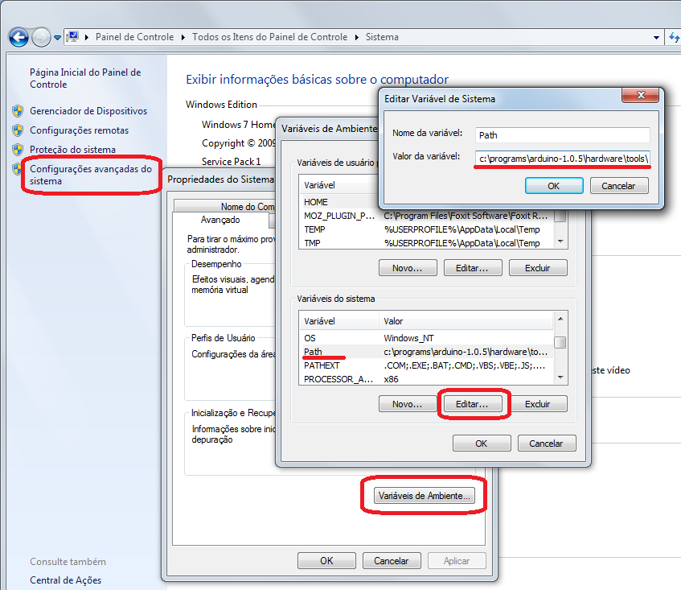

OBS: For arduino **1.6.5**, install cygwin and use these paths:

c:\cygwin\bin;c:\programs\GnuWin32\bin;c:\programs\arduino-1.6.5-r5\hardware\tools\avr\bin;

4) Start the NetBeans > menu Tools > Options > C/C++. Click on “Activate” if is the first time you use C/C++. Then, click on Add and inform that:

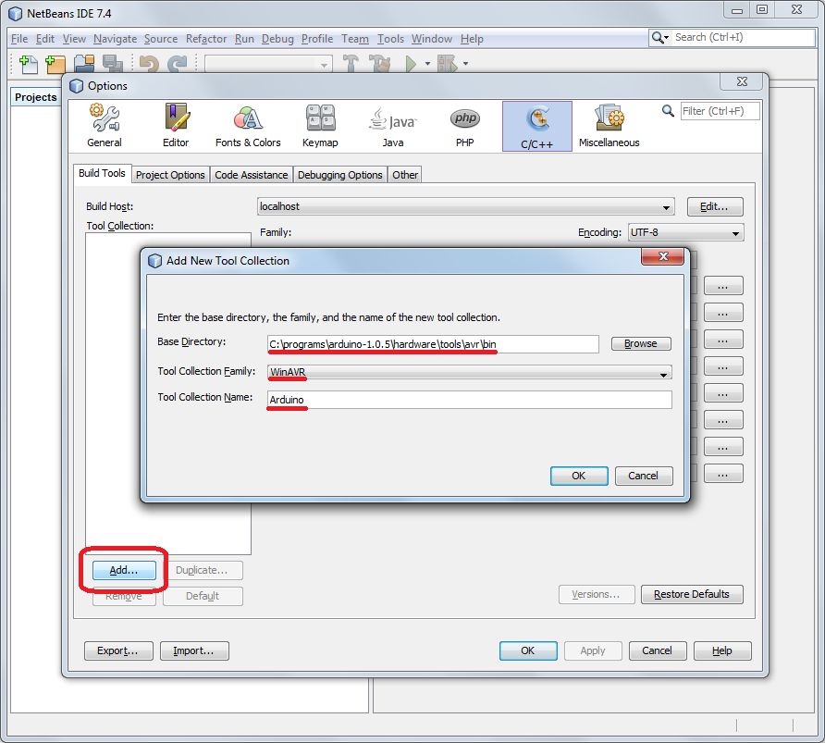

5) Enter the compiler paths:

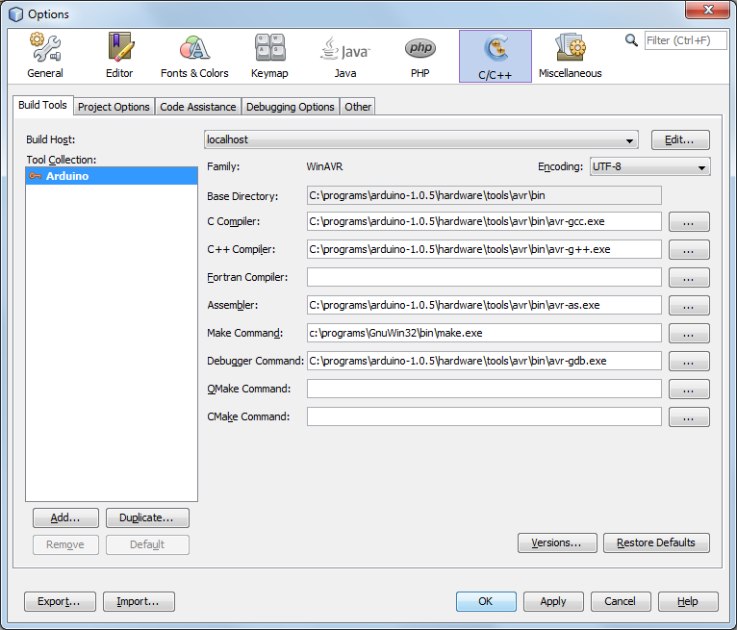

6) On “Code assistance” tab > C++ Compiler, add the paths of Arduino cores, pins, and libraries:

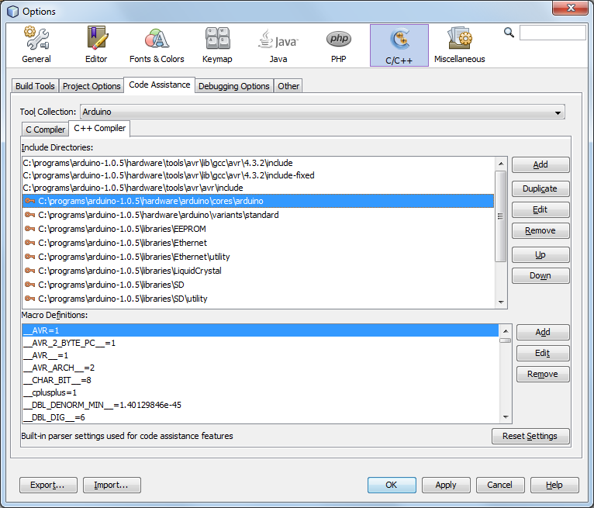

7) Download the plugin from <http://plugins.netbeans.org/plugin/46054/arduino>

8) Menu Tools > Plug-ins > Tab “Downloaded” > Click on “Add Plugins...” and select the .nbm file downloaded above. Click on “Install”:

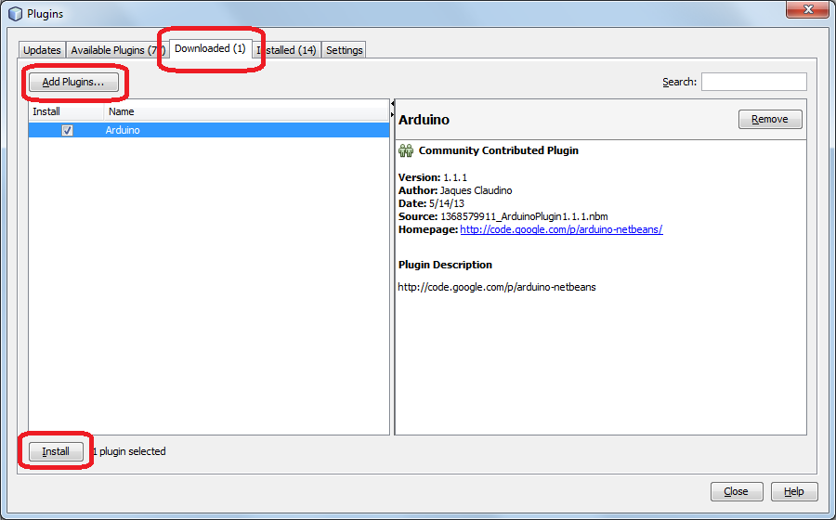

9) Create a new Arduino Project:

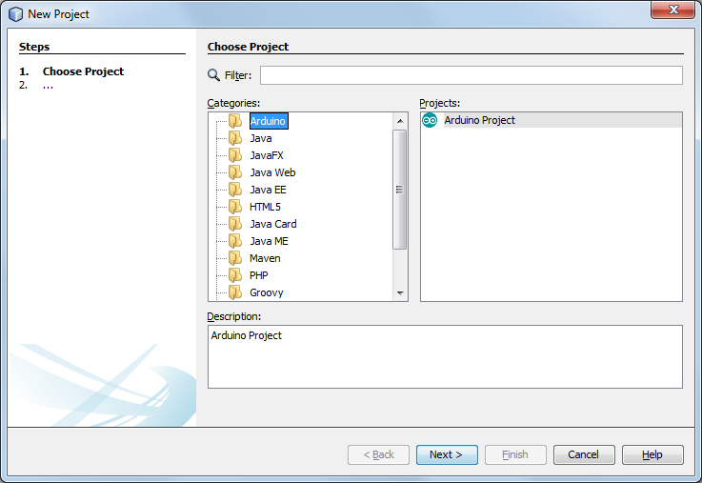

10) Configure the COM_PORT and ARDUINO_BASE_DIR on your Makefile and enjoy! Run the project to compile and upload to your Arduino.

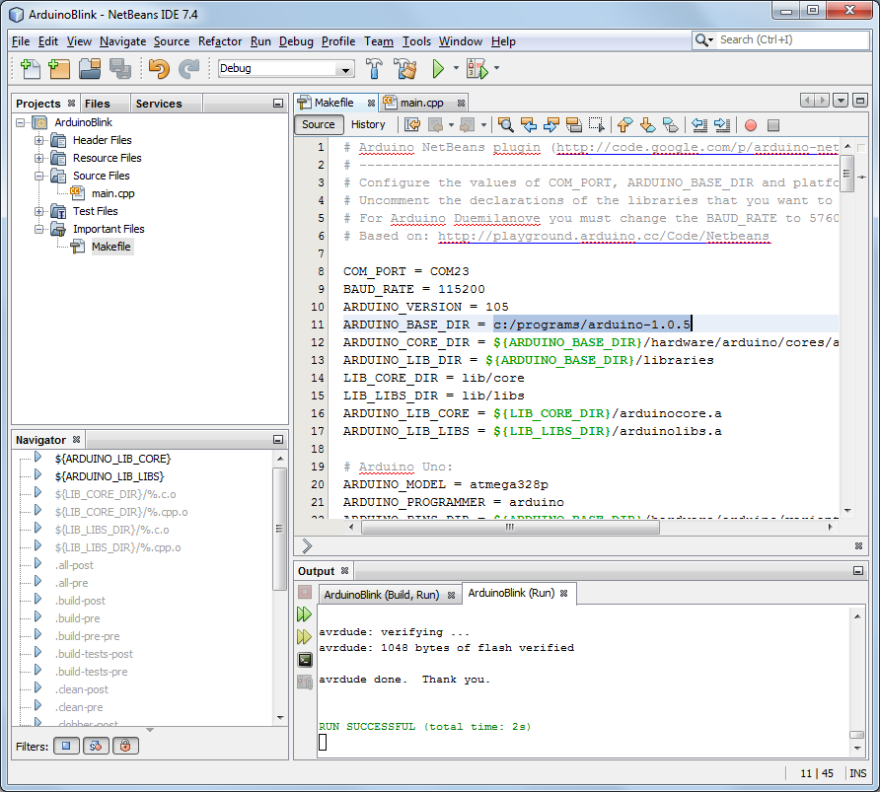

Troubles? Please send me an e-mail: jaques.claudino “at” gmail.com