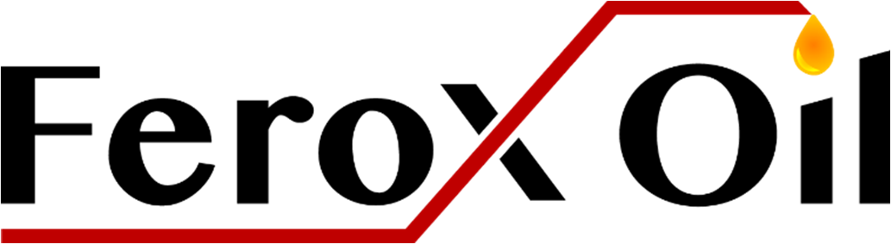
Ferox Oil, LLC
1910 Pacific Ave., Suite 5015
Dallas, TX 75201
The Robinson #1 Prospect
Subscription agreement
The “Undersigned” / (Non-Operating Participant) understands that Ferox Oil, LLC is offering for sale Units of fractional Working Interest (Units) in the above-referenced Prospect. I further understand that the Units are being offered to prospective purchasers at a price payable in one (1) installment. $45,000.00 for Drilling, Testing and completion per Unit. The first installment is due with this Subscription Agreement. There may be additional costs associated with the Drilling, Testing and Completion of the Prospect. In the event the Prospect exceeds the estimated cost, the notice is given. Failure to pay any additional cost could result in the loss of all Working Interest purchased and owned by the Undersigned.
All checks should be made Payable to “Ferox Oil, LLC”
Subscription: I hereby subscribe and agree to purchase ________ Unit(s), and tender this Subscription Agreement, together with a check made payable to Ferox Oil, LLC in the amount of $______________ ($45,000.00 x Number of Unit(s) purchased).
Each unit – which represents a 1% Working Interest (.75% of the Net Revenue Interest) is priced at $45,000.00 for Drilling and Testing and completion (estimated cost basis).
The Undersigned understands that:
- Upon execution of this subscription agreement by the Undersigned, payment by the Undersigned for the Unit(s) subscribed shall be due and payable and must accompany the delivery of this agreement to Ferox Oil, LLC
- The Unit(s) involve a high degree of risk of loss by the Undersigned of the Undersigned’s investment in the Prospect. There is no assurance or guarantee of any income from this Prospect.
- One Unit of participation in the Prospect constitutes a 1% Working Interest and .75% Net Revenue Interest.
- The Prospect will consist of Working Interest in one Well with a vertical depth of 8,900 ft. +/- to encounter the Travis Peak formation.
- There are various risks involved with the exploration and development of oil and gas prospects, including those involving normal drilling operations, complication in high pressured reservoirs, drilling and production risks (including, but not limited to possible loss of circulation, well bore collapses, blowouts, stuck drill pipe, production declines and speculative revenues) any of which may affect the economic feasibility of an oil and gas well.
- The net income, net losses, and distributions, if any, attributable to the Non-Operating Participant will be allocated among the Non-Operating Participants in proportion to the pro rata participation in the prospect.
- The Units in the Prospect are to be held by the Undersigned, will be acquired by the Undersigned, for the Undersigned’s own account or benefit and not for the account, in whole or part of any other persons or business entity.
- The Undersigned is experienced in business matters and has sufficient business acumen to analyze and evaluate the merits and risk of participation in the Prospect. The Undersigned acknowledges and understands that the Units in the Prospect are not intended to be “securities” as defined in any federal, state statute, law or regulation.
- The Undersigned understands that this agreement and all other documents prepared for the benefit of the person who will likely be acceptable to Ferox Oil, LLC as Non-Operating Participants. The Undersigned agrees that the Undersigned will not reproduce or distribute, by any means, any of those documents in whole or in part.
Suitability
- Representations and warranties of the Undersigned: I Understand that the units will be offered and sold in reliance upon certain exemptions from securities registration provisions of the Securities Act of 1933, as amended, and certain non-public offering exemptions of the securities acts of the states in which the Units may be offered. As a condition to purchasing Units, and for the purposes of the above-mentioned exemptions and/or qualifications to the extent applicable, and knowing that you will rely upon the statements made herein for such exemptions and in determining my suitability as a Non- Operating Participant, I represent and warrant to you that:
I am a person who meets one or more of the following categories of Accredited Investor as defined in rule 506(b) of Regulation D (initial which category you meet).
________ 1. Any natural person whose individual net worth, or joint net worth with that persons spouse, at the time of this purchase exceeds $1,000,000.00
________ 2. Any natural person who had an individual income in excess of $200,000.00 in each of the two most recent years or joint income with that person’s spouse in excess of $300,000.00 in each year of those years and has a reasonable expectation of reaching that same income level in the current year.


Ferox Oil, LLC
1910 Pacific Ave., Suite 5015
Dallas, TX 75201
Ownership of Record

Printed Name of Non-Operating Participant

Street Address for all Notices

City, State and Zip Code

Social Security or Federal Taxpayer ID Number

Area Code and Telephone Number

Email Address

Signature of Non-Operating Participant
The foregoing subscription is hereby accepted as of: _______________________________
By: _____________________________________________________________________
Ferox Oil, LLC
Brandon Chance, President

