Programming RN2903A Module Directly
1.Connections
Tools Needed
a. Download MPLAB X software (use the IPE that is bundled with it)
b..PoGo Pin Black box adapter

**This is correct orientation**
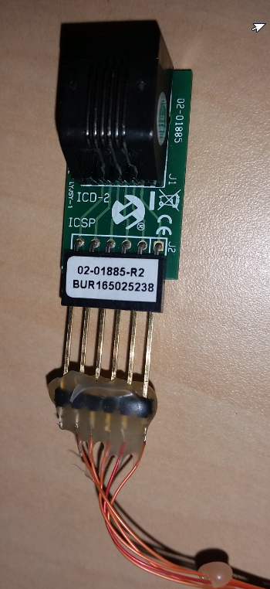
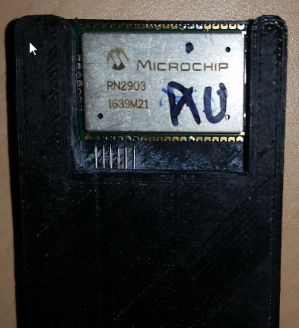

c. ICD3 (with adapter)
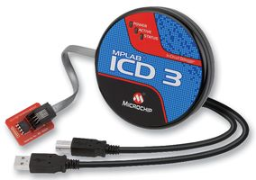

2. Programming
RUN MPLAB IPE program (comes shipped with MPLAB X)
- Load MPLAB X IPE program
- Select correct mcu inside PIC18LF46K22
- Select programmer debugger when installed via USB
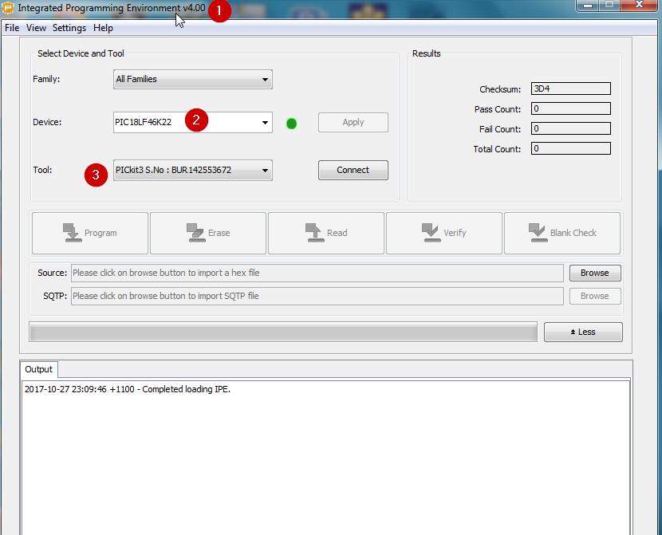

- We need to set some advanced settings
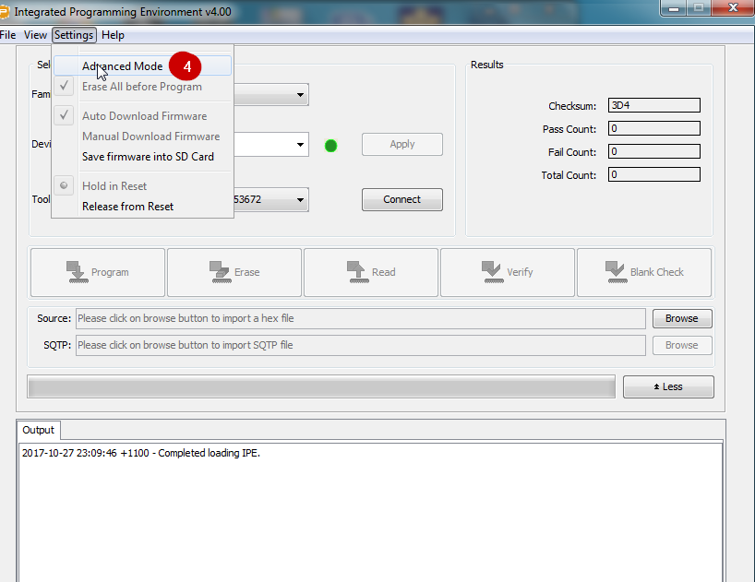

Enter “microchip” as the password
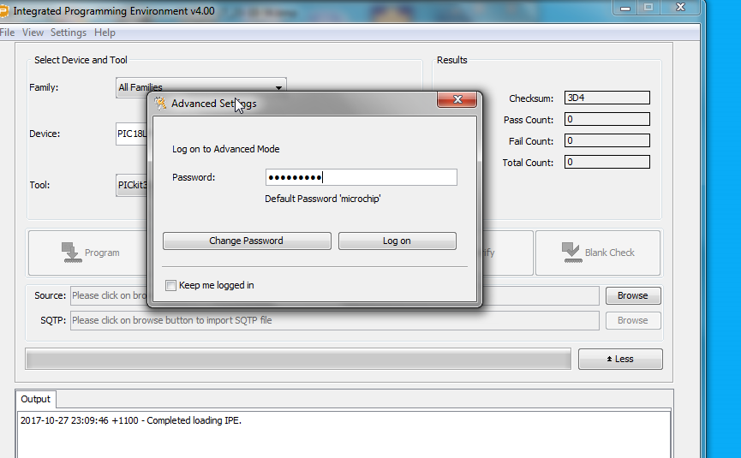
- Select the power settings
- Set the power settings so that debugger programmer (PICKit3 or ICD3) powers the Mote
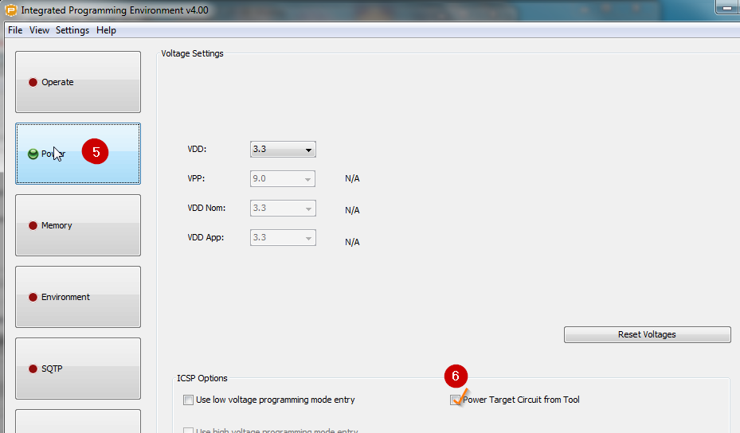

- Back to operate mode
- And 9 Select the correct hex file to program
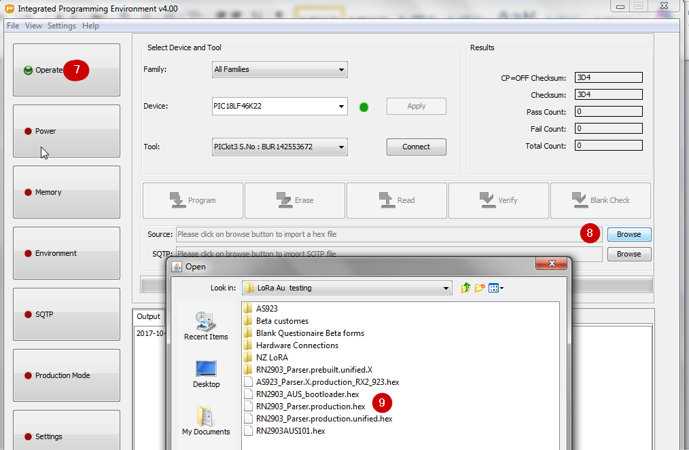

*** Just before connection and programming connect the BLACK BOX and 6 POGO pins to the RN2903 and hold in to the POGO pins continuously **

- Connect to the target Rn2903 mcu
(the first connecting might force the programmer debugger to automatically update so that can program the PIC18LF46K22)
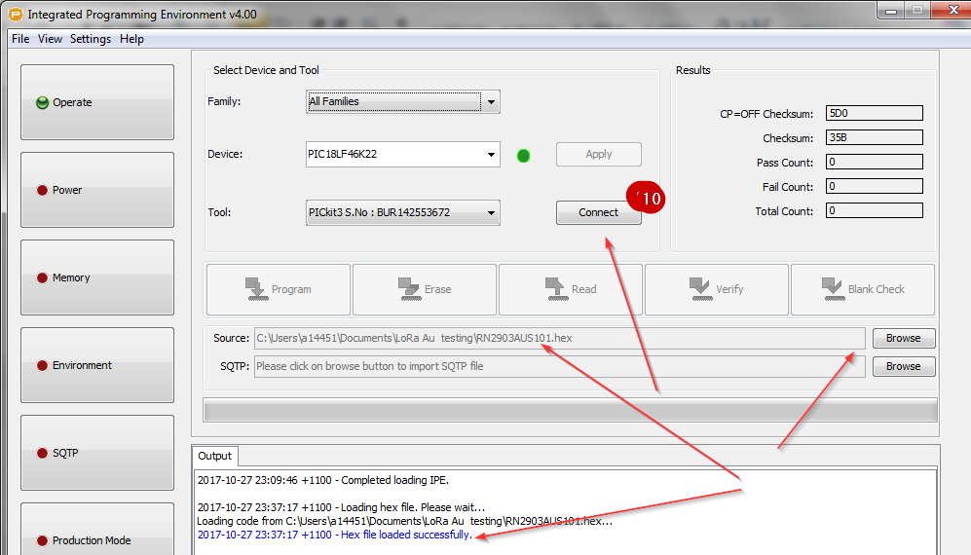

11.The IPE double checks the we have the correct part to program. Press OK
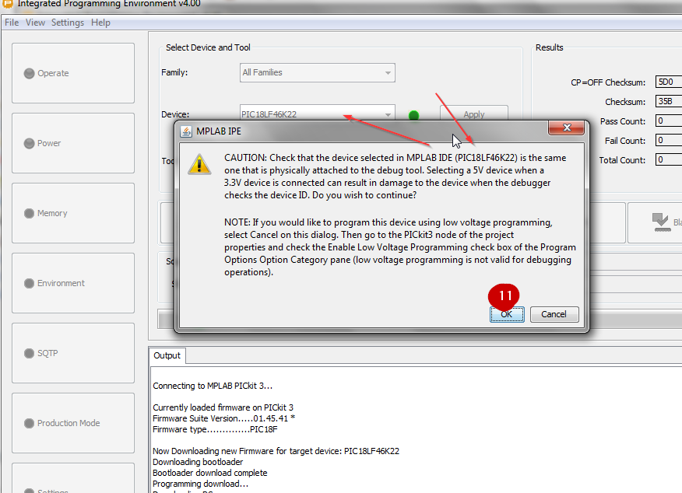
**** Continue to hold down the 6 POGO pins to the RN2903 module*****
12 Check the programmer debugger is connected
13. Press [Program] to program the hex file
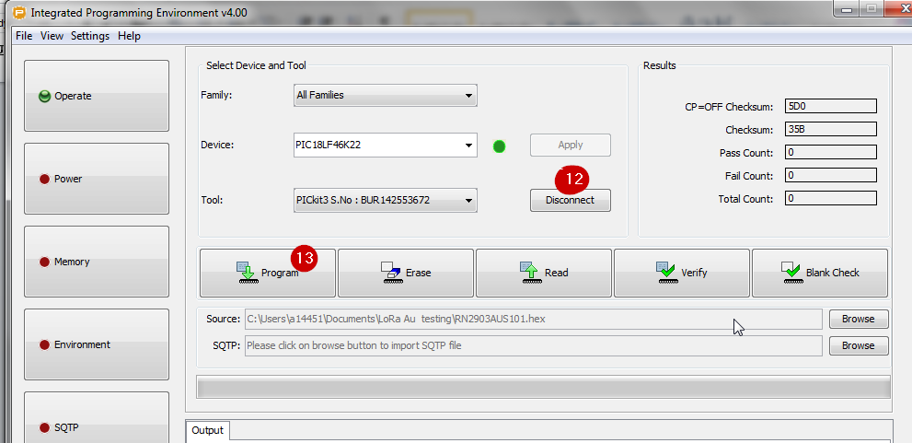
**** Once programmed : Release the POGO PINS from the module ***

BACKUP Wiring Diagram Just for reference only
=========================================
