RN2903A UART BOOT LOADER
The RN2903A receives ASCII UART commands.
The “LoRaDevUtility” PC software allows importing of the AU915 bootloader hex file and programming the RN2903 connected via UART.
DFU = Device Firmware Update
Typical connection of the RN2903 for UART bootloader
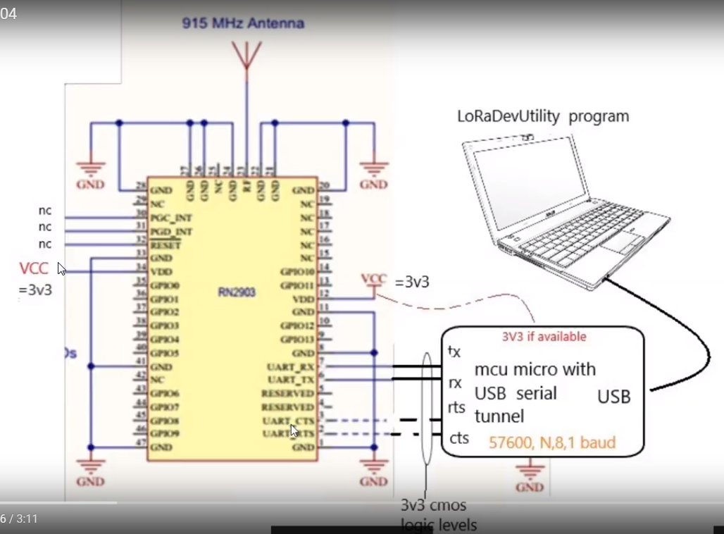

LoRaDevUtility
See info here
https://youtu.be/s3507ZLmZvE
https://youtu.be/T2c_iLpkXCI

LoRaDevUtility Operation
Once connected to the RN2903
- Select the DFU TAB
- Select the AU915 hex file
- 4. 5. 6. Select the default UART connections
7. Go… select device firmware update
Close LoRaDevUtiltiy and remove and then connect the RN2903
Restart the LoRaDevUtility and select the RN2903 UART comport

Next page is a screen shot of the LoRaDevUtility
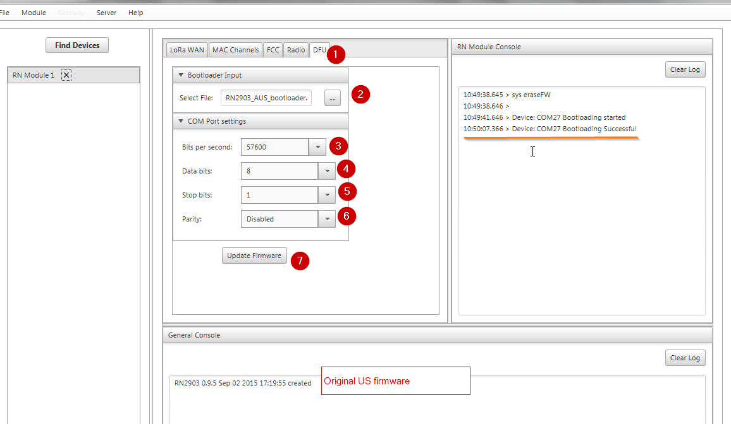
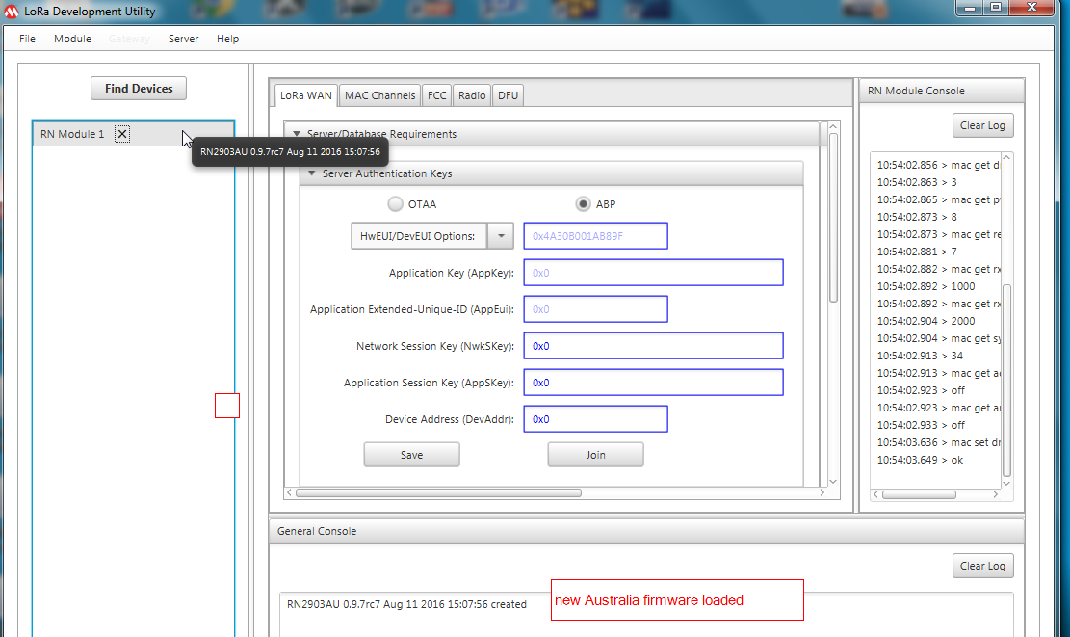

Download the loRaDevUtility from the link in the video
Also here http://ww1.microchip.com/downloads/en/DeviceDoc/LoRaSuite-windows-1.0.exe
See how I used the LoRaDevUntility to look at the settings and tinker with the setting
https://youtu.be/1JZg6rVEw2A
Using LoRaDevutility to program an RN2903

Additonal Information
============
LoRa® Technology Evaluation
Suite User’s Guide
http://ww1.microchip.com/downloads/en/DeviceDoc/40001847A.pdf
Section 5.2 should be useful

