**SQL**

* **Creating tables:**

**create table car_details(**

**car_id INT primary key,**

**make VARCHAR(20),**

**model int,**

**engine_type varchar(10),**

**num_previous_owners int,**

**insurance_last_date DATE,**

**condiotion VARCHAR(20),**

**price INT**

**);**

**create table selling_cars(**

**car_id INT,**

**sold_price INT,**

**FOREIGN KEY(car_id) REFERENCES car_details(car_id)**

**);**

* **Inserting data into tables:**

**insert into car_details values(1,'Maruti Swift',2008,'petrol',2,'2020-12-10','used',520000);**

**insert into car_details values(2,'Tata Altroz',2004,'diesel',1,'2021-01-03','used',540000);**

**insert into car_details values(3,'Hyundai i20',2009,'petrol',2,'2021-05-16','used',700000);**

**insert into car_details values(4,'Honda city 4th gen',2003,'petrol',2,'2020-11-05','used',1000000);**

**insert into car_details values(5,'Toyota Innova Crysta',2015,'diesel',1,'2020-12-23','used',1600000);**

**insert into car_details values(6,'Chevrolet Aveo',2002,'petrol',3,'2021-06-27','used',598000);**

**insert into car_details values(7,'Datsun Go',2004,'petrol',2,'2021-08-15','used',400000);**

**insert into car_details values(8,'Ford Ecosport',2012,'diesel',3,'2020-12-07','used',820000);**

**insert into car_details values(9,'Hyundai Creta',2014,'petrol',1,'2021-07-30','used',950000);**

**insert into car_details values(10,'Maruti Baleno',2013,'petrol',2,'2020-12-15','used',600000);**

**insert into selling_cars values(1,300000);**

**insert into selling_cars values(3,650000);**

**insert into selling_cars values(5,900000);**

**insert into selling_cars values(7,350000);**

**insert into selling_cars values(10,550000);**

**TABLES:**

1. **car_details:**

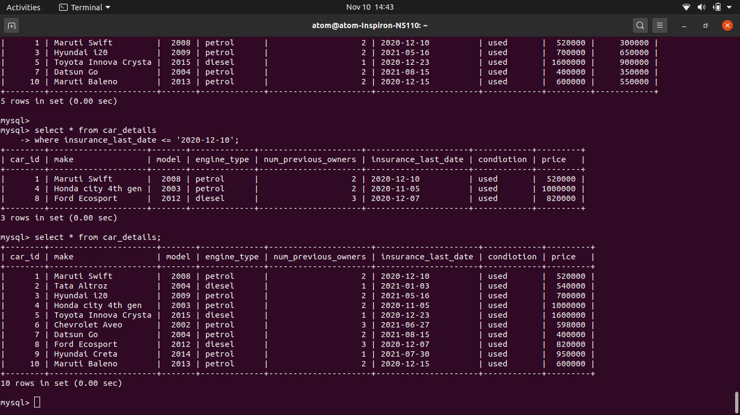

1. **selling_cars:**

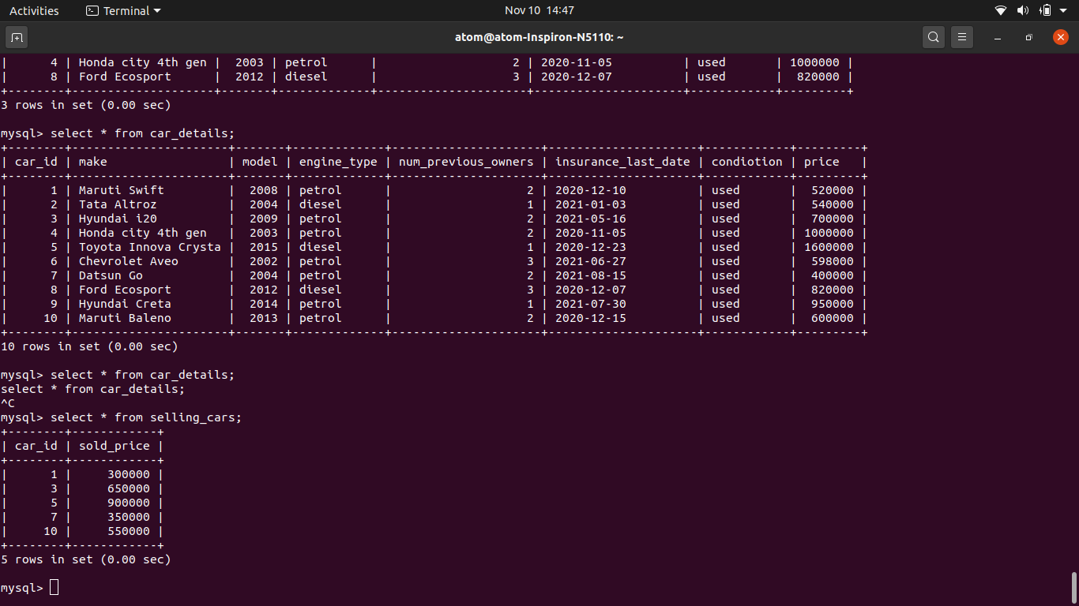

**QUERIES:**

1. **Show all cars above model 2005**

**select * from car_details**

**where model > 2005;**

**Output:**

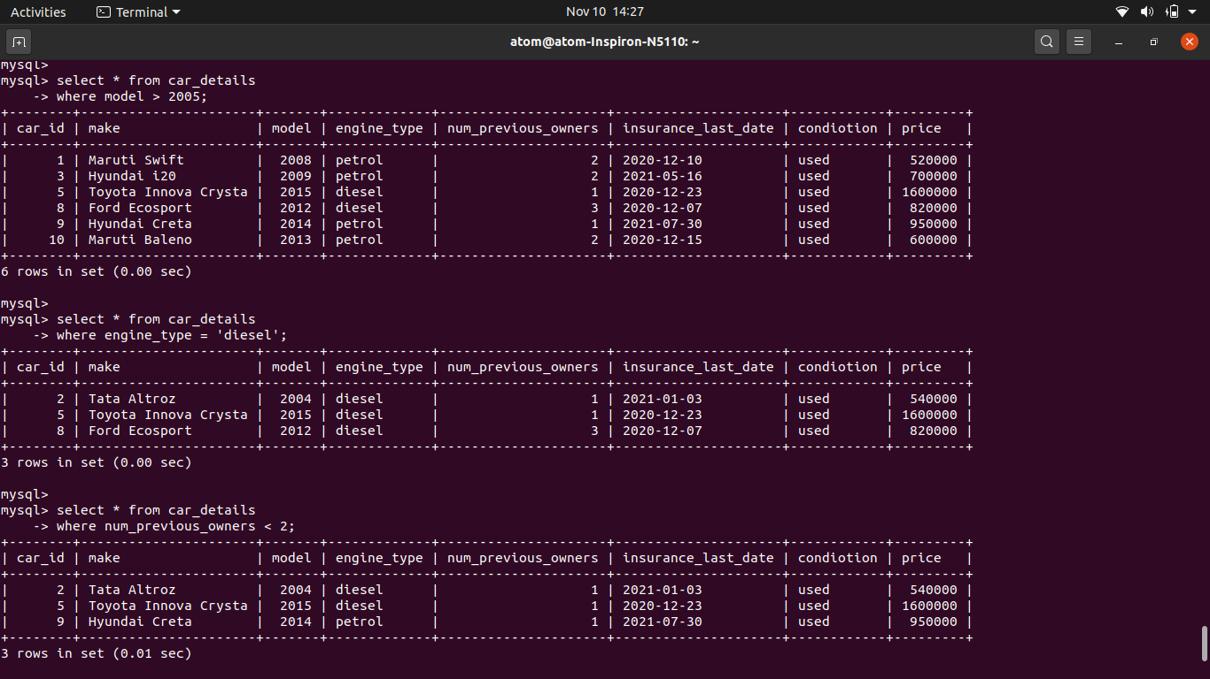

1. **Show all cars that are Diesel**

**select * from car_details**

**where engine_type = 'diesel';**

**Output:**



1. **Show all cars with less than 2 owners ( no of old owners)**

**select * from car_details**

**where num_previous_owners < 2;**

**Output:**



1. **Show cars sold**

**select car_details.car_id, car_details.make, car_details.model, car_details.engine_type, car_details.num_previous_owners, car_details.insurance_last_date, car_details.condiotion, car_details.price, selling_cars.sold_price**

**from car_details**

**JOIN selling_cars**

**on car_details.car_id = selling_cars.car_id;**

**Output:**

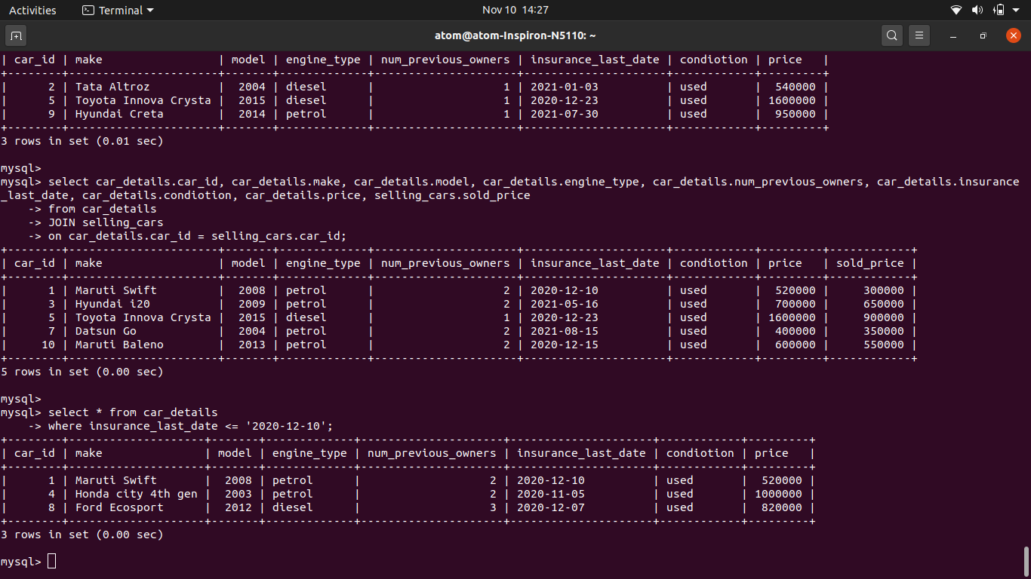

1. **Show cars whose insurance last date is pending in next 30 days**

**select * from car_details**

**where insurance_last_date <= '2020-12-10';**

**Output:**

