# Fubarino™ Mini Reference Manual

Last Revision: May 11th, 2013

## Introduction:

The Fubarino™ Mini is a small microcontroller board that uses a powerful PIC32 microcontroller. It is chipKITTM/MPIDE compatible and can run the same sketches that run on an ArduinoTM. It is designed to have all I/O pins on either side of the board in a traditional DIP pattern so that it can easily be plugged into a breadboard. It has a USB connector for power, programming, and a connection to a PC.

Features:

* PIC32MX250F128D-50I/ML microcontroller, which includes 128KB Flash and 32K RAM
* Supported as development target from within MPIDE
* Max 33 I/O pins (normally 27)
* Pads for 32 KHz crystal
* CPU runs at 48MHz
* USB connector for power, programming, and connection to PC (serial, mass storage, etc.)
* Two buttons: RESET for resetting the board, and PRG for getting into bootloader mode and user application use
* USB bootloader pre-programmed at the factory – no other hardware needed to program board\
* Separate ICSP connector – for hardware programming/debugging with PICKit3 or other ICSP programmer (not needed for use with MPIDE environment)

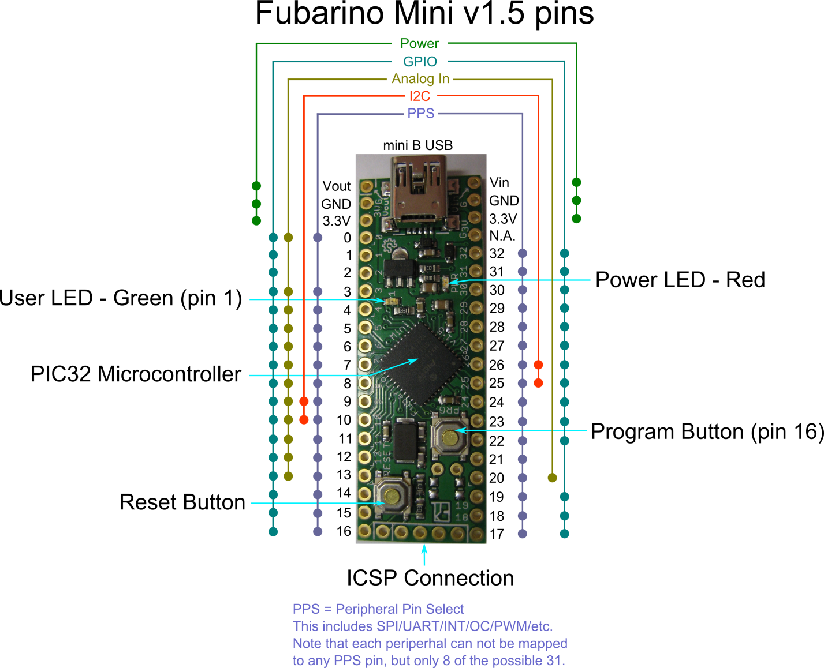

Figure 1 : Fubarino™ Mini Pin Map

## Entering Bootloader Mode

To enter bootloader mode (also called programming mode) simply press the PRG button while pressing and releasing the RESET button. As long as the PRG button is held down when the RESET button is released, the bootloader will start waiting for a new program to be downloaded over USB. It will wait indefinitely.

The bootloader on the Fubarino™ Mini implements the avrdude STK500 v2 protocol, just like the other chipKITTM/MPIDE boards. For Windows users, you may need to install the drivers\Stk500v2.ini file so that the FubarinoTM Mini is recognized by the PC. Mac and Linux users do not have to install any drivers.

## Programming in MPIDE

To program the Fubarino Mini board from within MPIDE, simply download the [latest MPIDE version](http://bit.ly/getmpide), http://bit.ly/getmpide, unzip and run it, and select “Fubarino Mini” from the Tools->Boards->Fubarino menu. Then, put the Fubarino Mini into bootloader mode (see above), and then select the proper serial port in the Tools->Serial Port menu.

After you enter your sketch and click the Upload button, MPIDE will compile your sketch and upload it to the Fubarino Mini. After the upload is complete, the Fubarino Mini will automatically reset and immediately begin running your sketch code. This includes sending information to the USB serial, UART1, and UART2.

## Serial communications

The Fubarino Mini board has two hardware serial ports: UART1 on pins 17 (TX) and 18 (RX), and UART2 on pins 26 (TX) and 25 (RX). It also has a USB serial port that operates as the default serial port. See the Code Examples wiki page on the Fubarino Mini website for example sketch code on how to uses the three serial ports. Note that UART1 and UART2 can be configured (using PPS) to appear on multiple different I/O pins – the pins listed below are simply the defaults that are applied at boot.

* USB serial init: Serial.begin()
* UART1 pins 17 (TX), 18 (RX): Serial0.begin()
* UART2 pins 26 (TX), 25 (RX): Serial1.begin()

## Power

The Fubarino Mini can be powered in a number of different ways.

1. USB: When 5V is present on the USB connector (from a PC or a powered hub for example), the Fubarino Mini will use this power source. This power source has a reverse protection diode connection to the 3.3V regulator. If both USB and Vin are powered, whichever is higher will end up providing the power to the regulator.
2. Vin pin: You can also place 2.8V to 13.2V on the Vin pin to power it from an external power source. This power source has a reverse protection diode connection to the 3.3V regulator. If both USB and Vin are powered, whichever is higher in voltage will power the device.
3. 3.3V pin(s): You can power the Fubarino Mini by connecting a 3.3V source to either 3.3V pin. You must be careful not to exceed 3.6V on these pins or the PIC32 will be destroyed.

## Fubarino Mini Versions

Fubarino Mini versions 1.0 to 1.3 were not produced in any number and were not widely distributed.

Fubarino Mini version 1.4 made its way into several users’ hands, and is functionally identical to version 1.5 except that it uses a 40MHz rated PIC32 part and only runs at 40MHz. Thus the bootloader is slightly different, and the “Fubarino Mini (dev)” board should be chosen in the MPIDE Boards->Fubarino menu.

Fubarino Mini v1.5 was the first version Microchip built, and uses a 50MHz rated PIC32 part. Its internal clock speed is set to 48MHz, and thus uses a slightly different bootloader than the v1.4 and earlier boards. Make sure to select “Fubarino Mini” from the MPIDE Boards->Fubarino menu for version 1.5 boards.

## Peripheral Pin Select

The PIC32MX250 part used on Fubarino Mini has a Peripheral Pin Select function for almost all of its I/O pins. When writing sketches for the Fubarino Mini, you must remember to connect an internal peripheral (like SPI or UART) to a particular set of I/O pins using the PPS functions (ppsInputSelect() and ppsOutputSelect()) before trying to use the peripheral. See the example code on the Fubarino Mini Github site for more detailed information.

## Pin Reference

This table provides a cross reference of all functions and labels for each pin of the Fubarino Mini. Note that the ‘Fubarino Pin’ is the pin number of the whole board (as if the whole thing were one large DIP chip), starting with pin 1 = Vout, and correspond to the J1 and J2 pin numbers in the schematic. The ‘Arduino Pin’ is the pin number you use in your code, and is what is listed on the silk screen of the board. (Note that the Mini is too small for all pins to have numbers printed next to each pin – so use the diagram above to see the pin number for every pin on the board.) Make sure to never put more than 3.3V into any pin that is not 5V tolerant, as that will damage the PIC32 CPU.

|  |  |  |  |  |  |  |
| --- | --- | --- | --- | --- | --- | --- |
| **Fubarino Pin** | **Arduino Pin** | **Analog** | **PIC32 Pin** | **Silk**  **Name** | **Alt functions** | **5V tolerant?** |
| J1-1 | - | - | - | Vout | - | - |
| J1-2 | - | - | - | G | GND | - |
| J1-3 | - | - | - | 3V | - | - |
| J1-4 | Pin 0 | Yes | RB13 | 0 | AN11/RPB13/CTPLS/PMRD | No |
| J1-5 | Pin 1 | - | RA10 | 1 | PGED/TMS/PMA10 (LED) | Yes |
| J1-6 | Pin 2 | - | RA7 | 2 | PGEC/TCK/CTED8/PMA7 | Yes |
| J1-7 | Pin 3 | Yes | RB14 | 3 | CVREF/AN10/C3INB/RPB14/VBUSON/ SCK1/CTED5 (used – USB) | No |
| J1-8 | Pin 4 | Yes | RB15 | 4 | AN9/C3INA/RPB15/SCK2/CTED6/PMCS1 | No |
| J1-9 | Pin 5 | Yes | RA0 | 5 | PGED3/VREF+/CVREF+/AN0/C3INC/ RPA0/CTED1/PMD7 | No |
| J1-10 | Pin 6 | Yes | RA1 | 6 | PGEC3/VREF-/CVREF-/AN1/RPA1/ CTED2/PMD6 | No |
| J1-11 | Pin 7 | Yes | RB0 | 7 | PGED1/AN2/C1IND/C2INB/C3IND/ RPB0/PMD0 | No |
| J1-12 | Pin 8 | Yes | RB1 | 8 | PGEC1/AN3/C1INC/C2INA/RPB1/ CTED12/PMD1 | No |
| J1-13 | Pin 9 | Yes | RB2 | 9 | AN4/C1INB/C2IND/RPB2/SDA2/ CTED13/PMD2 | No |
| J1-14 | Pin 10 | Yes | RB3 | 10 | AN5/C1INA/C2INC/RTCC/RPB3/SCL2/  PMWR/CNB3 | No |
| J1-15 | Pin 11 | Yes | RC0 | 11 | AN6/RPC0 | No |
| J1-16 | Pin 12 | Yes | RC1 | 12 | AN7/RPC1 | No |
| J2-17 | Pin 13 | Yes | RC2 | 13 | AN8/RPC2/PMA2 | No |
| J2-18 | Pin 14 | - | RA2 | 14 | OSC1/CLKI/PRA2 (used - crystal) | No |
| J2-19 | Pin 15 | - | RA3 | 15 | OSC2/CLKO/RPA3 (used - crystal) | No |
| J2-20 | Pin 16 | - | RA8 | 16 | TDO/RPA8/PMA8 (PRG button) | Yes |
| J2-1 | Pin 17 | - | RB4 | 17 | SOSCI/PRB4 | No |
| J2-2 | Pin 18 | - | RA4 | 18 | SOSCO/RPA4/T1CK/CTED9 | No |
| J2-3 | Pin 19 | - | RA9 | 19 | TDI/RPA9/PMA9 | Yes |
| J2-4 | Pin 20 | Yes | RC3 | 20 | AN12/RPC4 | No |
| J2-5 | Pin 21 | - | RC4 | 21 | RPC4/PMA4 | Yes |
| J2-6 | Pin 22 | - | RC5 | 22 | RPC5/PMA3 | Yes |
| J2-7 | Pin 23 | - | RB5 | 23 | PRB5/USBID (used - USB) | Yes |
| J2-8 | Pin 24 | - | RB7 | 24 | RPB7/CTED3/PMD5/INT0 | Yes |
| J2-9 | Pin 25 | - | RB8 | 25 | RPB8/SCL1/CTED10/PMD4 | Yes |
| J2-10 | Pin 26 | - | RB9 | 26 | RPB9/SDA1/CTED4/PMD3 | Yes |
| J2-11 | Pin 27 | - | RC6 | 27 | RPC6/PMA1 | Yes |
| J2-12 | Pin 28 | - | RC7 | 28 | RPC7/PMA0 | Yes |
| J2-13 | Pin 29 | - | RC8 | 29 | RPC8/PMA5 | Yes |
| J2-14 | Pin 30 | - | RC9 | 30 | RPC9/CTED7/PMA6 | Yes |
| J2-15 | Pin 31 | - | RB10 | 31 | PGED2/RPB10/D+/CTED11 (used - USB) | No |
| J2-16 | Pin 32 | - | RB11 | 32 | PGEC2/RPB11/D- (used - USB) | No |
| J2-17 | - | - | - | G | Do not use (reserved for future use) | - |
| J2-18 | - | - | - | 3V | 3.3V | - |
| J2-19 | - | - | - | G | GND | - |
| J2-20 | - | - | - | Vin | Vin | - |

## Schematic

For the schematic, please see the [Fubarino_Mini_v15_sch.pdf](https://github.com/fubarino/fubarino.github.com/blob/master/mini/v15/FubarinoMini_v15_sch.pdf?raw=true) file on the Fubarino Mini website. <https://github.com/fubarino/fubarino.github.com/blob/master/mini/v15/FubarinoMini_v15_sch.pdf?raw=true>

## More Information

The best places to get support for Fubarino Mini are

* [Main chipKIT website](http://chipkit.net/)
* [chipKIT forum](http://www.chipkit.org/forum/index.php)

## License

The Fubarino series of boards are released by Schmalz Haus LLC and FubarLabs under a Solderpad Hardware License v0.51. For more information, see: <http://solderpad.org/licenses/SHL-0.51/>

## Developers

The Fubarino series of boards were developed by Rick Anderson of [FubarLabs](http://www.fubarlabs.org/) and Brian Schmalz of [Schmalz Haus LLC](http://www.schmalzhaus.com/). They are registered chipKITTM boards and are designed to be programmed with the MPIDE system.