# FubarinoSD Reference Manual

Last Revision: September 25th, 2012 – Applies to version 1.4 of FubarinoSD hardware

## Introduction:

The FubarinoSD is a small microcontroller board that uses a powerful PIC32 microcontroller. It is chipKITTM/MPIDE compatible and can run the same sketches that run on an ArduinoTM. It is designed to have all I/O pins on either side of the board in a traditional DIP pattern so that it can easily be plugged into a breadboard. It has a USB connector for power, programming, and a connection to a PC. It also has a microSD slot for increased storage.

Features:

* PIC32MX440F256H microcontroller, which includes 256KB Flash and 32K RAM
* Supported as development target from within MPIDE
* 45 I/O pins
* microSD slot connected to hardware SPI port
* Pads for 32 KHz crystal
* USB connector for power, programming, and connection to PC (serial, mass storage, etc.)
* Two buttons: RESET for resetting the board, and PRG for getting into bootloader mode and user application use
* USB bootloader pre-programmed at the factory – no other hardware needed to program board

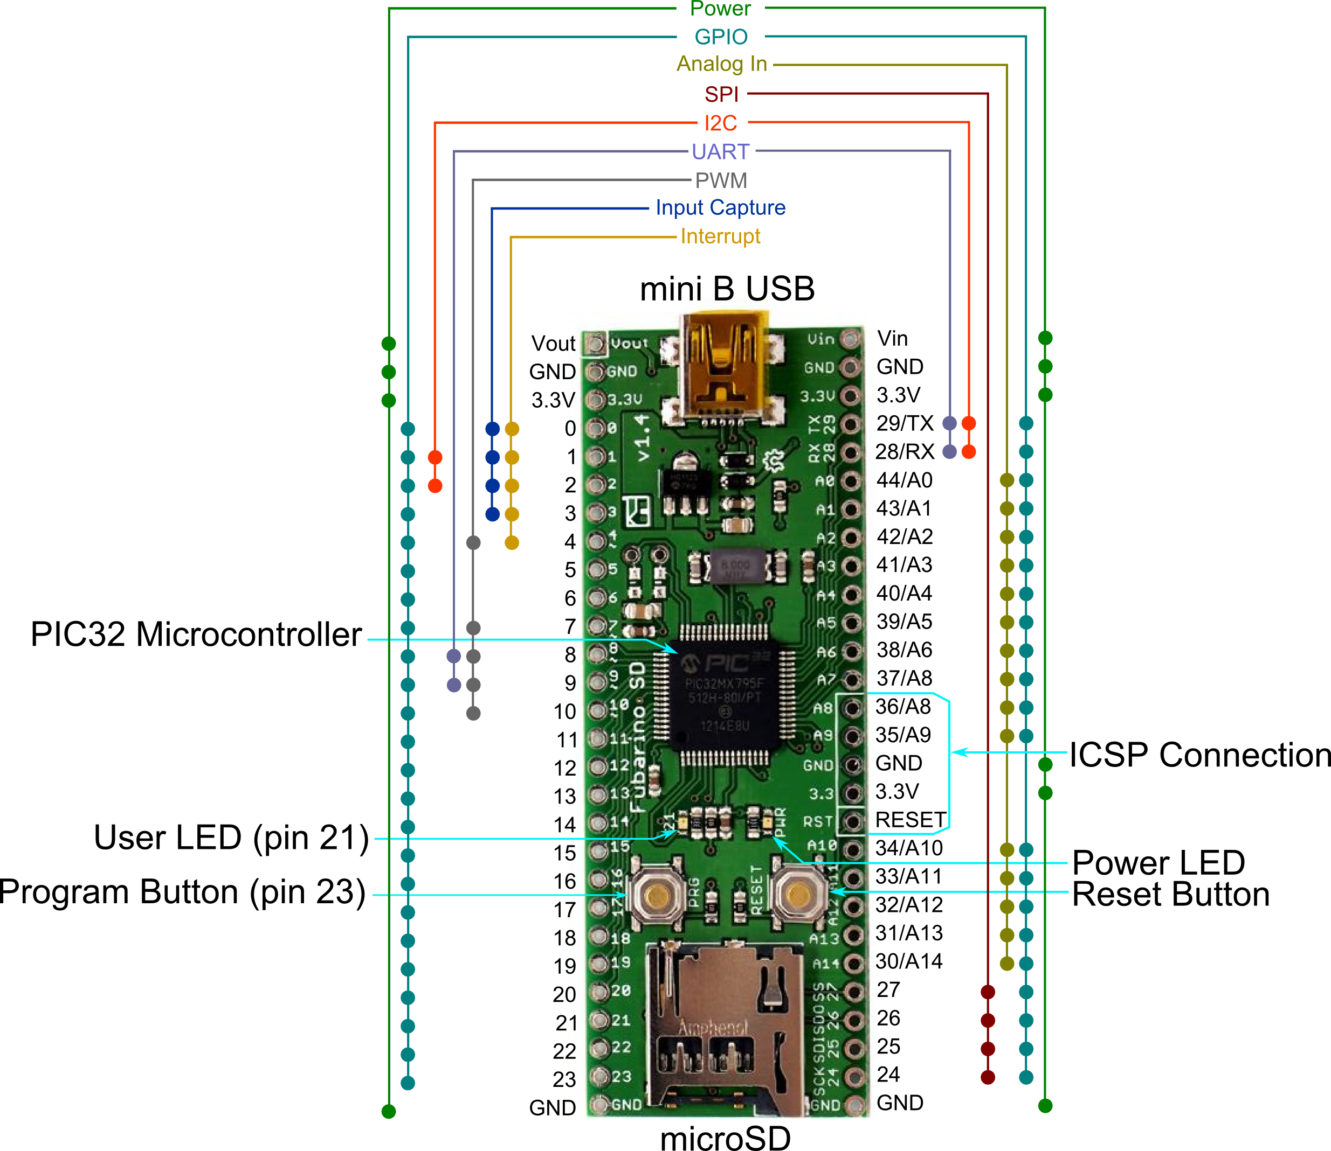

Figure : FubarinoSD Pin Map

## Entering Bootloader Mode

To enter bootloader mode (also called programming mode) simply press the PRG button while pressing and releasing the RESET button. As long as the PRG button is held down when the BUTTON button comes out of is released, the bootloader will start waiting for a new program to be downloaded over USB. It will wait indefinitely.

The bootloader on the FubarinoSD implements the avrdude STK500 v2 protocol, just like the other chipKITTM/MPIDE boards.

## Programming in MPIDE

To program the FubarinoSD board from within MPIDE, simply download the latest MPIDE version, http://bit.ly/getmpide, unzip and run it, and select FubarinoSD from the Tools->Boards menu. Then, put the FubarinoSD into bootloader mode (see above), and then select the proper serial port in the Tools->Serial Port menu.

After you enter your sketch and click the Upload button, MPIDE will compile your sketch and then upload it to the FubarinoSD. After the upload is complete, the FubarinoSD will automatically reset and immediately begin running your sketch code. This includes sending information to the USB serial, UART1, and UART2.

## Serial communications

The FubarinoSD board has two hardware serial ports: UART2 on pins 29 (TX) and 28 (RX), and UART1 on pins 9 (TX) and 8 (RX). It also has a USB serial port that operates as the default serial port. See the Code Examples wiki page on the FubarinoSD website for example sketch code on how to uses the three serial ports.

* USB serial init: Serial.begin()
* On board serial1 pins 8 (RX), 9 (TX): Serial0.begin()
* On board serial2 pins 28 (RX), 29 (TX): Serial1.begin()

## Using the microSD

The FubarinoSD has a single SPI port, which is tied to the microSD memory card slot as well as pins 24 through 27. The standard SD library that comes with MPIDE will work with the FubarinoSD microSD slot without modifications.

## Power

The FubarinoSD can be powered in a number of different ways.

1. USB : When 5V are present on the USB connector (from a PC or a powered hub for example), the FubarinoSD will use this power source. This power source has a reverse protection diode connection to the 3.3V regulator. If both USB and Vin are powered, whichever is higher will end up providing the power to the regulator.
2. Vin pin: You can also place 2.8V to 13.2V on the Vin pin to power it from an external power source. This power source has a reverse protection diode connection to the 3.3V regulator. If both USB and Vin are powered, whichever is higher in voltage will power the device.
3. 3.3V pin(s): You can power the FubarinoSD by connecting a 3.3V source to either 3.3V pin. You must be careful not to exceed 3.6V on these pins or the PIC32 will be destroyed.

## Pin Reference

This table provides a cross reference of all functions and labels for each pin of the FubarinoSD. Note that the ‘Fubarino Pin’ is the pin number of the entire board, starting with pin 1 = Vout and correspond to the J2 and J3 pin numbers in the schematic. The ‘Arduino Pin’ is the pin number you use in your code, and is what is listed on the silk screen of the board.

|  |  |  |  |  |  |  |
| --- | --- | --- | --- | --- | --- | --- |
| **Fubarino Pin** | **Arduino Pin** | **Analog** | **PIC32 Pin** | **Silk**  **Name** | **Alt functions** | **5V tolerant?** |
| J2-1 | - | - | - | Vout | - | - |
| J2-2 | - | - | - | Gnd | - | - |
| J2-3 | - | - | - | 3.3V | - | - |
| J2-4 | Pin 0 | - | RD8 | 0 | RTCC/IC1/INT1 | Yes |
| J2-5 | Pin 1 | - | RD9 | 1 | U1CTS/SDA1/IC2/INT2 | Yes |
| J2-6 | Pin 2 | - | RD10 | 2 | SCL1/IC3/PMCS2/PMA15/INT3 | Yes |
| J2-7 | Pin 3 | - | RD11 | 3 | IC4/PMCS1/PMA14/INT4 | Yes |
| J2-8 | Pin 4 | - | RD0 | 4 | OC1/INT0/RD0 | Yes |
| J2-9 | Pin 5 | - | RC13 | 5 | SOSCI/CN1 | No |
| J2-10 | Pin 6 | - | RC14 | 6 | SOSCO/T1CK/CN0 | No |
| J2-11 | Pin 7 | - | RD1 | 7 | U1RTS/OC2 | Yes |
| J2-12 | Pin 8 | - | RD2 | 8 | U1RX/OC3 | Yes |
| J2-13 | Pin 9 | - | RD3 | 9 | U1TX/OC4 | Yes |
| J2-14 | Pin 10 | - | RD4 | 10 | OC5/IC5/PMWR/CN13 | Yes |
| J2-15 | Pin 11 | - | RD5 | 11 | PMRD/CN14 | Yes |
| J2-16 | Pin 12 | - | RD6 | 12 | CN15 | Yes |
| J2-17 | Pin 13 | - | RD7 | 13 | CN16 | Yes |
| J2-18 | Pin 14 | - | RF0 | 14 |  | Yes |
| J2-19 | Pin 15 | - | RF1 | 15 |  | Yes |
| J2-20 | Pin 16 | - | RE0 | 16 | PMD0 | Yes |
| J2-21 | Pin 17 | - | RE1 | 17 | PMD1 | Yes |
| J2-22 | Pin 18 | - | RE2 | 18 | PMD2 | Yes |
| J2-23 | Pin 19 | - | RE3 | 19 | PMD3 | Yes |
| J2-24 | Pin 20 | - | RE4 | 20 | PMD4 | Yes |
| J2-25 | Pin 21 | - | RE5 | 21 | PMD5 | Yes |
| J2-26 | Pin 22 | - | RE6 | 22 | PMD6 | Yes |
| J2-27 | Pin 23 | - | RE7 | 23 | PMD7 | Yes |
| J2-28 | - | - | - | GND | - | - |
| J3-1 | - | - | - | GND | - | - |
| J3-2 | Pin 24 | - | RG6 | SCK/24 | SCK2/PMA5/CN8 | Yes |
| J3-3 | Pin 25 | - | RG7 | SDI/25 | SDI2/PMA4/CN9 | Yes |
| J3-4 | Pin 26 | - | RG8 | SDO/26 | SDO2/PMA3/CN10 | Yes |
| J3-5 | Pin 27 | - | RG9 | SCK/27 | SS2/PMA2/CN11 | Yes |
| J3-6 | Pin 30 | A14 | RB4 | A14 | AN4/C1IN-/CN6 | No |
| J3-7 | Pin 31 | A13 | RB3 | A13 | AN3/C2IN+/CN5 | No |
| J3-8 | Pin 32 | A12 | RB2 | A12 | AN2/C2IN-/CN4 | No |
| J3-9 | Pin 33 | A11 | RB1 | A11 | PGEC1/AN1/VREF-/CVREF-/CN3 | No |
| J3-10 | Pin 34 | A10 | RB0 | A10 | PGED1/AN0/VREG+/CVREF+/PMA6/CN2 | No |
| J3-11 | - | - | MCLR | RST | MCLR | Yes |
| J3-12 | - | - | - | 3.3V | - | - |
| J3-13 | - | - | - | GND | - | - |
| J3-14 | Pin 35 | A9 | RB7 | A9 | PGED2/AN7 | No |
| J3-15 | Pin 36 | A8 | RB6 | A8 | PGEC2/AN6/OCFA | No |
| J3-16 | Pin 37 | A7 | RB8 | A7 | AN8/U2CTS/C1OUT | No |
| J3-17 | Pin 38 | A6 | RB9 | A6 | AN9/C2OUT/PMA7 | No |
| J3-18 | Pin 39 | A5 | RB10 | A5 | TMS/AN10/CVREFOUT/PMA13 | No |
| J3-19 | Pin 40 | A4 | RB11 | A4 | TDO/AN11/PMA12/RB11 | No |
| J3-20 | Pin 41 | A3 | RB12 | A3 | TCK/AN12/PMA11 | No |
| J3-21 | Pin 42 | A2 | RB13 | A2 | TDI/AN13/PMA10 | No |
| J3-22 | Pin 43 | A1 | RB14 | A1 | AN14/U2RTS/PMALH/PMA1 | No |
| J3-23 | Pin 44 | A0 | RB15 | A0 | AN15/OCFB/PMALL/PMA0/CN12 | No |
| J3-24 | Pin 28 | - | RF4 | RX/28 | SDA2/U2RC/PMA9/CN17 | Yes |
| J3-25 | Pin 29 | - | RF5 | TX/29 | SCL2/U2TX/PMA8/CN18 | Yes |
| J3-26 | - | - | - | 3.3V | - | - |
| J3-27 | - | - | - | GND | - | - |
| J3-28 | - | - | - | Vin | - | - |

## Schematic

For the schematic, please see the Fubarino_SD_v14_sch.pdf file on the FubarinoSD website. https://github.com/fubarino/fubarino.github.com/tree/master/sd/v1.4