Issues from Nick:

**From:** DiOrio, Nicholas  
**Sent:** Wednesday, December 27, 2017 1:48 PM  
**To:** Janzou, Steven; Paul Gilman (paulgilman@earthlink.net)  
**Subject:** RE: Thought on PPA with Utility Rate and battery

Steve, just a quick note.  I was testing in lifetime mode and ran into a notice within the utility rate model.  Essentially, grid_to_batt is being treated as “load”, but is a lifetime variable, and so is not 8760.  For now I commented out those warnings (line 545-548).

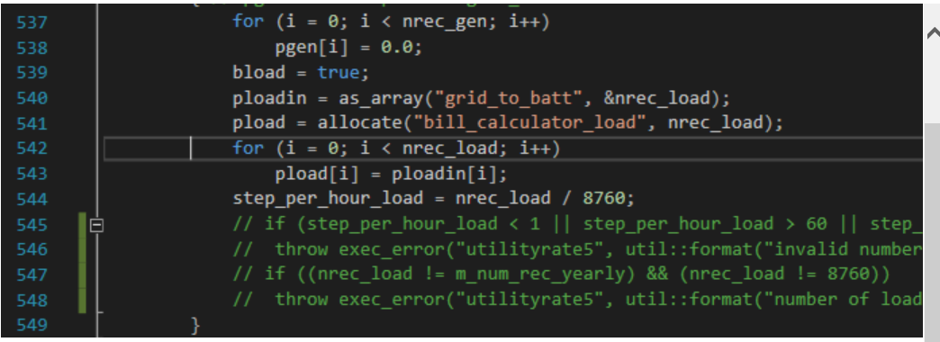

Thanks,

Nick

**From:** DiOrio, Nicholas   
**Sent:** Wednesday, December 27, 2017 9:35 AM  
**To:** Janzou, Steven <Steven.Janzou@nrel.gov>; Paul Gilman (paulgilman@earthlink.net) <paulgilman@earthlink.net>  
**Subject:** RE: Thought on PPA with Utility Rate and battery

Hi Steve,

From my initial testing, I’d say that I concur.  I tested a case that had a battery charging from the grid, and found that:

Annual Energy (year 1) = 37,518,968 kWh.  This is *P_gen = P_pv + P_battery*

Battery annual energy charged from grid (year 1) = 514,995 kWh.  This is *P_grid_to_batt*

Energy (year 1) in cash flow = 38,033,964  kWh, which appears to be *P_gen + P_grid_to_batt*

Subsequently in the cash flow, it appears the PPA revenue does not reflect the correct amount, which get’s down to the remaining to-do’s.

For incentives, I suppose we are mostly talking about production-based incentives?  I’m not sure whether these incentives are credited based on the amount of energy produced on the AC-side of the array, or the amount that actually gets exported to the grid.  In the first case, we’d be using *P_pv* with no battery consideration.  In the second, we’d be using *P_pv – P_pv_to_batt.*

All in all, I think we’re on the right track (thanks to your diligence 😊).  Would you like to discuss this week, or do you feel you have enough to go on?

Thanks!

Nick

Uncomment code and test with lifetime battery.

Duplicate issue from Nick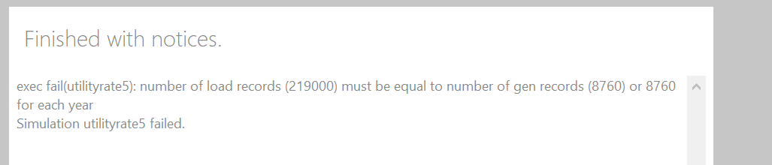

Go through cmod_utilityrate5 – update both load and grid_to_batt to handle lifetime inputs as follows: 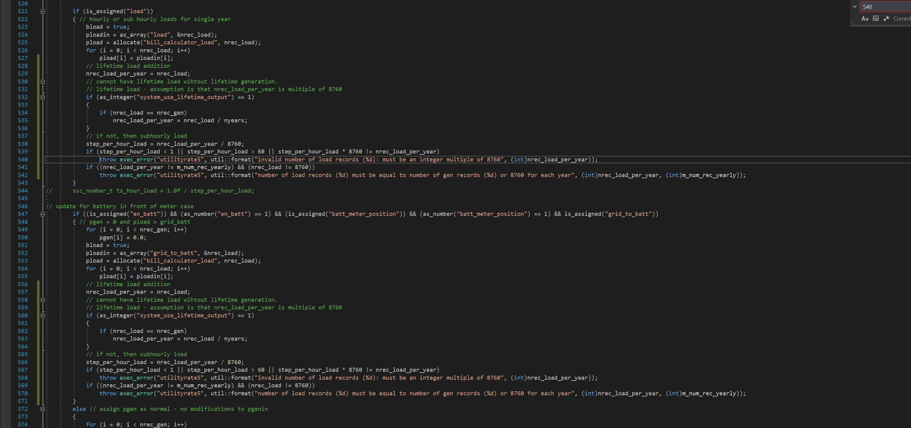

Build and test – current project working with some issues –

1. All project files report - No default value found for 'batt_initial_SOC' in external file (Flat Plate PV/Single Owner PPA Buy Rate), using internal default
2. Lifetime battery energy values seem suspect –

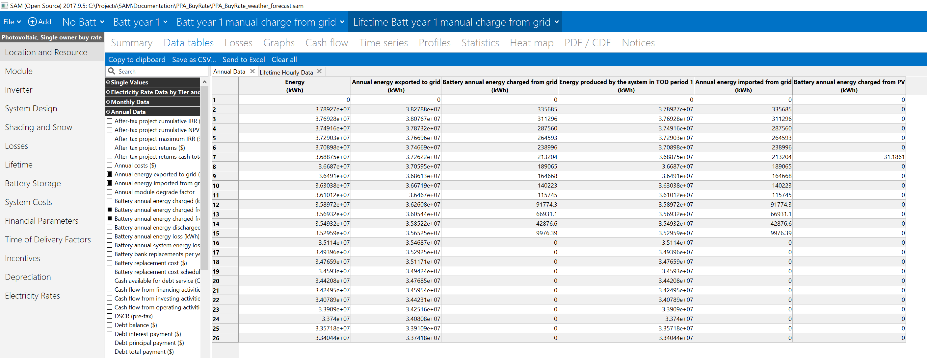

After year 15 battery stop charging from grid?

Also, electricity purchase – check offset in common_financial.cpp

Now, monthly totals show correct values for single year analysis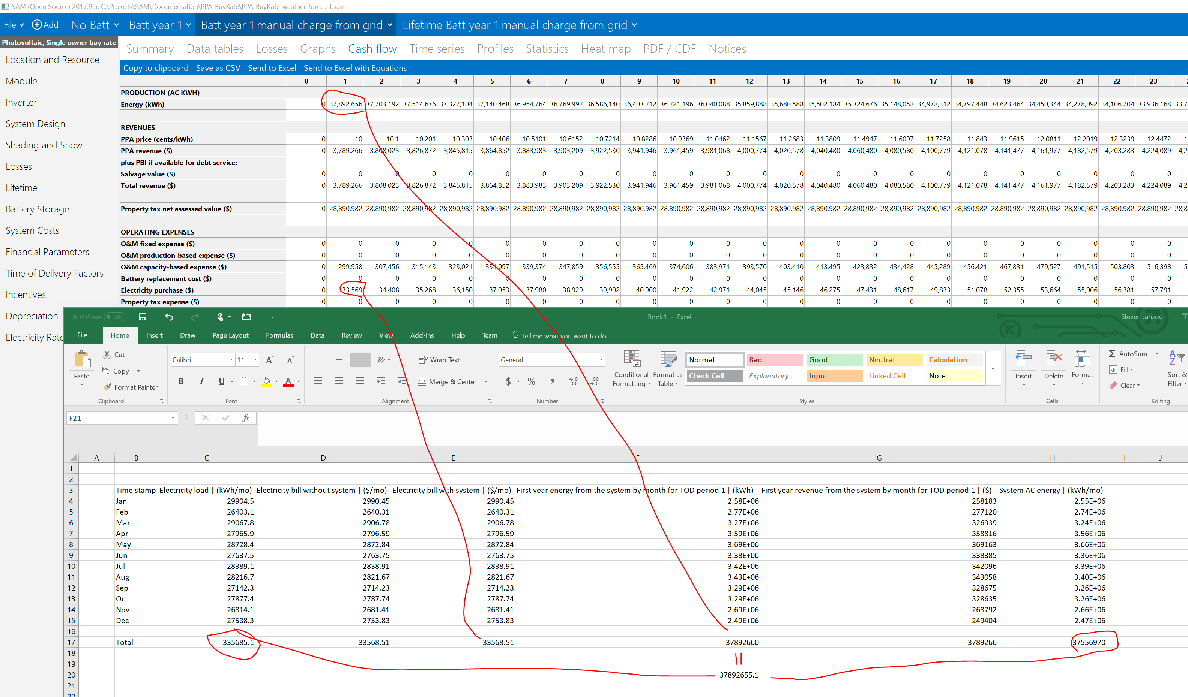

The system (PV+Batt) for PPA revenue is 37556970(PV) + 335685(load=grid to batt) = 37892655 year 1 output * PPA (0.1)

Lifetime working similarly.

All seem to be working in weather_forecast branches of SAM and ssc