PPA Buy rate for Southern Company.

Setup in ssc and SAM PPA_Buyrate branches in GitHub.

Implement initially as separate Single Owner Buy Rate financial model with Detailed PV.

Will test for backwards compatibility and adding additional O and M cost to pro-forma.

Will use output utility_bill_w_sys as additional o and m stream for Single Owner Buy Rate financial model.

Windows 10 creator update issues

<https://forums.adobe.com/message/9741268#9741268>

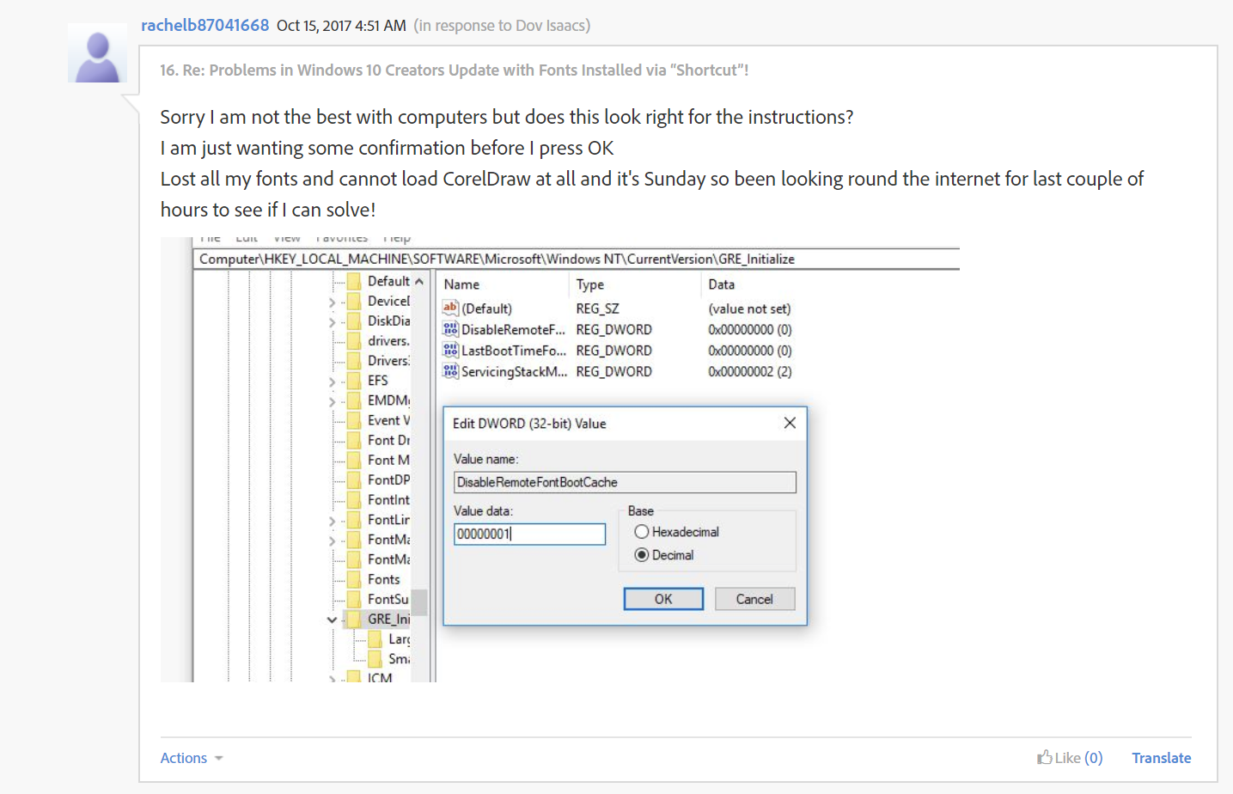

Update, reboot and test – issue remains – step through in x64 debug mode – popup menu created without issue and then get message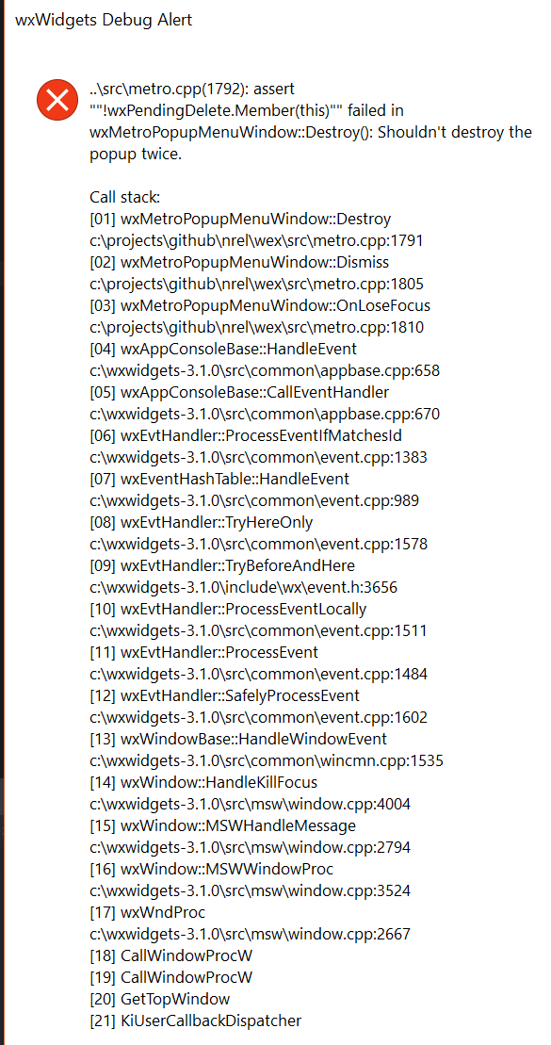

Users reporting issue with Microsoft 1709 update at <https://sam.nrel.gov/node/75291>

Change from pending event to queue event and test – access violation when deleting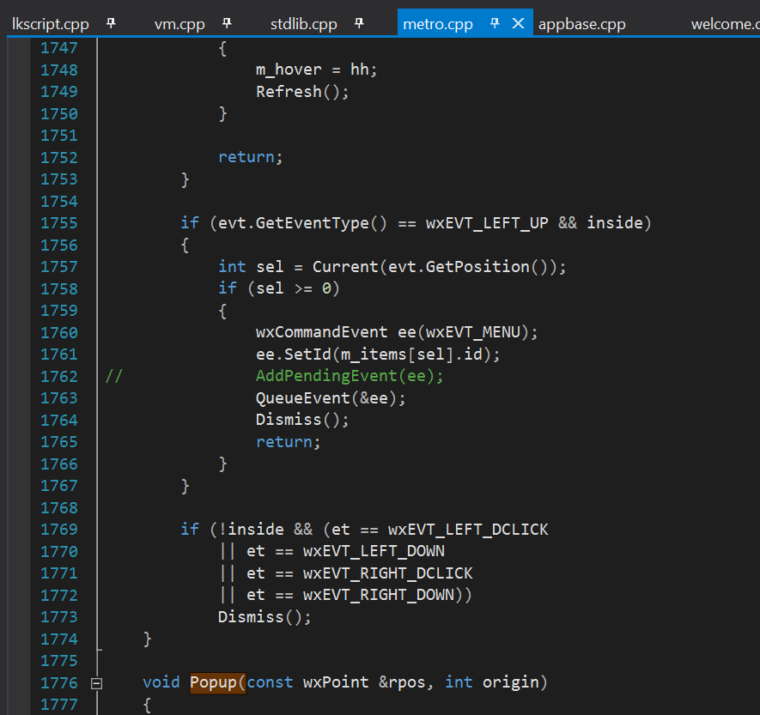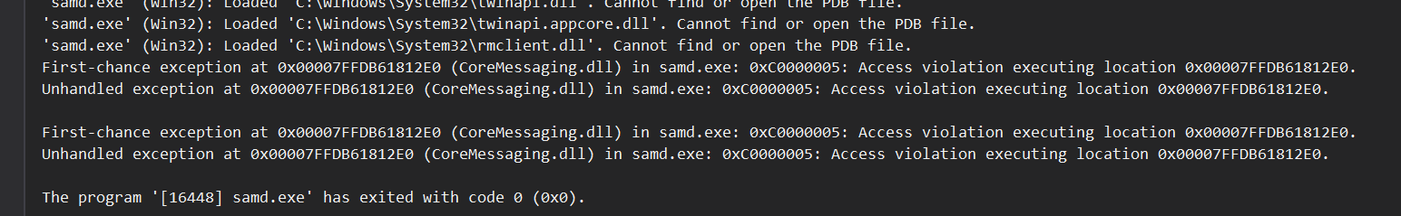

Research and trace through to Dismiss call in wxMetroPopupMenuWindow::OnMouse Left up event – menu destroyed before pending event is logged. Update per lines 1763-1767 in metro.cpp: 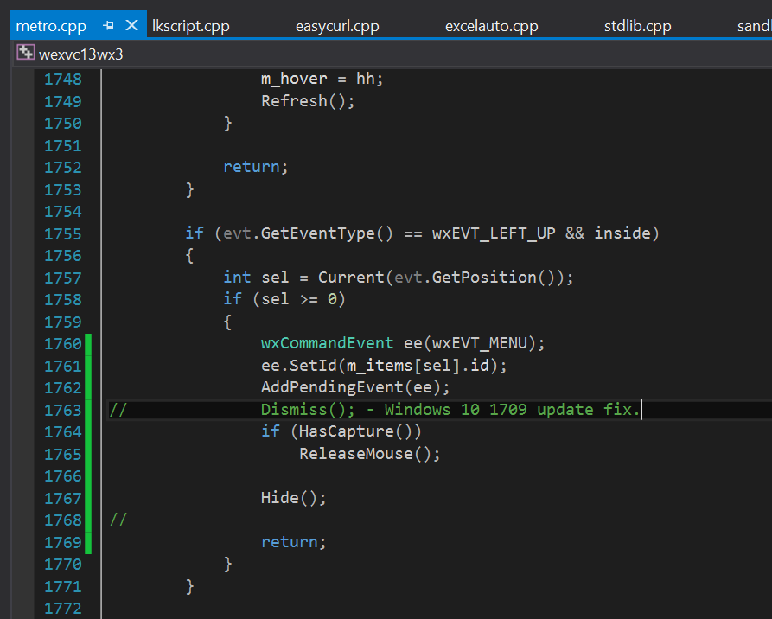

Build and test Windows 10 Creator update and Windows 7 win32 and x64 versions.

Commit and push to wex multi-thread and develop branches