**From:** Janzou, Steven  
**Sent:** Wednesday, December 20, 2017 1:04 AM  
**To:** DiOrio, Nicholas; Paul Gilman (paulgilman@earthlink.net)  
**Subject:** Re: Thought on PPA with Utility Rate and battery

Nick,

This sounds exactly like I was thinking, too.

For item 3, the common financial model should probably have "grid" (changes depending on metering selected) as input to correctly reflect PPA generated for the Power Producer (not consumer...)

We can discuss further on Thursday - Paul will be back - yay!

Steve

**From:** DiOrio, Nicholas  
**Sent:** Tuesday, December 19, 2017 12:44 PM  
**To:** Janzou, Steven; Paul Gilman (paulgilman@earthlink.net)  
**Subject:** RE: Thought on PPA with Utility Rate and battery

Hi Steve,

Sorry for the delayed response and for not being able to discuss last week much.

Regarding timestep 2, your second explanation is what we should be doing to be correct from my understanding.  In the first explanation, I’ve annotated what is the incorrect current approach, simply updating the sign of the battery power.

So I think the action items are:

1. I think it’s fine to leave the inverter tare loss alone, keep treating as lost revenue on the PPA.  People probably aren’t connecting to the grid just for this (but I don’t know really how this is practically handled or how “real” of a phenomenon it is).
2. Pass “gen” and “grid_batt” to utility rate module
   1. In the behind-the-meter case, can just use “gen”.  Or compute grid = gen – load – grid_batt, and pass in grid_batt = 0
   2. In the front-of-meter case, essentially want to use “grid_batt”, as this is the only component which is purchased.  So grid = gen – load – grid_batt, and pass in “gen” = 0.
   3. If that doesn’t work with NEM, perhaps we can figure out another approach.
3. Within the common financial model, need to either pass in “gen” + “grid_batt” as the gen quantity, or pass them in separately and add internally.

Does any of that sound reasonable or make sense?  Maybe we can discuss Thursday too.

Thanks,  
Nick

**From:** Janzou, Steven   
**Sent:** Thursday, December 14, 2017 12:57 AM  
**To:** DiOrio, Nicholas <Nicholas.DiOrio@nrel.gov>; Paul Gilman (paulgilman@earthlink.net) <paulgilman@earthlink.net>  
**Cc:** Freeman, Janine <Janine.Freeman@nrel.gov>  
**Subject:** Re: Thought on PPA with Utility Rate and battery

Nick,

Thanks for the detailed description...

To clarify timestep 2,

This explanation details the current approach, which is incorrect, since the amount of energy valued at the PPA sell rate is reduced, even though some of the energy came from the grid, which is costed at a different buy rate:

1. The power from the pv and from the battery are both used to produce energy sold at the PPA price, so, 100+50 kWh * PPA rate (0.1$/kWh) = $15.00

The 50 kWh should be negative (charging is negative, sorry for the confusion), so 100 – 50 kWh * PPA rate = $5.00

2. The power to the battery 50kWh is purchased from the grid at the buy rate 0.05 $/kWh = $ 2.50

3. So, the net revenue for the PPA producer during timestep 2 is $15.00 - $2.50 = $12.50 - correct? What is the $7.50 shown in the table?

                So net revenue is $5.00 from step 1 - $2.50 from step 2 = $2.50

What did I miss? I was assuming that there was revenue from the 50kWh to the battery but now I see that is included in the PV production - correct?

Then, timestep 2 becomes:

1. 100kWh from battery and pv * PPA rate = $10.00

2. 50 kWh from grid to charge battery at buy rate = $2.50

3. Net revenue for PPA producer of $7.50 as shown in table...

For "grid" in the utility rate compute module - this value is also based on the metering option selected. So gen-load-grid_batt would be okay for net metering but not the other metering options.

The negative gen for inverter tare losses is currently treated as loss revenue and reflected in gen value passed to the financial models (no grid charge for this) - energy accumulated at annual value and then multiplied by PPA rate for current year.

If you want to pull out the tare loss from gen and add to grid_batt, then that could be separated out as an explicit buy rate with the battery consumption.

If not, then gen is fine as is to utility rate module with grid_batt as value passed to utility rate compute module with gen = 0; or, just use electricity bill and charges without system as cost incurred by PPA producer.

Let's discuss further at or after or before the meeting - okay?

Steve

**From:** DiOrio, Nicholas  
**Sent:** Wednesday, December 13, 2017 3:51 PM  
**To:** Janzou, Steven; Paul Gilman ([paulgilman@earthlink.net](mailto:paulgilman@earthlink.net))  
**Subject:** Thought on PPA with Utility Rate and battery

Hi Steve,

While working on the Southern Company PPA/with buy rate, I just ran into something that I didn’t anticipate:

* If the grid is used to charge the battery, the battery model treats it conceptually the same, by reducing “Gen”.  This works fine for cases where the same utility rate or PPA rate is used to value Grid purchases and sales, but doesn’t work if the buy rate is treated separately from the sell rate.

As an example, consider the simple example with a PPA rate of $0.1/kWh, and a electricity buy rate of $0.05/kWh, over a few time steps:

|  |  |  |  |  |  |
| --- | --- | --- | --- | --- | --- |
| P_pv (kWh) | P_pv_to_batt (kWh) | P_grid_to_batt (kWh) | P_gen (kWh) | Correct Revenue ($) | SAM calculated Revenue ($) |
| 100 | 50 | 0 | 50 | 5.00 | 5.00 |
| 100 | 0 | 50 | 50 | 7.50 | 5.00 – 2.50 = 2.50 |

In timestep 1, 50 kWh of energy is diverted from PV into the battery, effectively reducing the amount of energy sold via the PPA.  In this case, SAM correctly calculates the revenue.

In timestep 2, 50 kWh of energy is used from the grid to charge the battery.  The battery model computes gen = 50 kWh.  The utility rate model should cost the grid power used as -$2.50, and the single owner model computes the revenue for the PPA as $5.00.

It seems as if a few possible changes are needed:

1. Within the battery model, output a “grid_batt” variable that contains the power consumed from the grid for charging.  Pass this to Utility Rate.
2. Modify “gen” output to only contain power that originated from within the system (PV, PV charging battery, Battery discharging).  Pass this to Utility Rate
3. Within Utility rate, compute “grid” as gen – load – grid_batt
4. Within Single Owner (common financials), can now accurately compute revenue using “gen”.

Does that seem correct to you?  Another thought would be how negative gen is currently handled in the PPA (from inverter tare losses).

Thanks,

Nick

Make changes in weather_forecast branches.

1. Pass “gen” and “grid_batt” to utility rate module
   1. In the behind-the-meter case, can just use “gen”.  Or compute grid = gen – load – grid_batt, and pass in grid_batt = 0
   2. In the front-of-meter case, essentially want to use “grid_batt”, as this is the only component which is purchased.  So grid = gen – load – grid_batt, and pass in “gen” = 0.
2. Within the common financial model, need to either pass in “gen” + “grid_batt” as the gen quantity, or pass them in separately and add internally.

Basically, for ppa revenue, gen = gen + grid_batt and for utility rate charges load = grid_batt

Output in cmod_battery.cpp in weather_forecast branch “grid_to_batt”



Weather forecasts branches for ssc and SAM – go through and build latest and run pvsamv1 with single owner ppa buy rate for all dispatch scenarios:

1. No battery single year
2. Battery single year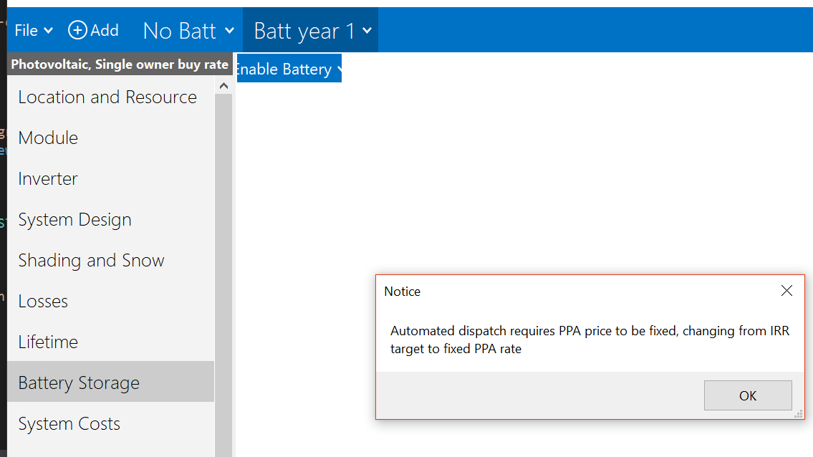

Add “hidden” variable “batt_front_of_meter” to Batt Dispatch Front of Meter form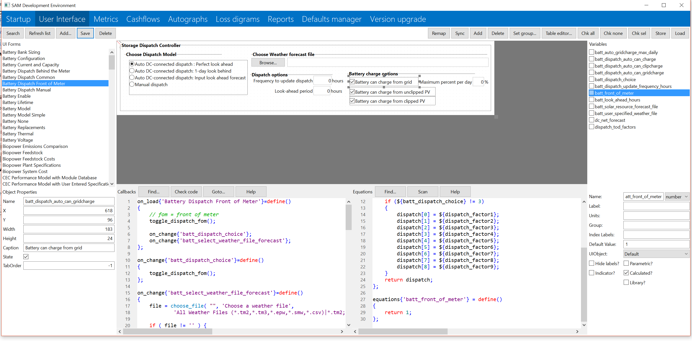

Have as optional input to utility rate and single owner compute modules with default of zero.

Update for cmod_utilityrate5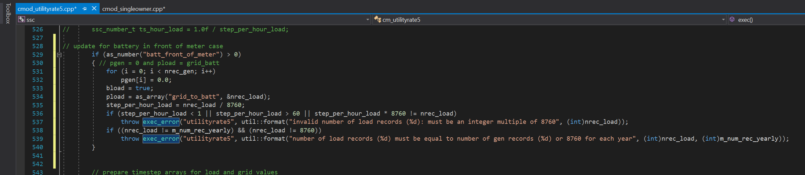

Update for cmod_singleowner (will need to do for other in front of meter battery markets)

Build and test – issue with missing grid_to_batt and batt_front_of_meter always set to 1 event when battery not enabled. 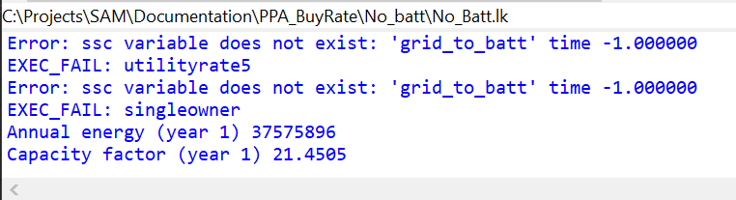

Cash flow issue with battery with in front of meter but batt_to_grid = 0 – apparently utility rate compute module is zeroing out generation used in financial model??? 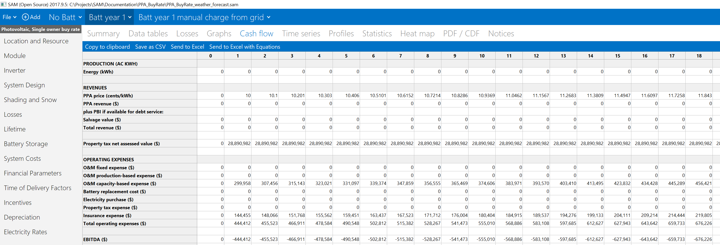

Also, electricity purchase in cash flow does not agree with data table items with non-zero grid_to_batt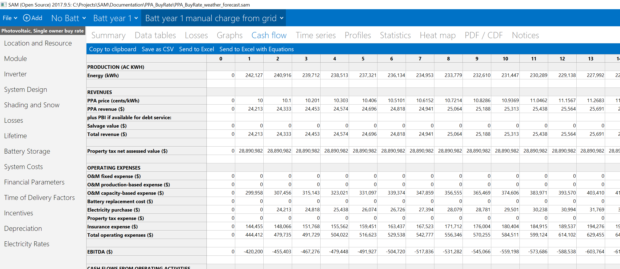

Go through feedback from Nick and continue working out issues – utility rate resetting energy value.

Create and allocate separate energy and load values used in cmod_utility rate 5 and same for single owner

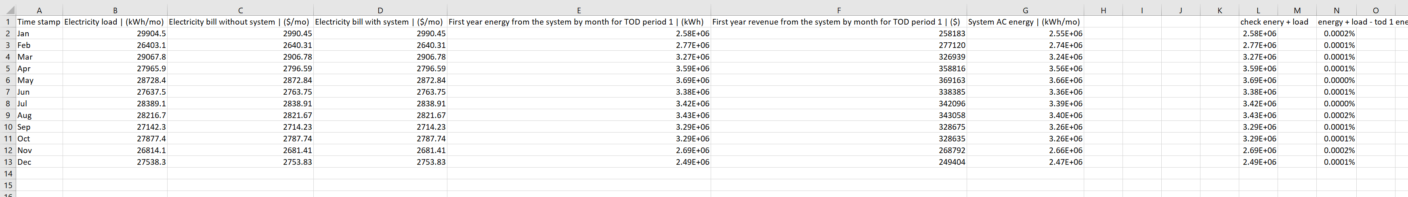

All working -

TODO

1. Resolve energy value(s) used in financial model – one for ppa revenue and then pv only for incentives and operating expenses.
2. Test for all markets with and without batteries