Benchmark for matching cmod_levpartflip.cpp to v4.1 of DHF model for leveraged partnership flip structure.

Match inputs and run ssc and save script to levpartflip_v4.1_bm.ss and Excel workbook to DHF_Team_SAM_Model_Update_-_v4.1_bm.xlsm

Copy results for partners (tax investor and sponsor) for after tax total, irr and npv.

The totals and npv agree to less than 0.0001% and the irr agrees to less than 0.5% when > 0.

Can investigate irr further but forward and backwards solution are giving same ppa.

Results stored in ssc rev 3 and in DHF_Team_SAM_Model_Update_-_v4.1_bm.xlsm (max differences in red)

Tax investor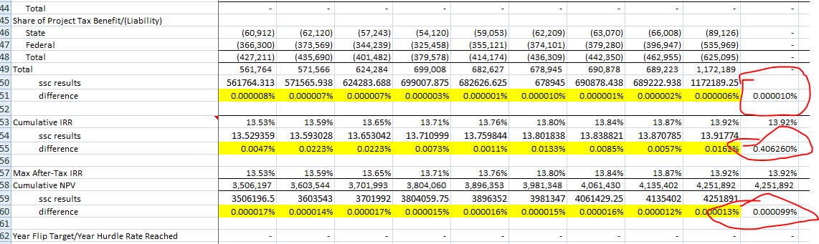

Sponsor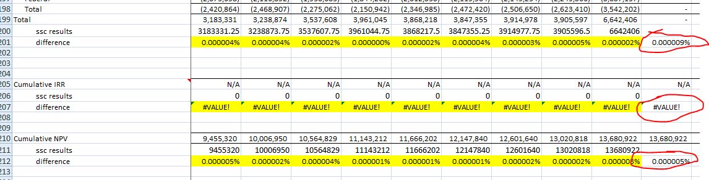

Checked into ssc rev 83