3Implementation of DHF v2 model into ssc

Vba included is 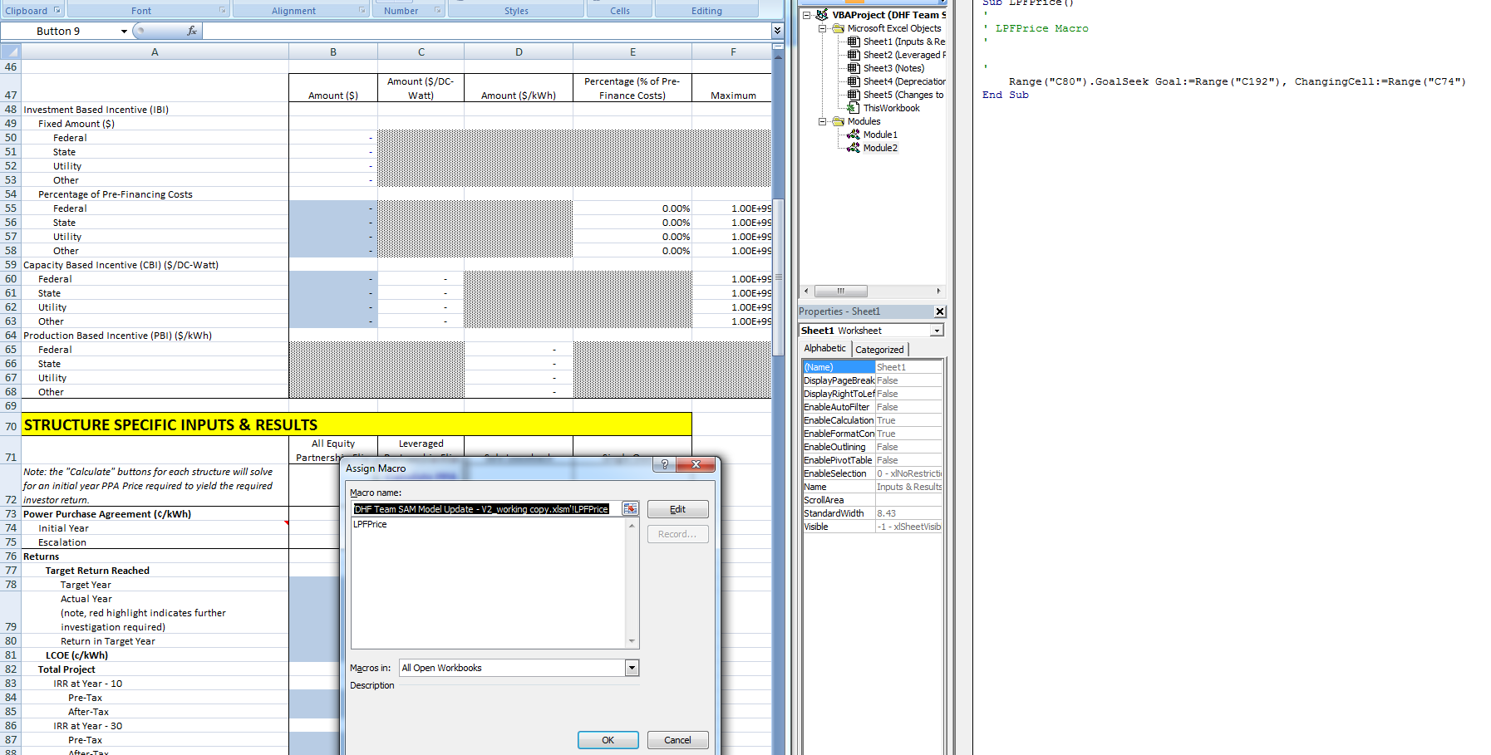

Calculating the “Return in Target Year” (cell C80) by changing the initial year PPA price (cell C74) to meet the goal of the “After-Tax Flip/Return Targets” (cell C192).

Handles construction interest by interest months/2 – cell C124.

Interesting sheet is the Notes sheet in the workbook.

Complete validation of cashloan compute module – see SAM\documentation\ssc\scripts\Aron_11192010

And

SAM\ssc\sscdev\deploy\validation\cashloan_validation_20101121.sscdat

SAM\ssc\sscdev\deploy\validation\cashloan_validation_script_20101121.ss

SAM\ssc\sscdev\deploy\validation\cashloan_validation_20101121.zsam

All inputs – use vtab_common static table inputs whenever possible.

Use named range variable names from DHF whenever possible.

Comments to Matt – sent 11/29/10- responded 11/29 – 1 fixed and 2 being addressed

1. Spelling and use of indirect and direct instead of soft and hard costs in “Taxes and Insurance” on Inputs and Results sheet
2. PBI implemented as single value with no escalation and no term on partnership sheet line 646

Questions to Matt – sent 12/1/10

Reserve accounts

1. O and m – is there no interest gained on this account and no way to release funds until the end of the analysis? That is, this is just additional funds that are tied up that the project must incur – correct?
2. Equipment reserve funding – is this usually equal funding independent of inflation? That is, the cost is inflated but the actual funding is in equal installments.
3. Equipment funding – what happens if the equipment replacement interval is greater than 10?

Debt

1. Is the DSCR section starting at row 681 just a check? The debt is constructed based on the DSCR so is this section necessary?

Goal Seek issues in Excel

<http://www.clear-lines.com/blog/post/Excel-Goal-Seek-Caution!.aspx>

Goal seek forward solution

Outline –

1. Bounded PPA range for iterative solution.
2. Bounded rates of consideration for IRR and then N/A or something?
3. Check cash flow of interest and skip if all negative or all positive – “N/A”?
4. Run NPV at different rates over bounded interval and check for zero with negative slope.
5. Iterate to within tolerance for solution – if multiple solutions, then report to user?

Questions/comments

1. Why is half of the ITC disallowed for the ITC bases? E.g. I583 on Leverage Partnership Flip sheet.
2. How to handle multi-year ITC values? Do not – 1st year only
3. Should the ITC qualifying reduction be at year 1 or 0? Do we need a discounted npv?
4. IRR function needs work – issue for flip calculation – not consistent with Excel.

Setup iterative loop and test – issue with capacity based o and m when looping 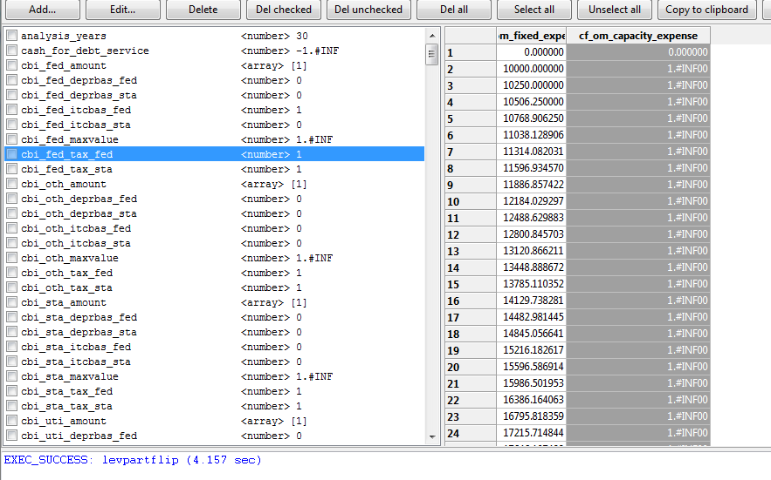

Pre calculate expenses (not dependent on ppa)

Write out iterative steps – issue with npv and irr 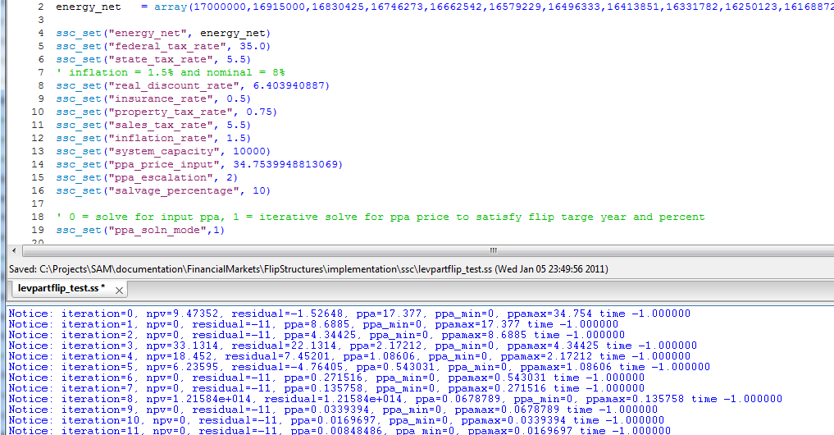

Run one iteration and check with spreadsheet flows

Notice: iteration=0, npv=9.47352, residual=-1.52648, ppa=37.377, ppa_min=34.754, ppamax=40 time -1.000000

Go through and fix major equipment depreciation – outside of solution loop and add solution control parameters and run 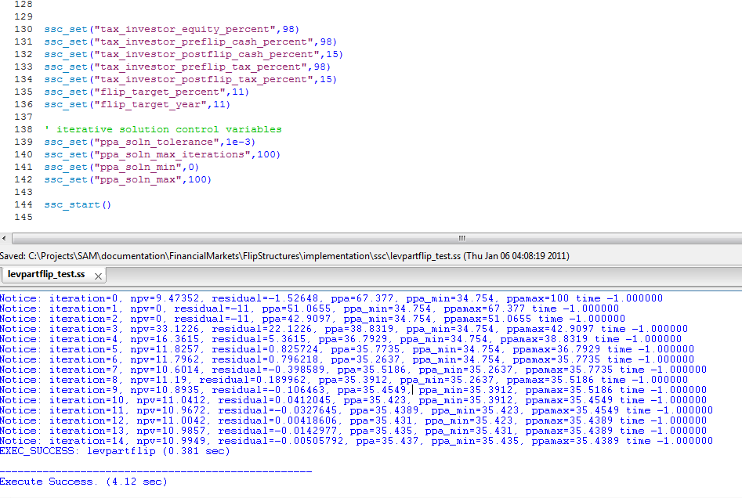

Check with Excel solution 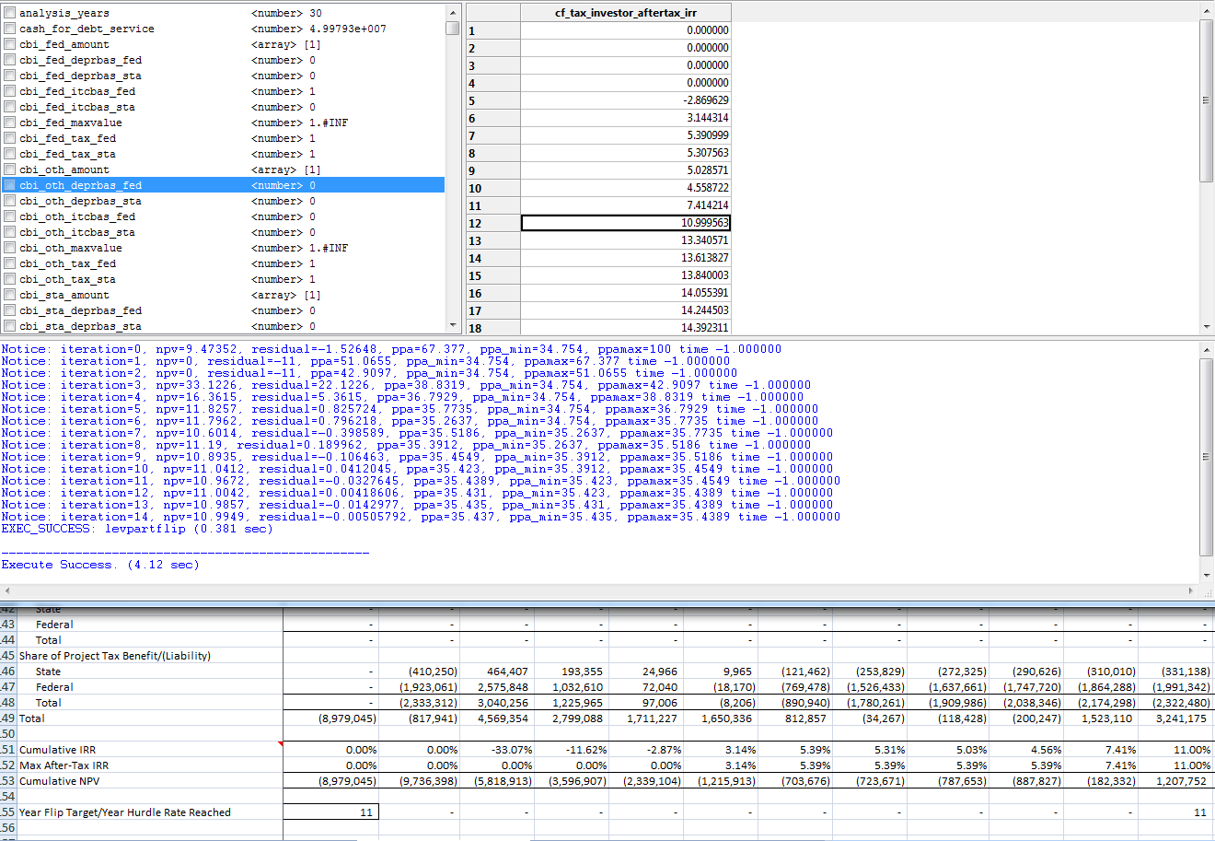

PPA matches with excel. However, irr and npv values after the flip year do not match as close as before.

Differs in 5th significant figure 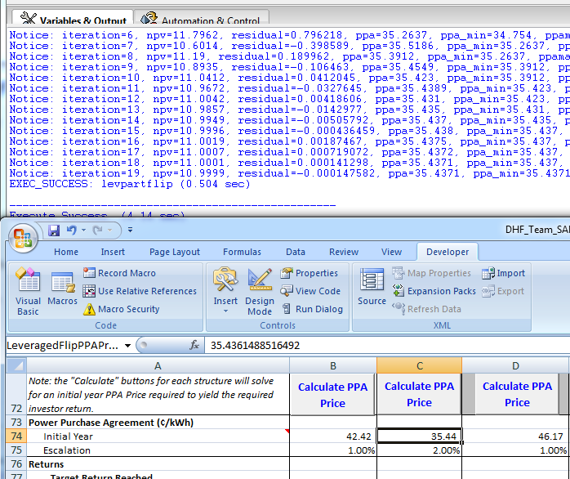

Values agree well when tolerance change to 1e-9 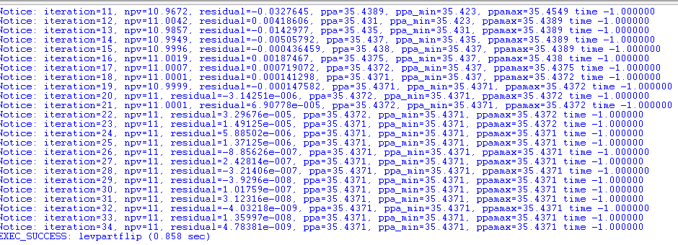

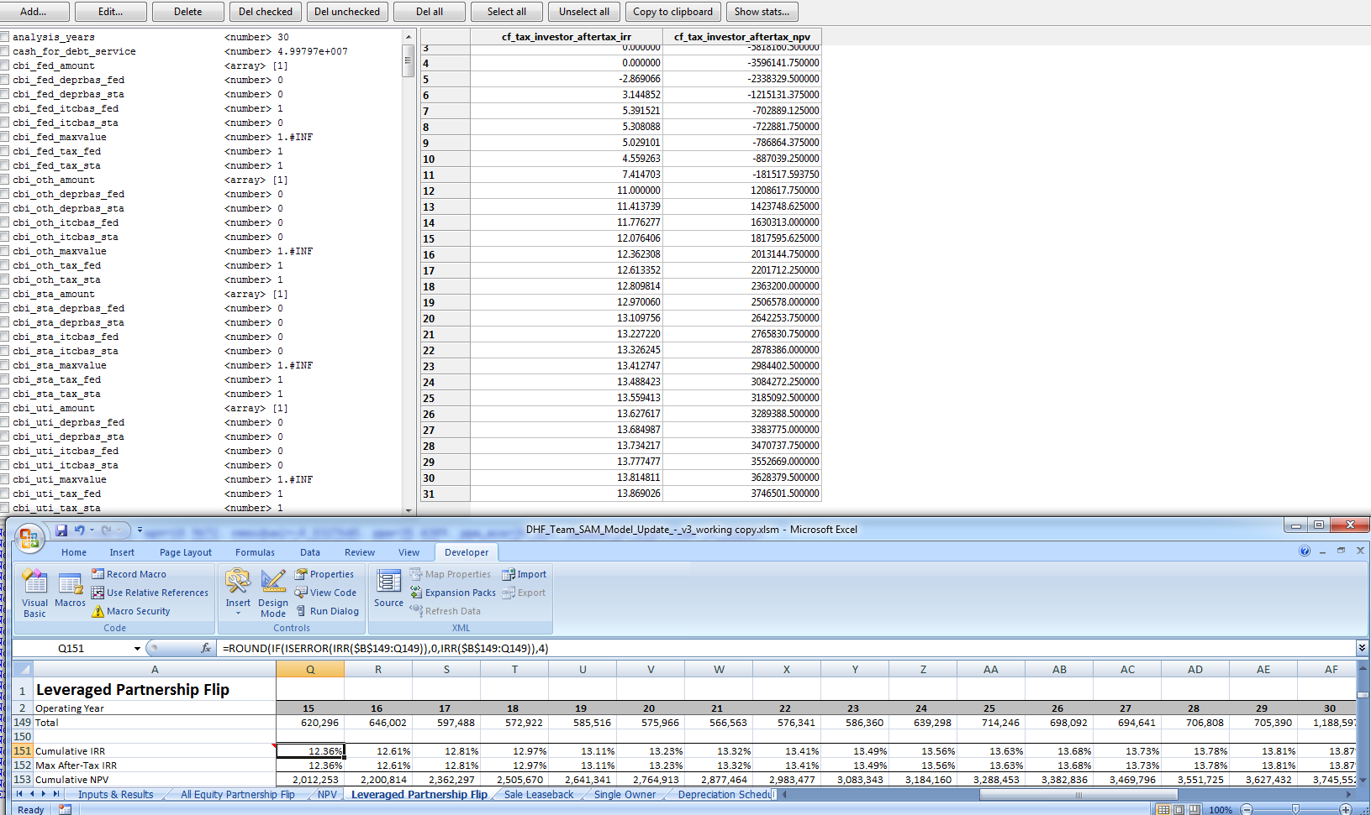

Check that ppa solution mode matches exactly with workbook as before 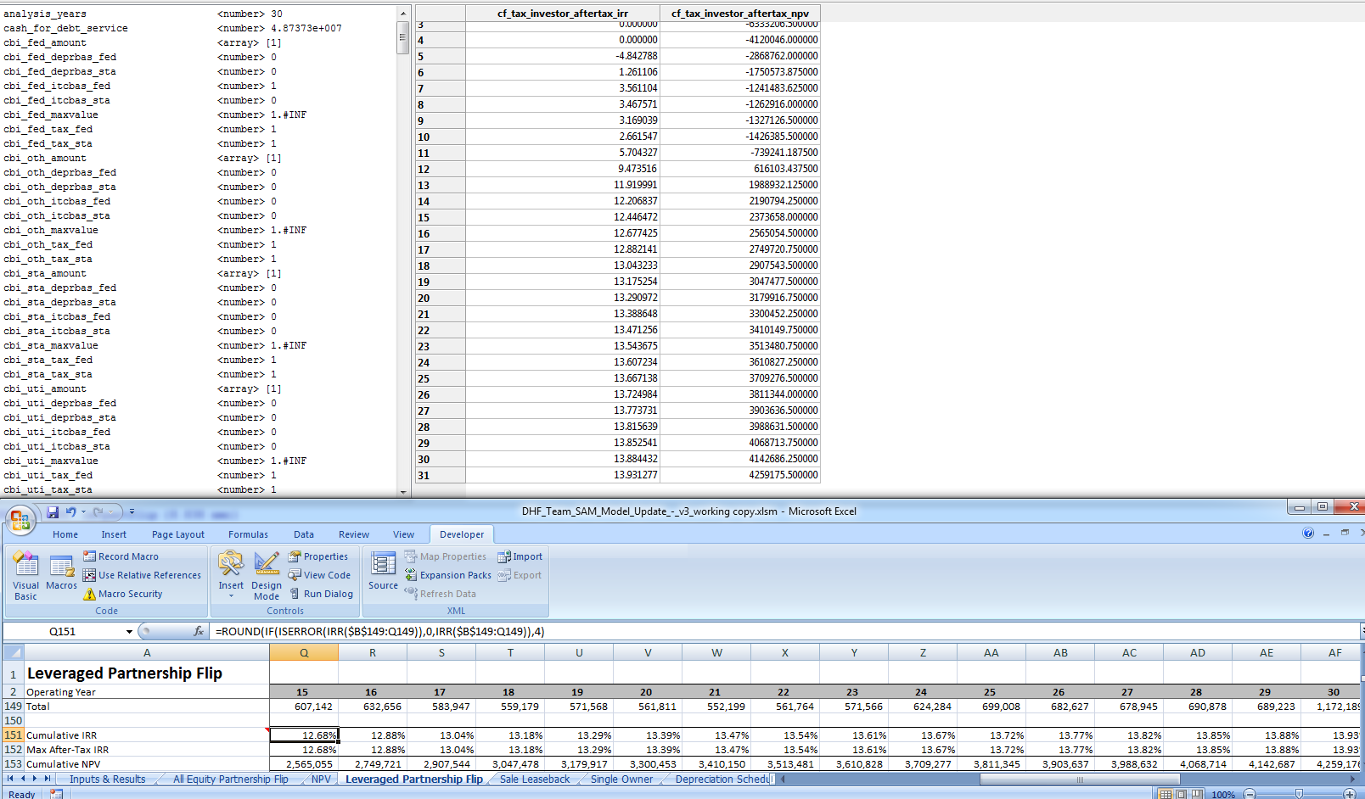

TODO

1. Verify irr and npv cash flow with Excel workbook with different tolerances.
2. 1st year ITC, IBI and CBI – ssc and in sam with updates for previous projects.
3. Minimize recalculations within solution loop
4. Setup validation cases (scripts and workbooks)
5. Implement the other three DHF models.