#### Roger Williams University

#### ENGR 431

#### Homework Set 8

8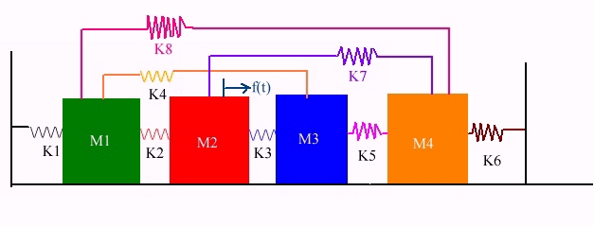If a three mass system has three modes of vibration then a four mass system has four modes of vibration. Fortunately, the steps required for modal analysis are unchanged.

|  |  |
| --- | --- |
| M1 | 1. |
| M2 | 3. |
| M3 | 4. |
| M4 | 8. |

|  |  |
| --- | --- |
| K1 | 10 |
| K2 | 15 |
| K3 | 25 |
| K4 | 12 |
| K5 | 10 |
| K6 | 15 |
| K7 | 30 |
| K8 | 20 |

All masses start from rest

|  |
| --- |
| F(t)=2*sin(f*t) |

1. Create modified K and M matrices from the figure and parameters listed above.
2. Use the previously developed forced modal analysis procedure to find the modes of the system.
3. Apply a sinusoidal force on M2 as shown.
4. List the frequencies and excite the system at frequencies near the mode frequencies and observe the vibration modes
5. Copy and paste the graphs of the vibration modes into this document and describe the four modes of vibration, using expressions like “in mode 1 mass 2 and 3 move together, masses 1 and 4 move the opposite direction”, etc.
6. What would happen if Spring 7 were cut?
7. Answer this question by setting k7 to zero and simulating again. Compare and contrast the four modes. Do any change their shape? I.e. does the system now vibrate *in a different way* without spring 7, or does it vibrate the same way at somewhat different frequencies? Submit an MS Word document containing all figures and text.

Mode 1:

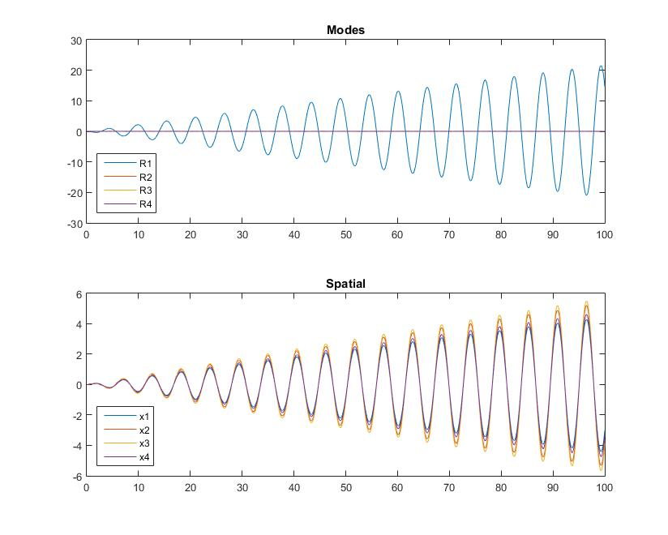

Mass 1, 2, 3, and 4 all move together in the same direction. They are all in synch and increase magnitude to infinity.

Mode 2:

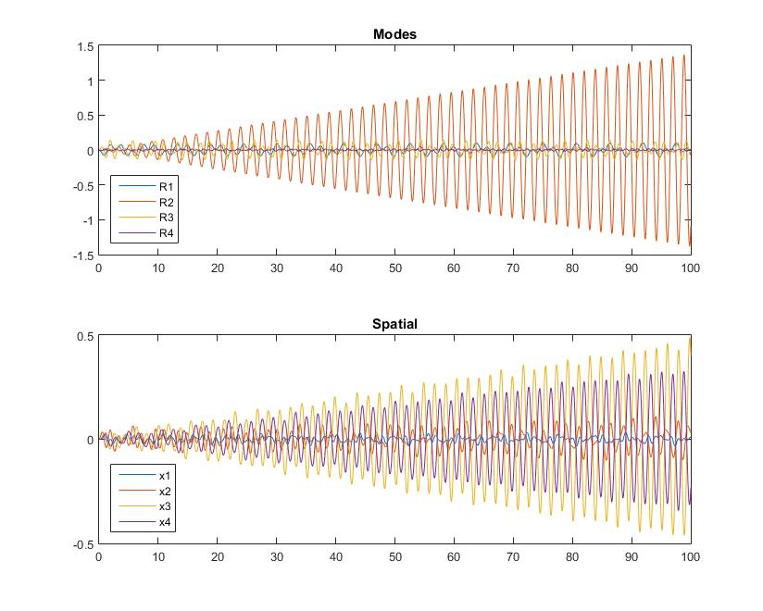

Mass 1, 2, 3 all move together, though mass 1 barely moves from its starting position. Mass 4 moves opposite from the other masses. R2 increases to infinity while the others supposedly interfere with each other.

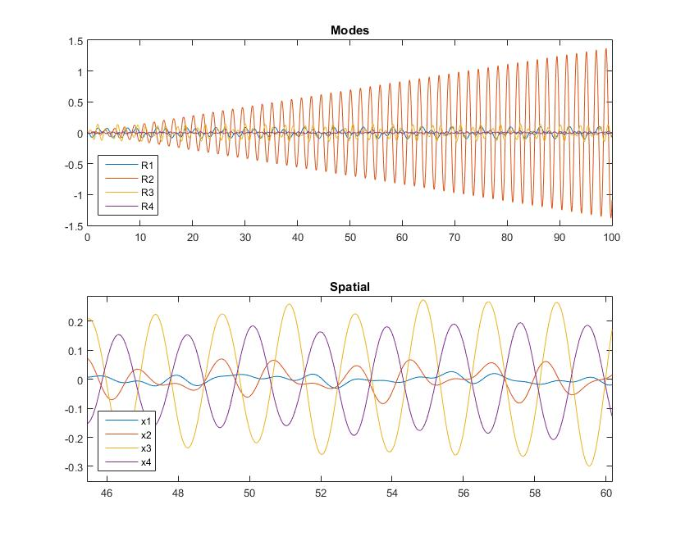

Mode 3:

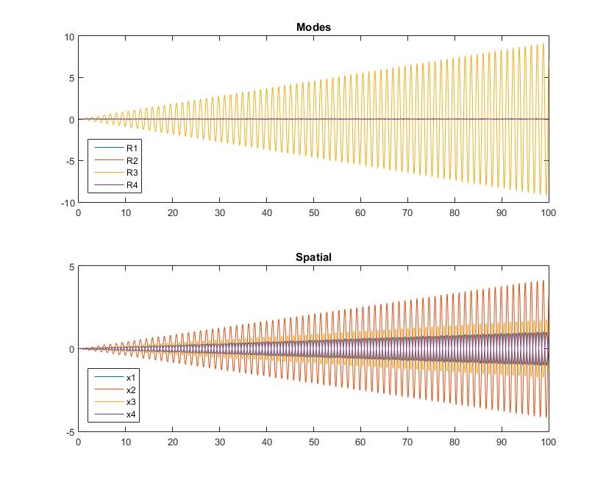

Mass 1 and 2 move opposite from 3 and 4. Looks as if the oscillation was split down the middle. Increases to infinity.

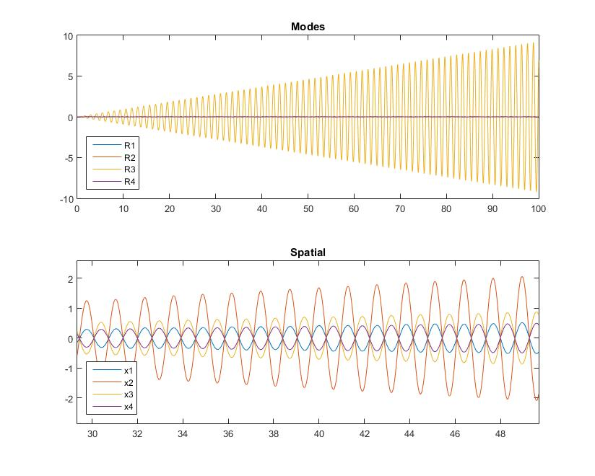

Mode 4:

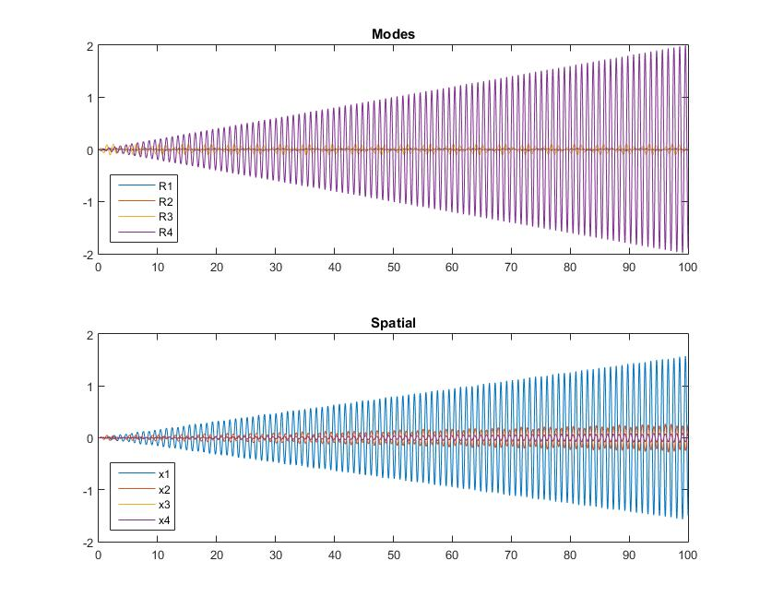

Mass 1 moves opposite from the others. Mass 3 and 4 move about the same but it is tiny compared to mass 1. Mass 1 heads to infinity and the other follow at a slower rate.

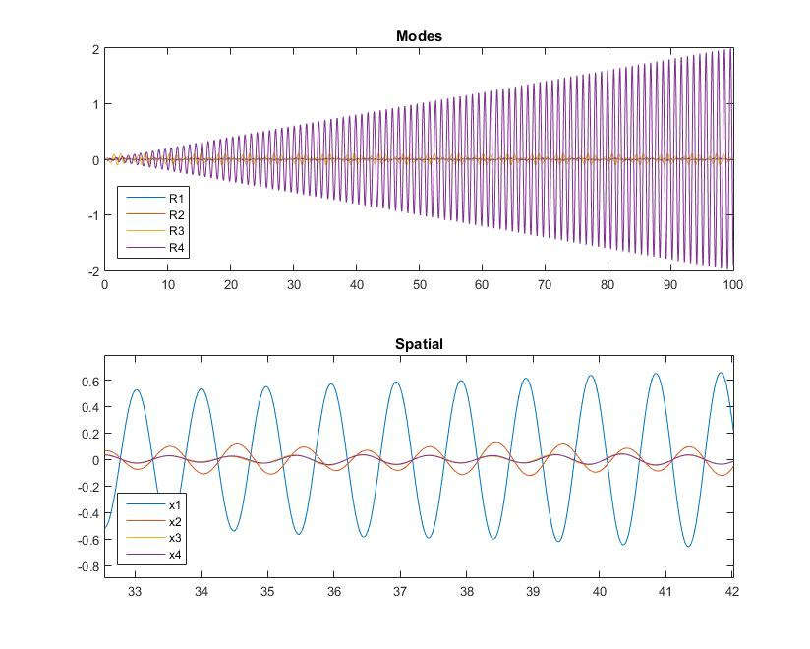

7) The only obvious difference is that in mode 3 mass 4 is moving at a much higher magnitude and with mass 1 and 2 instead of opposite them and with 3. All the others are moving in the same directions as if spring 7 were still there. All the different omegas for the modes have changed number as well but nothing else is different.

S =

-0.2066 -0.0072 -0.0622 0.7924

-0.2779 -0.2467 -0.3718 -0.1039

-0.2741 -0.1795 0.3370 -0.0467

-0.1976 0.2754 -0.0209 -0.0506

Mode 1:

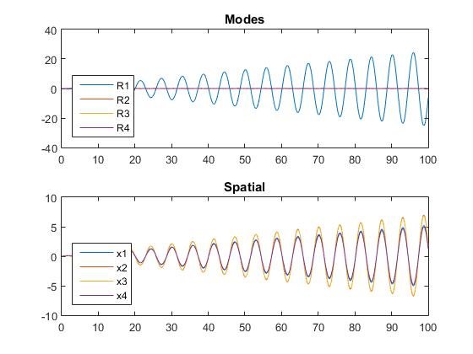

Mode 2:

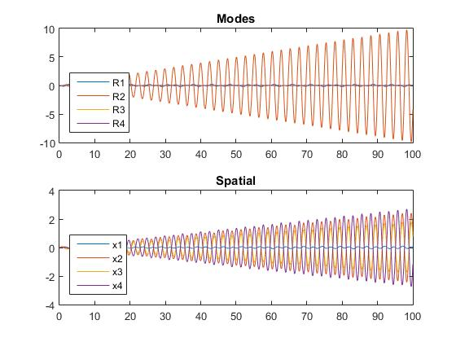

Mode 3:

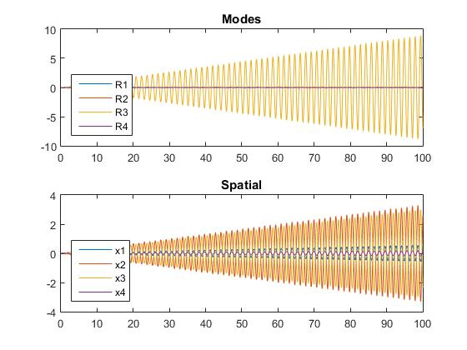

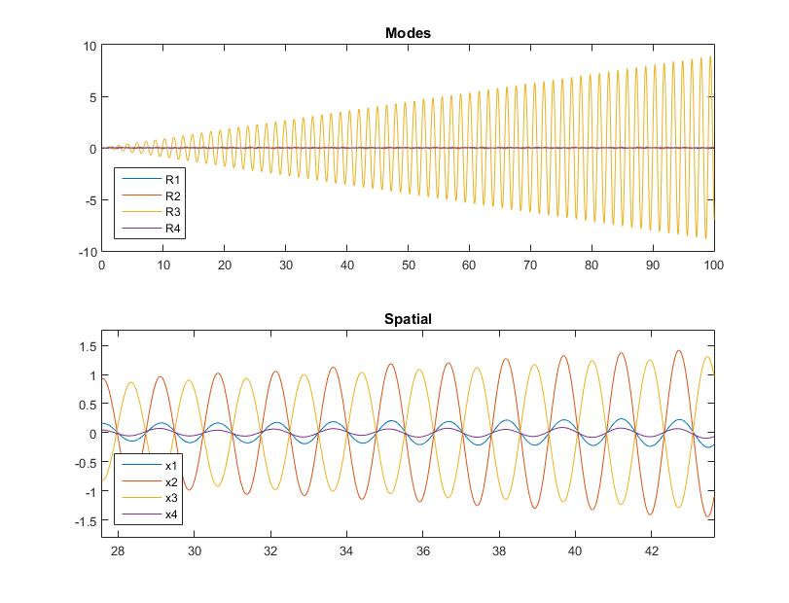

Mode 4:

